If you wish to change the Hero articles appearance in the homepage,
go to Homepage  and make the amendment in Hero Articles section by clicking the box and select the articles and click “Save”.
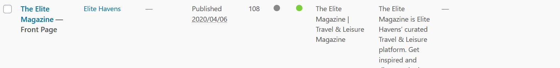
New Procedure: Go to Pages and edit the Front Page refer to the image below

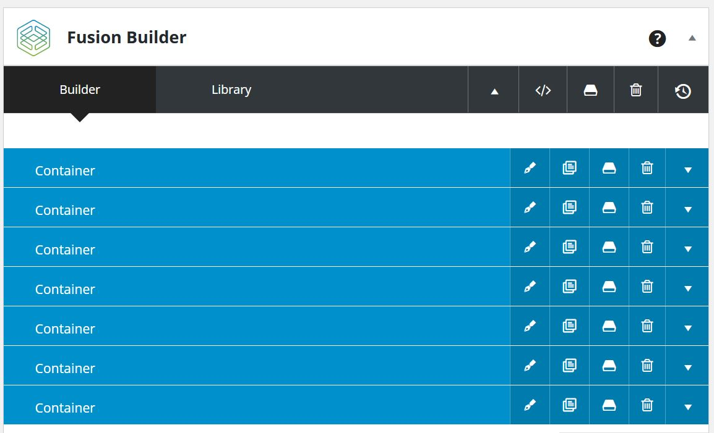
Once inside the editor, you will see the image below

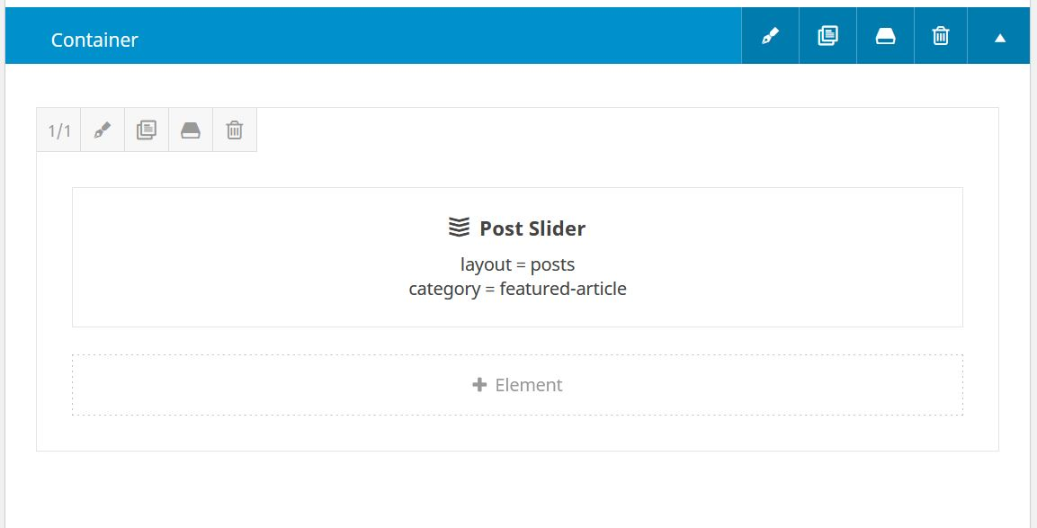
First Container – Post Sliders. These contain the featured and/or latest articles. You can edit the list by clicking the down arrow on the far right and will take you here,

When you hover on the Post Slider area, a bunch of Icons will appear, 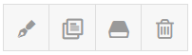icons from left to right, Edit, Clone Element, Save Element, Delete Element. Be careful when clicking these icons.
Clicking the Edit Icon ( Pen Icon ) a pop-up window will appear, refer to image below,
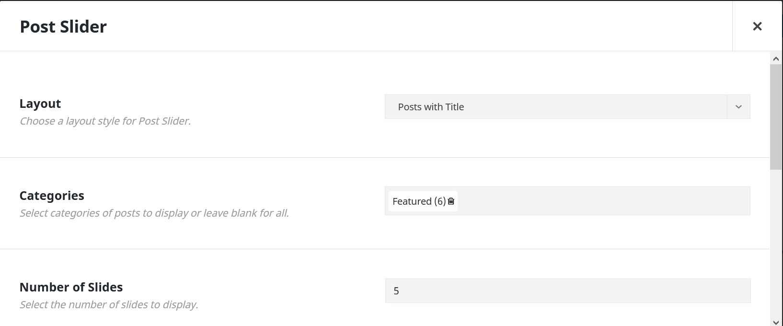

You will primarily focus on these three fields, Layout, Categories and Number of Slides.
The Layout will let you choose how the articles will appear on the slider, Post with Title (current setting), Post with Title and Excerpt, Attachment Layout, Only Images attached to Post/Page. If you want to display extra info on the Home Slider, choose Post with Title and Excerpt.
Categories lets you choose the articles you want to feature on the slider default is Featured. You can choose other categories you want to feature on the slider by clicking on the text box and a list of existing categories will appear. If you want to remove a category on the list just click the little garbage bin beside it.
Number of slides lets you choose how many articles from the chosen category above will be featured.

Second Container element is the Places to stay portion. Just like the Post Slider, you can edit the portions by hovering on it and clicking the Pen Icon only this time there are a couple more options you can adjust.
When you hover at the Places to Stay text, you can edit the text via Pen Icon
- Title Type (Text, Rotating, Highlight) set to Text by default
- Title lets you edit in a Rich Text Editor; you can edit the link to a title here. For example, Editor’s Pick, on the editor highlight the text and click on the Insert/Edit Link. Refer to the image below.
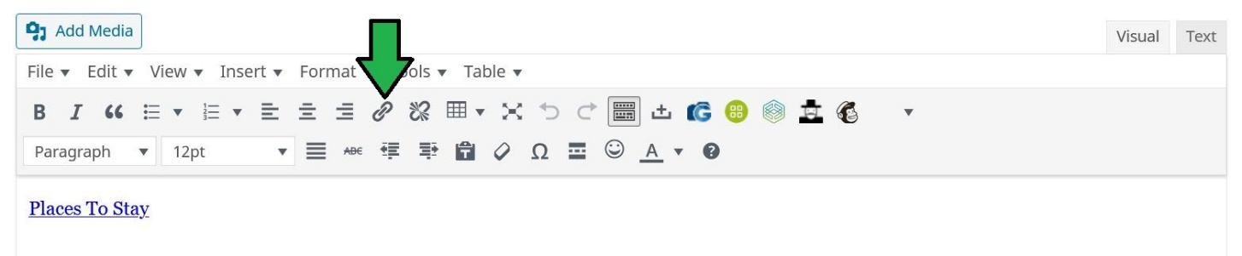

- Element Visibility, CSS Class, CSS ID leave it as is.
When you hover on the Recent Posts Box and clicking on the Pen Icon,
- Layout (Standard, Thumbnails on Side, Date on Side) default setting is Standard
- Picture Size (Fixed, Auto) default set to Auto
- Hover Type (None, Zoom In, Zoom Out, Lift Up) default set to Zoom In. You can see this effect when you hover on a picture of an article on the homepage.
- Number of Columns currently set to 3.
- Posts per page also currently set to 3 to match the preferred layout of the homepage.
- Posts Status currently set to Published. Other options when you click on the text area are Drafted, Scheduled, Private, Pending. Leave this to Published.
- Post offset allows you to skip several articles. For example, when you put 1, it will skip the first latest article and show the rest depending on the number or articles to be posted.
- Pull Posts by lets you choose if you want to display articles by Categories or by Tags. Currently set to Categories.
- If you choose Categories, it will let you filter the display by Categories. Same when you choose Tags.
- Show Thumbnail, Show Title, Show Meta are all set to Yes. If Show Meta is set to Yes, it will let you choose other info to be shown like Show Author Name, Show Categories, Show Date, Show Comment Count, Show Tags which you can set to Yes or No. Currently only Show Date is set.
- Content Alignment (Text Flow, Left, Center, Right) set to Text Flow by default.
- Text Display (Excerpt, Full Text, None) set to Excerpt as default.
- Excerpt Length is set to 35 to this part of the homepage. If you want to edit excerpts for all parts, you need to edit their respective Container.
- Strip HTML set to Yes. Leave as is.
- Pagination Type (No Pagination, Pagination, Infinite Scrolling, Load More Button) current set to No Pagination.
- Element Visibility leave as is. This is a theme option better leave it as is.
- CSS Class lets you attach a CSS class if you plan to do a custom adjustment via CSS Coding.
- CSS ID same as CSS Class.
Third Container is the Editor’s Pick portion. Functions and features are the same as Places to Stay above.
Fourth Container divided in to two columns, Life Style and Culture. Functions and features are also the same with Places to Stay and Editor’s Pick.
Fifth Container is divided into two columns as well, Food and Drink and Travel and Tips. Functions and features are the same also with Life Style and Culture Container.
Sixth Container is the Join the Elite Club at the footer section which you can also edit the text.
Seventh Container is the Instagram Feed portion.
Please note also that in here you can change how the appearance of the homepage will look like.

