IMU Verification

**Accelerometer Verification**

Following the revised verification methods, I have captured and plotted the data, shown below. I have included the raw data of the drop tests and also a filtered version of the drop test. Then for each test I plotted the targeted axis to show that during the fall the accelerometer readings go from 1 g to 0 g.

The only issue is that after the fall, when the IMU hits my lower hand, the accelerometer shoots upward to the bounds of the accelerometer (4g). This is probably because during the collision, there is a brief moment when the IMU actually bounces upward, which will cause the accelerometer to have such a high reading. Another possible explanation is that accelerometers are inherently noisy and the impact of the accelerometer causes the internal crystal to react greatly. I think these two factors in combination would cause the accelerometer to give those sharp increased readings.

X Axis drop test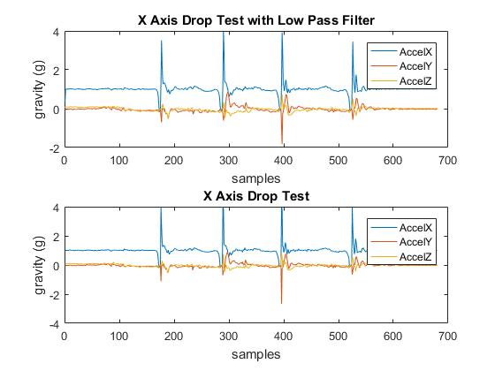

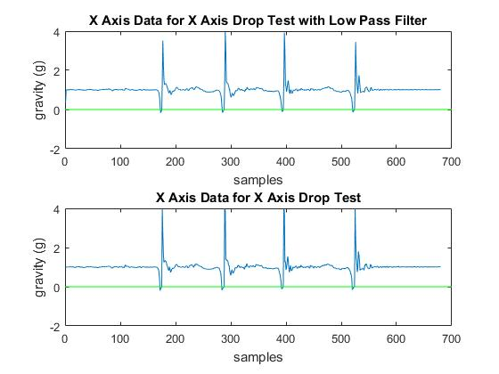

Y Axis drop test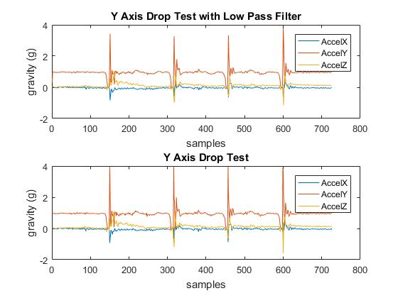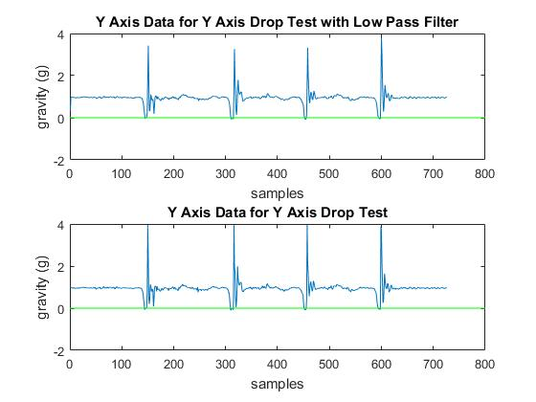

Z Axis drop test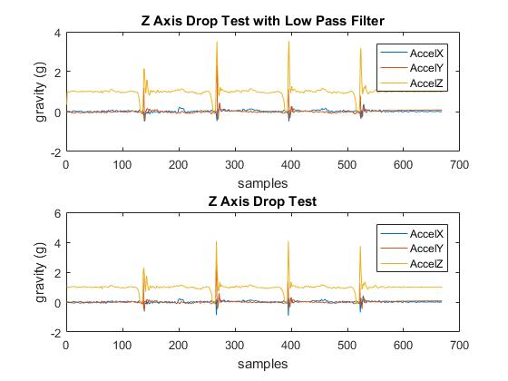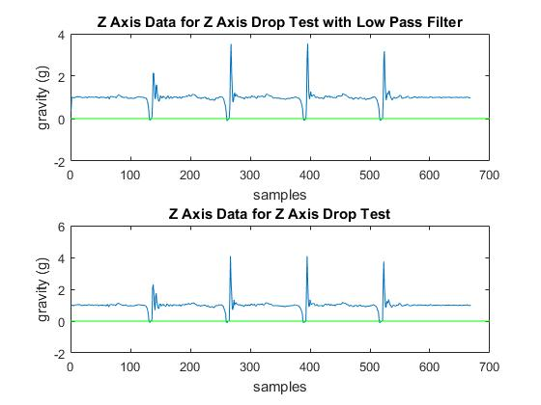

**Gyroscope Verification**

Below is the verification plots for the x axis (roll) and y axis (pitch) rotation. We will not use the Z axis because a compass is needed as reference in order to solve the drift problem for the Z axis. The plots included is the angles from the gyroscope data of all three axis. This is to show that the axis reacts correctly for isolated axis tests. Following that plot is the output of the target angle after going through the complimentary filter, overlaid with the original angle from the gyroscope.

X axis

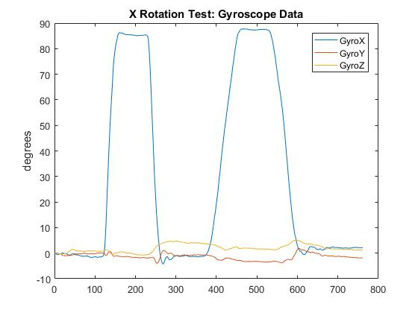

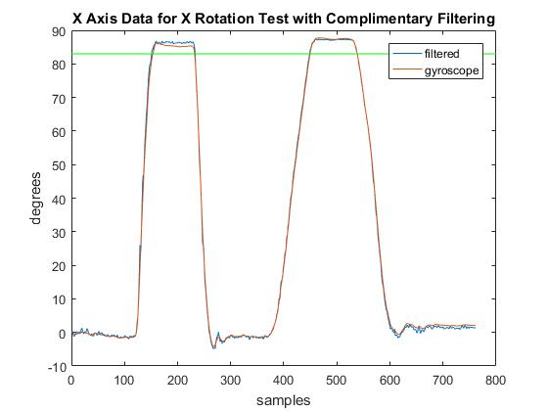

Y axis

