Low Pass Filter Verification

There are four low pass filters that I verified below. There are two devices, one for each foot, and on each device there are two low pass filters for each of the FSR’s. After soldering the components onto the PCB I used a couple of ways to distinguish between each of the four filters. Since there are two PCB’s I will use descriptive qualities to distinguish between the two; one will be called PCB marked because it has a checkmark on it and the other will be called PCB rounded because it has rounded edges. To distinguish between the two filters on one PCB, I will refer to the marking next to the capacitor of the filter, C4 or C5.

Based on the RV table, 10% error from 20 Hz cutoff frequency is acceptable, which means that the half power cutoff frequency can fall between 18 Hz and 22 Hz. Thus the method I used to test the filter is to test each filter at 20 Hz and compare the output and the input to get the gain. If the gain is less than 1/sqrt(2) then I would test the filter at 18 Hz input to see if the gain is larger than 1/sqrt(2). If this is the case then the real half power gain is between 20 Hz and 18 Hz, thus fulfilling the requirements. If at 20 Hz the gain is larger, then I would test at 22 Hz and check if the gain is less than 1/sqrt(2). For all of the cases, the gain at 20 Hz was on the lesser side. Below are the oscilloscope captures and the calculated gains.

Filter for C4 of PCB check at 20 Hz (gain = .681)

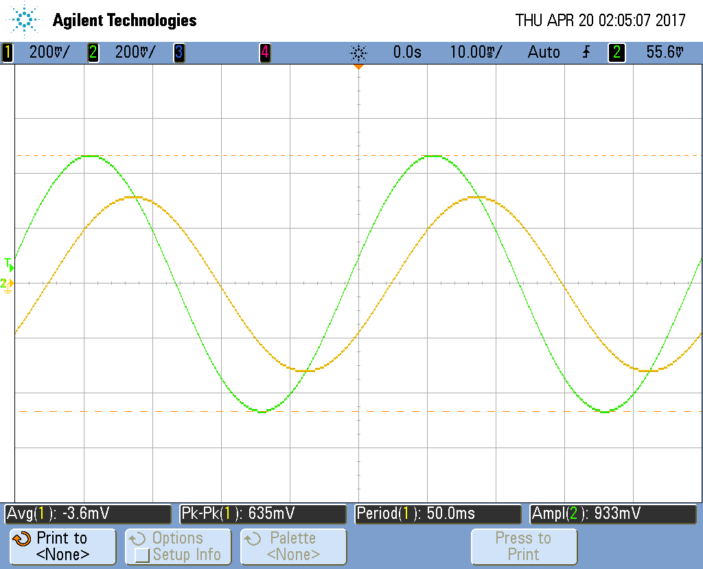

Filter for C4 of PCB check at 18 Hz (gain = .721)

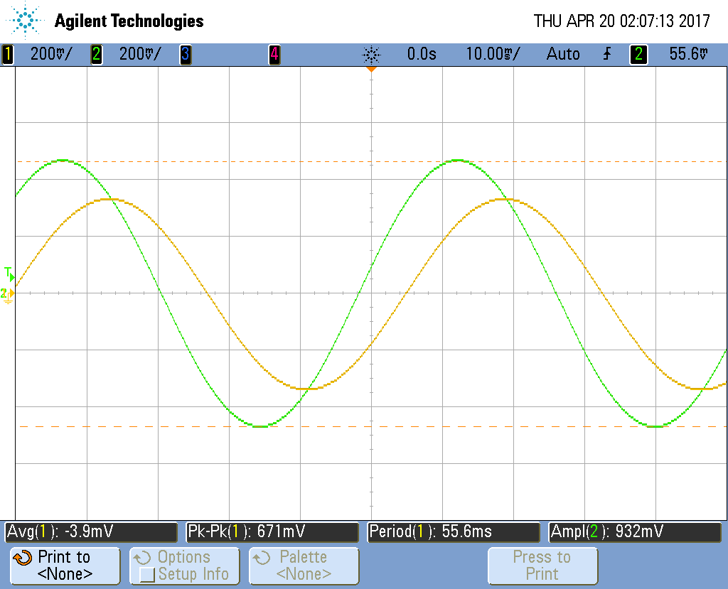

Filter for C5 of PCB check at 20 Hz (gain = .681)

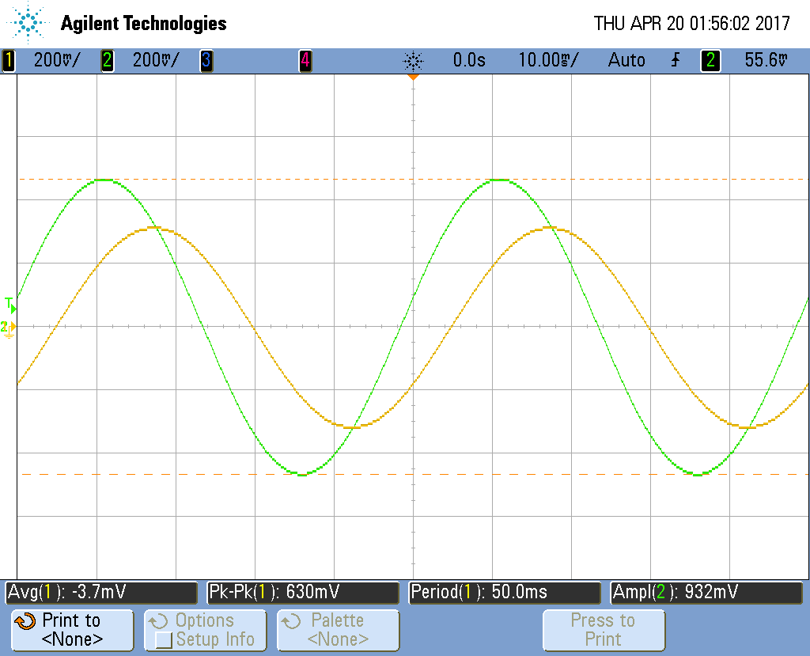

Filter for C5 of PCB check at 18 Hz (gain = .717)

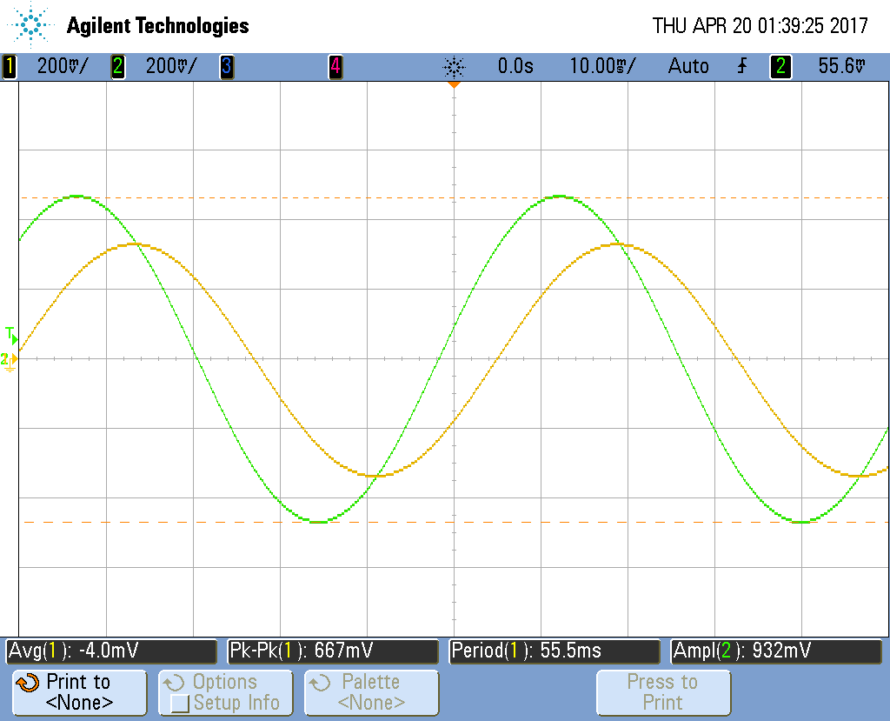

Filter for C4 of PCB round at 20 Hz (gain = .671)

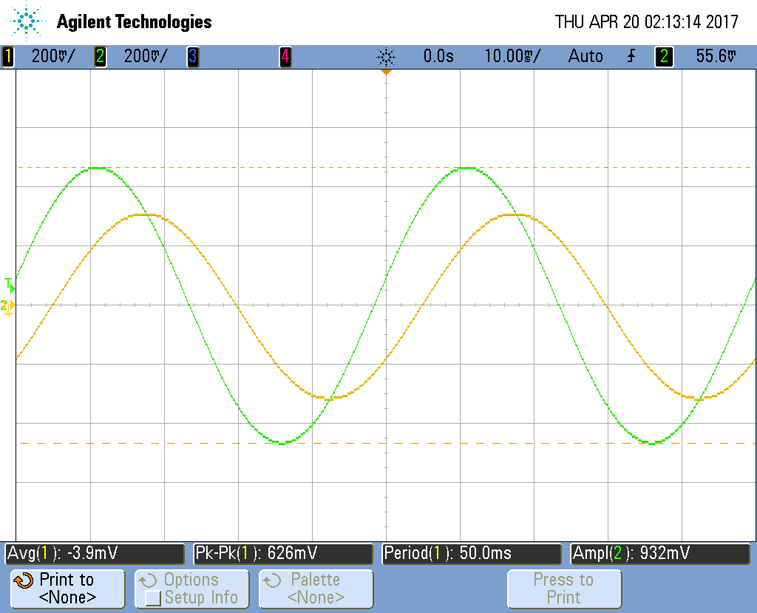

Filter for C4 of PCB round at 18 Hz (gain = .712)

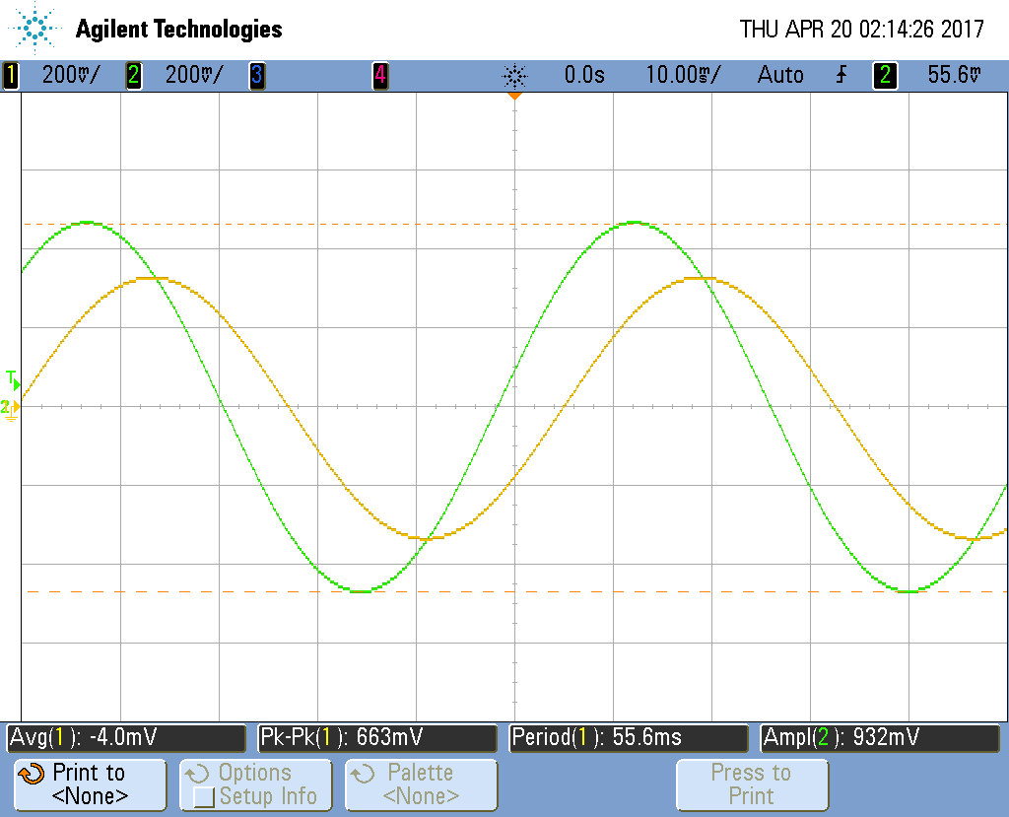

Filter for C5 of PCB round at 20 Hz (gain = .680)

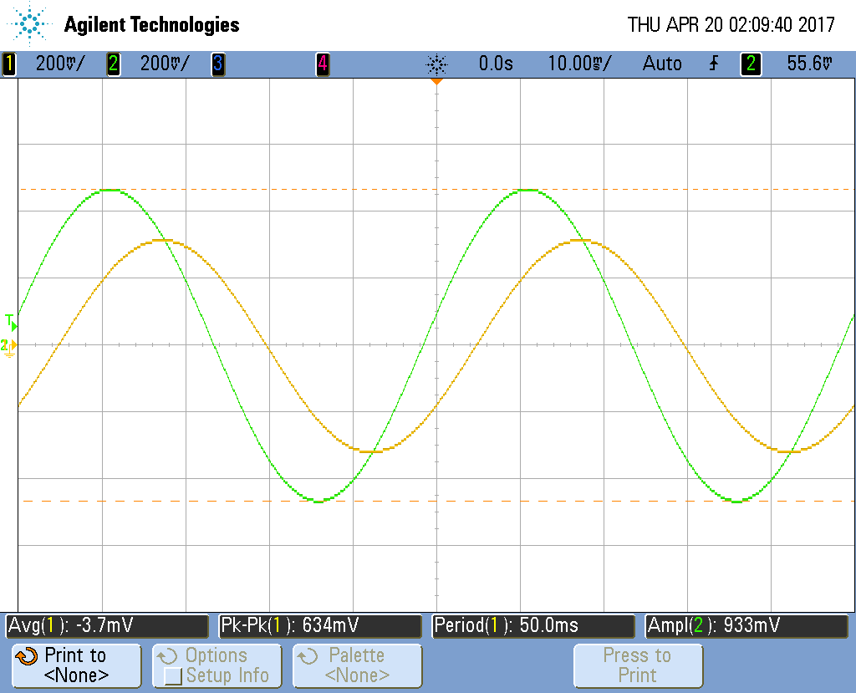

Filter for C5 of PCB round at 18 Hz (gain = .720)

