LAB 1

COMPONENTS OF COMPUTER SYSTEM

A computer system is made up of different parts that work together to process, store, and display data. The most important part of a computer is the system unit, which contains all the internal components required for the computer to function properly.

System Unit:
The system unit is the main case of a computer. It protects all the important parts such as the motherboard, processor, memory, and storage devices. Without it, the computer cannot work because it connects and powers all other components.

COMPONENTS OF SYSTEM UNIT

Motherboard:
The motherboard is like the central commun-
ication hub of the computer. It is the main circuit board inside the
system unit and connects all the parts together, including the CPU,
RAM,and storage devices. It contains chips, circuits, and transistors
that allow the components to exchange information.

Daughter Board:

A daughter board is a smaller circuit board
that connects to the main motherboard. It is used to expand
the functions of the computer without replacing the mother-
board itself.

Power Supply (PSU):
The power supply unit provides electricity to all
the computer parts. It changes the electricity from alternating
current into direct current that the computer can use. Every
part of the system unit gets the right amount of voltage from
the PSU.

Hard Disk Drive (HDD):
The hard drive is the main storage device of the computer. It stores data permanently, which means even when the power is off, the information is not lost. Hard drives are usually placed inside the system case, but portable external drives can also be connected through USB.

Compact Disc Drive (CD Drive):
A CD drive is used to read and sometimes write data to compact discs.
It can store huge amount of data in Gigabytes.

Integrated Drive Electronics (IDE):
IDE refers to the type of connection used
between storage devices like hard drives and CD drives
and the motherboard.

RAM (Random Access Memory):
RAM is the main temporary memory of the computer.
It stores data only while the computer is on. Once the power is
turned off, everything in RAM is erased, which is why it is called
volatile memory. RAM helps the computer work faster because
it gives quick access to the data and programs currently in use.

Read Only Memory (ROM):
ROM is a type of permanent memory that
stores essential instructions for the computer. Unlike RAM,
The data in ROM does not disappear when the power is off.
Users cannot change or delete the information in ROM.

Central Processing Unit (CPU):
The CPU is often called the “brain of the computer.” It processes all instructions coming from software and hardware. The CPU has two main parts:
- Arithmetic Logic Unit (ALU): Performs arithmetic and logical operations.
- Control Unit (CU): Fetches instructions, interprets them, and controls execution.

Expansion Card:
Expansion cards are extra boards that can be added to a computer to give it more features. For example, a graphics card can improve video performance.

Video Card (Graphics Card):
A video card, also known as a graphics card
or display adapter, is responsible for generating and displaying
images on the monitor. Types include PCI and AGP.

CPU Socket:
The CPU socket holds the processor and connects it to the
motherboard.

Memory Slot:
Memory slots allow RAM to be inserted into the computer.

CPU Fan and Heat Sink:
These are used to keep the processor cool.

CMOS(Complementary Metal-Oxide Semiconductor):

CMOS is a battery-powered chip that stores information such as system time, date, and hardware settings, even when the computer is turned off.

BIOS:
BIOS is a chip on the motherboard that lets you access and set up
your computer system at the most basic level.

North Bridge:
The north bridge manages communication between the CPU, memory, and graphics.

South Bridge:
The south bridge handles hard drive controllers, input/output controllers, and integrated hardware like sound cards, USB, and network connections.

PCI Slot:
A PCI slot is used to connect add-on devices like network cards, sound cards, and VGA cards.

AGP Slot:
An AGP slot is mainly used for installing video cards, especially for 3D graphics.

ATX Power Connector:
This connector supplies power to the motherboard, CPU, and other components.

Primary Connector (HDD):
This connector is used to connect the hard drive to the motherboard.

Secondary Connector (ODD):
This connector is used to connect the optical disc drive to the motherboard.

FDD Connector:
This connector is used to connect the floppy disk drive.

Super I/O:
Super I/O manages input/output devices such as floppy drives, game ports, keyboard, mouse, and serial/parallel ports.

Capacitor:
A capacitor stores electrical energy and releases it when needed in the circuit.

Audio Codec:
An audio codec converts digital sound waves.

Connectors:
- 20/24 ATX pin connector: Connects the power supply to the motherboard
- CPU connector (4/8 pin): Supplies power to the CPU.
- Molex connector: Connects to hard drives and CD drives.
- Floppy connector: Provides power to floppy drives.
- AUX connector: Required for some motherboards.
- SATA connector: Used for SATA hard drives.
- PCI Express connector: Provides power directly to PCI Express video cards.

Back Panel:
The back panel allows you to connect external devices like monitors, speakers, keyboard, and mouse to the computer.

LAPTOP CONFIGURATION
To check your laptop’s configuration:
- Press Windows Key + R → type msinfo32 → hit Enter.
- A window will open showing:

___________________________________________________________________________________

LAB 2

Input/Output Units and Connectors

Introduction:
A computer does not work alone it communicates with the outside world using input and output devices. Input devices like keyboards and flash drives allow users to enter data while output devices like monitors, printers, and projectors display the results. Different connectors and ports are used to link these devices with the computer.

Output Devices:
- Monitor, Printers, Scanners, Projectors, and Sound Systems can all be connected to a desktop or laptop.
- Computers can even send output to multiple monitors or projectors at the same time for better display.

Process of Connecting Output Devices
- Connecting a Printer:
Printers connect to computers through power cables and connecting wires (USB or network). They allow users to print documents, images, and graphics on paper.
- Plug the power cable of the printer into an electrical socket.
- Connect the printer to the computer using a USB cable or set it up through Wi-Fi (if it’s a wireless printer).
- Install the printer driver(it usually installs automatically in modern systems)
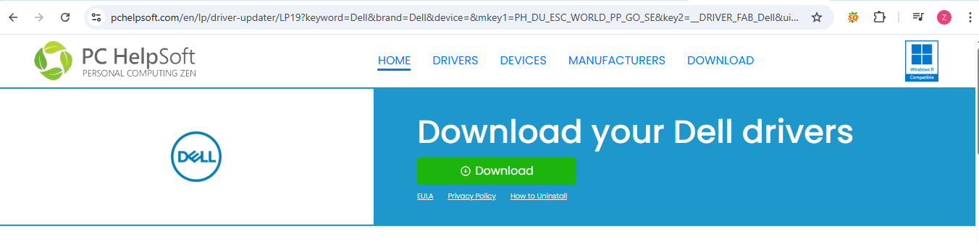
- On your computer go to:
Start → Settings → Devices → Printers & Scanners

- Click on Add a printer.

- Select the file you want to print.
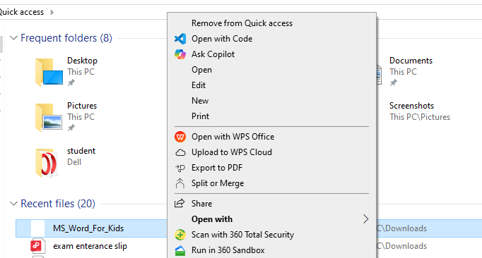
- Select print
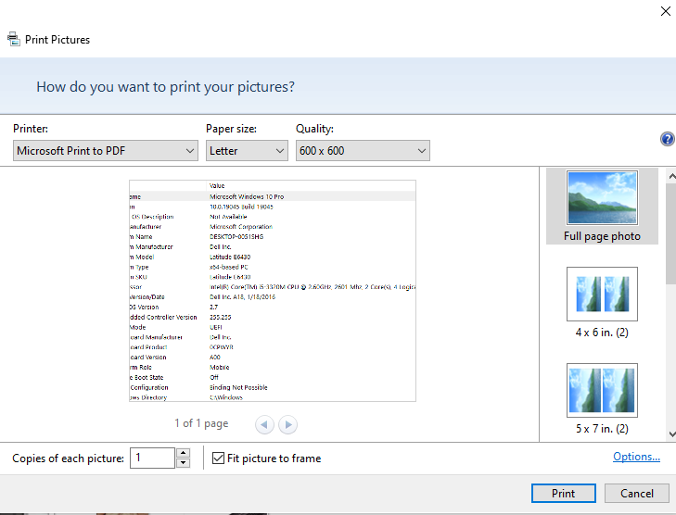
Note: I do not have a physical printer, so I demonstrated the process using Windows printer settings and available system printers.

3. Connecting a Scanner:

- Connect the scanner to the computer using a USB cable or Wi-Fi (if wireless).
- Install the scanner driver or software.

- On your computer go to:
Open Settings → Devices → Printers & Scanners

- Click Add a scanner and wait for the scanner to appear.

- Once added, open the Windows Scan app to scan a document or image.
Note:
I do not have a physical scanner, so I demonstrated the process using Windows scanner setup options.

2. Connecting a Projector:
- Plug in the power cable of the projector.
- Connect the projector to the computer using HDMI, VGA, or DisplayPort cable.
- On the laptop/PC, press Windows Key + P and choose “Duplicate” (to show the same screen) or “Extend” (to use projector as a second screen). or “Second screen only”(to only display on the projector).
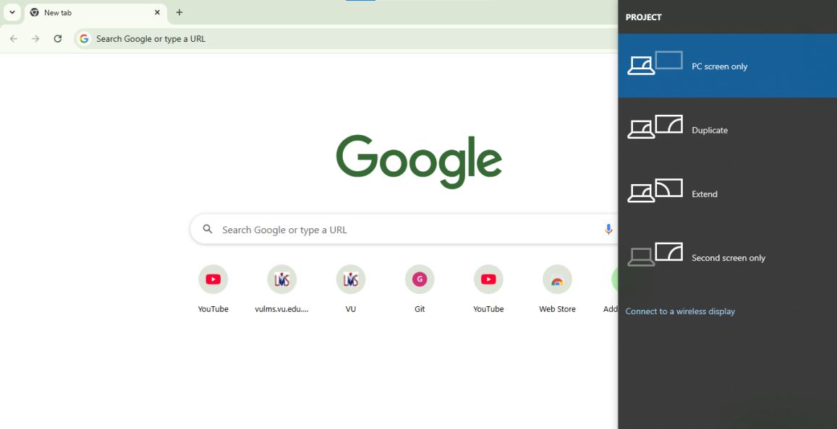

Connectors:
A connector is a physical component that transmits video signals between devices. It connects the computer (source) to a monitor, projector, or TV (display device). Common types are:
- RCA Connector: Used for carrying audio and video signals, often called A/V jacks.

- VGA (Video Graphics Array): A 15-pin connector used since the 1980s to connect computers to monitors and projectors.

- DVI (Digital Visual Interface): A digital interface to connect video sources like display controllers to monitors.

- HDMI (High Definition Multimedia Interface): Transmits both video and audio from computers to TVs, projectors, or monitors.

- DisplayPort (DP): A modern connector that supports higher resolutions and refresh rates than VGA, DVI, or HDMI. Preferred by gamers.

- FireWire: Used for high-speed data transfer, often in printers and scanners. Available in 1394a (400 Mbps) and 1394b (800 Mbps).

Keyboard Attachment:
Keyboards can be attached in different ways:
1.Wired Keyboards
- USB Keyboard: Most common today.
- PS/2 Keyboard: Old type with a round purple connector.
2.Wireless Keyboards
- RF (Radio Frequency): Uses a USB dongle or receiver.
- Bluetooth: Connects directly to the computer’s Bluetooth.
3.Laptop Keyboards
- Built-in but external keyboards can also be attached for comfort or gaming.

Role of Keypad/Alphanumeric Keyboard:
A keyboard consists of different keys with specific roles:
- Function Keys (F1–F12)
- Escape (Esc)
- Tab and Enter
- Shift, Control (Ctrl), and Alt Keys
- Arrow Keys and Navigation Keys
- Numeric and Special Character Keys
- Backspace, Delete, Insert
- Caps Lock and Windows Key
Each key helps in typing and performing shortcuts.

Flash Disk (USB Drive):
A flash disk, also known as a pen drive, is a portable storage device.
Roles:
- Data Storage (documents, music, videos, backups)
- Data Transfer (move files between devices)
- Bootable Device (install operating systems)
- Portable Applications (run software directly from USB)
Usability:
- Small and easy to carry
- Plug-and-play (no extra drivers)
- Works on Windows, macOS, Linux, TVs, and projectors
- Reusable and rewritable

USB Versions, Speed & Limitations:
- USB 1.0 / 1.1 (1996–1998): Very slow, used for basic devices like keyboards and printers.
- USB 2.0 (2000): 480 Mbps, common for pen drives, external HDDs, and controllers.
- USB 3.0 / 3.1 Gen 1 (2008): 5 Gbps, used for HD video transfer and fast external drives.
- USB 3.2 Gen 2 (2013): 10 Gbps, supports high-speed SSDs and 4K video transfer.
- USB 3.2 Gen 2x2 (2017): 20 Gbps, for VR devices and high-end SSDs.
- USB 4.0 (2019): 40 Gbps, supports external GPUs, gaming monitors, and 8K video transfer.

Conclusion:
Input and output devices are essential for communication between the computer and the user. Connectors like HDMI, VGA, and USB make this interaction possible. With the evolution of USB and display technologies, data transfer and display quality have become much faster and more reliable.
___________________________________________________________________________________

LAB 3

MAKING FLASH BOOTABLE
Step 1: Visit the Official Microsoft Website
- Open your web browser and go to https://www.microsoft.com/software-download.
- Choose the version you want to download (for example, Windows 10 or Windows 11).
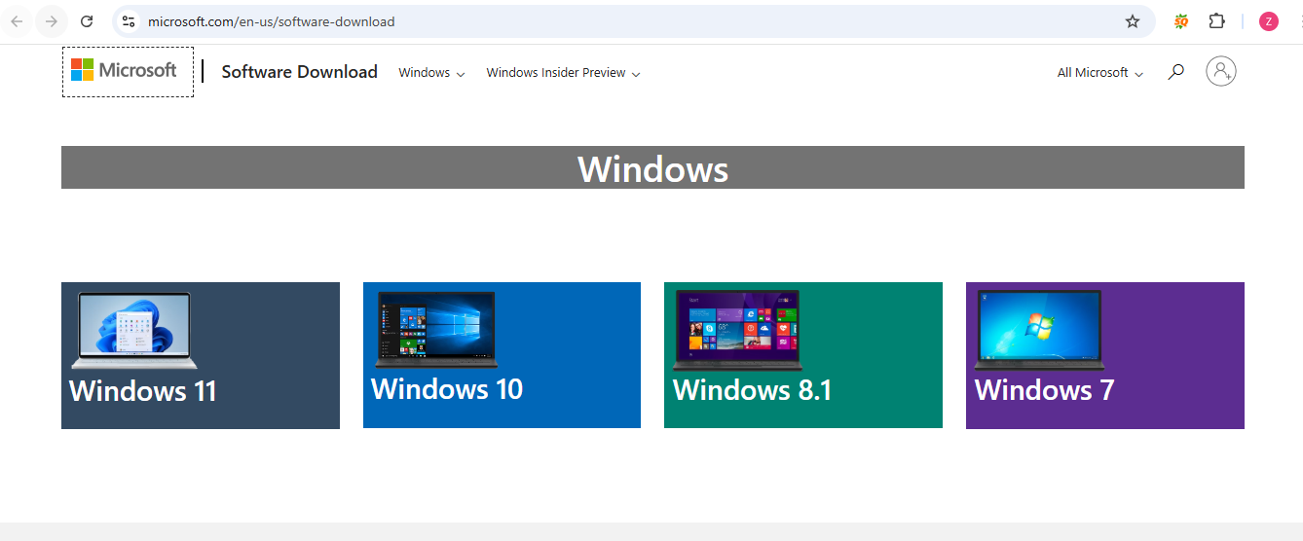
Step 2: Download the Media Creation Tool
- Click on Download under the Windows version you want.
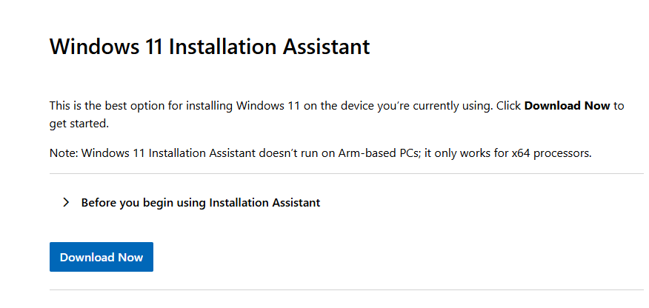
- After downloading, open the MediaCreationTool.exe file.
Step 3: Accept Terms and Conditions
- The setup will open. Read and accept the Microsoft Software License Terms to continue.
- 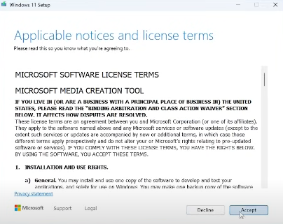

Step 5: Select Language, Edition, and Architecture
- Choose your preferred language, Windows edition, and architecture (64-bit or 32-bit).
- Click Next.
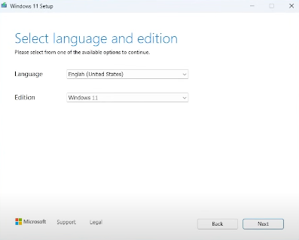
Step 6: Choose Media Type
- Select ISO file .
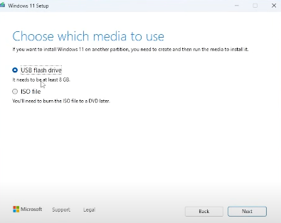
- Click Next and wait for downloading.
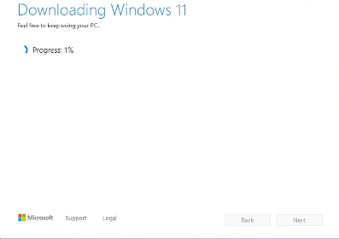

Step 7: Using Rufus
- Open Rufus from https://rufus.ie.
- Insert your USB drive into the computer.
- Open Rufus and select your USB drive under Device.
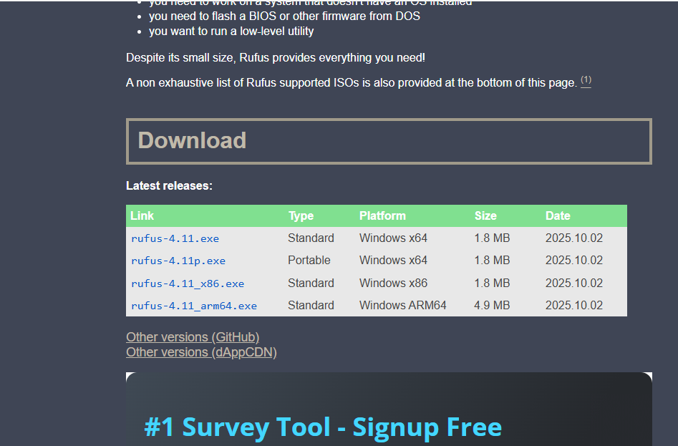
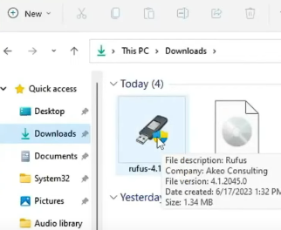
- Select the ISO file (Windows or Linux).

- Choose Partition Scheme as GPT (for UEFI) or MBR (for Legacy BIOS)
- Click Start to begin the process.
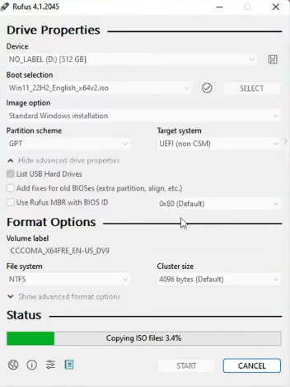
- Wait for Rufus to finish your USB is now bootable.
___________________________________________________________________________________

LAB 4,5

Installation of System Software (Operating System: Windows / Ubuntu / Kali)

1. Downloading of System Software
Before installing any operating system, it is important to download it from official sources.
- For Windows, the official website is https://www.microsoft.com/software-download.
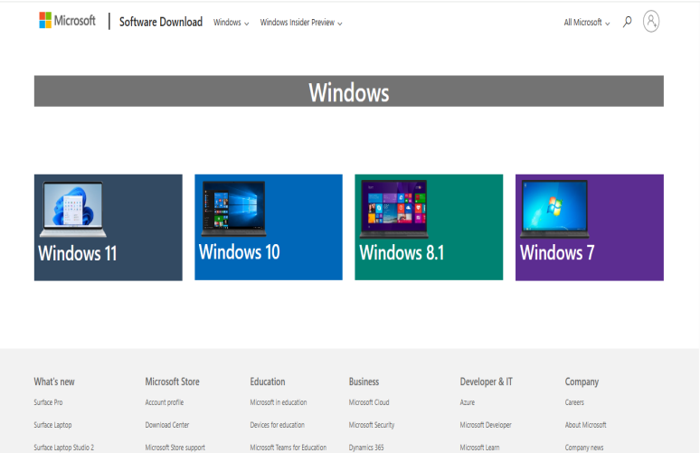
- For Ubuntu, visit https://ubuntu.com/download.
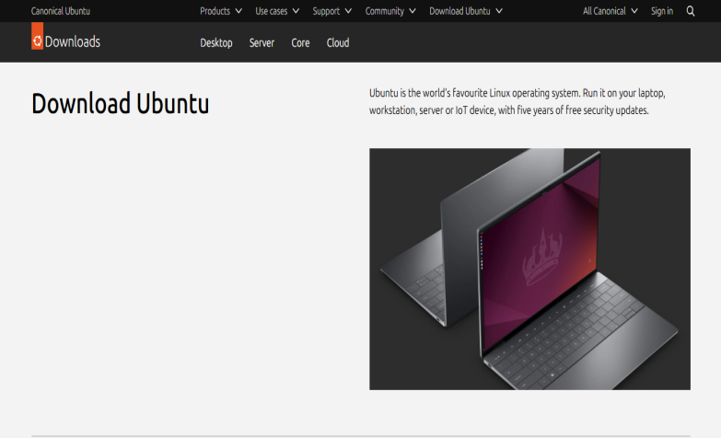
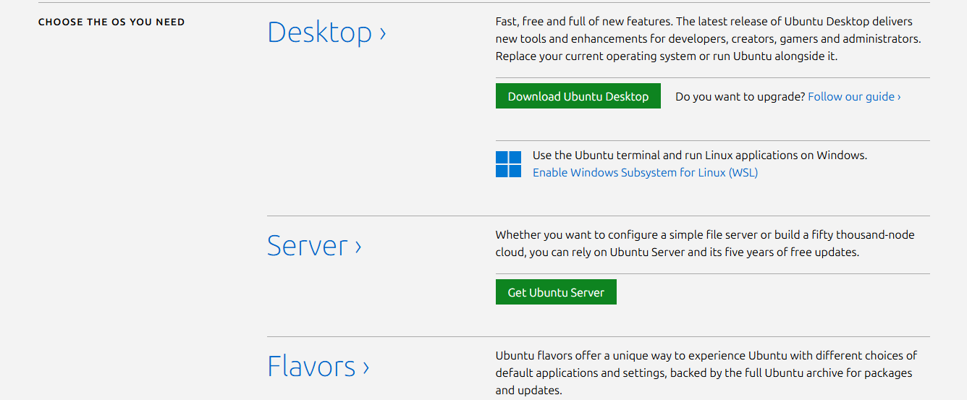
- For Kali Linux, visit https://www.kali.org/get-kali/
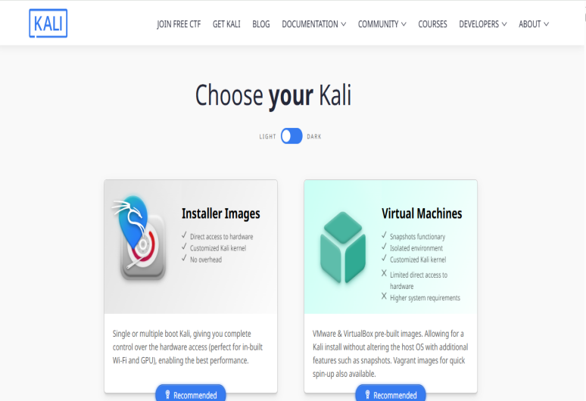

2. Installation of Windows Operating System
Steps:
- Create a Bootable USB:
Use tools like Rufus or Media Creation Tool to make bootable USB with the windows ISO file.
2.Boot from USB:
- Restart your PC and open the Boot Menu by pressing keys like F8, F9, F12, or Esc (depends on your system). Select the USB drive.
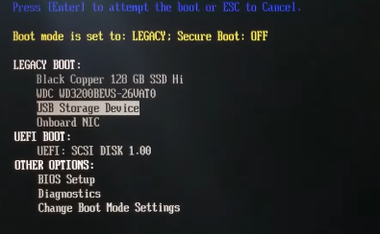
- Enter your language and preferences. Click Next to continue
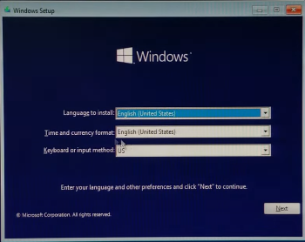
- Click on install now.
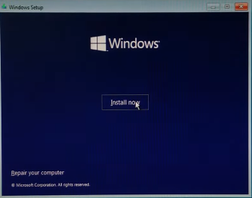
- Setup will start.
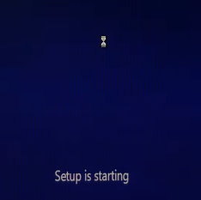
- We don’t have any product key. So select I don’t have a product key.
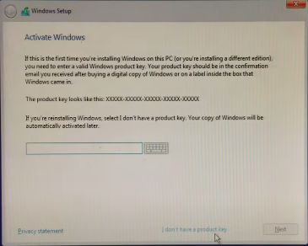
- Select the operating you want to install.
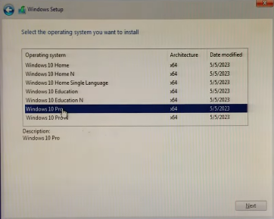
- Accept all the license terms.
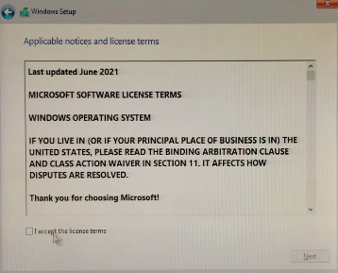
- Select which type of installation you want.
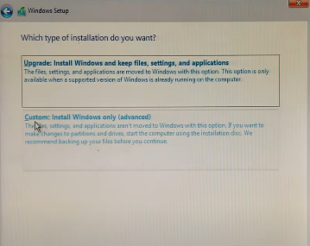
3.Partitioning the Hard Disk:
- Primary Partition: Used to install the operating system.
- Extended Partition: Used to create logical partitions.
- Logical Partition: Used for data storage (like drives D, E, etc.).
4.Install Windows:
- Select the primary partition.
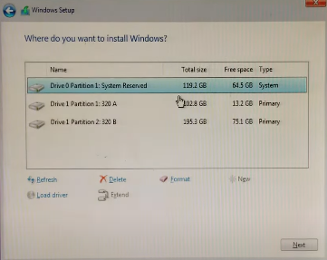
- Choose “Install Now.”
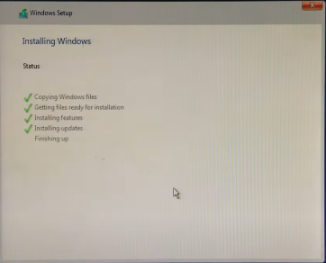
5.Finalize Setup:
- Create a user account.
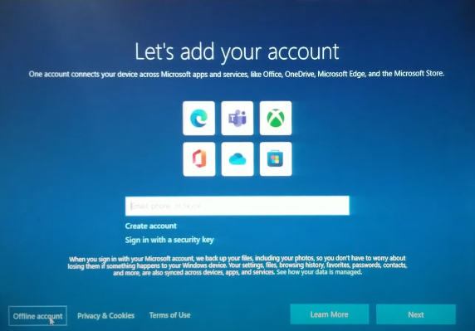
- Install drivers and Windows updates for better performance and security.
- Follow on-screen instructions and complete the setup.

3. Installation of Unix-Based Operating System (Kali Linux)

1. Enabling Virtualization Support in Windows
Before installing Kali Linux, the first step is to enable virtualization features in Windows. This allows the system to run another operating system inside Windows without removing any data.
Steps:
- Open the Start Menu and search for “Windows Features.”
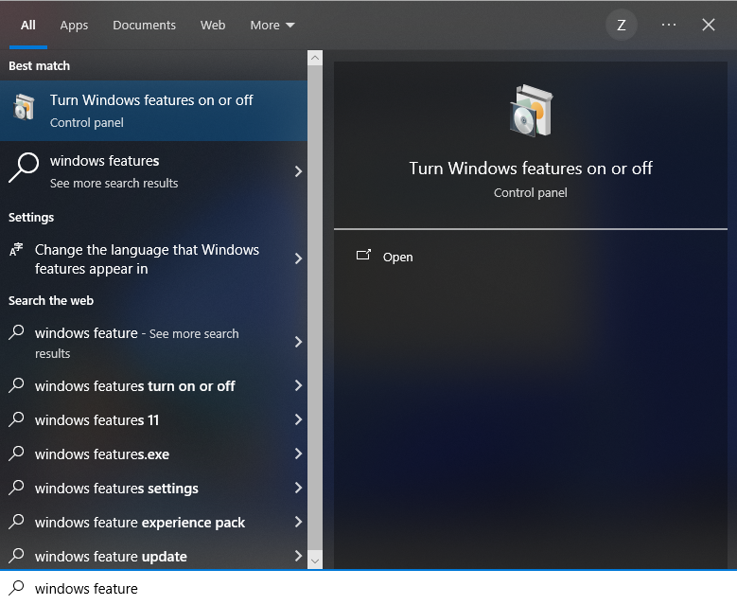
- Click “Turn Windows features on or off.”
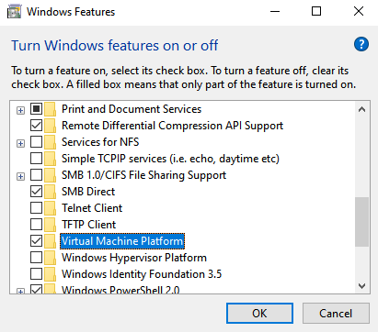
- From the list, enable the following options:
- Virtual Machine Platform
- Windows Hypervisor Platform
- Windows Subsystem for Linux
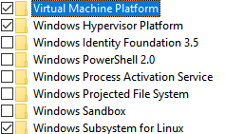
- Click OK, wait for Windows to install the features.
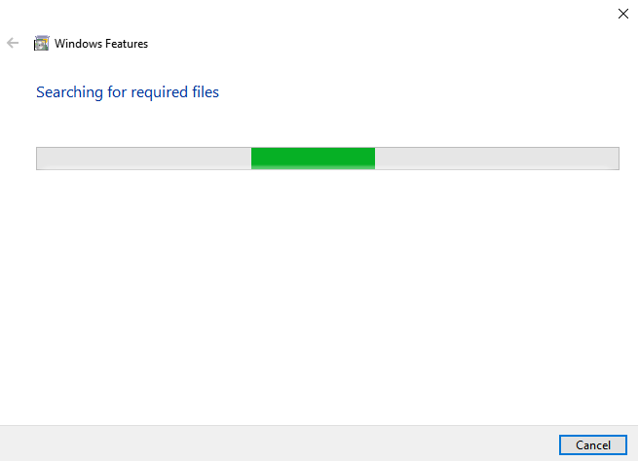
- And then restart your computer.
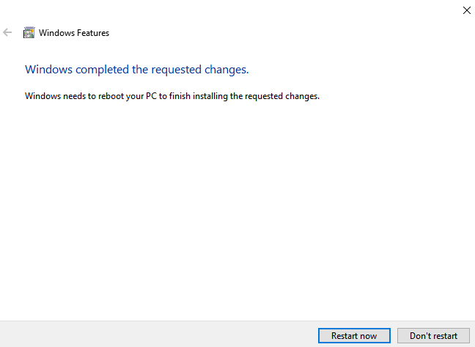
This step ensures that your system supports virtualization, which is required to install Kali Linux in a safe environment.

2. Downloading Kali Linux
- Visit the official website: https://www.kali.org/get-kali/.
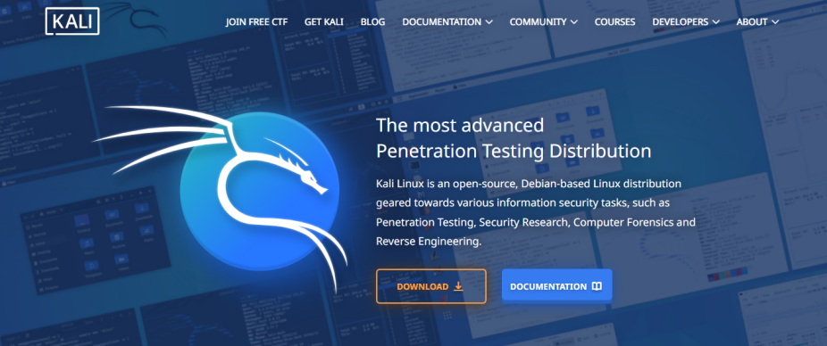
- Download the correct ISO image or Virtual Machine version (for Hyper-V, VMware, or VirtualBox).
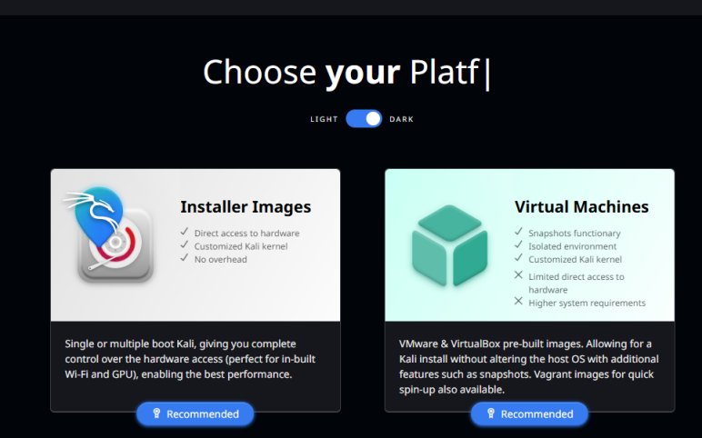
- Click on Download.
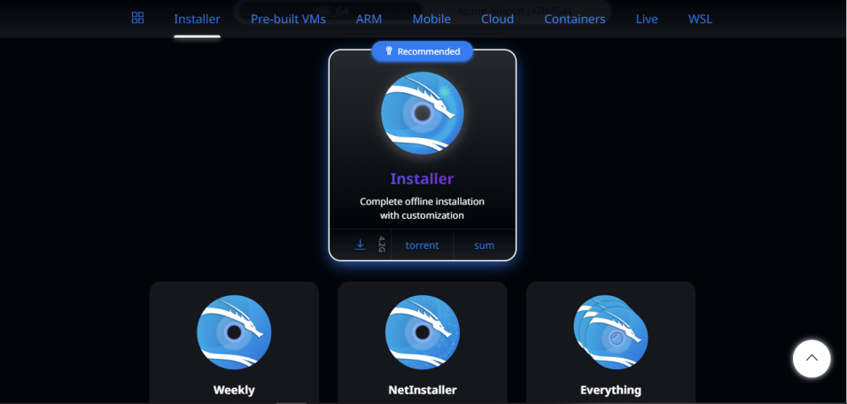
- Downloading will start.
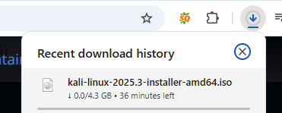
3.Create a Bootable USB:
- Use Rufus to make a bootable USB using the downloaded ISO file.
- Boot from USB:
Restart your PC and choose the USB from the boot menu.
- Kali Linux installation menu will appear. Choose Graphical Install.
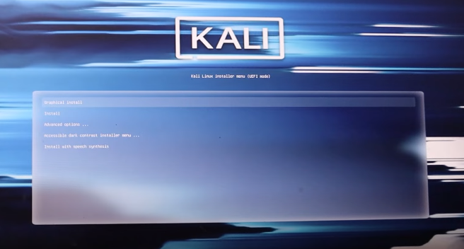

4.Install Kali Linux:
Follow the on-screen steps:
- Choose Language, Location, and Keyboard layout.

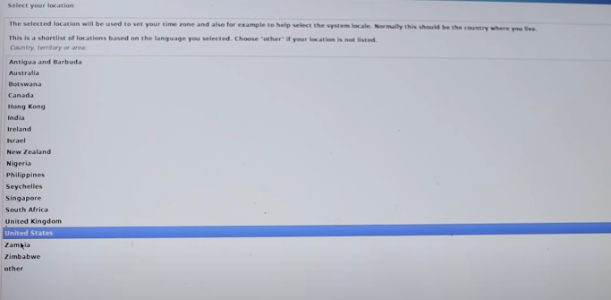
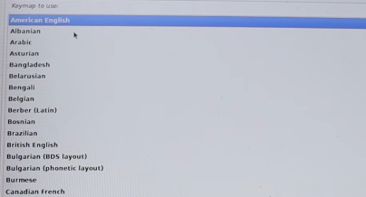
- Set a username and password for your account.
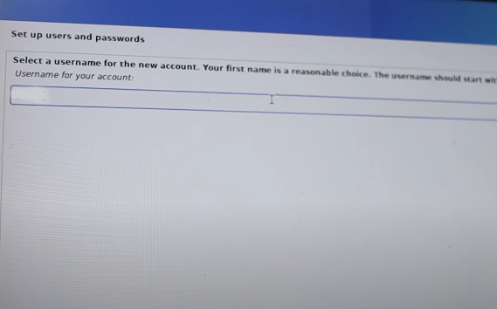
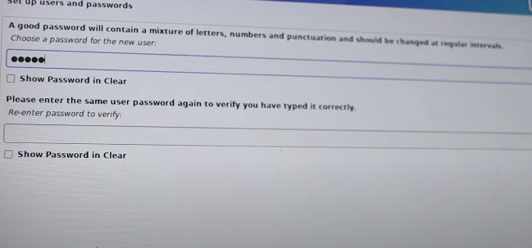
- When it asks about disk partitioning, choose carefully:

Partitioning options:
- Guided – use entire disk → installs Kali as the only OS (erases everything on your laptop)..
- Manual → you choose partitions yourself.
- Select Guided - use entire disk.
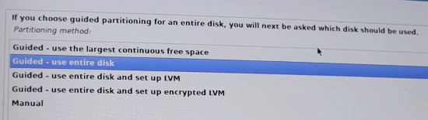
- Select your hard disk.
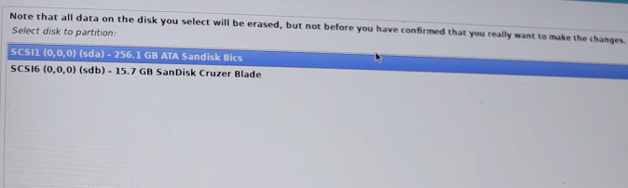
- Choose All files in one partition.
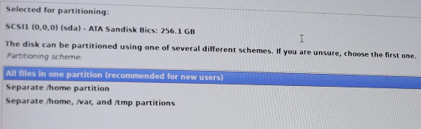
- Review the summary. If it looks okay choose Finish partitioning and write changes to disk.
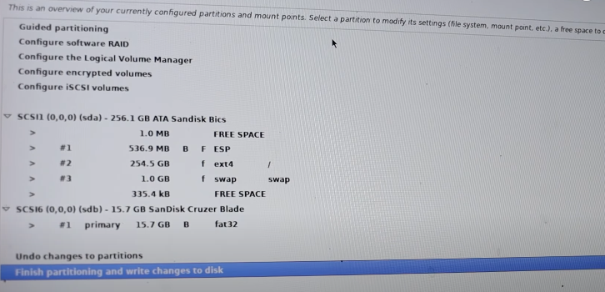
- When asked “Write the changes to disk?”, select Yes.
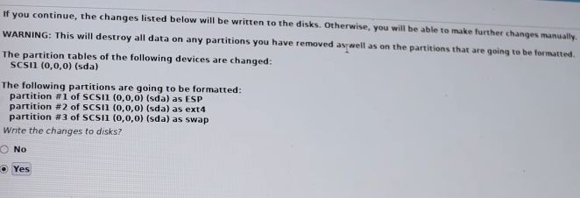
- After the main installation finished, a new screen appeared for Software Selection.
This step allows us to choose which tools and desktop environment to install.
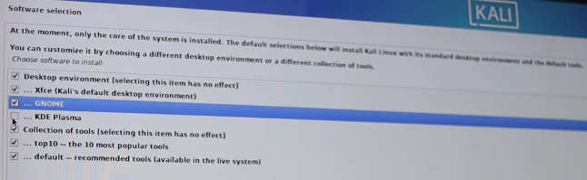
- Continue with installation. It will take 10–20 minutes.
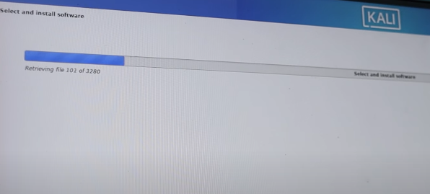

- When it says Installation Complete, remove the USB and click Continue to reboot.

5.After Installation
- Your computer will restart.
- Login using your username and password.
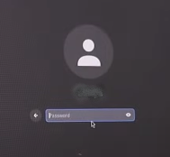
- Open Terminal and run sudo apt update
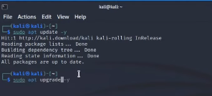
- You’re now running Kali Linux directly from your system.

- Installing Ubuntu Using Bootable USB

1. Enabling Virtualization Support in Windows
Before installing Ubuntu, the first step is to enable virtualization features in Windows. This allows the system to run another operating system inside Windows without removing any data.
Steps:
- Open the Start Menu and search for “Windows Features.”

- Click “Turn Windows features on or off.”

- From the list, enable the following options:
- Virtual Machine Platform
- Windows Hypervisor Platform
- Windows Subsystem for Linux

- Click OK, wait for Windows to install the features.

- And then restart your computer.

2.Download Ubunto
- Visit the official website and download.
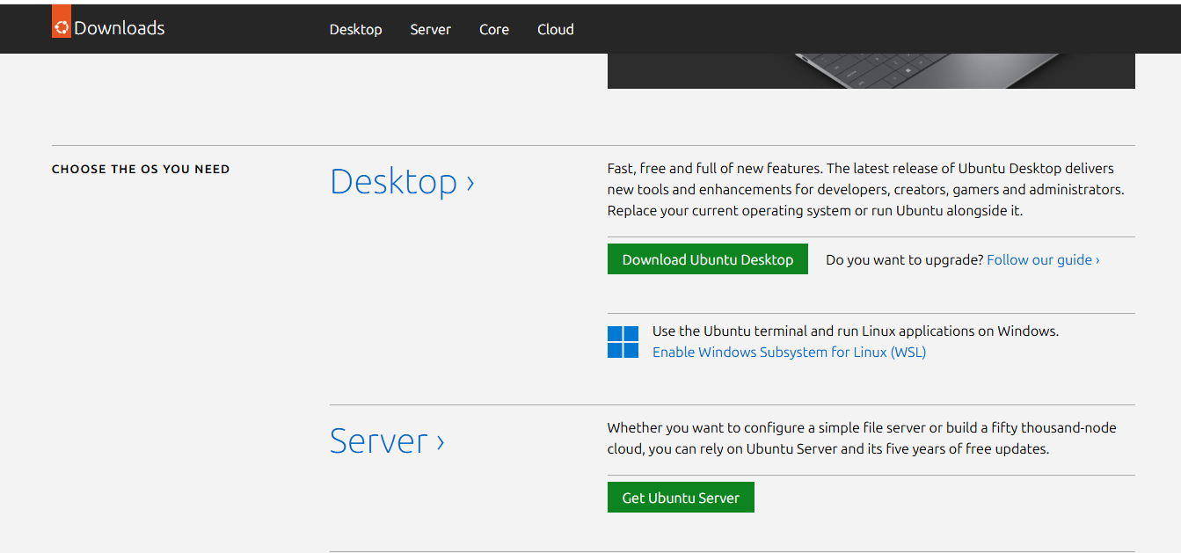
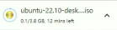

3.Creating a Bootable USB
To install Ubuntu, I first made my USB drive bootable using Rufus:
- Plugged in my USB drive.
- Opened Rufus on my laptop.
- Under Device, selected my USB drive.
- Under Boot Selection, clicked Select and chose the Ubuntu ISO file.
- Kept all default settings (Partition scheme: GPT if my system uses UEFI).
- Clicked Start and waited until it said READY.
Now my USB was ready to install Ubuntu.

4.Booting from the USB
- I restarted my laptop.
- Pressed the Boot Menu key .
- Selected the USB drive from the boot menu.
- The Ubuntu welcome screen appeared.
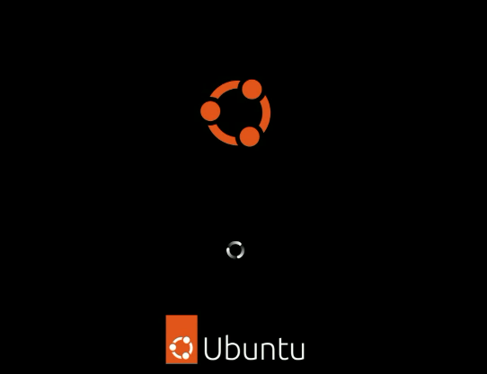

5.Choosing Language and Keyboard
In the next steps:
- I selected my language (English).
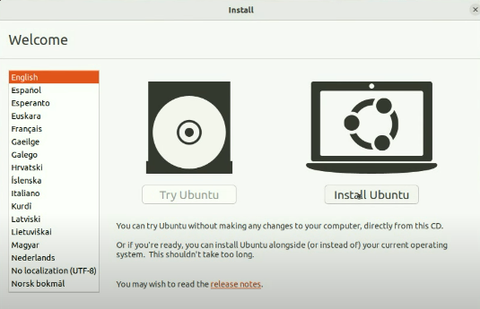
- Chose my keyboard layout (English US).
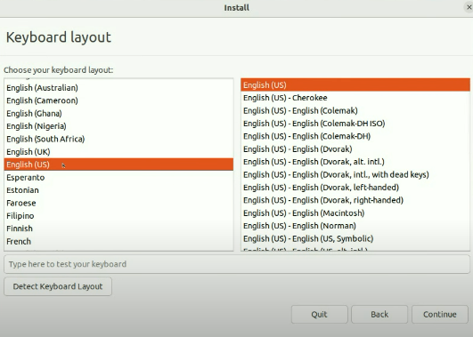
- Clicked Continue.

6.Preparing for Installation
Ubuntu asked what kind of installation I wanted.
I selected:
- Normal Installation (includes basic tools and software like web browser and media player).
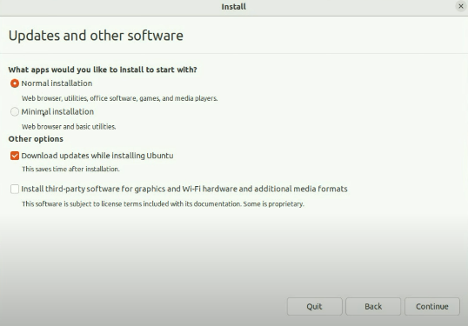
- Checked Download updates while installing Ubuntu for latest updates.
- Then I clicked Continue.

7.Guided Partitioning (Automatic Disk Setup)
Next, Ubuntu asked where to install.
I selected:
- Erase disk and install Ubuntu (this automatically partitions the drive).
(Note: This option erases existing data on the selected drive.)
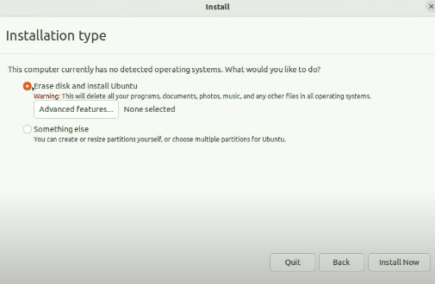
- Clicked Install Now .

8.Choosing Time Zone
After installation began, Ubuntu asked for my location to set the time zone.
I selected Pakistan and clicked Continue.

9.Creating a User Account
Then I created my user details:
- Your Name: (entered my name)
- Computer Name: ubuntu
- Username: (entered my desired username)
- Password: (entered a secure password)
- Selected Require my password to log in
Then clicked Continue.
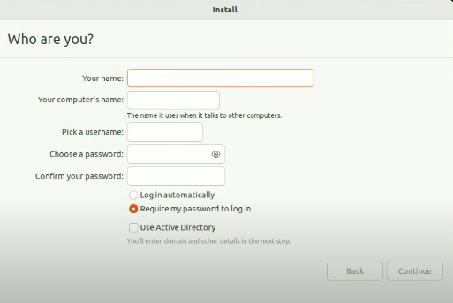

10.Finishing Installation
After the setup finished:
- Ubuntu displayed a message: Installation complete.
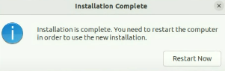
- I removed my USB drive.
- Pressed Enter to reboot the system.
- After restart, Ubuntu started successfully.
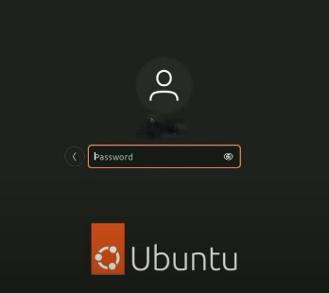
- I logged in using the username and password I created.

11.Post-Installation Setup
Once I logged in:
- I opened Terminal.
- Ran the following commands to update the system:
sudo apt update && sudo apt upgrade -y
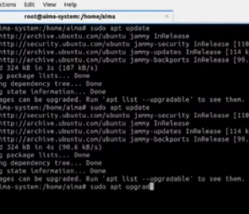
- After updates finished, I restarted the laptop.Now Ubuntu was fully ready to use.

Difference Between Linux, Unix, and Windows

1. Introduction
Operating systems are software that manage computer hardware and allow users to run programs.
The three most common operating systems are Linux, Unix, and Windows.
Although they perform similar functions, they differ in structure, features, and usage.

2. Linux
- Type: Open-source operating system.
- Developer: Created by Linus Torvalds in 1991.
- Cost: Free and open-source.
- User Interface: Supports both Command Line Interface (CLI) and Graphical User Interface (GUI).
- Security: Very secure and less affected by viruses
- Use: Commonly used by programmers, ethical hackers, and servers.
- Example Distros: Ubuntu, Kali Linux, Fedora, Debian.

3. Unix
- Type: Proprietary (originally commercial) operating system.
- Developer: Developed in the 1970s by AT&T Bell Labs.
- Cost: Paid and licensed.
- User Interface: Mostly Command Line Interface; modern versions have GUI too.
- Security: Highly secure and stable.
- Use: Mostly used in big organizations, servers, and research systems.
- Examples: Solaris, AIX, HP-UX.

4. Windows
- Type: Commercial operating system.
- Developer: Microsoft Corporation.
- Cost: Paid (requires license).
- User Interface: Mostly Graphical (easy to use).
- Security: Less secure than Linux/Unix but user-friendly.
- Use: Commonly used in homes, schools, and offices.
- Examples: Windows 10, Windows 11, Windows Server.

Conclusion
In summary:
- Linux is open-source and ideal for tech users and servers.
- Unix is powerful and used mainly in large, professional systems.
- Windows is easy to use and most popular among home and office users.
Each operating system is unique and serves different purposes depending on user needs.

What is Kali Linux
Kali Linux is a special type of Linux operating system that is mainly used for ethical hacking, penetration testing, and cybersecurity research.
It is developed and maintained by Offensive Security and is completely free and open-source.
- Kali Linux is a Debian-based Linux distribution.
- It comes preloaded with hundreds of security and hacking tools used for testing the security of computer systems and networks.
- Some of the popular tools include:
- Nmap – for network scanning
- Wireshark – for packet analysis
- Metasploit – for exploiting system vulnerabilities
- Aircrack-ng – for testing Wi-Fi security
- Burp Suite – for web security testing
Kali Linux can be installed on a computer, used in a virtual machine, or even run directly from a USB.

Why ethical hackers use Kali Linux?
Ethical hackers use Kali Linux because it already has many hacking and security tools built in.
It helps them find and fix security problems in computers and networks.
Kali Linux is free, safe, and easy to customize, which makes it the best choice for learning and testing cybersecurity.
___________________________________________________________________________________

Lab 6: Working with Graphical User Interface

1. Application of GUI, Its Handling and Administration
A Graphical User Interface (GUI) is a visual way of interacting with the computer.
Instead of typing commands, the user can click icons, buttons, menus, and use windows to perform different tasks. GUI makes computers easier, faster, and more user-friendly, especially for beginners.

Applications of GUI
- To perform everyday tasks like opening files, browsing the internet, or playing media.
- To help users interact with software through icons, toolbars, and graphical controls.
- To manage system settings, devices, and installed applications.
- To allow multitasking using multiple windows on the screen.

Handling and Administration
- GUI allows users to easily move, resize or close windows.
- Using the taskbar to switch between running programs.
- Managing settings such as display, sound, network, and user accounts.
- Using control panels or system settings to configure different features.
- Administrators can install/uninstall software, manage users, control permissions, and monitor system performance—all through GUI tools.

2. Folder, Subfolder Creation & Accounts

Folder and Subfolder Creation
Folders help organize data properly so users can find their files easily.
- Creating a Folder:
Right-click → New → Folder → Type name.
- Creating a Subfolder:
Open a folder → Right-click → New → Folder → Give a new name.
- Folders and subfolders make it easier to store documents, images, videos, and project files in a structured way.

Accounts
User accounts allow multiple people to use the same computer with their own settings and files.
Types of accounts in Windows:
- Administrator Account:
Full control of the system, can install software and change settings.
- Standard/User Account:
Limited access, used for normal daily tasks.
- Guest Account (optional):
Temporary access without saving personal settings.
Accounts improve security, privacy, and organization in shared computers.

3. Default Installation of Application Software and Their Role
Operating systems come with some software pre-installed by default. These applications help users perform basic tasks immediately without installing anything extra.

Examples of Default Applications

1. Notepad
- A simple text editor.
- Used for writing quick notes, editing small text files, or writing code in plain text.

2. WordPad
- More advanced than Notepad.
- Used for formatted text, simple document creation, and basic editing.

3. Web Browsers (e.g., Microsoft Edge, Chrome if preinstalled)
- Used for browsing the internet.
- Help users search information, download files, watch videos, etc.

4. File Explorer
- Helps users view, manage, copy, move, rename, and delete files and folders.

5. Paint
- Basic drawing tool for creating or editing images.

Role of Default Applications
- Provide essential tools so users can perform important tasks immediately.
- Help in learning the system.
- Reduce the need for external software for basic functions.
- Make the operating system more user-friendly.

Task 1: Blocking Google Chrome
First of all, I started by blocking the Google Chrome browser from accessing the internet.
To do this, I used the Windows Defender Firewall. Here are the steps I followed:
- I clicked on the Windows Icon searched windows Defender Firewall.
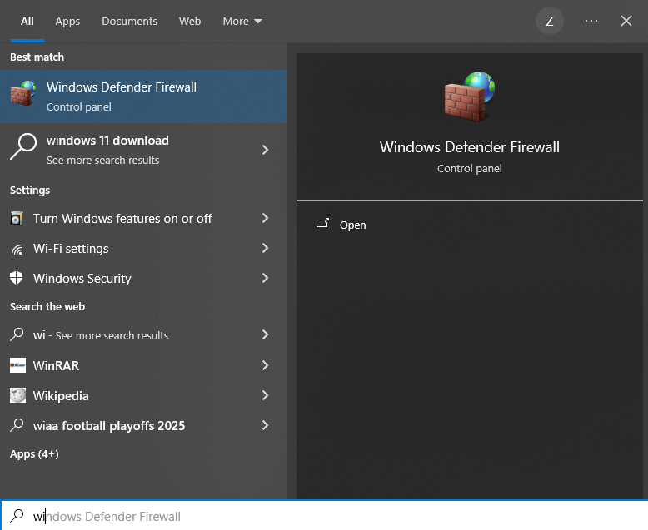
- From the left side, I clicked on Advanced settings.
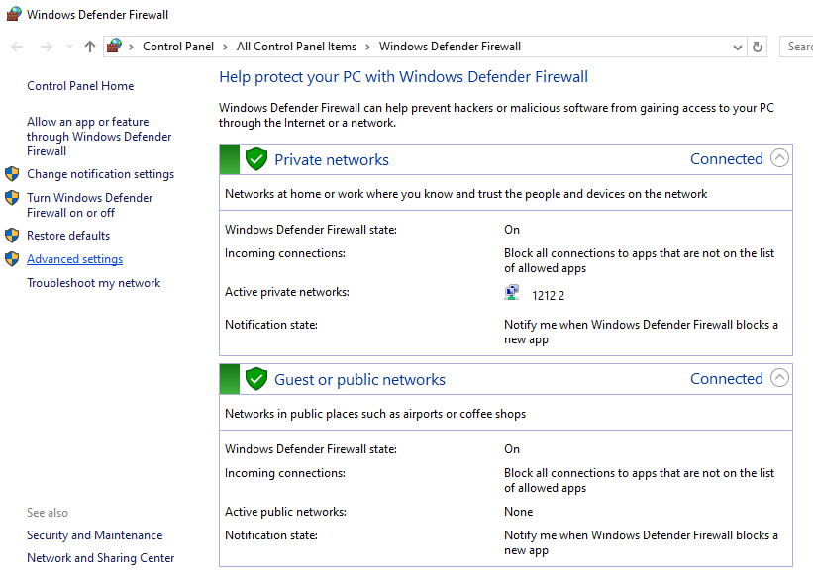
- Then, I selected Outbound Rules and clicked New Rule.
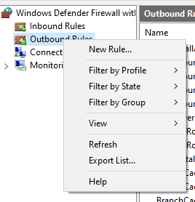
- I chose Program, and browsed for the Chrome application path:
C:\users\dell\appdata\local\google\chrome\application\chrome.exe
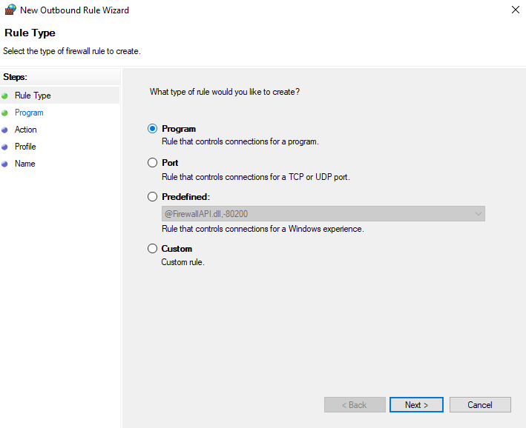
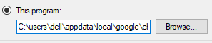
- After selecting it, I chose Block the connection and applied it to Domain, Private, and Public profiles.
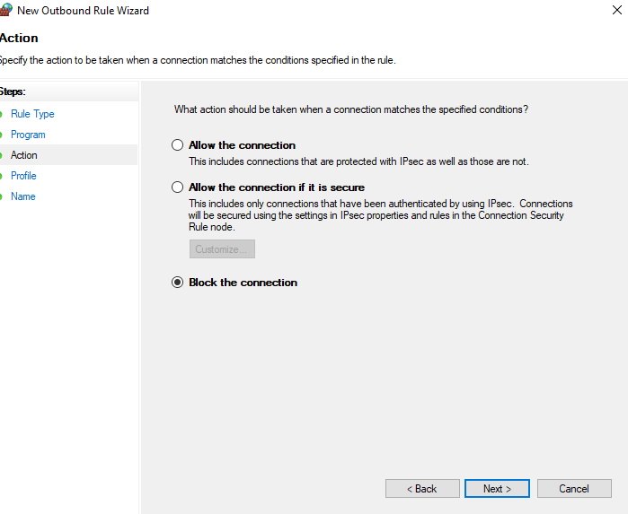
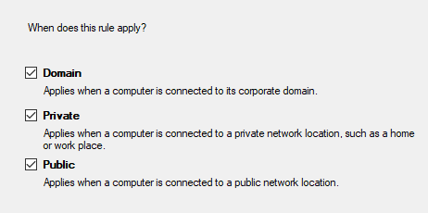
- Lastly, I named the rule “Block Chrome” and saved it.
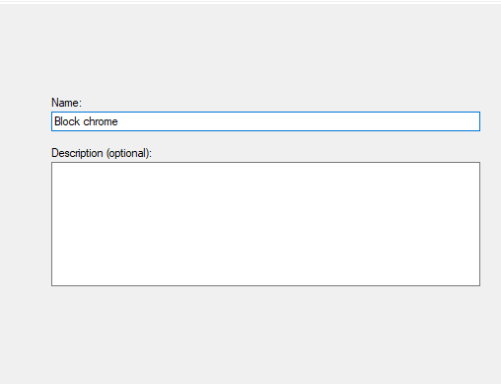

After doing this, I tested by opening Chrome, and it could no longer connect to the internet.
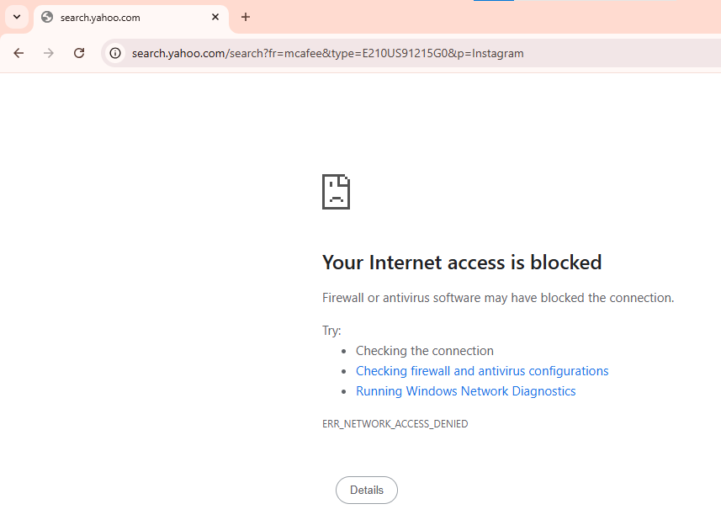
Task 2: Downloading and Installing an Antivirus
After blocking Chrome, I needed to install an antivirus on my laptop.
Since Chrome was blocked, I used Microsoft Edge to open the antivirus website.
Steps I followed:
- I searched for Avast Free Antivirus on Edge.

- From the official website, I downloaded the installer.

- After downloading, I opened the setup file and followed the installation process.
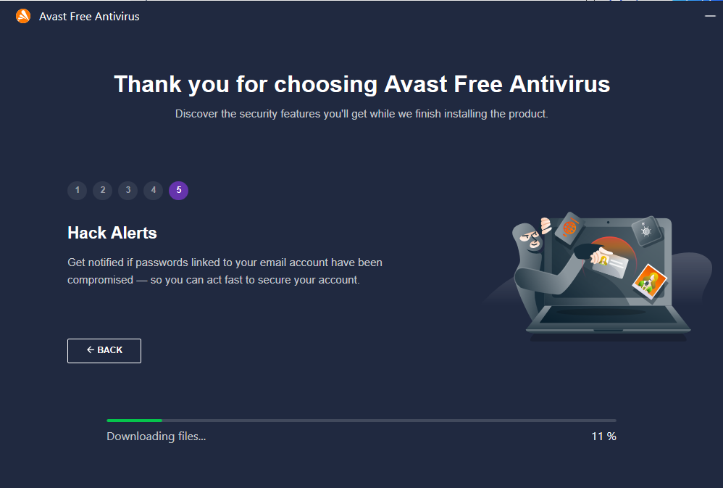
- Once installed, I opened the antivirus and performed a Quick Scan to check if everything was working properly.
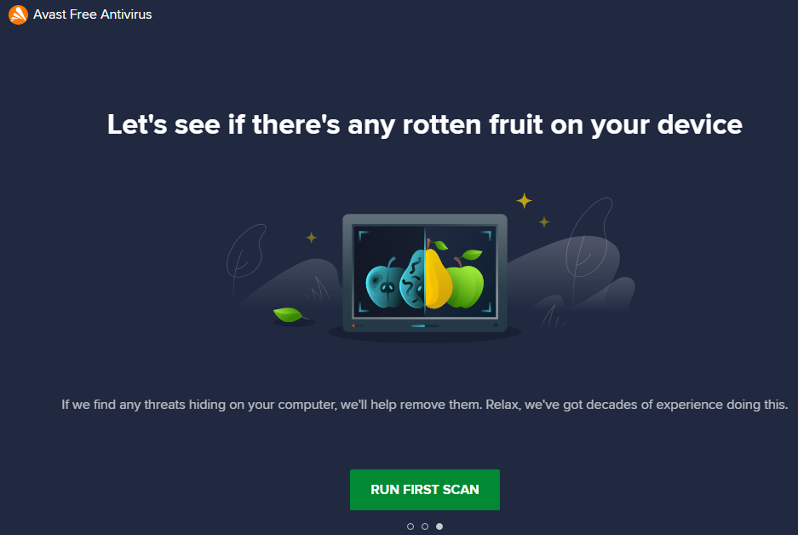
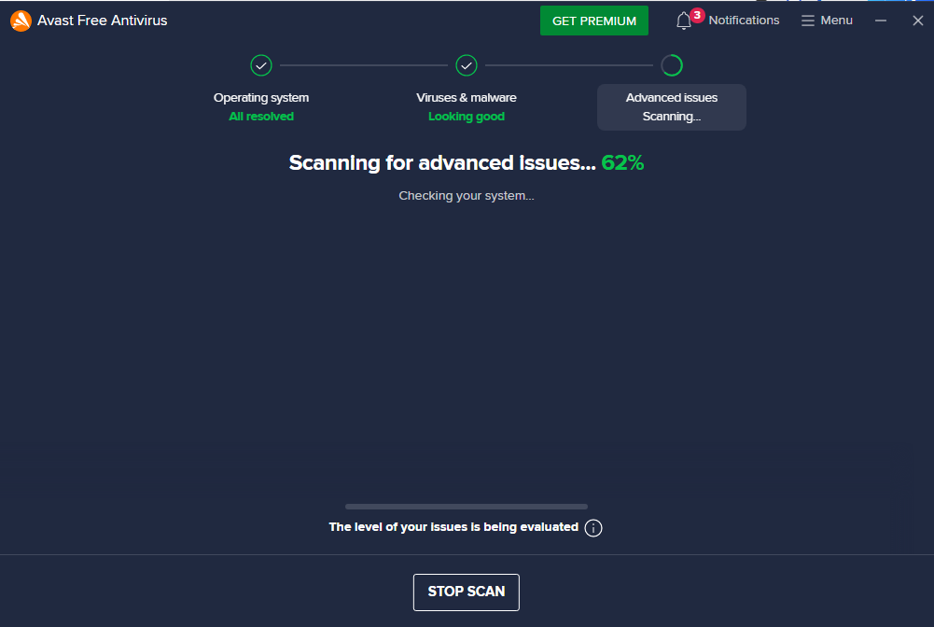

The antivirus successfully scanned my system and showed that the protection was active.

Task 3: Blocking Chrome Again

After installing the antivirus, I repeated the blocking process for Chrome again.
I went back to the Firewall settings, created the same outbound rule, and confirmed that Chrome couldn’t access the internet once more.
This step was to ensure that even after installing new software, I could still manage app permissions using Windows Firewall.

Task 4: Activating Windows
Finally, I activated my Windows operating system.
To do this, I followed these steps:
- I opened Settings → System → Activation.
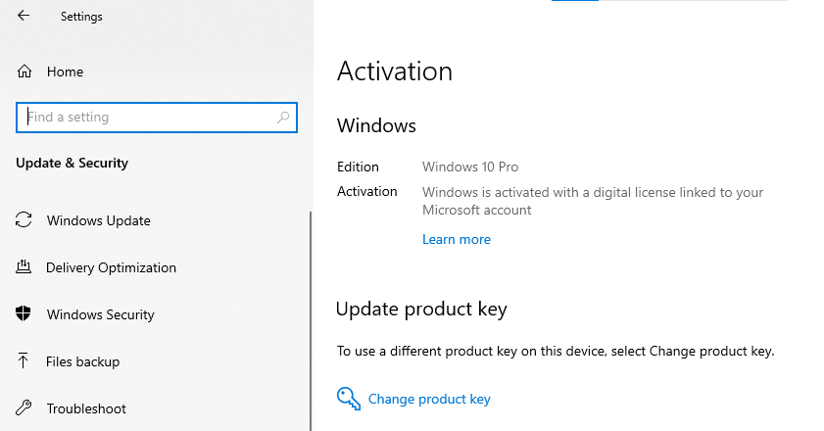
- There, I clicked Change product key and entered the Windows activation key.
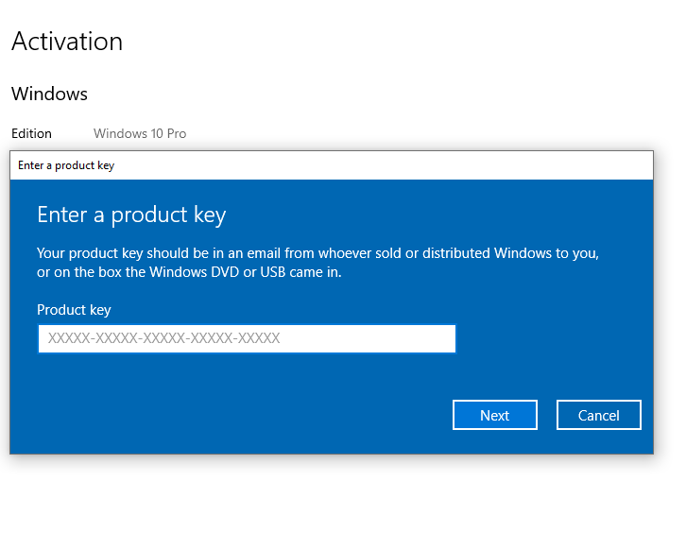
- After clicking Next, Windows verified the key and showed the message “Windows is Activated”.
___________________________________________________________________________________

LAB 7

Assignment on Command Prompt (CMD)

1. Introduction to CLI
CLI (Command Line Interface) is a text-based interface used to interact with the computer system. Instead of clicking icons or using menus like in a Graphical User Interface (GUI), users type commands to perform tasks.
It allows users to control their operating system or software by entering commands directly.

2. History of Command Line Interface
The Command Line Interface dates back to the early days of computing.
- In the 1960s, computers used teletype machines for input and output.
- MS-DOS (Microsoft Disk Operating System), introduced in 1981, brought CLI to personal computers.
- The Command Prompt (cmd.exe) was later developed for Windows systems to maintain compatibility with DOS commands.
Even today, CLI is used by developers, administrators, and power users for advanced control.

Advantages of CLI
- Requires fewer system resources.
- Faster for experienced users.
- Allows automation using scripts.
- Provides detailed control over the system.

Disadvantages of CLI
- Difficult for beginners.
- Commands must be memorized.
- No visual feedback.
- A small mistake can cause serious issues.

How to Locate and Open Command Prompt

Method 1:
Press Windows Key + R, type cmd, and press Enter.
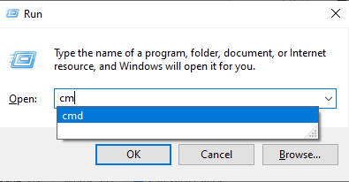

Method 2:
Search Command Prompt in the Windows Search bar and click Open.
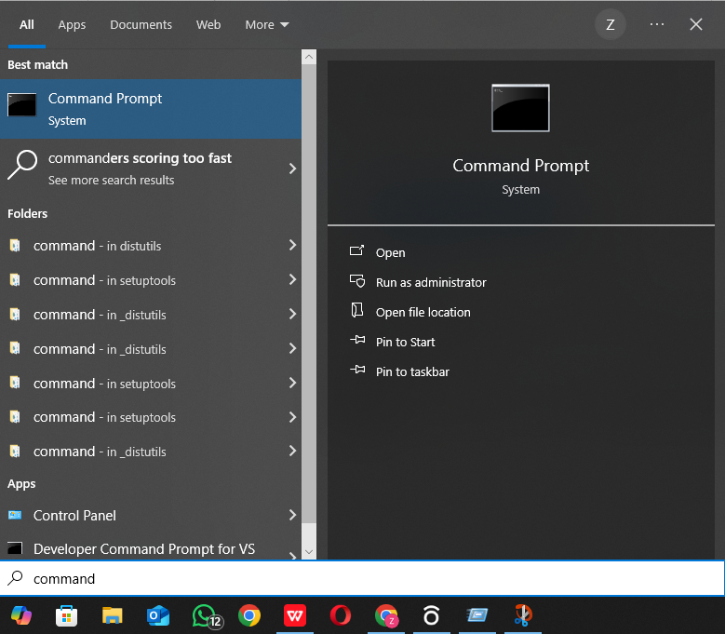

6. Useful Command Prompt Commands

1. Help
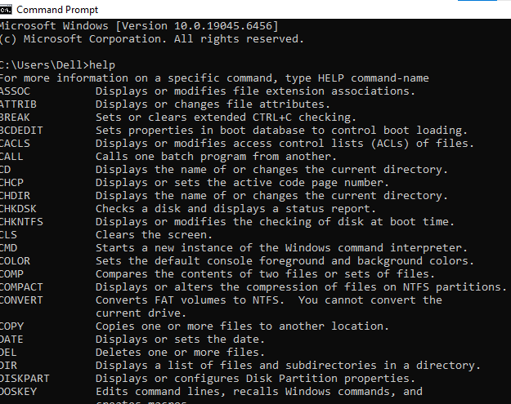

This prints a list of most CMD commands with a short one-line description.

- Change Colors

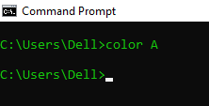

Changes CMD text to green on black background.

- Color Help
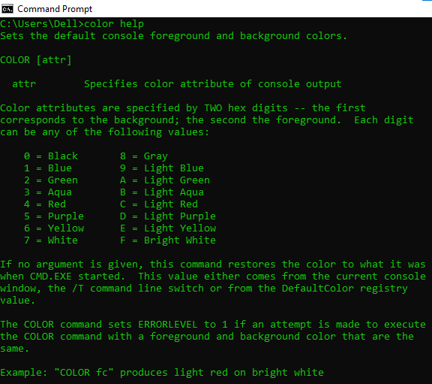

View Command History
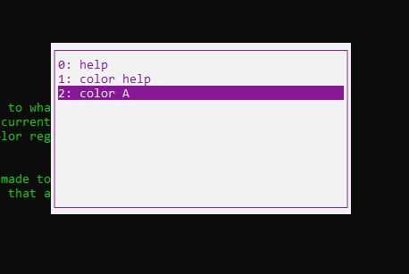
Press F7 — it displays a list of previously used commands in CMD.

Change Drive
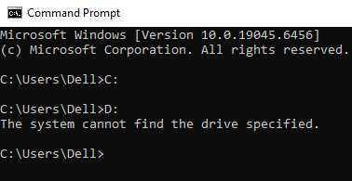
Switches from the C: drive to D: or E: drive.

- Make a new folder
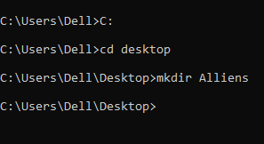
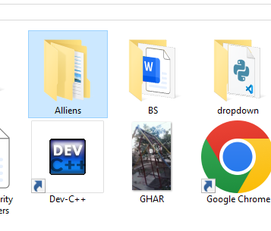

- Create Subfolders (Folders inside Folders)
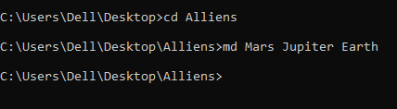
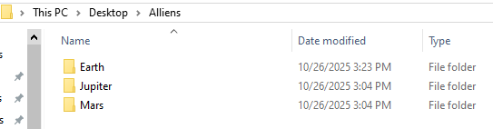

- Delete a Folder
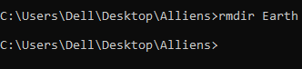
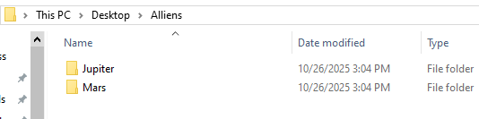

Delete Folder with Confirmation
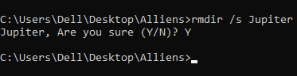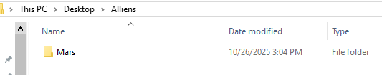
The /s flag asks for confirmation before deleting each file.

- Rename a Folder

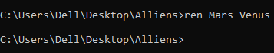
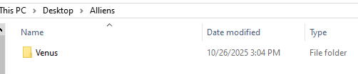

Make a DOC File
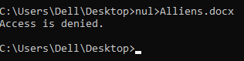
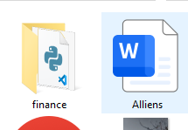
Creates a .doc file with the written content.

- Go Back One Directory
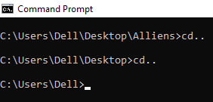

- Encrypt a Folder
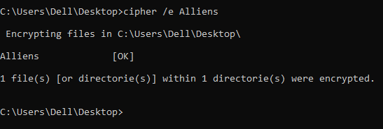

Decrypt (Unlock) a Folder
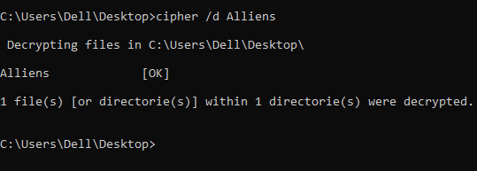

15.Check the List of Files and Folders
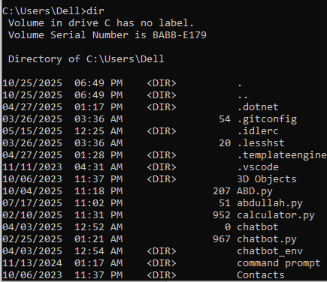

- Uninstall a Program

Start/Stop the Internet

- Show Date
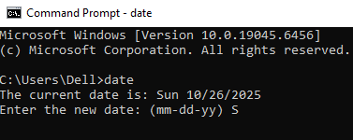
- Show Time
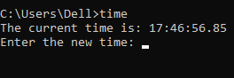

- Hide a Folder

- On-Screen Keyboard
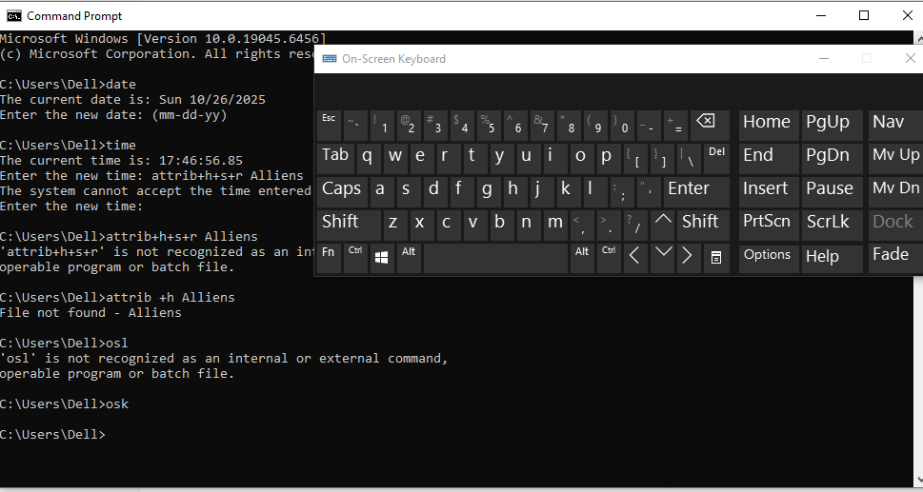
Type osk

- Display Network Connections
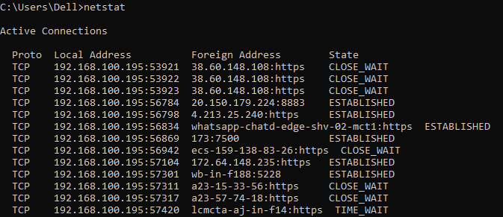
Type netstat

- Display Network Configuration
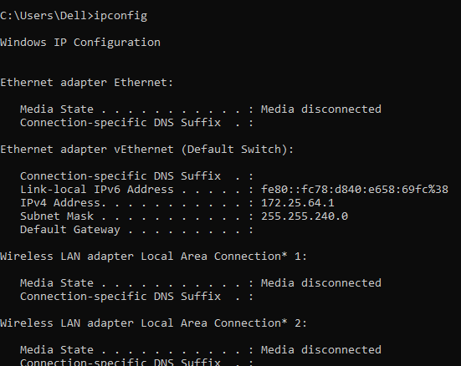
Type ipconfig

- Check Connectivity to a Website
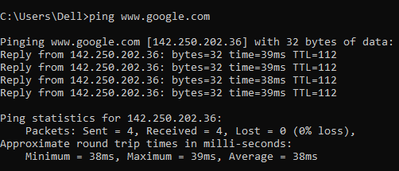
Type ping ww.google.com

24. Display DNS Information
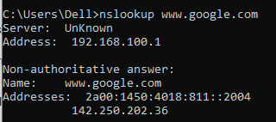
Type nslookup www.google.com
- Show the Route that Packets Take to Reach a Destination

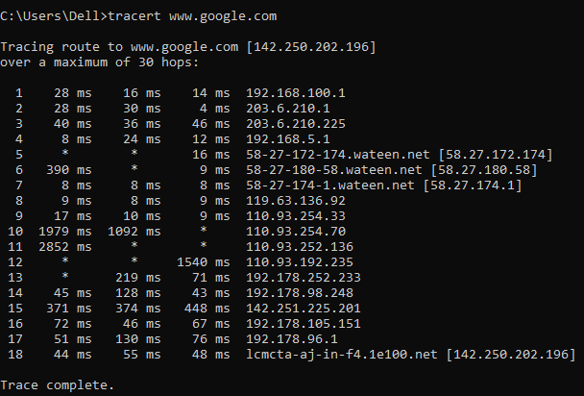type tracert ww.google.com

Conclusion
Command Prompt is a powerful tool for controlling and managing the Windows operating system. Though it requires memorizing commands, it provides speed, flexibility, and deep control over files, networks, and system settings.

___________________________________________________________________________________

LAB 8

Installation of Unix-Based Operating System (Kali Linux)

1. Enabling Virtualization Support in Windows
Before installing Kali Linux, the first step is to enable virtualization features in Windows. This allows the system to run another operating system inside Windows without removing any data.
Steps:
- Open the Start Menu and search for “Windows Features.”

- Click “Turn Windows features on or off.”

- From the list, enable the following options:
- Virtual Machine Platform
- Windows Hypervisor Platform
- Windows Subsystem for Linux

- Click OK, wait for Windows to install the features.

- And then restart your computer.

2.Install VirtualBox
- Download VirtualBox from the official website.
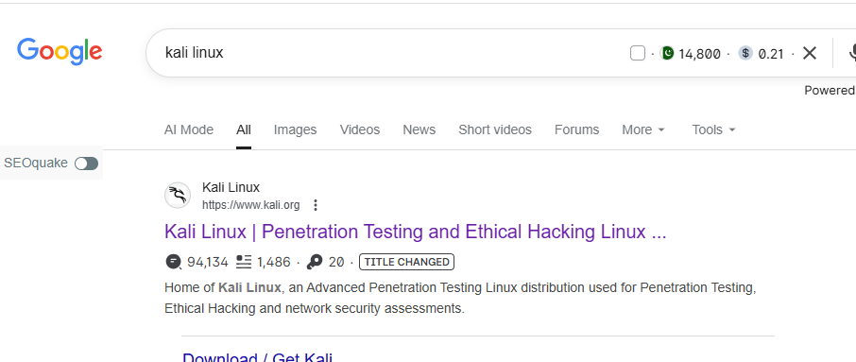
- Click on Download.
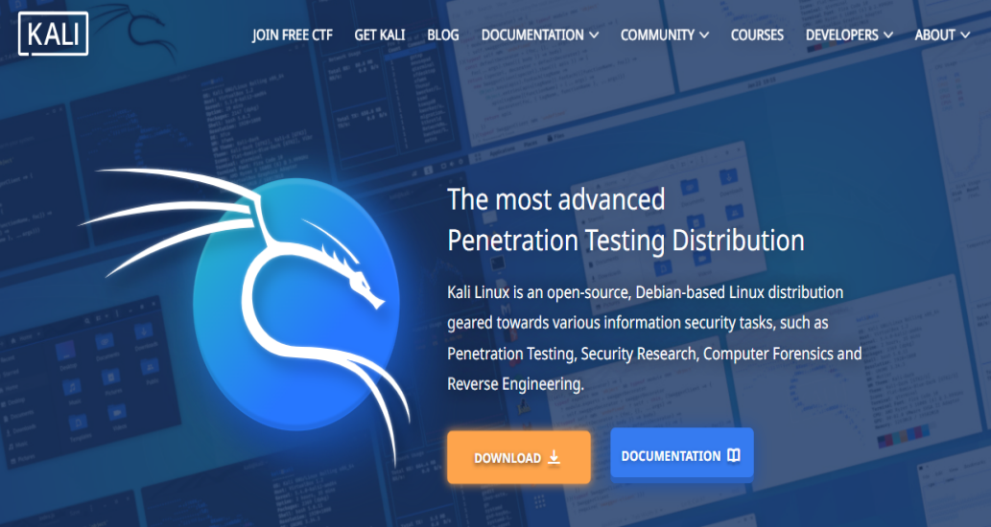
- Select Virtual Machine.
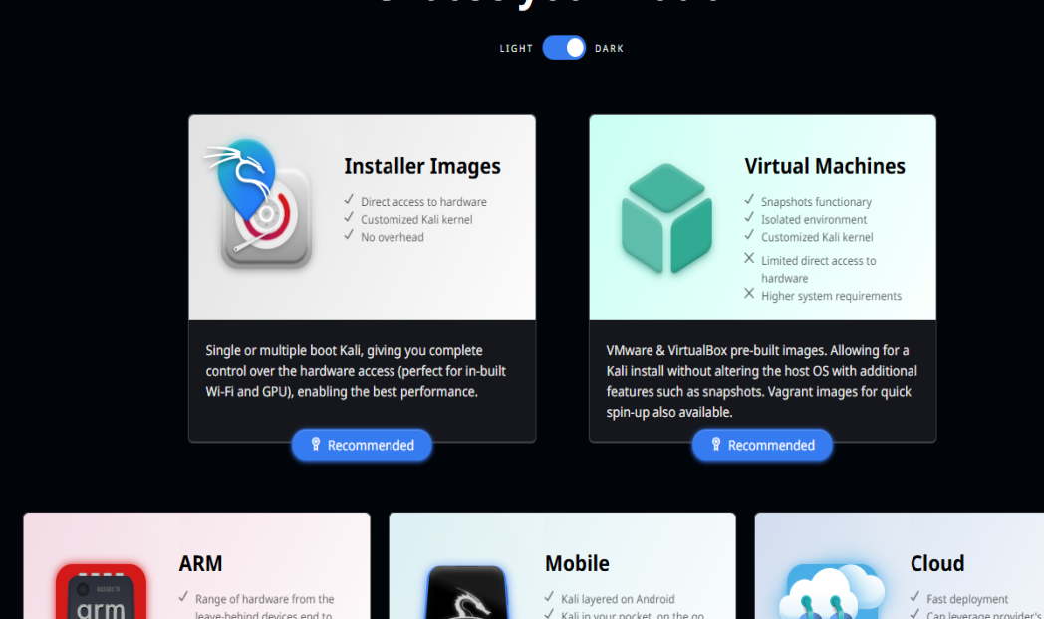
- Download Virtual Box.
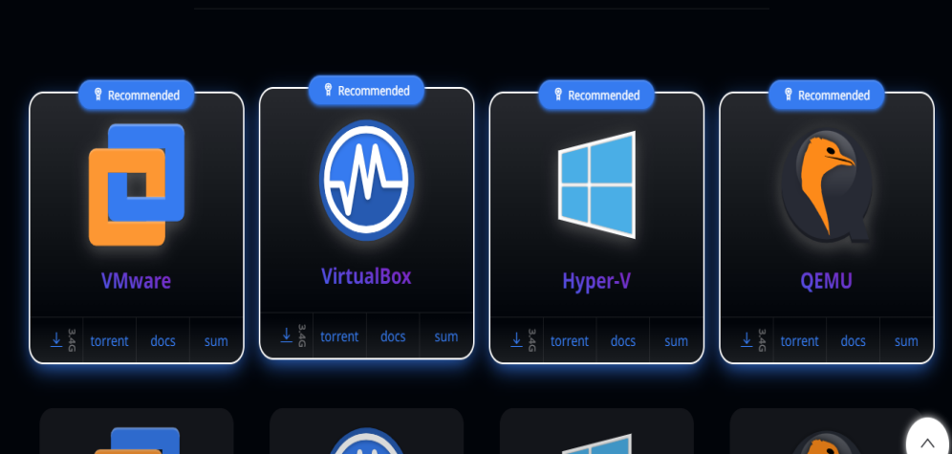
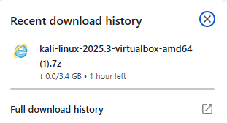

- After the downloading in complete. click the file and select Extract file.
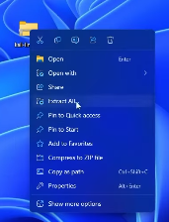
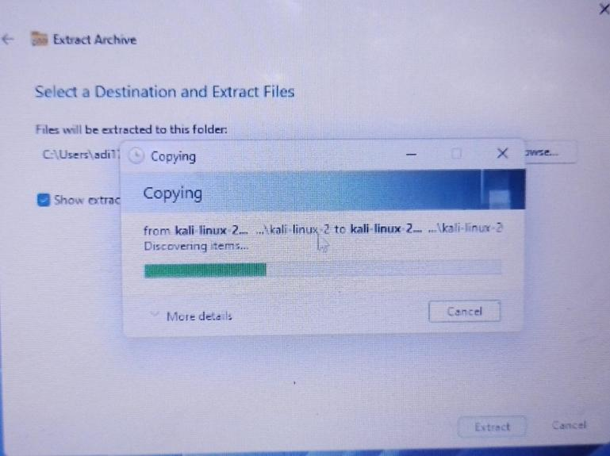

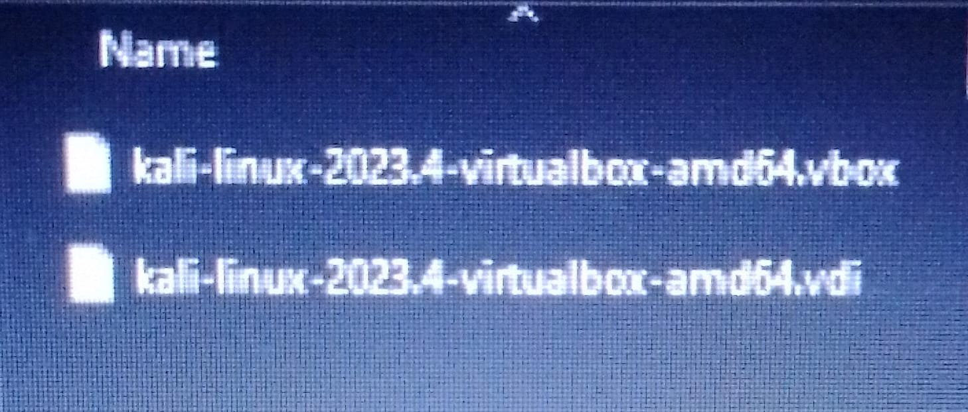

- Now downloading VirtualBox.

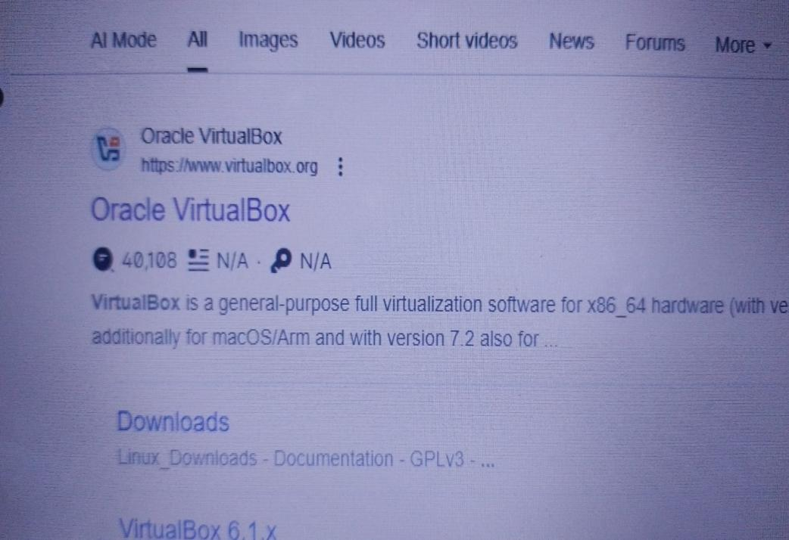

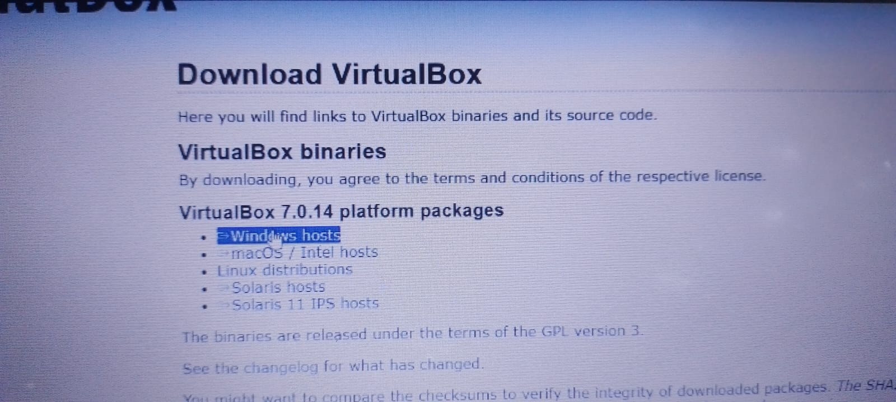

- Dowloading started.

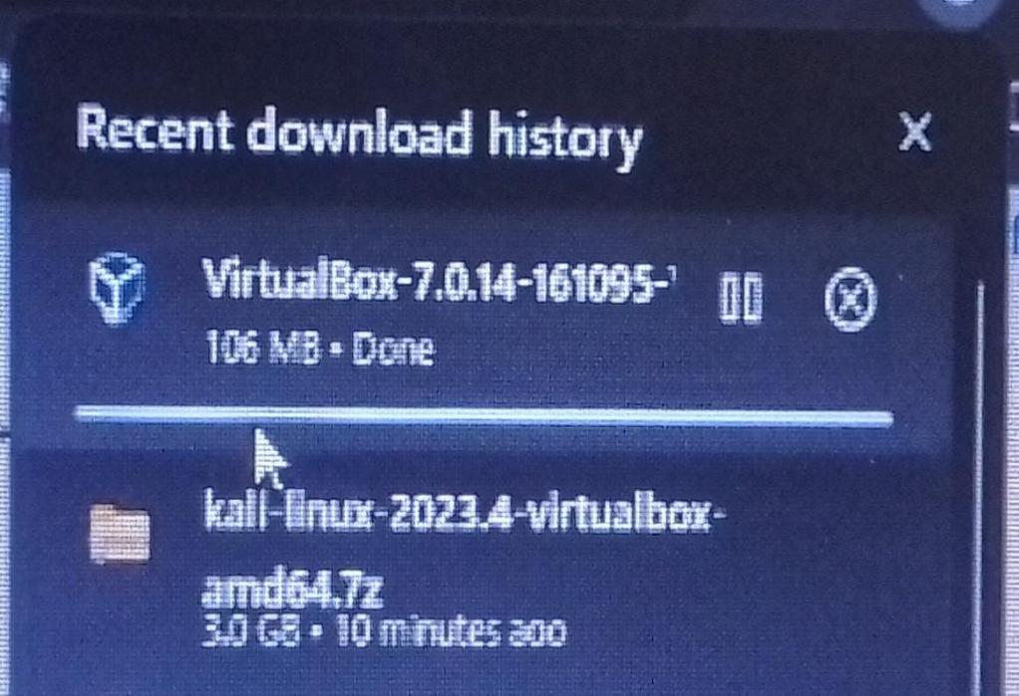

- Now open it. And click on Add.

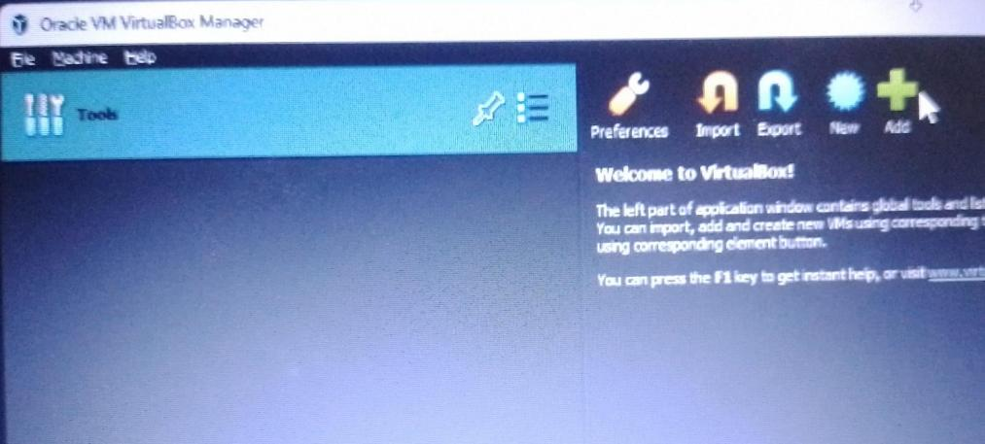
- Select the Kali Linux we downloaded before.
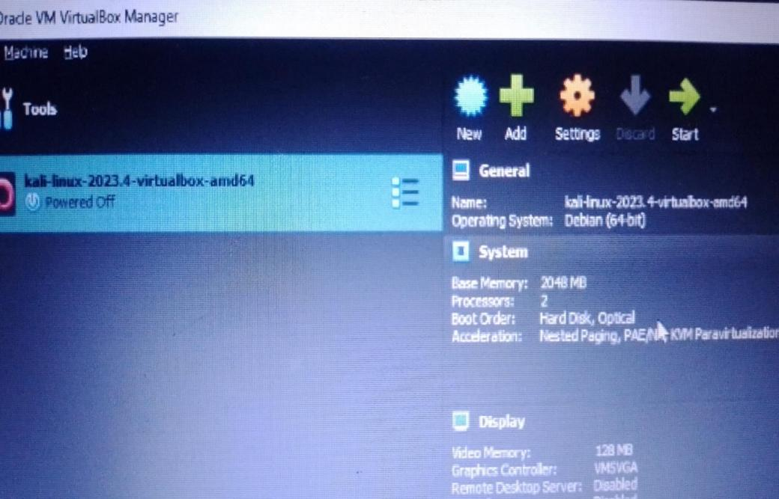

- Click on start.

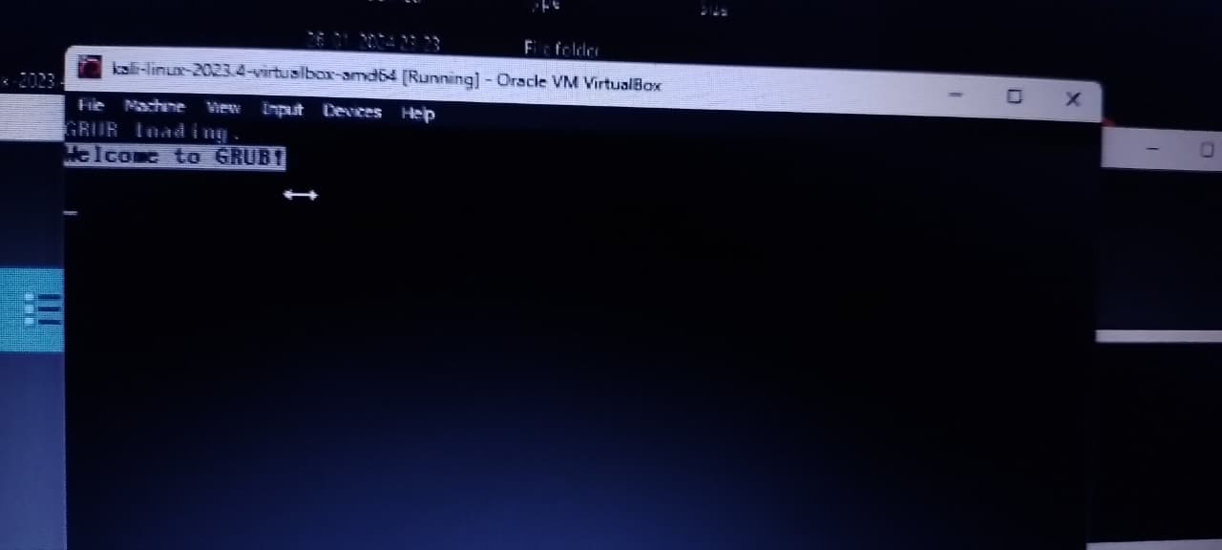

- Click on Kali GNU/Linux.
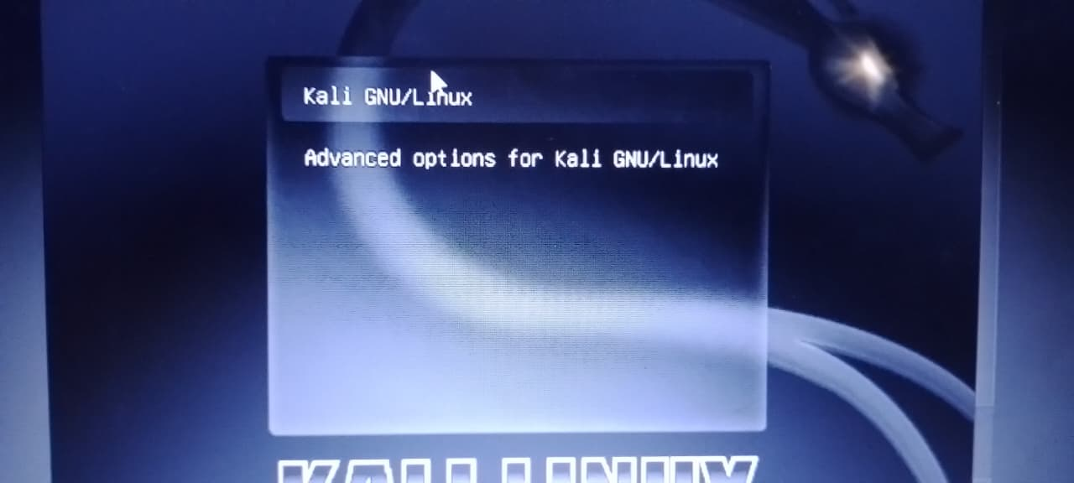
- Log In.
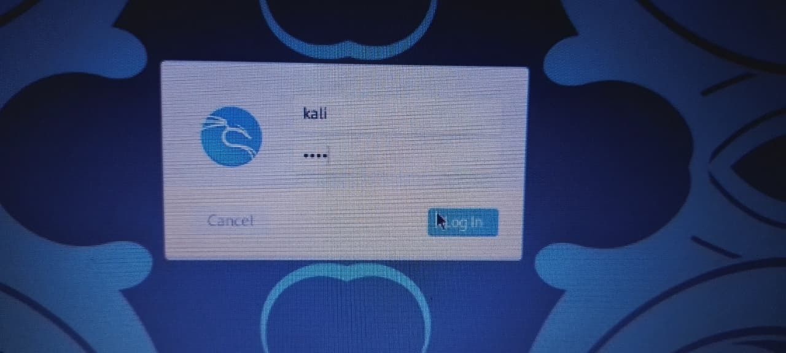

- After Log In we are done with the installation of Kali Linux using VirtualBox.




