Benjamin Zhou — NYO2 (National Youth Orchestra 2) Violinist
Structural Feature Trends in Western Classical Music, c. 1700–1910: A Symbolic-Score Pilot Study
An exploratory study testing whether classical music shows the kind of cyclical structural trends documented in fashion and, separately, in recent popular music — measured directly from score data, with an explicit statistical check for a common confound: composer-level clustering masquerading as an era-level effect.

Motivation
Fashion and popular music are widely described as moving in nostalgia-driven cycles — styles rise, fade, and resurface decades later. Whether classical music shows an analogous pattern is rarely tested with quantitative, score-based methods. Because audio recordings do not exist for most of the classical era, this project works from symbolic data (digital scores / MIDI) rather than audio, comparing structural parameters that are directly extractable from a score and unaffected by recording technology or performance interpretation.
A closely related independent study (Chen-Plotkin, Kulkarni & Bassett, 2025, arXiv:2509.24172) applies Markov-chain and mutual-information methods to 605 piano sonatas and string quartets by Mozart, Haydn, Beethoven, and Schubert, finding that Mozart's melodic sequences are systematically more locally predictable than the other three composers'. This project asks a related but different question — trend and reversal in four structural features across a broader stylistic span (Baroque through early 20th century), rather than sequence predictability within four Classical/Romantic composers — but shares the same underlying commitment to testing claims about compositional style with statistical rigor rather than description alone.

Corpus and Method
26 works spanning four style periods were drawn from two symbolic-score sources: music21's built-in corpus (Bach, Corelli, Haydn, Mozart, Beethoven, Schumann) and the OpenScore String Quartets project (CC0-licensed MusicXML transcriptions of IMSLP public-domain scores: Debussy, Brahms, Ravel, Dvořák, Bartók, and Mendelssohn). Four features were computed uniformly across all works: pitch range (semitone span, highest to lowest pitch), harmonic complexity (mean distinct pitch classes per vertical slice after chordify()), rhythmic variability (coefficient of variation of note durations), and note density (note/chord events per measure). With only 5–8 works per period, classical time-series methods (autocorrelation, Fourier analysis, formal changepoint detection) don't have enough data points to be meaningful; group differences were instead tested with Kruskal-Wallis, directional trend with Mann-Kendall, and uncertainty with bootstrap resampling.
Style Period | n | Pitch Range  (semitones) | Harmonic Complexity  (pitch classes/slice) | Rhythmic Variability  (CoV) | Note Density  (events/measure)
Baroque, c.1700–1750 | 6 | 35.67 | 3.14 | 0.48 | 16.18
Classical, c.1760–1800 | 8 | 52.75 | 2.61 | 0.81 | 15.03
Early Romantic, c.1800–1840 | 7 | 58.29 | 2.69 | 0.89 | 14.36
Late Romantic / early 20th c., c.1870–1910 | 5 | 61.20 | 2.90 | 0.87 | 16.09

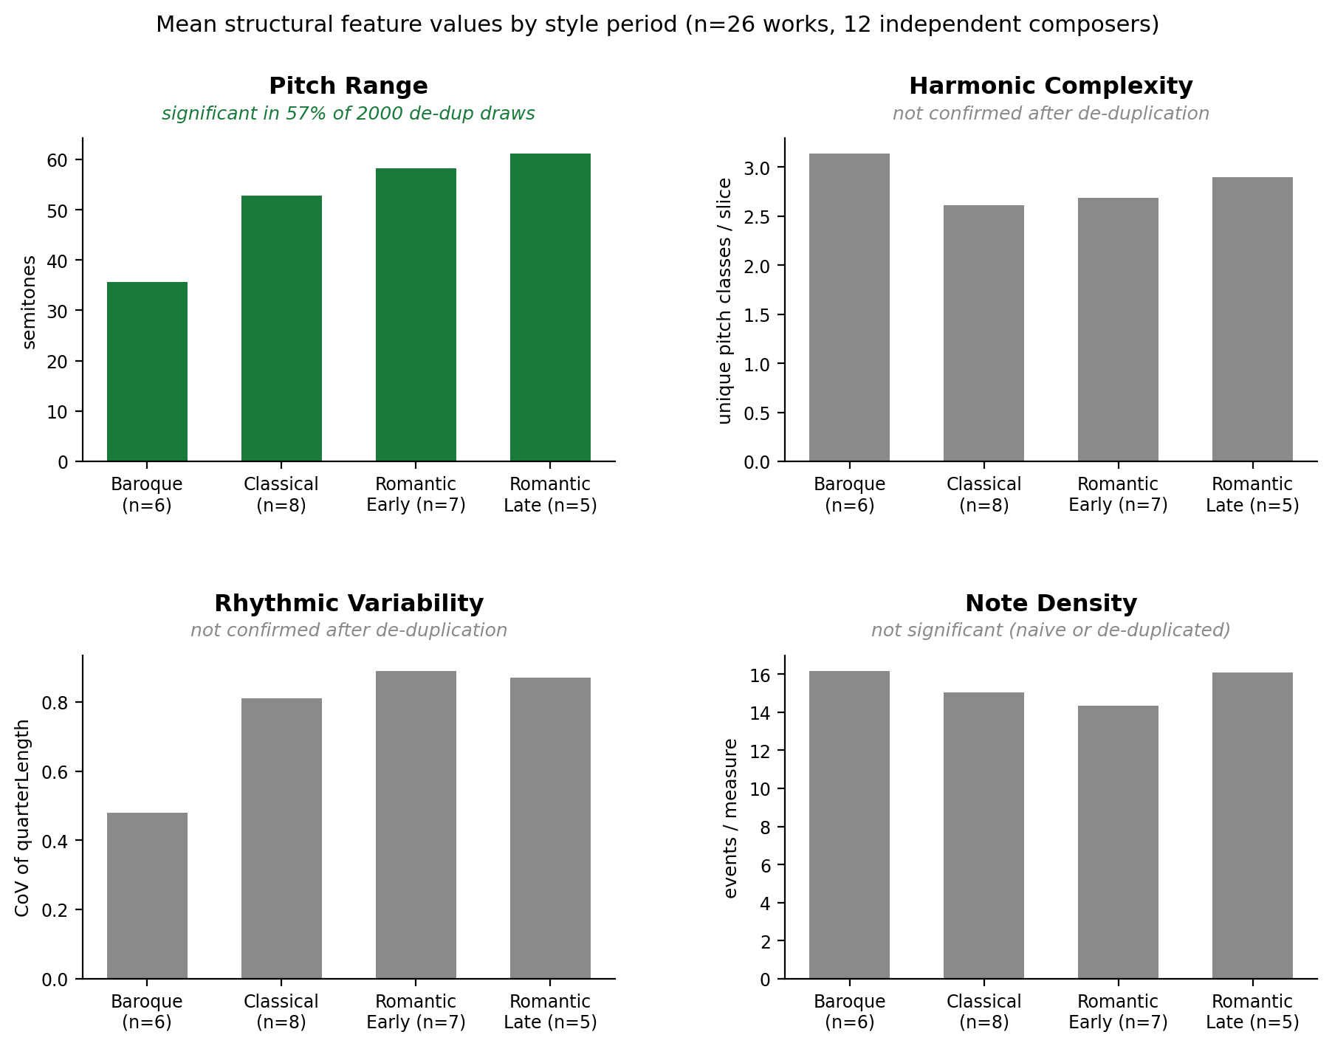

Key Finding: A Pseudoreplication Check
A naive Kruskal-Wallis test across the four groups found significant differences in three of four features (pitch range, harmonic complexity, rhythmic variability; all p < 0.02). But two groups were dominated by a single composer — Bach accounted for 5 of 6 Baroque works, and Beethoven for 5 of 6 works in the original Early Romantic group — so an apparent “era effect” could really be a “this one composer's style” effect. As a robustness check, I re-ran the test keeping only one representative work per composer, and added a further Early Romantic composer (Mendelssohn, String Quartet No. 2, Op. 13, 1827) specifically to dilute the Beethoven-dominance in that group. Because that de-duplication result depends on which single work happens to be kept for each multi-work composer, I repeated the draw 2,000 times with a different random selection each time (12 independent composers): pitch range reached significance in 57% of draws (median p = 0.046) — an improvement from 36% before the Mendelssohn addition, but not yet fully stable. Harmonic complexity and rhythmic variability, both significant in the naive analysis, were not confirmed in any meaningful share of draws once composer-level clustering was controlled for. I report the resampling percentage rather than a single p-value because one arbitrary draw is not a reliable summary at this sample size.

What I'm Hoping to Discuss
Two questions in particular. First: the Baroque group is still represented by only two independent composers (Bach and Corelli) — partly because the string quartet genre hadn't matured yet in this period, so the corpus currently substitutes chorales and a trio sonata, and partly because OpenScore doesn't cover this era. Is there a defensible way to broaden Baroque representation without undermining a like-for-like comparison across periods? Second: does this periodization hold up musicologically, and would extending toward Impressionism/Neoclassicism — to test whether an actual reversal follows the accumulation this pilot documents — be a sound next step?

Proposed Next Steps
• Extend the corpus into Neoclassicism (e.g. Prokofiev's String Quartet No. 1, Op. 50, 1930) to test whether the reaction this pilot finds reverses again, rather than only documenting a single shift.
• Resolve the Baroque-representation question above.
• Add tempo (BPM) — the one feature a 2024 Scientific Reports study on 1950–2023 popular melody found to behave differently from the others, and not yet captured here.
Longer-term, once this classical-side analysis is on firmer footing, I'm planning a separate second phase applying the same structural-feature approach to popular music (using the public BiMMuDa MIDI corpus) to compare trend shapes across the two traditions — but that's a later phase, not an immediate next step for this pilot.

