COMP6452 assignment2

Fengting YANG

Z5089358

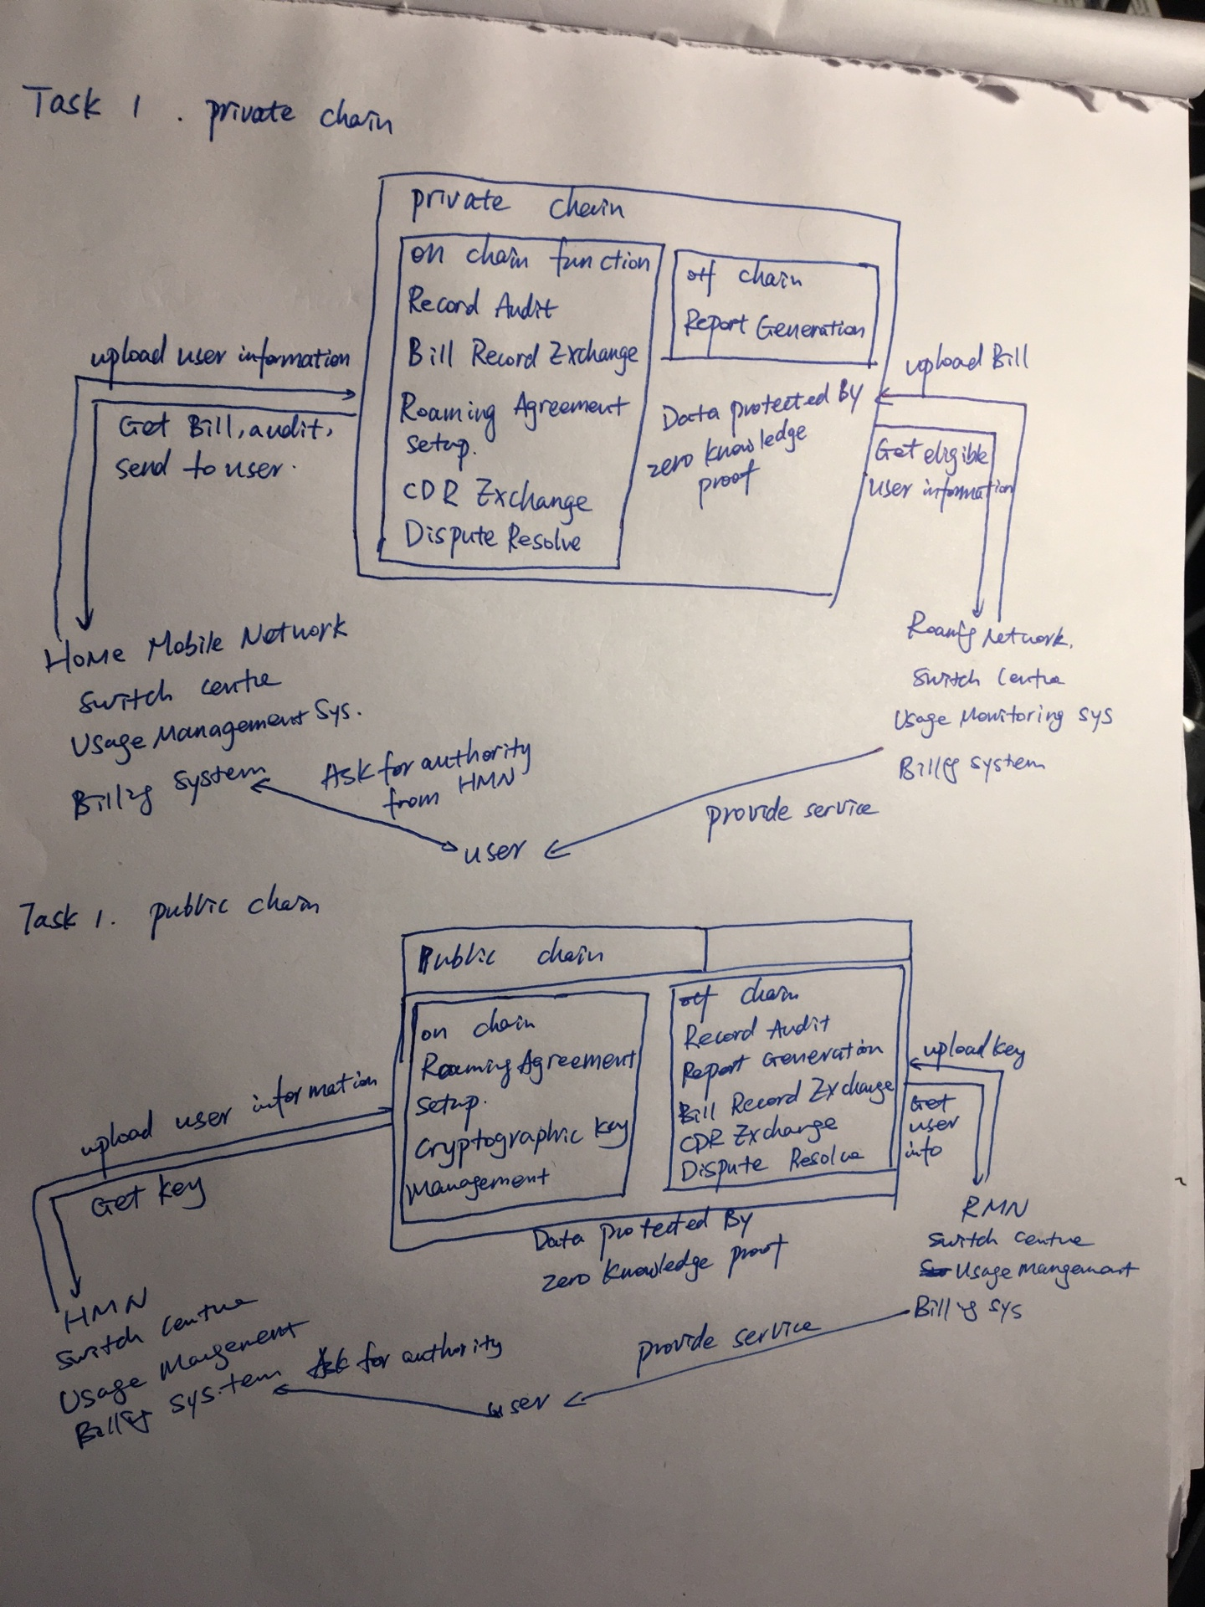

In public blockchain, the blockchain is like an authority center. However, in private blockchain, it likes a clearing house

Task 2

|  |  |  |  |
| --- | --- | --- | --- |
|  | S1 | S2 | S3 |
| Name | Attacked by hacker | Unauthorized user wants to roam in another city | Unauthorized roaming service provider |
| Description | A hacker hack one server | A user wants to roam in another city but not authorized | An unauthorized roaming service provider wants to join the network without any agreement |
| Attribute | security | availability | Security |
| Environment | Under attack | Normal usage without authorized | Unauthorized join |
| Stimulus | External attack | User has no authority | Service provider wants to join the network without any agreement |
| Response | Shut down the attacked server, use backup server | Reject user’s request | Join denied |
| Why deal with the risk | Ensure the commercial confidentiality | The user should get the roaming agreement first to roam | The roaming service provider should get an agreement to get the access key to join the network |

|  |  |  |  |
| --- | --- | --- | --- |
|  | S4 | S5 | S6 |
| Name | User bill delay | CDR generate delay | One of server failure |
| Description | The user cannot get bill on time | HMN cannot get CDR on time | One server on cluster failure |
| Attribute | Performance | Performance | Availability |
| Environment | Normal operation | Normal operation | One server down |
| Stimulus | When the server is busy, there will be high delay in bill generation system | In every CDR exchange day, there will be high throughput caused by CDR exchange | Multiple reasons to cause a server down |
| Response | Server expansion temporarily | CDR exchange later than CDR generation (for example, every 1st day of month to generate CDR but exchange on 10th) | Deploy workload balance in advance. Once a server down, the cluster can still work |
| Why deal with the risk | The user should get there bill on time to pay correct fare. | Ensure the consistency | Ensure the availability |

|  |  |  |  |
| --- | --- | --- | --- |
|  | S7 | S8 | S9 |
| Name | Low throughput | Unnecessary information access request | Insufficient information user |
| Description | When the throughput is low, the cluster shrink the server quantity | RMN wants to access some unnecessary user information | One user asks for authority from HMN but he cannot provide sufficient personal information |
| Attribute | Performance | Security | Security |
| Environment | Low throughput | Normal operation but with unnecessary information access request | Normal operation |
| Stimulus | Automatic | Unnecessary information access | Insufficient information provided |
| Response | Shut down some servers automatically | Request denied | Request denied |
| Why deal with the risk | To reduce cost | To protect user privacy | To ensure every user is traceable |

|  |  |  |  |
| --- | --- | --- | --- |
|  | S10 | S11 | S12 |
| Name | Cannot submit user information on time | Server failure on switch center | Roaming agreement update failure |
| Description | Once a user gets agreement from HMN, HMN must let RMN know this user immediately | One of the servers is down on HMN switch center | When updating roaming agreement, some exception occurs |
| Attribute | Performance | Availability | Availability |
| Environment | New user join | Normal operation | Normal operation |
| Stimulus | New user join | CPU failure | Exception thrown |
| Response | Try to upload user information from backup server | Switch to backup CPU immediately by deploying watchdog | Roll back to old version and debug new version |
| Why deal with the risk | HMN should let RMN know a new user joined the roaming network immediately so that user will not be confused why he can’t roam | To ensure the reasonable server quantity to provide service to user | Though the agreement failed to update, the system should still run. |

Task 3

In my opinion, a private blockchain should be used to implement the whole system. Private blockchain can provide high integrity, performance and privacy compare to public blockchain. Although conventional blockchain can provide highest confidentiality, integrity is still the most important feature, which private blockchain can provide best.