# 项目命名

rx-rmip-**** (****为各系统的名称)，子系统名称如下：

一体化门户：rm-rmip-portal

核心业务：rm-rmip-corebusiness

公共信息服务：rm-rmip-site

移动信息服务：rm-rmip-mobile

移动基站：rm-rmip-basestation

统一信息展示：rm-rmip-display

# Maven 父子项目建立：

项目包含

* + - 父项目（例如：demo）rx-rmip-demo
    - 子项目rx-rmip-demo-app : java 代码，
    - 子项目rx-rmip-demo-service :java 代码 ，服务层
    - 子项目rx-rmip-demo-common ：java 代码 ，
    - 子项目rx-rmip-demo-back ：web项目（其java代码在rx-rmip-demo-service项目中），
    - 子项目rx-rmip-demo-front ：web项目（其java代码在rx-rmip-demo-app项目中），前端界面

先建立父项目：demo

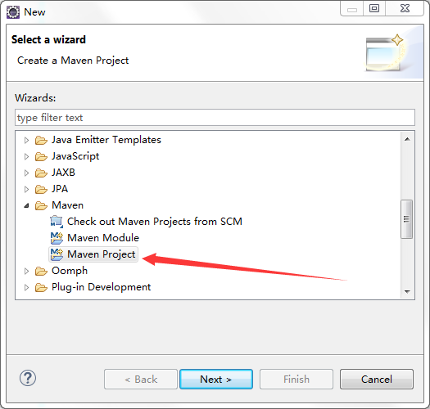

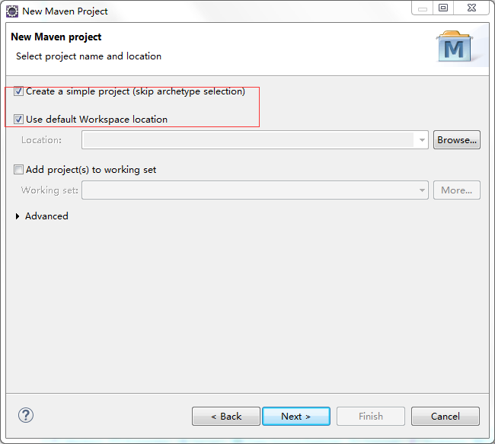

选择默认工作空间

**rx-rmip-demo：**demo 为你的子项目名称

version:为0.0.1

父项目Packaging为pom

点击finish。

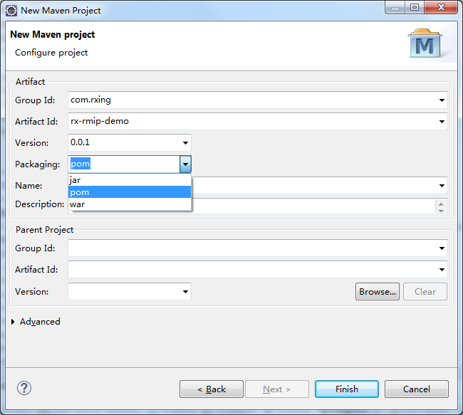

# Maven 建立子项目。

### 开始

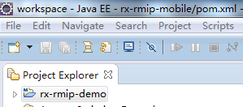

右键父项目->New->Other->

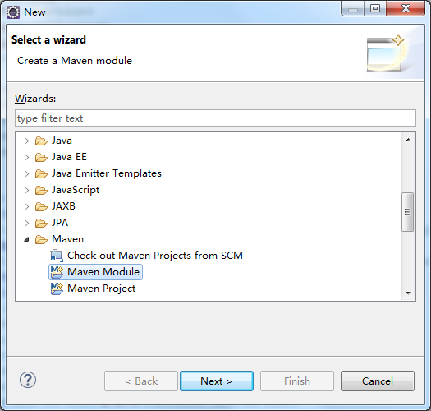

### app、service、common

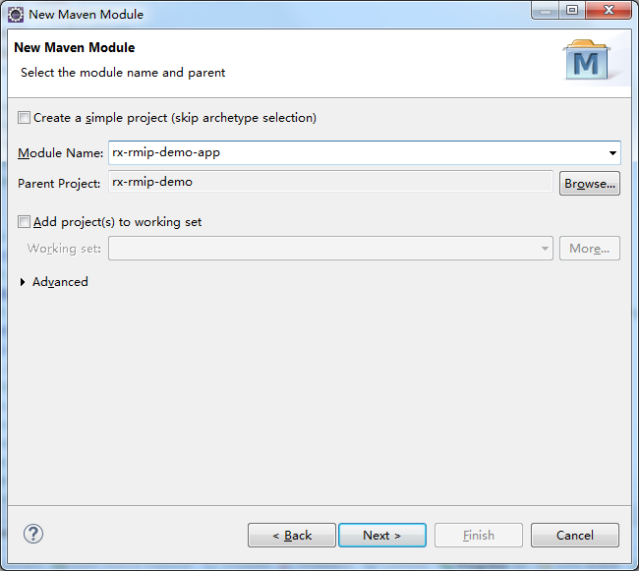

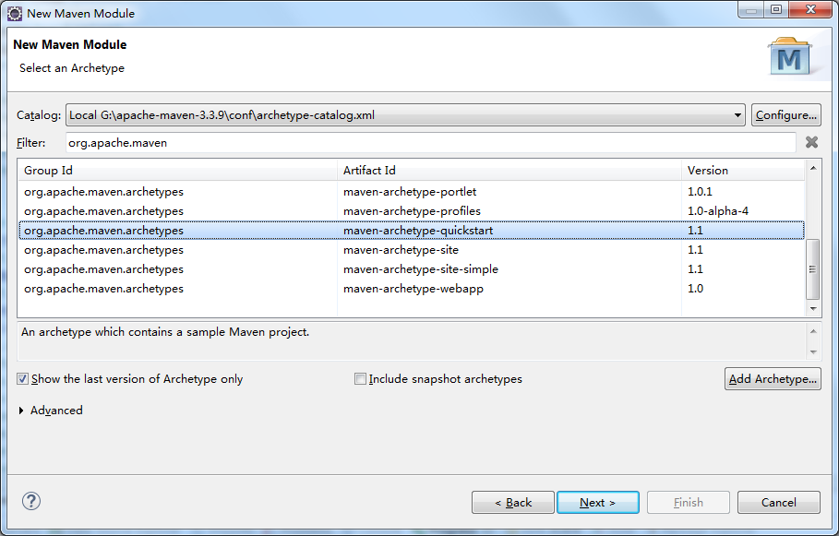

### 其他（back、front）

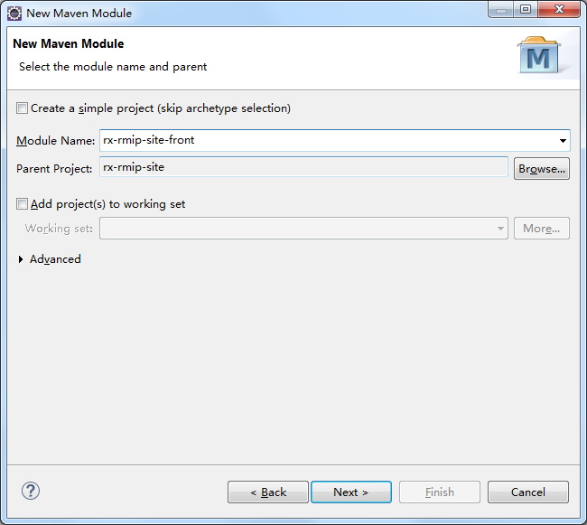

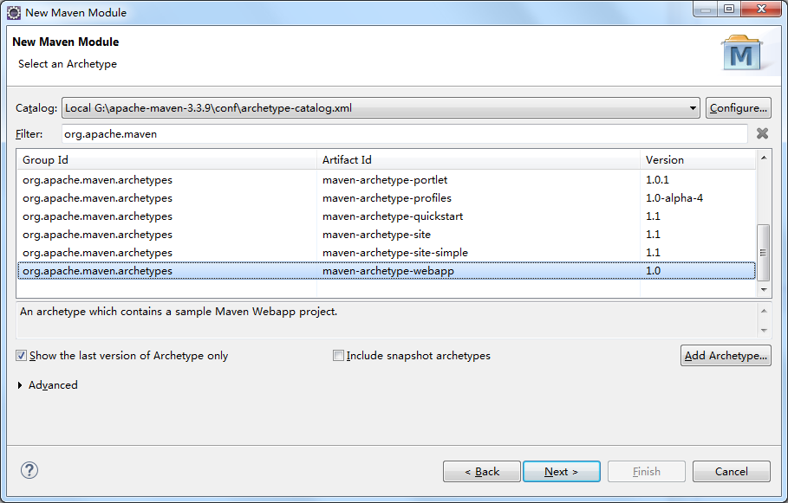

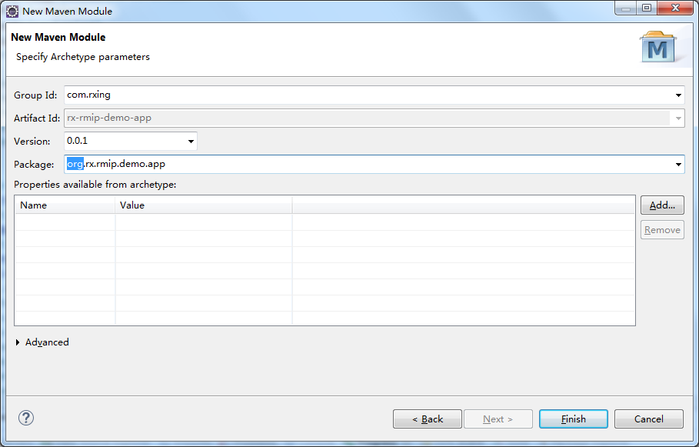

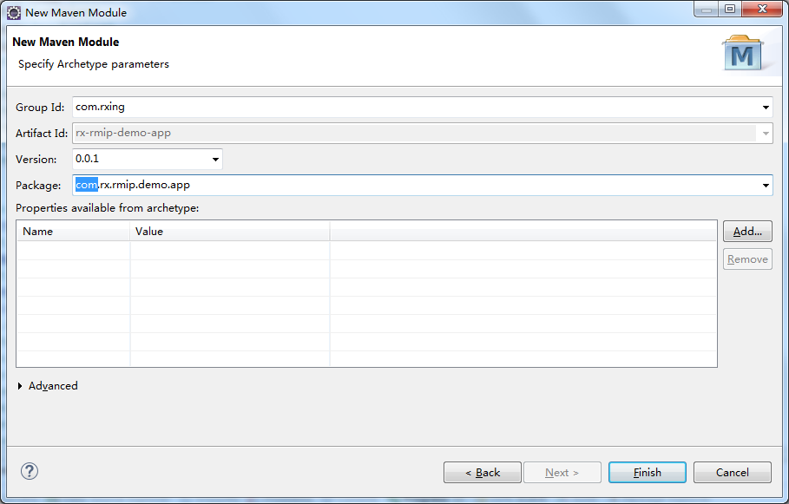

### 缺少包-建立失败

1如果缺少maven-archetype-quickstart-1.1.jar、maven-archetype-webapp-1.0.jar

安装jar 包

2.cmd窗口执行

1：mvn install:install-file -DgroupId=org.apache.maven.archetypes -DartifactId=maven-archetype-quickstart -Dversion=1.1 -Dpackaging=jar -Dfile=maven-archetype-quickstart-1.1.jar:

2：

mvn install:install-file -DgroupId=org.apache.maven.archetypes -DartifactId=maven-archetype-webapp -Dversion=1.0 -Dpackaging=jar -Dfile=maven-archetype-webapp-1.0.jar

# POM文件：

## 父项目

其中dependencies中的依赖包为父子项目共同需要。只需定义在父项目中的dependencies中。

DependencyManagement为父项目所有、子项目部分需要。子项目的pom.xml需要定义了自己所需要的部分，不需要定义版本号。

如：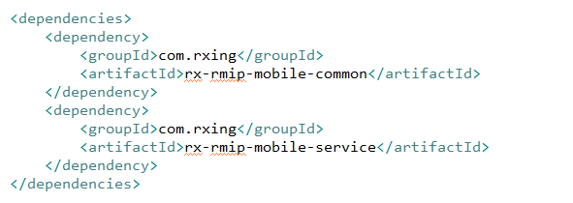

### 父项目-目录结构：

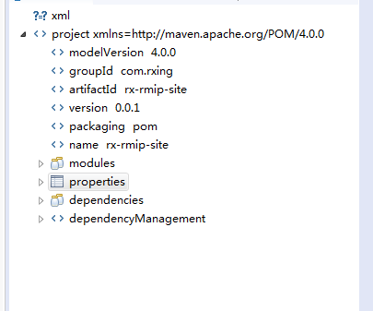

### 父项目-目录结构Properties：

**定义了版本号**

<properties>

<!-- 源文件字符编 -->

<project.build.sourceEncoding>UTF-8</project.build.sourceEncoding>

<!-- 构建输出目录 -->

<project.build.deploydir>${project.parent.basedir}/target/</project.build.deploydir>

<!-- 各种包的版本 -->

<!-- main version setting -->

<spring.version>4.1.9.RELEASE</spring.version>

<validator.version>5.2.4.Final</validator.version>

<mybatis.version>3.2.8</mybatis.version>

<mybatis-spring.version>1.2.3</mybatis-spring.version>

<druid.version>1.0.18</druid.version>

<ehcache.version>2.6.11</ehcache.version>

<ehcache-web.version>2.0.4</ehcache-web.version>

<shiro.version>1.2.3</shiro.version>

<sitemesh.version>2.4.2</sitemesh.version>

<activiti.version>5.21.0</activiti.version>

<!-- tools version setting -->

<slf4j.version>1.7.7</slf4j.version>

<commons-lang3.version>3.3.2</commons-lang3.version>

<commons-io.version>2.4</commons-io.version>

<commons-codec.version>1.9</commons-codec.version>

<commons-fileupload.version>1.3.1</commons-fileupload.version>

<commons-beanutils.version>1.9.1</commons-beanutils.version>

<jackson.version>2.2.3</jackson.version>

<fastjson.version>1.1.40</fastjson.version>

<xstream.version>1.4.7</xstream.version>

<guava.version>17.0</guava.version>

<dozer.version>5.5.1</dozer.version>

<poi.version>3.9</poi.version>

<freemarker.version>2.3.20</freemarker.version>

<!-- jdbc driver setting -->

<mysql.driver.version>5.1.30</mysql.driver.version>

<oracle.driver.version>10.2</oracle.driver.version>

<mssql.driver.version>1.3.1</mssql.driver.version>

<!-- environment setting -->

<jdk.version>1.6</jdk.version>

<tomcat.version>2.2</tomcat.version>

<jetty.version>7.6.14.v20131031</jetty.version>

<webserver.port>8181</webserver.port>

<project.build.sourceEncoding>UTF-8</project.build.sourceEncoding>

<downloadSources>true</downloadSources>

<junit.version>4.12</junit.version>

</properties>

### 父项目-目录结构Dependencies

**全部共有依赖包**

<dependencies>

<!-- TEST begin -->

<dependency>

<groupId>junit</groupId>

<artifactId>junit</artifactId>

<version>${junit.version}</version>

</dependency>

<dependency>

<groupId>org.springframework</groupId>

<artifactId>spring-test</artifactId>

<version>${spring.version}</version>

</dependency>

<!-- TEST end -->

<!-- SPRING common begin -->

<dependency>

<groupId>org.springframework</groupId>

<artifactId>spring-core</artifactId>

<version>${spring.version}</version>

<exclusions>

<exclusion>

<groupId>commons-logging</groupId>

<artifactId>commons-logging</artifactId>

</exclusion>

</exclusions>

</dependency>

<dependency>

<groupId>org.springframework</groupId>

<artifactId>spring-beans</artifactId>

<version>${spring.version}</version>

</dependency>

<dependency>

<groupId>org.springframework</groupId>

<artifactId>spring-context</artifactId>

<version>${spring.version}</version>

</dependency>

<dependency>

<groupId>org.springframework</groupId>

<artifactId>spring-context-support</artifactId>

<version>${spring.version}</version>

</dependency>

<dependency>

<groupId>org.springframework</groupId>

<artifactId>spring-aop</artifactId>

<version>${spring.version}</version>

<exclusions>

<exclusion>

<groupId>commons-logging</groupId>

<artifactId>commons-logging</artifactId>

</exclusion>

</exclusions>

</dependency>

<dependency>

<groupId>org.springframework</groupId>

<artifactId>spring-tx</artifactId>

<version>${spring.version}</version>

</dependency>

<!-- SPRING common end -->

<!-- email -->

<dependency>

<groupId>javax.mail</groupId>

<artifactId>mail</artifactId>

<version>1.4.7</version>

</dependency>

<dependency>

<groupId>org.apache.commons</groupId>

<artifactId>commons-email</artifactId>

<version>1.4</version>

</dependency>

<dependency>

<groupId>javax.activation</groupId>

<artifactId>activation</artifactId>

<version>1.1.1</version>

</dependency>

<!-- bean validate -->

<dependency>

<groupId>org.hibernate</groupId>

<artifactId>hibernate-validator</artifactId>

<version>${validator.version}</version>

</dependency>

<!-- AOP begin -->

<dependency>

<groupId>org.aspectj</groupId>

<artifactId>aspectjrt</artifactId>

<version>1.7.4</version>

</dependency>

<dependency>

<groupId>org.aspectj</groupId>

<artifactId>aspectjweaver</artifactId>

<version>1.7.4</version>

</dependency>

<dependency>

<groupId>cglib</groupId>

<artifactId>cglib</artifactId>

<version>3.1</version>

</dependency>

<!-- AOP end -->

</dependencies>

### 父项目-目录结构dependencyManagement

**部分依赖包**

<dependencyManagement>

<dependencies>

<!-- rongxing begin -->

<dependency>

<groupId>com.rxing</groupId>

<artifactId>rx-rmip-mobile-common</artifactId>

<version>${project.version}</version>

</dependency>

<dependency>

<groupId>com.rxing</groupId>

<artifactId>rx-rmip-mobile-service</artifactId>

<version>${project.version}</version>

</dependency>

<dependency>

<groupId>com.rxing</groupId>

<artifactId>rx-rmip-mobile-app</artifactId>

<version>${project.version}</version>

</dependency>

<!-- rongxing end -->

<!-- spring orm -->

<dependency>

<groupId>org.springframework</groupId>

<artifactId>spring-orm</artifactId>

<version>${spring.version}</version>

</dependency>

<dependency>

<groupId>org.springframework</groupId>

<artifactId>spring-jdbc</artifactId>

<version>${spring.version}</version>

</dependency>

<!-- WEB begin -->

<dependency>

<groupId>org.springframework</groupId>

<artifactId>spring-web</artifactId>

<version>${spring.version}</version>

</dependency>

<dependency>

<groupId>org.springframework</groupId>

<artifactId>spring-webmvc</artifactId>

<version>${spring.version}</version>

</dependency>

<dependency>

<groupId>org.springframework</groupId>

<artifactId>spring-oxm</artifactId>

<version>${spring.version}</version>

</dependency>

<dependency>

<groupId>opensymphony</groupId>

<artifactId>sitemesh</artifactId>

<version>${sitemesh.version}</version>

</dependency>

<dependency>

<groupId>taglibs</groupId>

<artifactId>standard</artifactId>

<version>1.1.2</version>

<type>jar</type>

</dependency>

<dependency>

<groupId>javax.servlet</groupId>

<artifactId>jstl</artifactId>

<version>1.2</version>

<type>jar</type>

</dependency>

<dependency>

<groupId>javax.servlet</groupId>

<artifactId>servlet-api</artifactId>

<version>2.5</version>

<scope>provided</scope>

</dependency>

<dependency>

<groupId>javax.servlet.jsp</groupId>

<artifactId>jsp-api</artifactId>

<version>2.2</version>

<scope>provided</scope>

</dependency>

<!-- <dependency> <groupId>javax.servlet</groupId> <artifactId>javax.servlet-api</artifactId>

<version>3.0.1</version> <scope>provided</scope> </dependency> <dependency>

<groupId>javax.servlet.jsp</groupId> <artifactId>jsp-api</artifactId> <version>2.2</version>

<scope>provided</scope> </dependency> -->

<!-- WEB end -->

<!-- CACHE begin -->

<dependency>

<groupId>net.sf.ehcache</groupId>

<artifactId>ehcache-core</artifactId>

<version>${ehcache.version}</version>

</dependency>

<dependency>

<groupId>net.sf.ehcache</groupId>

<artifactId>ehcache-web</artifactId>

<version>${ehcache-web.version}</version>

</dependency>

<dependency>

<groupId>redis.clients</groupId>

<artifactId>jedis</artifactId>

<version>2.5.1</version>

</dependency>

<!-- CACHE end -->

<!-- SECURITY begin -->

<dependency>

<groupId>org.apache.shiro</groupId>

<artifactId>shiro-core</artifactId>

<version>${shiro.version}</version>

</dependency>

<dependency>

<groupId>org.apache.shiro</groupId>

<artifactId>shiro-spring</artifactId>

<version>${shiro.version}</version>

</dependency>

<dependency>

<groupId>org.apache.shiro</groupId>

<artifactId>shiro-cas</artifactId>

<version>${shiro.version}</version>

<exclusions>

<exclusion>

<groupId>commons-logging</groupId>

<artifactId>commons-logging</artifactId>

</exclusion>

</exclusions>

</dependency>

<dependency>

<groupId>org.apache.shiro</groupId>

<artifactId>shiro-web</artifactId>

<version>${shiro.version}</version>

</dependency>

<dependency>

<groupId>org.apache.shiro</groupId>

<artifactId>shiro-ehcache</artifactId>

<version>${shiro.version}</version>

</dependency>

<!-- SECURITY end -->

<!-- Activiti -->

<dependency>

<groupId>org.activiti</groupId>

<artifactId>activiti-engine</artifactId>

<version>${activiti.version}</version>

</dependency>

<dependency>

<groupId>org.activiti</groupId>

<artifactId>activiti-spring</artifactId>

<version>${activiti.version}</version>

</dependency>

<dependency>

<groupId>org.activiti</groupId>

<artifactId>activiti-explorer</artifactId>

<version>${activiti.version}</version>

<exclusions>

<exclusion>

<artifactId>vaadin</artifactId>

<groupId>com.vaadin</groupId>

</exclusion>

<exclusion>

<artifactId>dcharts-widget</artifactId>

<groupId>org.vaadin.addons</groupId>

</exclusion>

<exclusion>

<artifactId>activiti-simple-workflow</artifactId>

<groupId>org.activiti</groupId>

</exclusion>

</exclusions>

</dependency>

<dependency>

<groupId>org.activiti</groupId>

<artifactId>activiti-modeler</artifactId>

<version>${activiti.version}</version>

</dependency>

<dependency>

<groupId>org.activiti</groupId>

<artifactId>activiti-diagram-rest</artifactId>

<version>${activiti.version}</version>

</dependency>

<!-- 支持activiti缓存 -->

<!-- <dependency> <groupId>org.infinispan</groupId> <artifactId>infinispan-core</artifactId>

<version>5.1.7.Final</version> </dependency> -->

<!-- LOGGING begin -->

<dependency>

<groupId>org.slf4j</groupId>

<artifactId>slf4j-api</artifactId>

<version>${slf4j.version}</version>

</dependency>

<dependency>

<groupId>org.slf4j</groupId>

<artifactId>slf4j-log4j12</artifactId>

<version>${slf4j.version}</version>

</dependency>

<!-- common-logging 实际调用slf4j -->

<dependency>

<groupId>org.slf4j</groupId>

<artifactId>jcl-over-slf4j</artifactId>

<version>${slf4j.version}</version>

</dependency>

<!-- java.util.logging 实际调用slf4j -->

<dependency>

<groupId>org.slf4j</groupId>

<artifactId>jul-to-slf4j</artifactId>

<version>${slf4j.version}</version>

</dependency>

<!-- LOGGING end -->

<!-- GENERAL UTILS begin -->

<dependency>

<groupId>org.apache.commons</groupId>

<artifactId>commons-lang3</artifactId>

<version>${commons-lang3.version}</version>

</dependency>

<dependency>

<groupId>commons-io</groupId>

<artifactId>commons-io</artifactId>

<version>${commons-io.version}</version>

</dependency>

<dependency>

<groupId>commons-codec</groupId>

<artifactId>commons-codec</artifactId>

<version>${commons-codec.version}</version>

</dependency>

<dependency>

<groupId>commons-fileupload</groupId>

<artifactId>commons-fileupload</artifactId>

<version>${commons-fileupload.version}</version>

</dependency>

<dependency>

<groupId>commons-beanutils</groupId>

<artifactId>commons-beanutils</artifactId>

<version>${commons-beanutils.version}</version>

<exclusions>

<exclusion>

<groupId>commons-logging</groupId>

<artifactId>commons-logging</artifactId>

</exclusion>

</exclusions>

</dependency>

<!-- google java lib -->

<dependency>

<groupId>com.google.guava</groupId>

<artifactId>guava</artifactId>

<version>${guava.version}</version>

</dependency>

<!-- jackson json -->

<dependency>

<groupId>com.fasterxml.jackson.core</groupId>

<artifactId>jackson-core</artifactId>

<version>${jackson.version}</version>

</dependency>

<dependency>

<groupId>com.fasterxml.jackson.core</groupId>

<artifactId>jackson-databind</artifactId>

<version>${jackson.version}</version>

</dependency>

<dependency>

<groupId>com.fasterxml.jackson.core</groupId>

<artifactId>jackson-annotations</artifactId>

<version>${jackson.version}</version>

</dependency>

<dependency>

<groupId>com.fasterxml.jackson.module</groupId>

<artifactId>jackson-module-jaxb-annotations</artifactId>

<version>${jackson.version}</version>

</dependency>

<!-- fastjson json <dependency> <groupId>com.alibaba</groupId> <artifactId>fastjson</artifactId>

<version>${fastjson.version}</version> </dependency> -->

<!-- xstream xml -->

<dependency>

<groupId>com.thoughtworks.xstream</groupId>

<artifactId>xstream</artifactId>

<version>${xstream.version}</version>

</dependency>

<!-- pojo copy -->

<dependency>

<groupId>net.sf.dozer</groupId>

<artifactId>dozer</artifactId>

<version>${dozer.version}</version>

</dependency>

<!-- freemarker engine -->

<dependency>

<groupId>org.freemarker</groupId>

<artifactId>freemarker</artifactId>

<version>${freemarker.version}</version>

</dependency>

<!-- poi office -->

<dependency>

<groupId>org.apache.poi</groupId>

<artifactId>poi</artifactId>

<version>${poi.version}</version>

</dependency>

<dependency>

<groupId>org.apache.poi</groupId>

<artifactId>poi-ooxml</artifactId>

<version>${poi.version}</version>

</dependency>

<dependency>

<groupId>org.apache.poi</groupId>

<artifactId>poi-ooxml-schemas</artifactId>

<version>${poi.version}</version>

</dependency>

<!-- image util -->

<dependency>

<groupId>com.drewnoakes</groupId>

<artifactId>metadata-extractor</artifactId>

<version>2.6.2</version>

</dependency>

<!-- 条形码、二维码生成 -->

<dependency>

<groupId>com.google.zxing</groupId>

<artifactId>core</artifactId>

<version>2.2</version>

</dependency>

<dependency>

<groupId>com.google.zxing</groupId>

<artifactId>javase</artifactId>

<version>2.2</version>

</dependency>

<!-- 中文分词 -->

<dependency>

<groupId>org.wltea</groupId>

<artifactId>analyzer</artifactId>

<version>2012_u6</version>

</dependency>

<!-- GENERAL UTILS end -->

<!-- CKFinder begin -->

<dependency>

<groupId>net.coobird</groupId>

<artifactId>thumbnailator</artifactId>

<version>0.4.2</version>

</dependency>

<dependency>

<groupId>com.ckfinder</groupId>

<artifactId>apache-ant-zip</artifactId>

<version>2.3</version>

</dependency>

<dependency>

<groupId>com.ckfinder</groupId>

<artifactId>ckfinder</artifactId>

<version>2.3</version>

</dependency>

<dependency>

<groupId>com.ckfinder</groupId>

<artifactId>ckfinderplugin-fileeditor</artifactId>

<version>2.3</version>

</dependency>

<dependency>

<groupId>com.ckfinder</groupId>

<artifactId>ckfinderplugin-imageresize</artifactId>

<version>2.3</version>

</dependency>

<!-- CKFinder end -->

<!-- User Agent -->

<dependency>

<groupId>bitwalker</groupId>

<artifactId>UserAgentUtils</artifactId>

<version>1.13</version>

</dependency>

<!-- PERSISTENCE begin -->

<!-- MyBatis -->

<dependency>

<groupId>org.mybatis</groupId>

<artifactId>mybatis</artifactId>

<version>${mybatis.version}</version>

</dependency>

<dependency>

<groupId>org.mybatis</groupId>

<artifactId>mybatis-spring</artifactId>

<version>${mybatis-spring.version}</version>

</dependency>

<!-- connection pool -->

<dependency>

<groupId>com.alibaba</groupId>

<artifactId>druid</artifactId>

<version>${druid.version}</version>

</dependency>

<!-- jdbc driver -->

<!-- <dependency> <groupId>mysql</groupId> <artifactId>mysql-connector-java</artifactId>

<version>${mysql.driver.version}</version> <scope>runtime</scope> </dependency> -->

<dependency>

<groupId>com.oracle</groupId>

<artifactId>ojdbc14</artifactId>

<version>10.2.0.4.0</version>

<scope>runtime</scope>

</dependency>

<dependency>

<groupId>net.sourceforge.jtds</groupId>

<artifactId>jtds</artifactId>

<version>${mssql.driver.version}</version>

<scope>runtime</scope>

</dependency>

<!-- PERSISTENCE end -->

</dependencies>

</dependencyManagement>

## 子项目：目录结构。

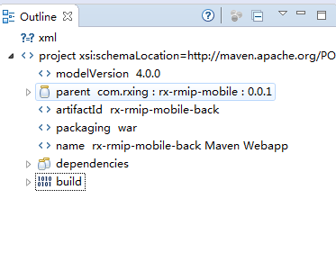

示例：（这是需要手动添加的。）这里不需要版本号。Dependencies依赖在父项目的dependencyManagement节点中有，父项目多了版本号节点。

这样做的好处是：能够对项目所依赖的包的版本进行同意管理。不会导致使用不同的版本依赖包导致冲突。

<dependencies>

<!-- WEB begin -->

<dependency>

<groupId>org.springframework</groupId>

<artifactId>spring-web</artifactId>

</dependency>

<dependency>

<groupId>org.springframework</groupId>

<artifactId>spring-webmvc</artifactId>

</dependency>

<dependency>

<groupId>org.springframework</groupId>

<artifactId>spring-oxm</artifactId>

</dependency>

<dependency>

<groupId>opensymphony</groupId>

<artifactId>sitemesh</artifactId>

</dependency>

<dependency>

<groupId>taglibs</groupId>

<artifactId>standard</artifactId>

<type>jar</type>

</dependency>

<dependency>

<groupId>javax.servlet</groupId>

<artifactId>jstl</artifactId>

<type>jar</type>

</dependency>

<dependency>

<groupId>javax.servlet</groupId>

<artifactId>servlet-api</artifactId>

<scope>provided</scope>

</dependency>

<dependency>

<groupId>javax.servlet.jsp</groupId>

<artifactId>jsp-api</artifactId>

<scope>provided</scope>

</dependency>

<!-- WEB end -->

<!-- LOGGING begin -->

<dependency>

<groupId>org.slf4j</groupId>

<artifactId>slf4j-api</artifactId>

</dependency>

<dependency>

<groupId>org.slf4j</groupId>

<artifactId>slf4j-log4j12</artifactId>

</dependency>

<!-- common-logging 实际调用slf4j -->

<dependency>

<groupId>org.slf4j</groupId>

<artifactId>jcl-over-slf4j</artifactId>

</dependency>

<!-- java.util.logging 实际调用slf4j -->

<dependency>

<groupId>org.slf4j</groupId>

<artifactId>jul-to-slf4j</artifactId>

</dependency>

<!-- LOGGING end -->

<!-- GENERAL UTILS begin -->

<dependency>

<groupId>org.apache.commons</groupId>

<artifactId>commons-lang3</artifactId>

</dependency>

<dependency>

<groupId>commons-io</groupId>

<artifactId>commons-io</artifactId>

</dependency>

<dependency>

<groupId>commons-codec</groupId>

<artifactId>commons-codec</artifactId>

</dependency>

<dependency>

<groupId>commons-fileupload</groupId>

<artifactId>commons-fileupload</artifactId>

</dependency>

<dependency>

<groupId>commons-beanutils</groupId>

<artifactId>commons-beanutils</artifactId>

<exclusions>

<exclusion>

<groupId>commons-logging</groupId>

<artifactId>commons-logging</artifactId>

</exclusion>

</exclusions>

</dependency>

<!-- google java lib -->

<dependency>

<groupId>com.google.guava</groupId>

<artifactId>guava</artifactId>

</dependency>

<!-- jackson json -->

<dependency>

<groupId>com.fasterxml.jackson.core</groupId>

<artifactId>jackson-core</artifactId>

</dependency>

<dependency>

<groupId>com.fasterxml.jackson.core</groupId>

<artifactId>jackson-databind</artifactId>

</dependency>

<dependency>

<groupId>com.fasterxml.jackson.core</groupId>

<artifactId>jackson-annotations</artifactId>

</dependency>

<dependency>

<groupId>com.fasterxml.jackson.module</groupId>

<artifactId>jackson-module-jaxb-annotations</artifactId>

</dependency>

<!-- fastjson json <dependency> <groupId>com.alibaba</groupId> <artifactId>fastjson</artifactId>

<version>${fastjson.version}</version> </dependency> -->

<!-- xstream xml -->

<dependency>

<groupId>com.thoughtworks.xstream</groupId>

<artifactId>xstream</artifactId>

</dependency>

<!-- pojo copy -->

<dependency>

<groupId>net.sf.dozer</groupId>

<artifactId>dozer</artifactId>

</dependency>

<!-- freemarker engine -->

<dependency>

<groupId>org.freemarker</groupId>

<artifactId>freemarker</artifactId>

</dependency>

<!-- poi office -->

<dependency>

<groupId>org.apache.poi</groupId>

<artifactId>poi</artifactId>

</dependency>

<dependency>

<groupId>org.apache.poi</groupId>

<artifactId>poi-ooxml</artifactId>

</dependency>

<dependency>

<groupId>org.apache.poi</groupId>

<artifactId>poi-ooxml-schemas</artifactId>

</dependency>

<!-- image util -->

<dependency>

<groupId>com.drewnoakes</groupId>

<artifactId>metadata-extractor</artifactId>

</dependency>

<!-- 条形码、二维码生成 -->

<dependency>

<groupId>com.google.zxing</groupId>

<artifactId>core</artifactId>

</dependency>

<dependency>

<groupId>com.google.zxing</groupId>

<artifactId>javase</artifactId>

</dependency>

<!-- 中文分词 -->

<dependency>

<groupId>org.wltea</groupId>

<artifactId>analyzer</artifactId>

</dependency>

<!-- GENERAL UTILS end -->

<!-- CKFinder begin -->

<dependency>

<groupId>net.coobird</groupId>

<artifactId>thumbnailator</artifactId>

</dependency>

<dependency>

<groupId>com.ckfinder</groupId>

<artifactId>apache-ant-zip</artifactId>

</dependency>

<dependency>

<groupId>com.ckfinder</groupId>

<artifactId>ckfinder</artifactId>

</dependency>

<dependency>

<groupId>com.ckfinder</groupId>

<artifactId>ckfinderplugin-fileeditor</artifactId>

</dependency>

<dependency>

<groupId>com.ckfinder</groupId>

<artifactId>ckfinderplugin-imageresize</artifactId>

</dependency>

<!-- CKFinder end -->

<!-- User Agent -->

<dependency>

<groupId>bitwalker</groupId>

<artifactId>UserAgentUtils</artifactId>

</dependency>

<!-- CACHE begin -->

<dependency>

<groupId>net.sf.ehcache</groupId>

<artifactId>ehcache-core</artifactId>

</dependency>

<dependency>

<groupId>net.sf.ehcache</groupId>

<artifactId>ehcache-web</artifactId>

</dependency>

<dependency>

<groupId>redis.clients</groupId>

<artifactId>jedis</artifactId>

</dependency>

<!-- CACHE end -->

<!-- SECURITY begin -->

<dependency>

<groupId>org.apache.shiro</groupId>

<artifactId>shiro-core</artifactId>

</dependency>

<dependency>

<groupId>org.apache.shiro</groupId>

<artifactId>shiro-spring</artifactId>

</dependency>

<dependency>

<groupId>org.apache.shiro</groupId>

<artifactId>shiro-cas</artifactId>

<exclusions>

<exclusion>

<groupId>commons-logging</groupId>

<artifactId>commons-logging</artifactId>

</exclusion>

</exclusions>

</dependency>

<dependency>

<groupId>org.apache.shiro</groupId>

<artifactId>shiro-web</artifactId>

</dependency>

<dependency>

<groupId>org.apache.shiro</groupId>

<artifactId>shiro-ehcache</artifactId>

</dependency>

<!-- SECURITY end -->

<!-- Activiti -->

<dependency>

<groupId>org.activiti</groupId>

<artifactId>activiti-engine</artifactId>

</dependency>

<dependency>

<groupId>org.activiti</groupId>

<artifactId>activiti-spring</artifactId>

</dependency>

<dependency>

<groupId>org.activiti</groupId>

<artifactId>activiti-explorer</artifactId>

<exclusions>

<exclusion>

<artifactId>vaadin</artifactId>

<groupId>com.vaadin</groupId>

</exclusion>

<exclusion>

<artifactId>dcharts-widget</artifactId>

<groupId>org.vaadin.addons</groupId>

</exclusion>

<exclusion>

<artifactId>activiti-simple-workflow</artifactId>

<groupId>org.activiti</groupId>

</exclusion>

</exclusions>

</dependency>

<dependency>

<groupId>org.activiti</groupId>

<artifactId>activiti-modeler</artifactId>

</dependency>

<dependency>

<groupId>org.activiti</groupId>

<artifactId>activiti-diagram-rest</artifactId>

</dependency>

<!-- PERSISTENCE begin -->

<!-- MyBatis -->

<dependency>

<groupId>org.mybatis</groupId>

<artifactId>mybatis</artifactId>

</dependency>

<dependency>

<groupId>org.mybatis</groupId>

<artifactId>mybatis-spring</artifactId>

</dependency>

<!-- connection pool -->

<dependency>

<groupId>com.alibaba</groupId>

<artifactId>druid</artifactId>

</dependency>

<dependency>

<groupId>com.oracle</groupId>

<artifactId>ojdbc14</artifactId>

<scope>runtime</scope>

</dependency>

<dependency>

<groupId>net.sourceforge.jtds</groupId>

<artifactId>jtds</artifactId>

<scope>runtime</scope>

</dependency>

<!-- PERSISTENCE end -->

</dependencies>

<dependencies>

<dependency>

<groupId>com.rxing</groupId>

<artifactId>rx-rmip-mobile-common</artifactId>

</dependency>

<dependency>

<groupId>com.rxing</groupId>

<artifactId>rx-rmip-mobile-service</artifactId>

</dependency>

</dependencies>