Bongeka Zuma

Bioinformatics Assignment

Dr. Qin

11.27.15

**Research topic:**

Analysis of adherence to HPV vaccination schedule

**Research question:**

What is the most likely cause for the low adherence to HPV vaccination schedule?

**Research Method:**

*Data collection*

The data that will be used for this study will be based on data that the Centers for Disease Control (CDC) has collected. The data, titled “2014 to Present: National Immunization Survey”, was obtained from the CDC website (<http://www.cdc.gov/nchs/nis/data_files_teen.htm>).

*Data analysis*

The data was analyzed using a programing language called R.

**Results:**

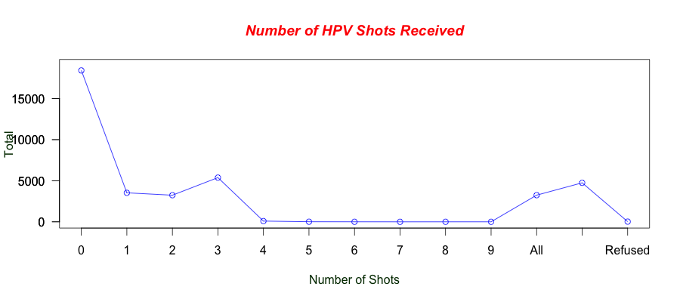

**Figure 1: Number of HPV shots received.**

Different households were asked about the number of HPV shots that they had received from a scale of 0 to 9. There was also an option of “all”, “non” as well as refusing to answer. A line graph was drawn to represent the answers that were given.

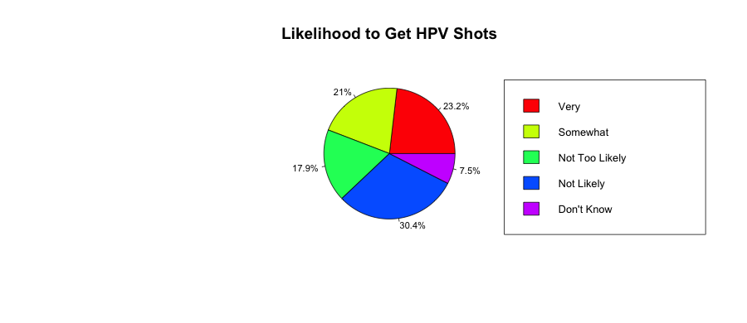

**Figure 2: Likelihood to get HPV shots**

Different households were also asked about their likelihood to obtain the HPV shots in the future. Their results are represented in the pie graph above.

It is quite clear from this preliminary analysis that not too many households reported having had many HPV shots. A significant number of guardians as well as parents reported that their teenagers had received 0 HPV shots. Additionally, when families were asked if they how likely they were to get some or all of the HPV shots. Majority the parents reported that they were **not very likely** to obtain HPV shots.

I have hypothesized that socioeconomic statuses are not the reason for the low HPV vaccination schedule adherence but the lack of recommendations from doctors is.

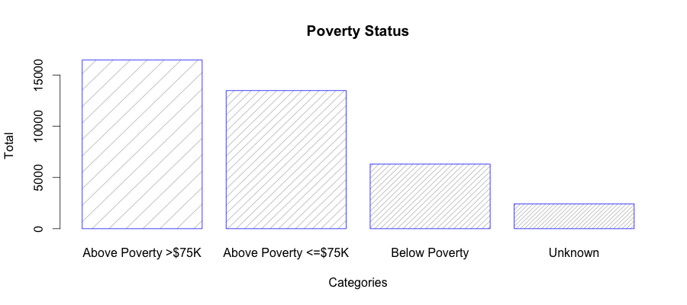

**Figure 3: Poverty status of families**

Households were asked to report their poverty status from 4 scales. Majority of families fall in the “above poverty” line.

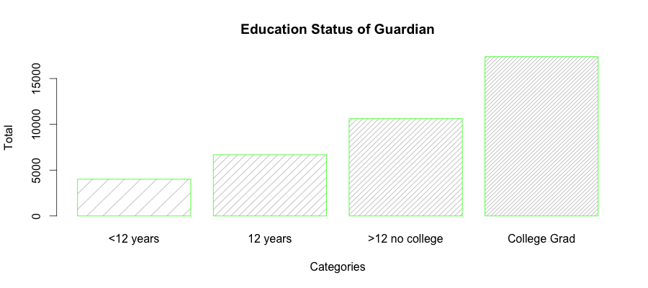

**Figure 4: Education status of guardians**

Households were asked to report the education status of the guardians from a list with 4 options. Majority of guardians were college graduates.

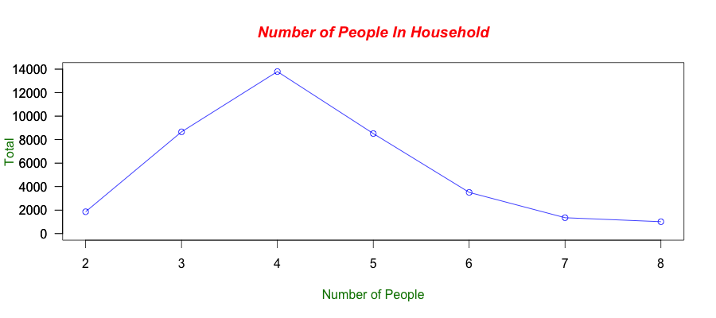

**Figure 5: Number of people**

Households were also asked to how many people are in the household.

The results show that most of the families that were interviewed were above the poverty line; college graduates and most of them had 4 people in their households. It seems that the some of the basic low socioeconomic indicators are not applicable to most of the people interviewed. Therefore, money, and education do not seem to be a problem to most of these families and these issues seem to not be the reason for the low HPV vaccination schedule adherence.

Another influential factor in whether people adhere to the schedule or not is if they receive recommendations from their health providers. The next thing that was analyzed was the responses that households gave to the question of whether their household providers had recommended HPV Vaccine for the teenagers.

The results are given below.

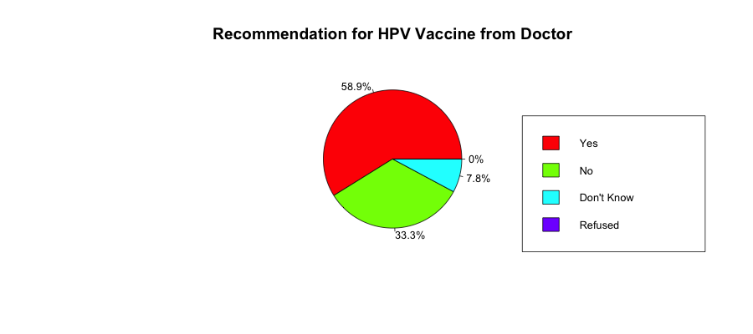

**Figure 6: Recommendation for HPV vaccine from health care provider**

Households were asked if they had received recommendation from their doctor for the teens to have the HPV shots.

59.9% of those who were interviewed indicated that they had in fact received a recommendation from their doctor to have the HPV shots. However, a significant number of those interviewed also indicated that they had not received a recommendation.

It seems that the problem that could be contributing to the low HPV vaccine schedule adherence is the lack of effort from the health care providers.