Bobbevy – This is how we disappear projection setup

Hardware

List of items:
- Extension cord
- Power strip
- Laptop + Power Cable + Thunderbolt to VGA + Thunderbolt to HDMI
- Kinect + Kinect cables
- iPad + iPad usb cable
- Projector + power cable + HDMI cable

Plug everything in. ;) Everything should be powered, and the iPad and Kinect usb cables should be plugged into the laptop. The laptop should be plugged into the projector.

Network

On the laptop:
- Disable the firewall.
- Hit Command-Space
- Type System Preferences
- Click on “Security and Privacy”
- Click on “Firewall”
- Click on the lock in the bottom left hand corner of the dialog box
- Click on “Turn off firewall”
- Close this screen
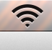
- Create a network called "mutant" with a 40 bit WEP security and a password of BEEFBEEF23.
- Click on the network icon in the upper right hand side of the screen
- Click on “Create Network”
- Enter “mutant” for network name
- Change security to 40-bit WEP
- Enter “BEEFBEEF23” into both password fields, then click “Create”
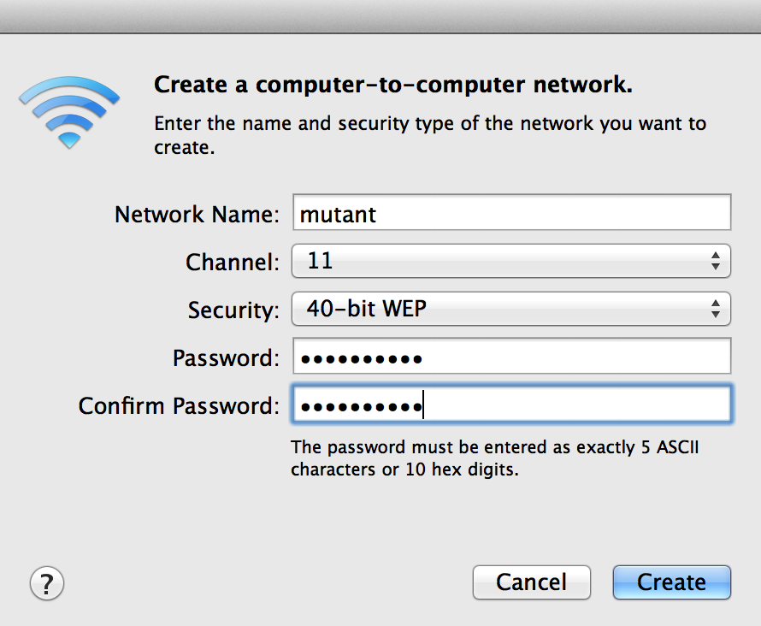

- Start the bobbevy app (do not enter fullscreen until the setup is complete, also while making warnings, do not unplug the Kinect while the app is running)
On the iPad:
- Connect to the mutant network. The password should already be saved.
- Go to the home screen
- Touch “Settings”
- Touch “Wi-Fi”
- Under “Choose a Network” touch “mutant”
- Wait for the wireless icon to reappear in the upper left hand side of the iPad
- Disable auto-lock so that the iPad will not sleep and lose the network connection.
- Click on “General”
- Click on “Auto-Lock”
- Click on “Never”
- Start the Control app
- Click on "Destinations", select the entry that ends with :23232, you may need to hit the Refresh button in the upper right hand part of the screen.
- Click on "Interfaces", select bobbevy
- You should see the "Raw" screen. Click on Toggle trees, the trees should appear in the app.

Kinect Calibration
On the laptop:
- Make sure the bobbevy app has focus
- Type "d" to toggle debug kinect rendering
- Type "p" to display the dev menu
- Scroll down the menu until you see "show contour" and turn that on, you should see a color web cam image. Ideally, you want to make this see only the outline of the projector.
- After you've done this, click on "show contour" again and see if you see large blocks on white on the screen. If so, move the kinect forward until you don't see them anymore.
- Type "a" when no one is in the view of the Kinect to get a base version of the depth information. (You can also click "Reset Depth" on the iPad control app in either the Raw or Interactive screens)
- Type "p" to get rid of the dev menu
- Type "d" to get rid of the kinect debug screen
- If the trees are still visible, type "t" to toggle them off.
- Click on the Display Icon in the upper right hand corner of the screen
- Select “Turn on Display Mirroring”
- Hit “F” to turn on full screen mode

On the iPad:
- Hit the "Start" button, this sets the fade. You're ready to perform! I often would hit "FadeInSlowNoMove" to be paranoid and test things, then hit "Start" again.

Keyboard Shortcut Reference
f = full screen
d = DebugDraw toggle
p = Param toggle
a = reset reference depth
l = enable Kinect
7 = disable kinect

c = fade color white
d = fade color black
o = fade out
i = fade in
g= fade in slow
h = clear timeline
t = tree toggle
e = tree toggle with leaves
b = close swarm
n = far swarm
v = particle field

Light
r = reveal
k = hide/show light

Trees
X = TreeCam X Right, x Left
Y = TreeCam Y Up, y Down
Z = TreeCAM Z In, z Out

1 = Tree Pan Normal
2 = First tree pan fast
3 = Second tree pan fast
4 = Fade to black
5 = Pan up
6 = Fast Z zoom
7 = Faded trees
8 = Transition to color
9 = Stop
0 = Reset
Q=intro blurry
w=fogged out
r=less fogged
u=normal fog

Particles
m = Particle drop
w = fog color tween

