Chris Biancone
10-26-2021
EEEE-220-L2
Lab 8: cjbRISC

Assignment Description:
This lab involved implementing our own architecture of a RISC processor in the VLSI language of our choice. Based on my IDN, I had to implement a 3-bus Harvard RISC with Memory-Mapped I/O-Ps. Thus, this design does not need registers before the inputs to the ALU, as the two internal data busses can be used to load the input data in one machine cycle. The third writeback bus provides the means of bringing data to the outputs, hardware stack, and back to the registers of the register file.

Solution Plan:
I began by completing the prelab activity starting with the ASM chart, then schematic of the Data Path, and finally the Control Signals table, using the computer system design methodology covered in lecture. From here, I modified the dxpRISC template files to implement my own architecture. I started with the Control Unit, essentially copying the information from the CST after changing the order of machine cycles to match the ASM. Once this was complete, I modified the data path file to reflect my schematic and moved the files for my structural ALU design into the project as per my IDN specifications. Upon simulating, I had to resolve an issue with the copy function, where I had mixed up the source location on the bus select, causing the CPU to copy the data back to the same register. The CPU was verified against the provided program and matches exactly the output from dxpRISC shown in the lab document.

Work Done:
I was able to fully complete this lab and verify the simulation against the provided waveform.

Problems Remaining to be Solved:
N/A.

Images & Tables:
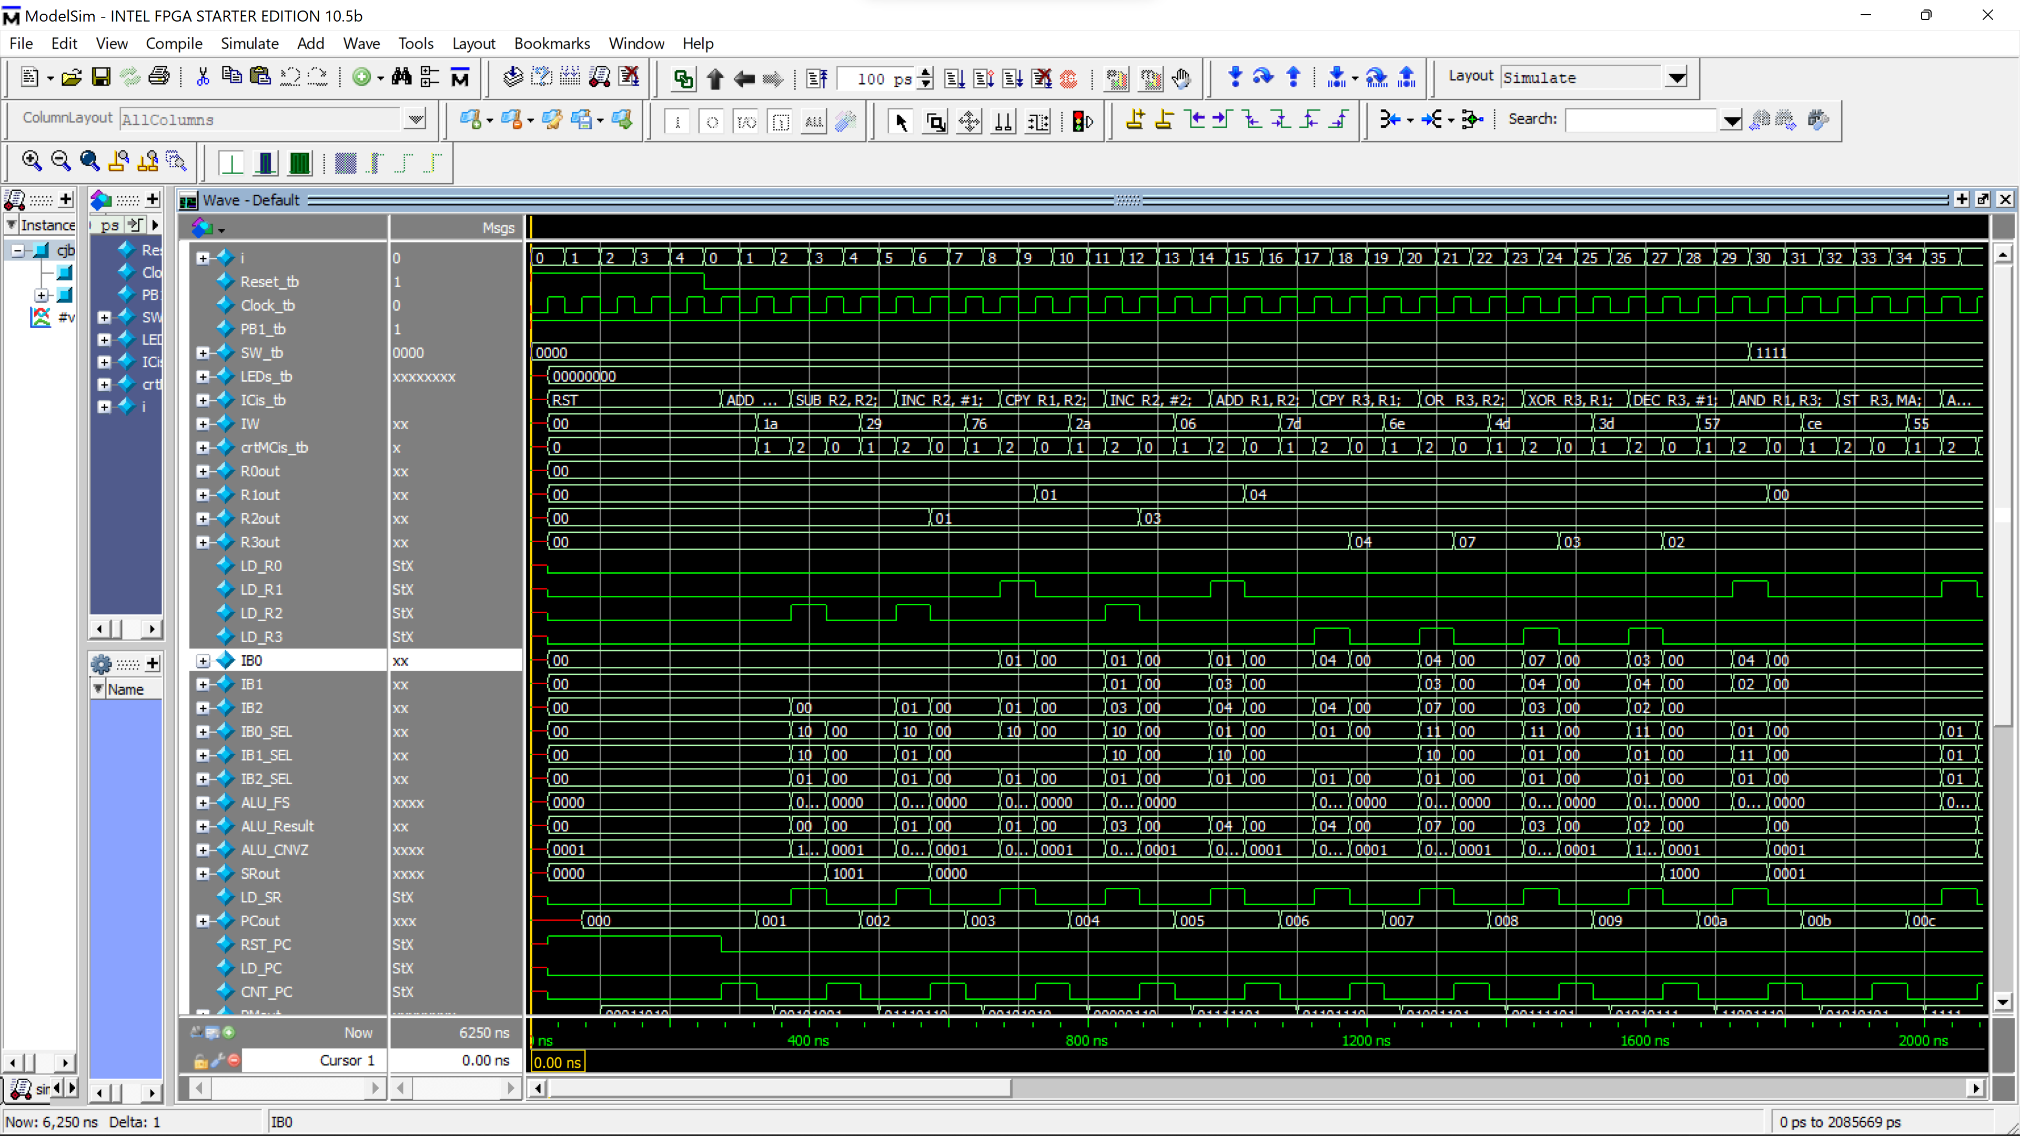
Fig.1: cjbRISC simulation with Program 1, and IC to ASCII module enabled.

Fig.2: ASM Chart
Fig. 3: cjbRISC Data Path Schematic

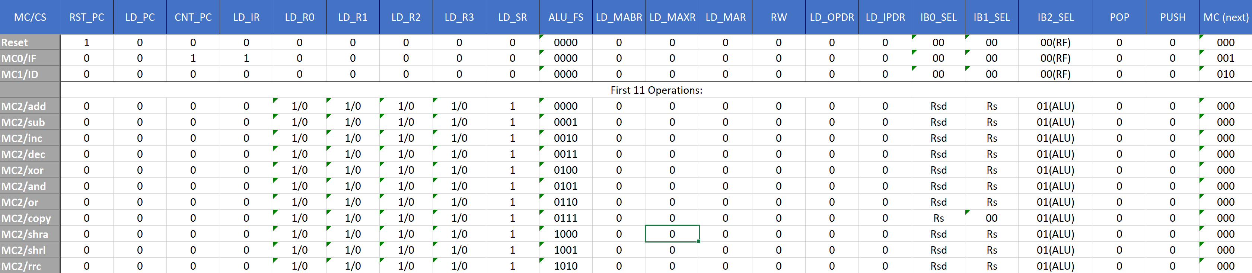
Fig. 4: Control Signals Table for functions relevant to this lab.

