Chris Biancone
11-03-2021
EEEE-220-L2
Lab 9: cjbRISC

Assignment Description:
This lab involved implementing the last 5 functions for our own architecture of a RISC processor in the VLSI language of our choice. Based on my IDN, I had to implement a 3-bus Harvard RISC with Memory-Mapped I/O-Ps. Thus, this design does not need registers before the inputs to the ALU, as the two internal data busses can be used to load the input data in one machine cycle. The third writeback bus provides the means of bringing data to the outputs, hardware stack, and back to the registers. The last 5 functions to be implemented were Store, Load, Jump, and Push and Pop since I have a 4-location hardware stack.

Solution Plan:
I began by uncommenting the parts of the control unit I had commented out for Lab 8 to reduce the complexity. I checked over the signals in the control unit with the ASM chart and Control Signals Table, changing a couple things that I needed to. After making sure the Data Path Verilog files were correct, I compiled, and it seemed that only Store was not working. On closer inspection, it appeared that the “if” statements in the Load and Store instructions were evaluating based on the MAR output from the previous machine cycle. I verified this by flipping the greater-than signs to less-than and checking the functionality. The only thing that solved this issue, since everything else was functioning as it should be, was also flipping the clock input to the MAR, so it and the DM are running on the inverse clock. This allowed the if statement to evaluate correctly for both operations and produce a LD_OPDR signal on the second store operation.

Work Done:
I was able to fully complete this lab, verify the simulation against the provided waveform, and implement the architecture on the FPGA after creating a top-level emulation Verilog file.

Problems Remaining to be Solved:
N/A.

Images & Tables:
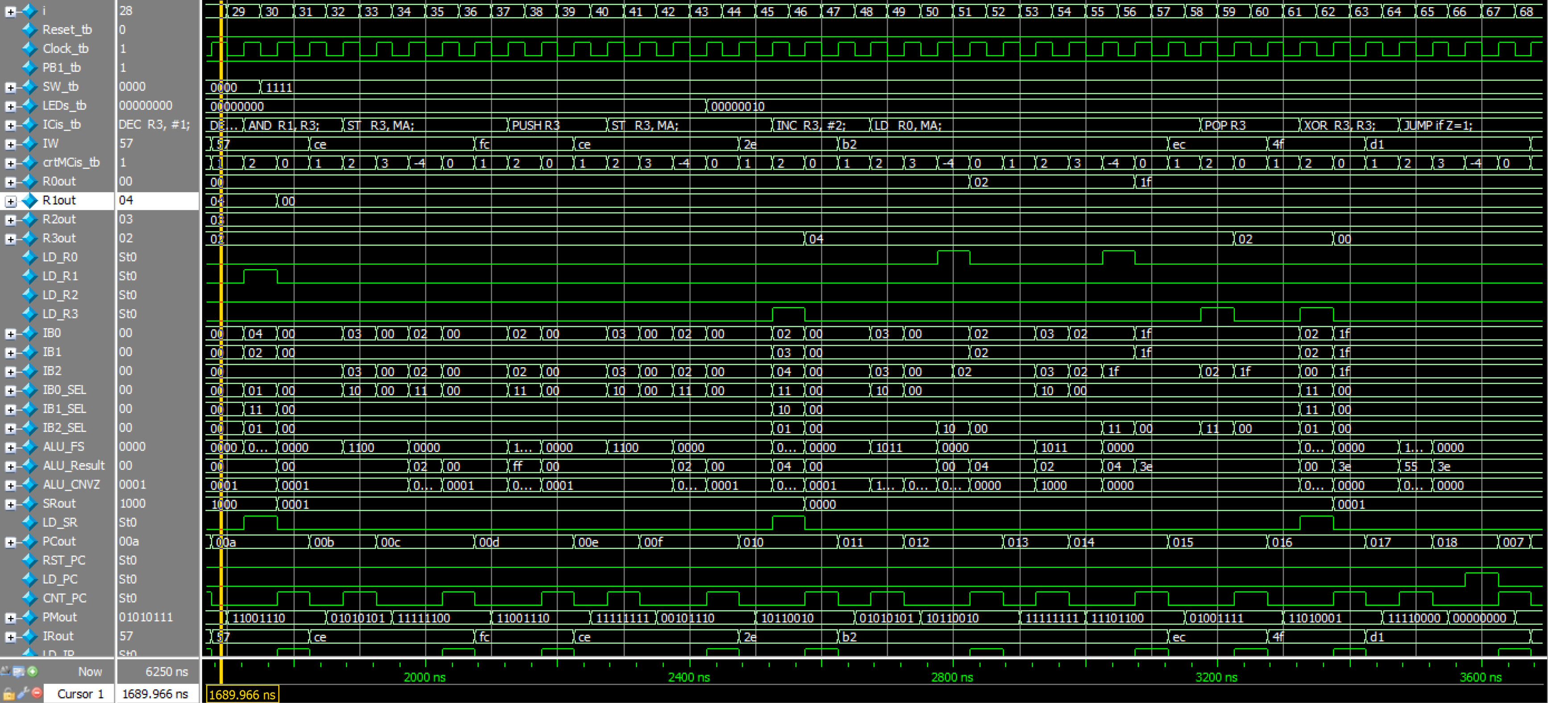
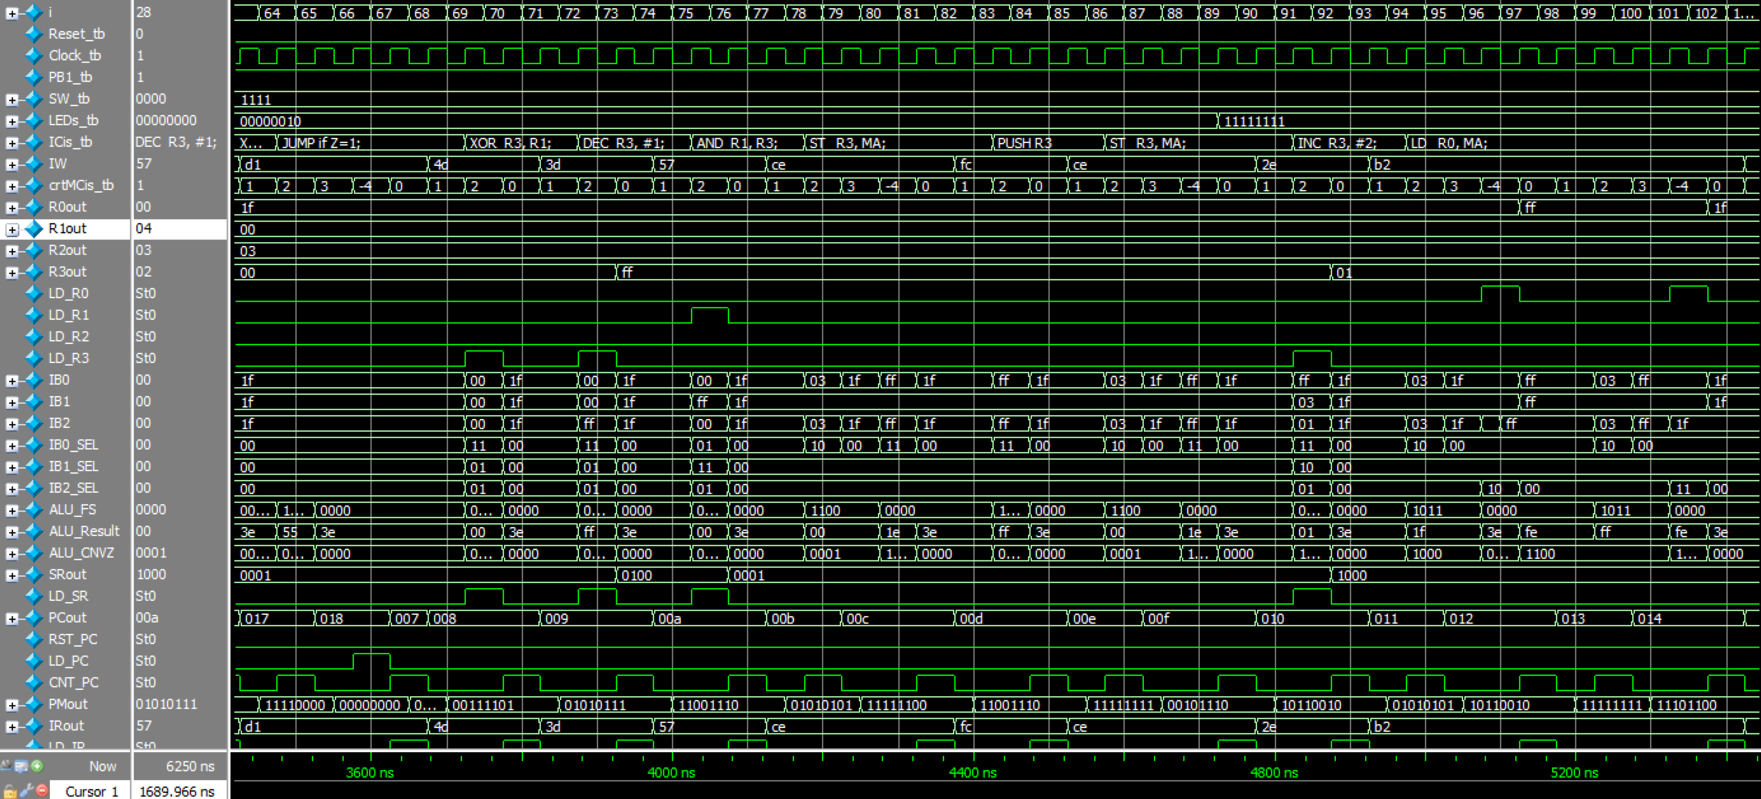
Fig.1: cjbRISC simulation of new functions with Program 1, and IC to ASCII module enabled.

Fig.2: Updated ASM Chart with simplified LD & ST

Fig. 3: cjbRISC Data Path Schematic updated with inverse clock signals

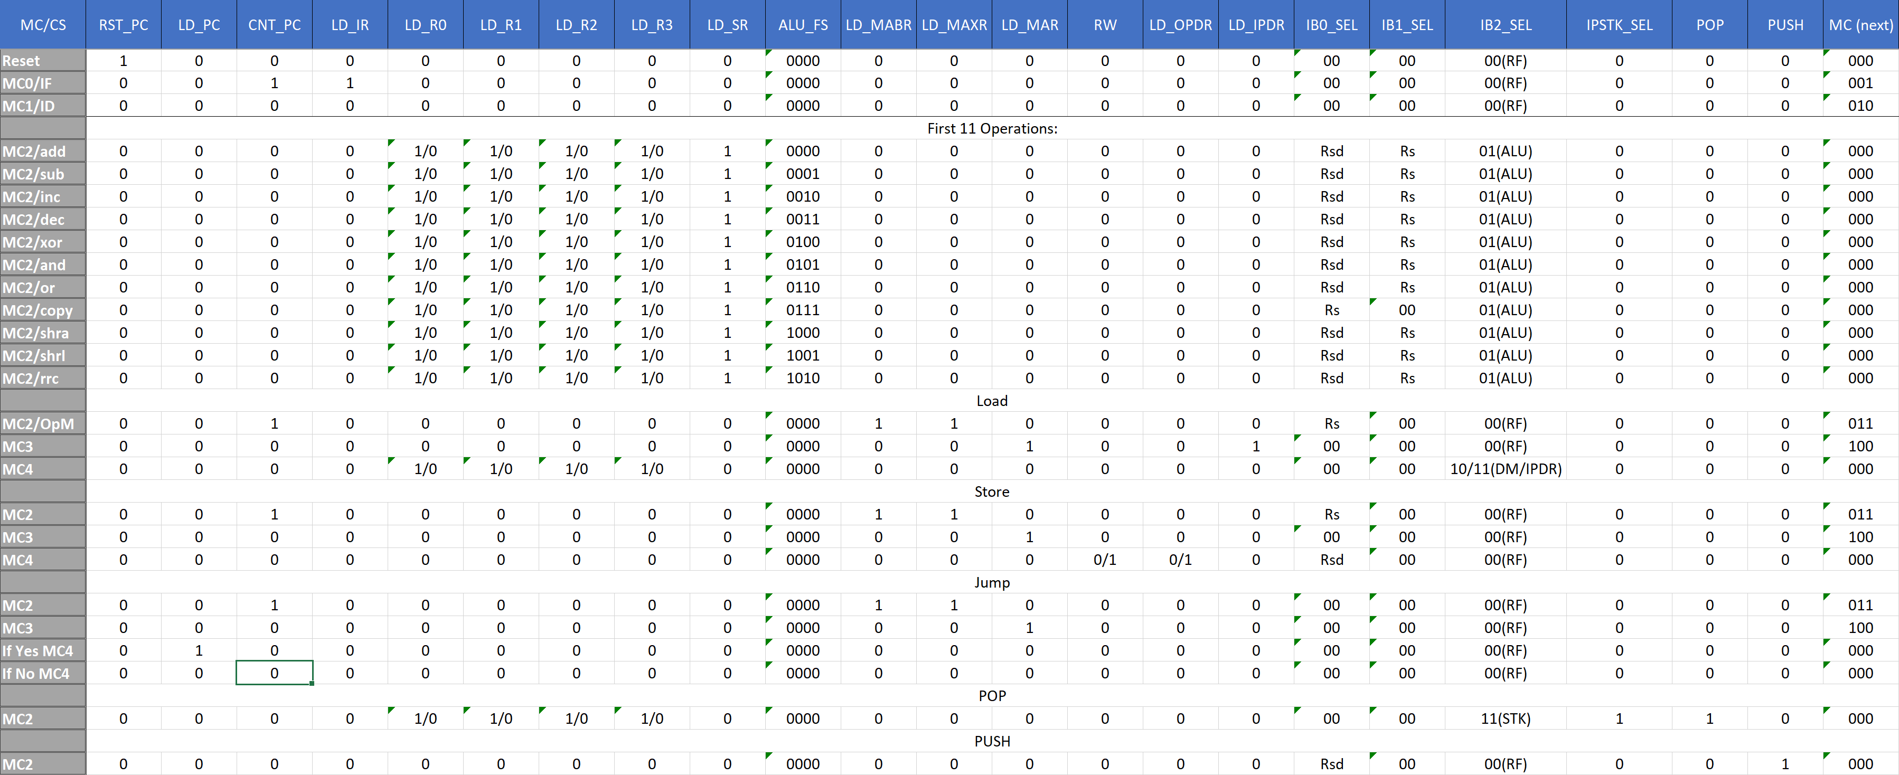
Fig. 4: Full Control Signals Table

