The Structured Query Language and Spark SQL

* What is Apache Spark
  + Scalable, efficient analysis of big data
* The Big Data Problem
  + Data growing faster than CPU speeds
  + Data growing faster than per-machine storage
* The opportunity
  + Cloud computing is game changer
  + Provides access to low-cost computing and storage
  + Costs decreasing every year
  + The challenge is programming the resources

**Cluster Computing Challenges and the Map reduce Programming Paradigm**

* What makes apache spark scalable
* Hardware for Big Data
  + Consumer-grade hardware
  + Easy to add capacity cheaper
  + But, requires complexity in software
* Problems with cheap hardware
  + Failures
  + Network
    - Much more latency
    - Network slower than storage
  + Uneven performance
* What’s hard about cluster computing
  + How do we split work across machine
    - Hash Table
      * Each time we see a word look up word in the table if it appears increment by one or add word to the dictionary
    - If document is big run partitions or shards and run on multiple machines
      * Then aggregate the machines to a final machine
      * The problem is that all the results have to fit on one machine
      * Alternative is using map reduce
  + Map Reduce for sorting
    - What word is used the most
    - Example – all words that are less than x go to the first machine
* How do we deal with failures
  + Start another task
* How to deal with slow tasks
  + Terminate and start another task

**Apache Spark: Technology Trends, Opportunity, and Advantages**

* Datacenter Organization
  + Node placed in rack interconnect with top of rack switches which are interconnected to other top of rack switches
* Map Reduce: Distributed Execution
  + Each stage passes through harddrive
* Map Reduce: Iterative Jobs
  + Iterative jobs involves a lot of disk I/O for each repetition
* Apache Spark Motivation
  + Use map reduce for complex jobs, interactive queries and online processing involves lots of disk I/O
    - Interactive mining
      * Reading from the disk for each query
    - Stream processing
      * Reading from the disk for each job
* Use Memory instead of disk
  + Each iteration read from disk and writing from disk
* Spark and Map Reduce Differences

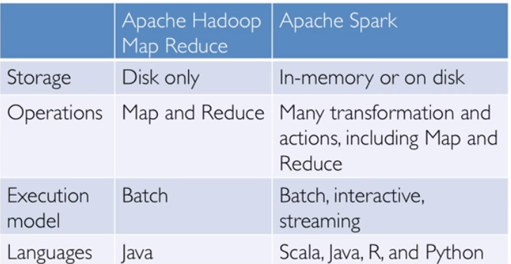

* Other Spark and Map Reduce Differences
  + Generalized Patterns for computation
  + Lazy evaluation of lineage graph
    - Can optimize, reduce wait states, pipeline
* In memory operation
* Spark performance optimizations
  + Catalyst optimization engine
    - Reduction in execution time
  + Project Tungsten off-heap memory management
    - 75% reduction in memory usage
* Catalyst: Shared Optimization and Execution
* Java Virtual Machine Object Overhead
  + “abcd”
    - native 4 bytes
    - java 48 bytes
* Project Tungsten’s Compact Encoding

**Structured Data and the Structured Query Language**

* Review: Key Data Management Concepts
  + A data model is a collection of concepts for describing data
  + A schema is a description of a particular collection of data, using a given data model
  + A relational data model is the most used data model
    - Relation, a table with rows and columns
    - Every relation has a schema defining fields in columns
* Relational database
  + Relational database: a set of relations
  + Two parts to a Relation
    - Schema: specifies name of relation, plus each column’s name and type
    - Instance: the actual data at a given time
      * #rows = cardinality
      * #fields = degree
* What is a database
  + Large organized collection of data
    - Transactions used to modify data
  + Models real word
    - Entities
    - Relationships
* SQL – A language for Relational DBs
  + SQL = Structured Query Language
  + Supported by Spark DataFrames (SparkSQL)
  + Some of the functionality SQL provides
    - Create, modify, delete relations
    - Add, modify, remove tuples
    - Specify queries to find tuples matching criteria
* Queries in SQL
  + Single-table queries are straightforward
  + To find all 18 year old students, we can write:
  + To find just names and logins
    - SELECT S.name, S.login
    - FROM Stduents S
    - WHERE S.age = 18
* Querying Multiple Relations
* Cross Join
  + Cartesian product of two tables (ExS)
* Where Clause
  + Choose matching rows using where clause
    - S.sid = E.sid
* Select Clause
  + Use the filtering
    - S.name, E.cid
* Equivalent SQL Join Notations
  + Explicit Join notation (preferred)
    - SELECT S.name, E.classid
    - FROM Students S INNER JOIN Enrolled E on S.sid=E.sid
    - FROM Students JOIN Enrolled E on S.sid=E.sid
  + Implicit join notation (deprecated)
    - SELECT S.name, E.cid
    - FROM Students S, Enrolled E
    - WHERE S.sid = E.sid
* SQL Types of Joins
  + Unmatched keys with inner join just drop the rows
* SQL Joins: Left Outer Join
  + Unmatched row appears in the results with a NULL value
* SQL Joins: Right Outer Join
  + Unmatched row appears in the results with a NULL value for the matching id

Spark SQL and Spark DataFrames

* Spark Joins
  + SparkSQL and Spark DataFrames support joins
  + Join(other, on, how)
    - Other – right side of the join
    - On –join column name, list of column (names), or join expression
    - how – inner, outer, left, right_outer, left_semi
* Spark Join Examples
  + Inner Join – X.join(Y,cols)
    - Return DF of rows with matching cols in both X and Y