Cece Geisler
CSD 325
Assignment 2.2
12/14/25

I decided to debug my assignment from last week. Here are the results:
- Breakpoint:
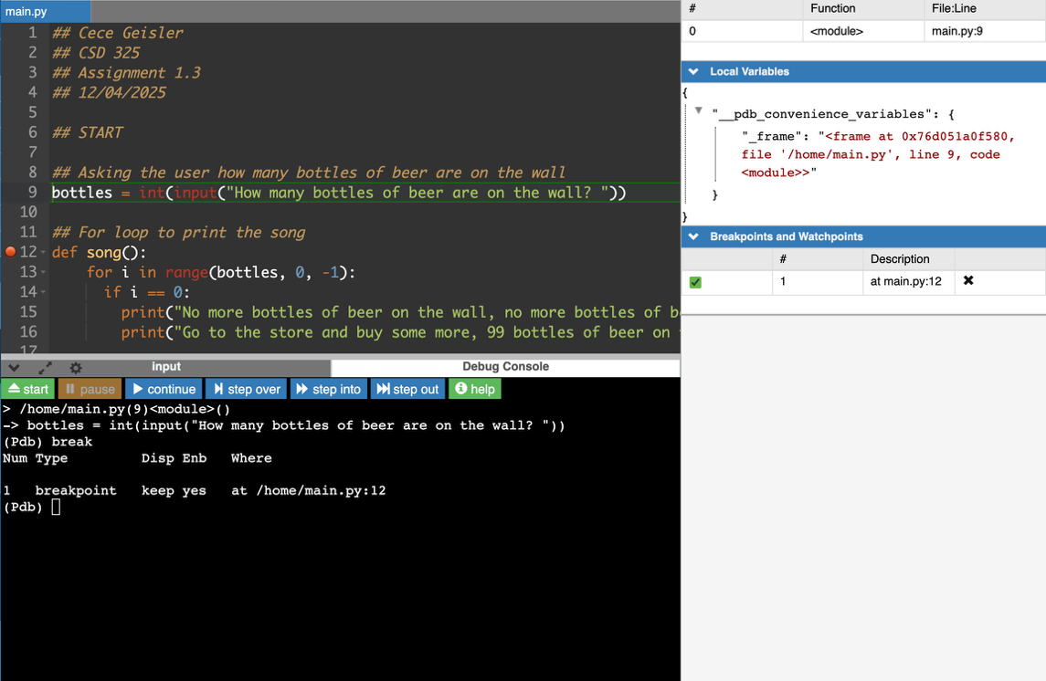
- Stepping in:
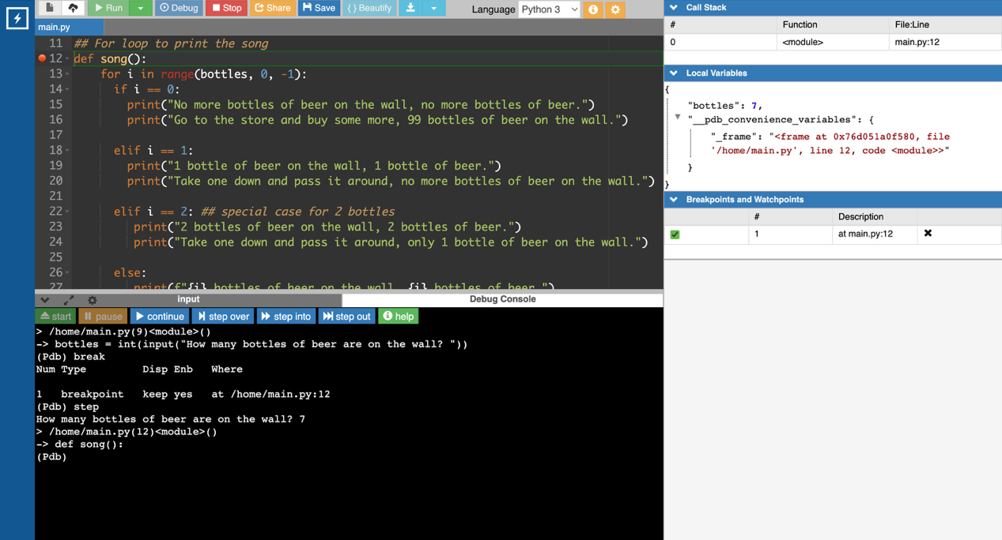
- Stepping over:
