Cece Geisler
CSD 325
M4.2 Assignment
January 14, 2026

Initial Flowchart
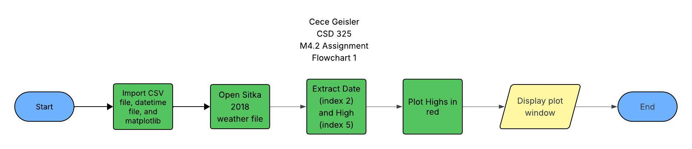

Revised Flowchart
