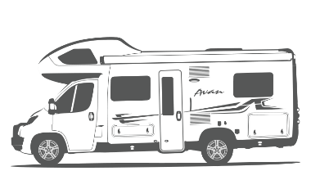

LILLEN CHECKLISTS

AND GUIDES

Contents

Checklists 2

Pre-Departure 2

On Arrival 3

Pre-Return 4

Bad Weather 4

Guides 5

Battery and Water Control Panel 5

Hot Water Heater Controls 6

Electric 6

Gas 6

Diesel Heater Control 6

Electric Bed 7

Step 1 - House Power Enabled 7

Step 2 - Electrical Cable Connectors 7

Step 3 - Fuse Box 7

Manual Operation 7

15A to 10A Power Adaptor 7

Nitrogen Tyre Inflation 8

# Checklists

## Pre-Departure

Ensure that the rooftop tv antenna is retracted and secured

Ensure awning is retracted and secured properly

Ensure sunroof hatch is closed. Including in the bathroom

Ensure bike rack is secure

Ensure that Button 1-4 on the *Battery and Water Control Panel* are off

Ensure that the hot water heater is off

*Buttons are located on the left-hand side back lounge area*

Ensure that the diesel heater is off *if applicable*

*Dial is located on the left-hand side back lounge area*

Disconnect 240v electricity *if applicable*

Disconnect city water *if applicable*

Disconnect greywater *if applicable*

Ensure LPG gas bottles are turned off

Ensure that the windows are securely closed and locked

Ensure that the TV is locked away and secured

Ensure that the bunk bed safety net is connected

Ensure everything in the kitchen has been put away and is rattle-proof

Secure all drawers and doors

Secure all loose objects for travel

Ensure the table is in travel position

Start the engine for warm up

Ensure that the refrigerator (in auto mode) has shifted back 12v

## On Arrival

Select as flat and level a parking site as possible. Use leveling blocks if required.

Connect 240v electricity *if applicable*

Connect city water *if applicable*

Connect greywater *if applicable*

Ensure LPG gas bottle is open

Turn on button 1-3 on the *Battery and Water Control Panel*

Turn the water pump on, if not connected to city water  
*Button 4 on the Battery and Water Control Panel*

Turn the hot water heater on using either 240v or LPG gas.

Ensure the refrigerator (in auto mode) switch to either 240v or LPG gas.

If using LPG gas, turn the refrigerator fan on.

**Please note!** If using LPG gas, it can take up **20 minutes** before the fridge turns on.

The refrigerator must be level and will not operate if not parked on a flat surface.

## Pre-Return

Full Tank of Diesel

Empty Toilet Cassette

Empty Greywater Tank

Interior Neat and Tidy

## Bad Weather

Before bad weather arises, please ensure the following:

Ensure awning is packed away

Ensure sunroof hatch is closed. Including in the bathroom

Ensure external storage hatches are closed

**Important!** Do not leave awning out overnight or unattended.

# Guides

## Battery and Water Control Panel

The Battery and Water Control Panel is located near the main door. As a rule of thumb, while stationary button 1-4 should be switched ON.

**Important!** All buttons must be switched **OFF** while driving.

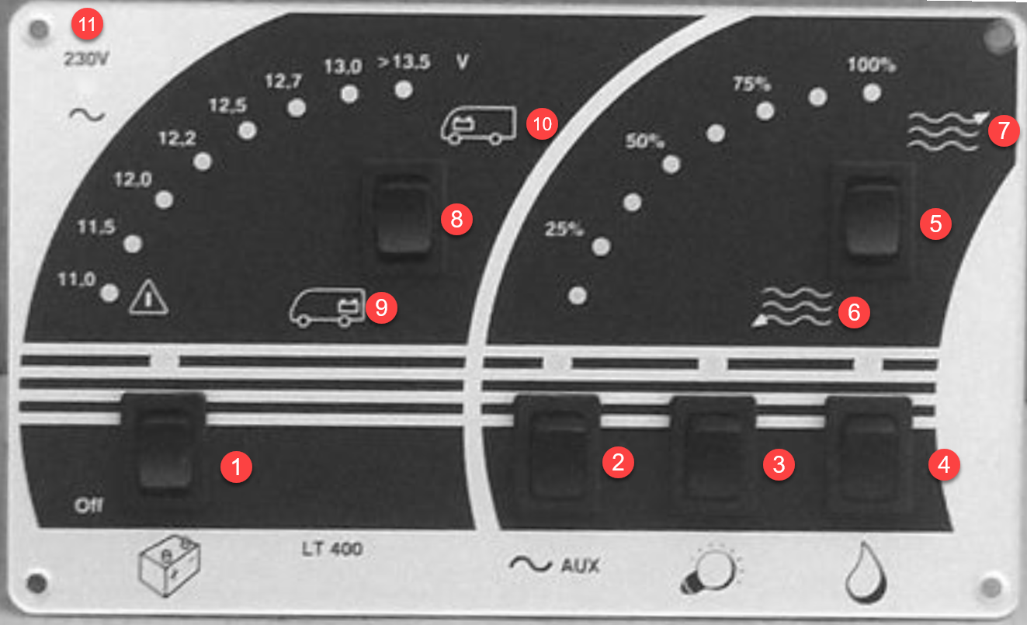

#### LEGEND

1. Main battery button
2. Turns on auxiliary power. (*Required for the powering the Bed, TV etc)*
3. Enables the lighting
4. Turns on the water pump *(Not required if connected to city water)*
5. Checks the water tank levels
6. Greywater tank
7. Fresh water tank
8. Check the 12v battery power levels
9. The house battery
10. The car battery
11. Light indicating that external 240v electricity is operational

## Hot Water Heater Controls

The hot water controls are located at the back of the motorhome on the left side next to the diesel heater control.

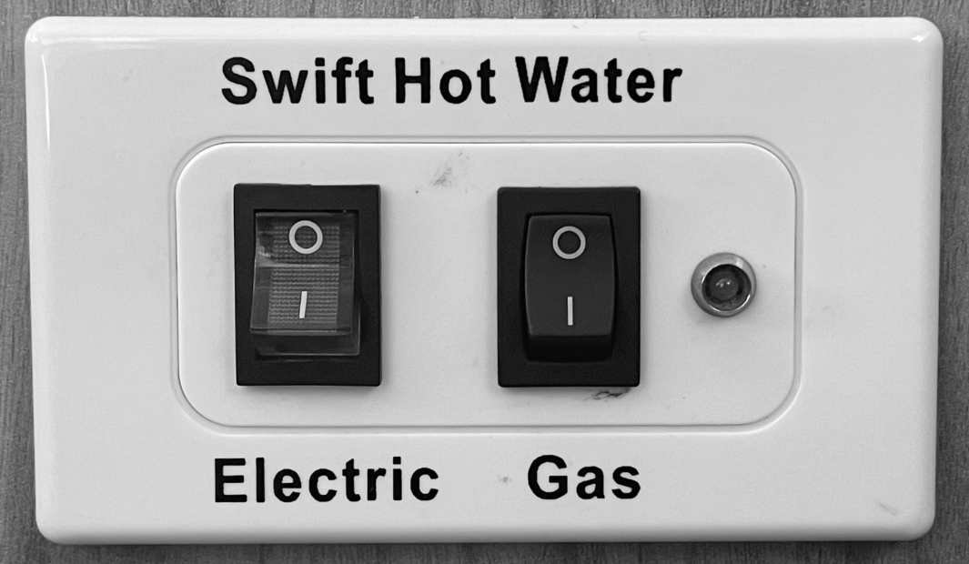

### Electric

When connected to 240v external power use the left electric button. The whole button is lit when the hot water heater is operating on 240v.

### Gas

If no access to external power, then use the right Gas button. The light to the right of the button indicates that the hot water heater is operating on LPG Gas.

## Diesel Heater Control

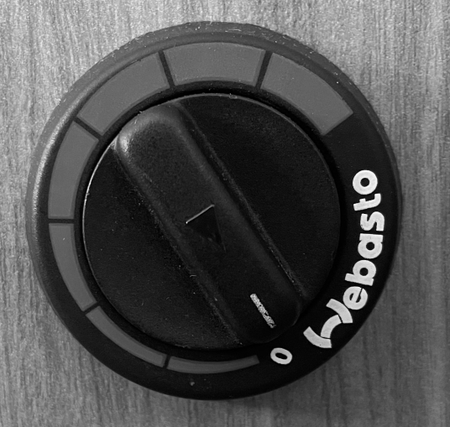Lillen is equipped with a diesel heater for those cold winter months. It is using the same diesel fuel tank as the Fiat engine.

The diesel heater control is a dial that is located at the back of the motorhome on the left side next to the hot water heater controls.

To turn the heater on, simply turn the dial anti clockwise to the desired level.

Hot air will then blow out from under the wardrobe.

## Electric Bed

In the unfortunate event that the bed has stopped working please follow these 3 steps.

### Step 1 - House Power Enabled

First check that button 1 and 2 on the *Battery and Water Control Panel* are turned on.

### Step 2 - Electrical Cable Connectors

Second , check that the electrical cables that hang down on the inside of the storage hatch on the left rear side are properly connected. It’s easy to accidentally knock them out when removing the camping chairs and other large objects.

### Step 3 - Fuse Box

If the cables are properly connected, the next place to check is the fuse box that is located under the passenger couch behind the driver seat. There is a Spare Fuses Kit inside the storage hatch at the rear on the right side (where the water hoses are stored).

### Manual Operation

According to the electric bed manual, there is an option for manual operation of the bed. It is a two-man job and it seem to be a complicated procedure.

**Important!** Do not attempt manual operation without first contacting the owner or Camplify support.

## 15A to 10A Power Adaptor

Lillen comes equipped with a weatherproof 15A to 10A power adaptor. It safely and legally connects the 15A power cable to 10A power point.

Generally, if you book a powered site at a caravan park it will be equipped with a 15A power point.

However, if you are taking Lillen to stay at someones property they might only have 10A power points.

## Nitrogen Tyre Inflation

Lillen's tyres have been inflated with nitrogen for increased tyre performance and better fuel economy.

This is identified by the red coloured valve cap.

If a top up is required and you are unable to find a workshop that offers nitrogen, air can be used but let the owner know upon return of the vehicle as the tyre will need to be fully deflated and refilled with nitrogen.