**Application has been deployed into following location**

UI : <http://localhost/pm/>

Api: <http://localhost/ProjectManagerApi/swagger>

**Source Repo**

<http://172.18.2.18/hariharasudhan.c/ProjectManager-Service>

<http://172.18.2.18/hariharasudhan.c/ProjectManager-Web>

you can call view the source on the cloud labs

C:\195500-Hari\ProjectManager-Service

C:\195500-Hari\ProjectManager-Web

**Build & coverage Reports**

C:\195500-Hari\Jenkins-Builds

**Steps to run the application**

* DB scripts are available in “DbScripts” folder under Service package
* Open the service solution “ProjectManager.sln” in Visual studio
* Build & Run
* You could validate the API via Swagger as well eg: “<http://localhost:62438/swagger>”
* Open the Web solution in Visual studio code
* Run “npm start” in terminal

**API (Swagger Page)**

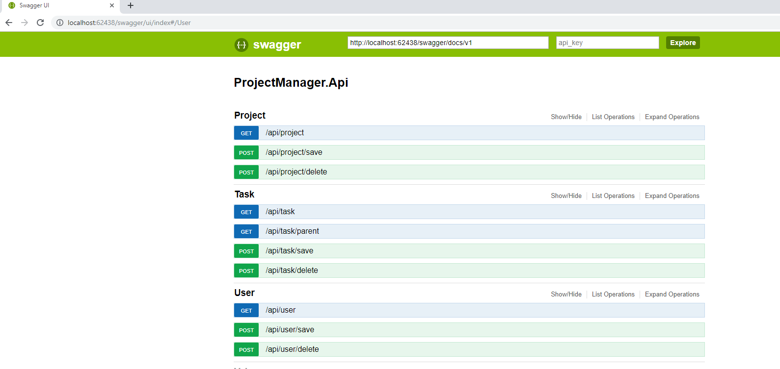

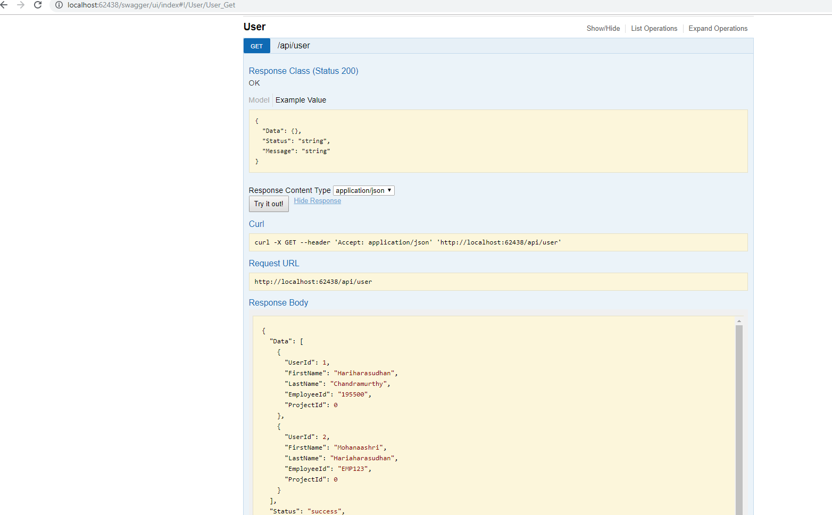

**UI**

**Add / View User**

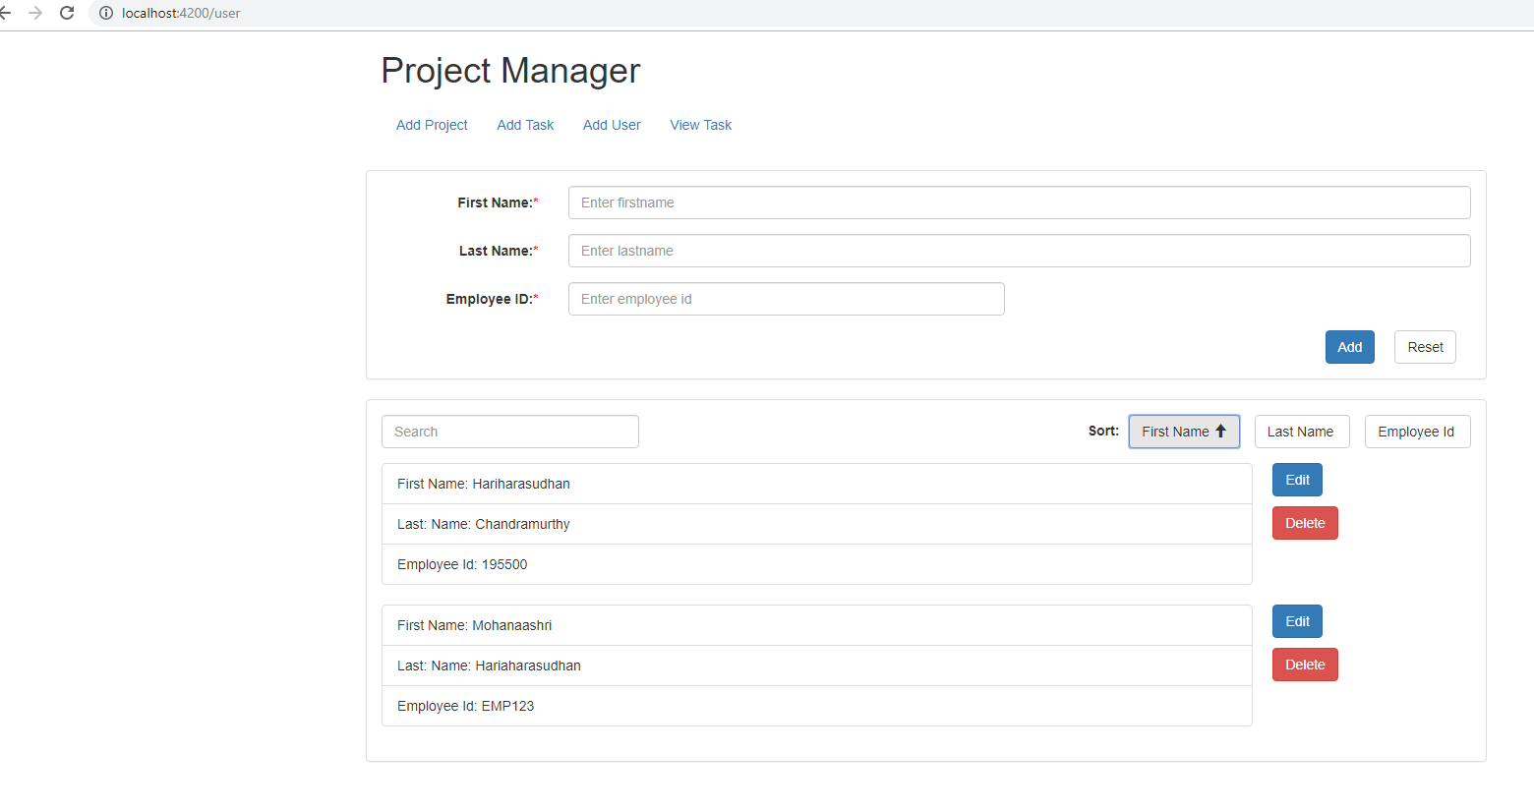

**Add / View Project**

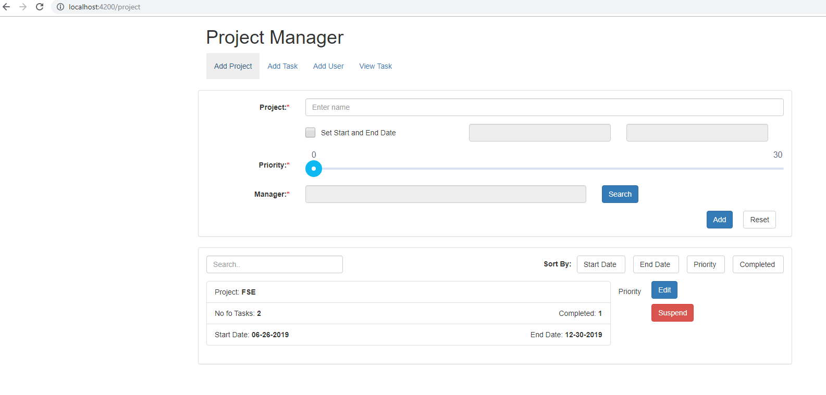

**Add Task**

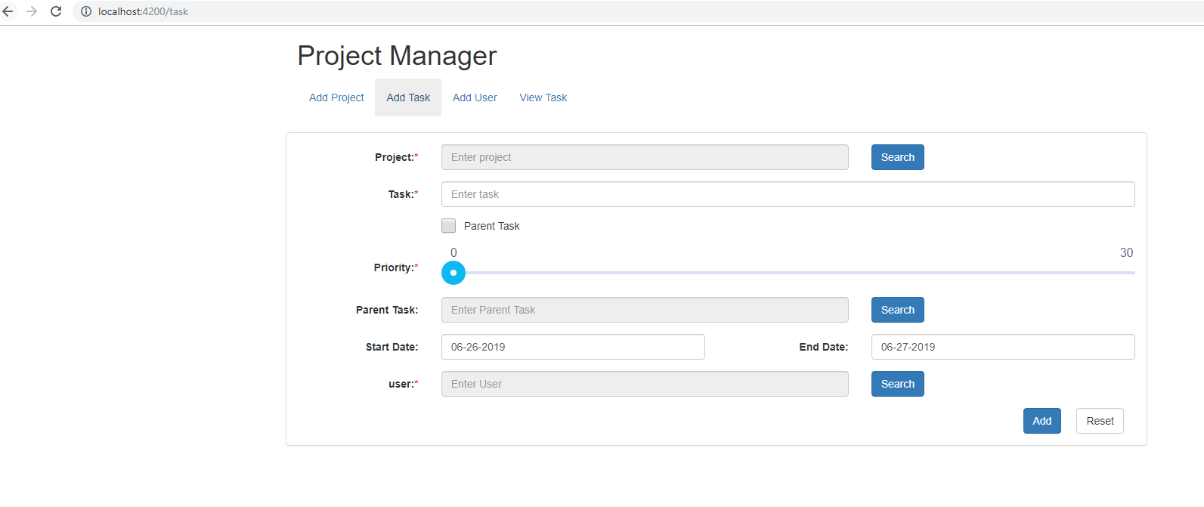

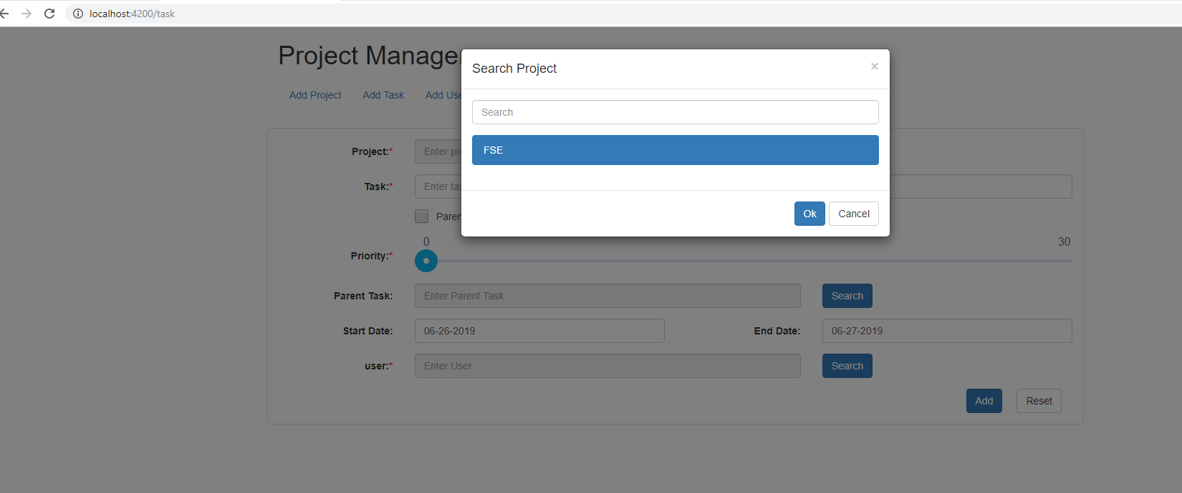

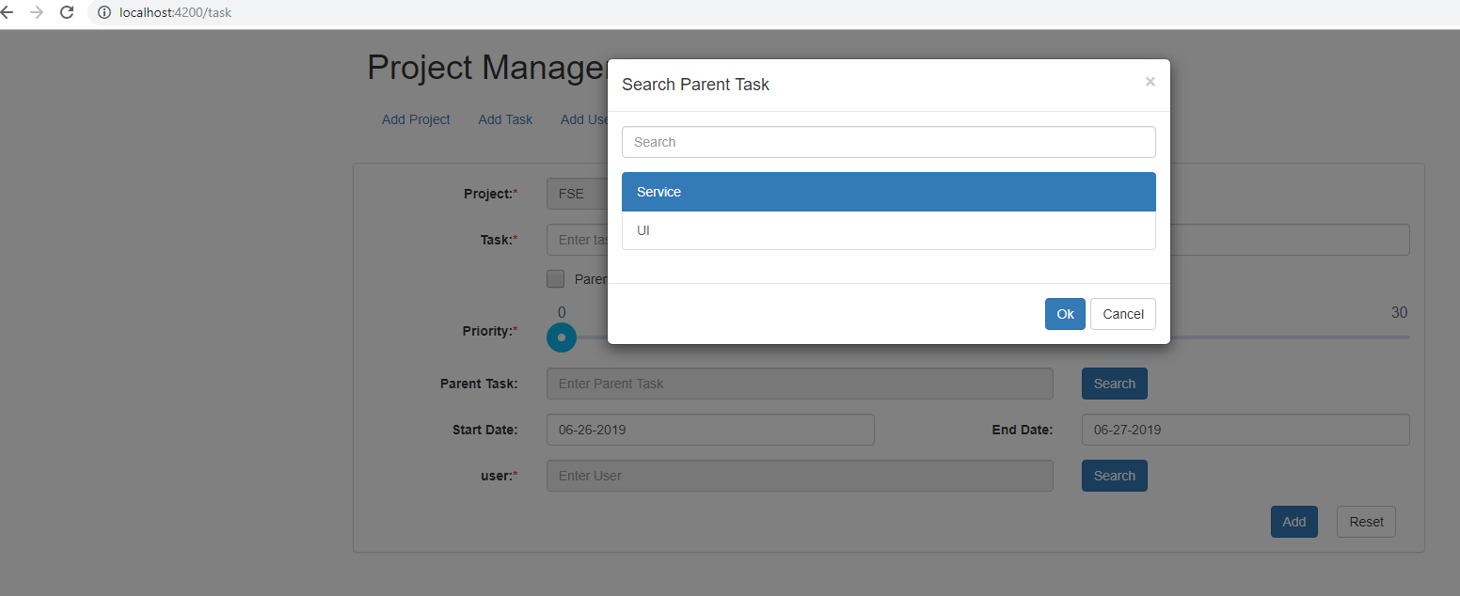

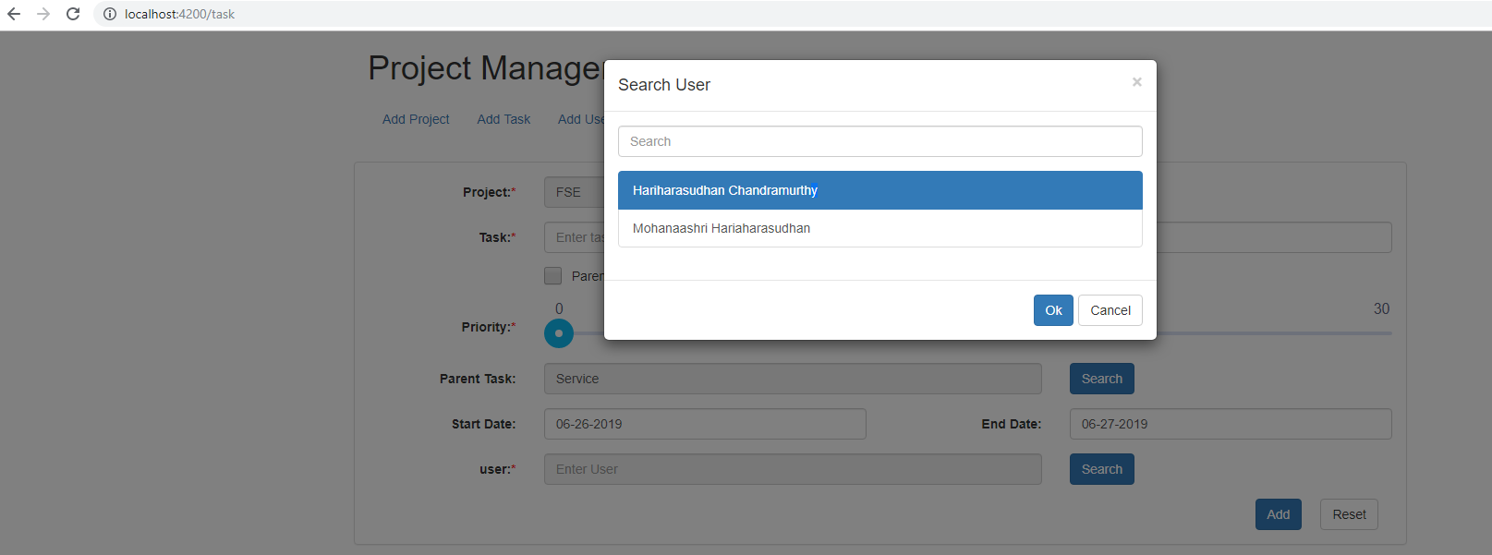

**View Task**

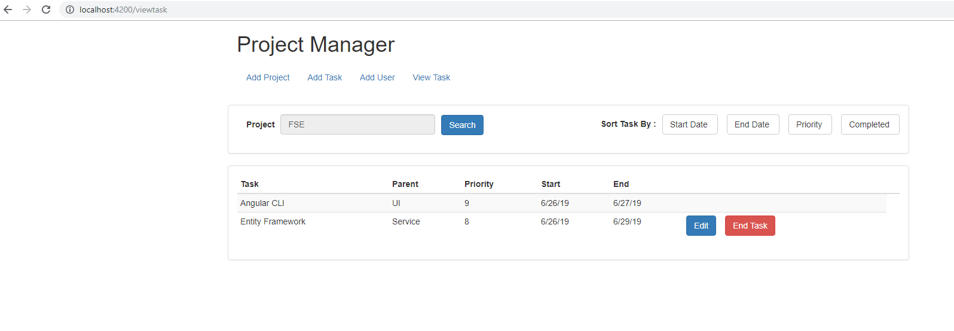

**Jenkins**

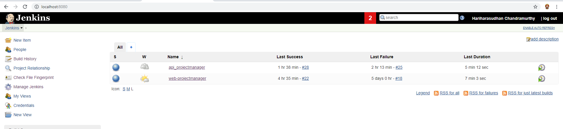

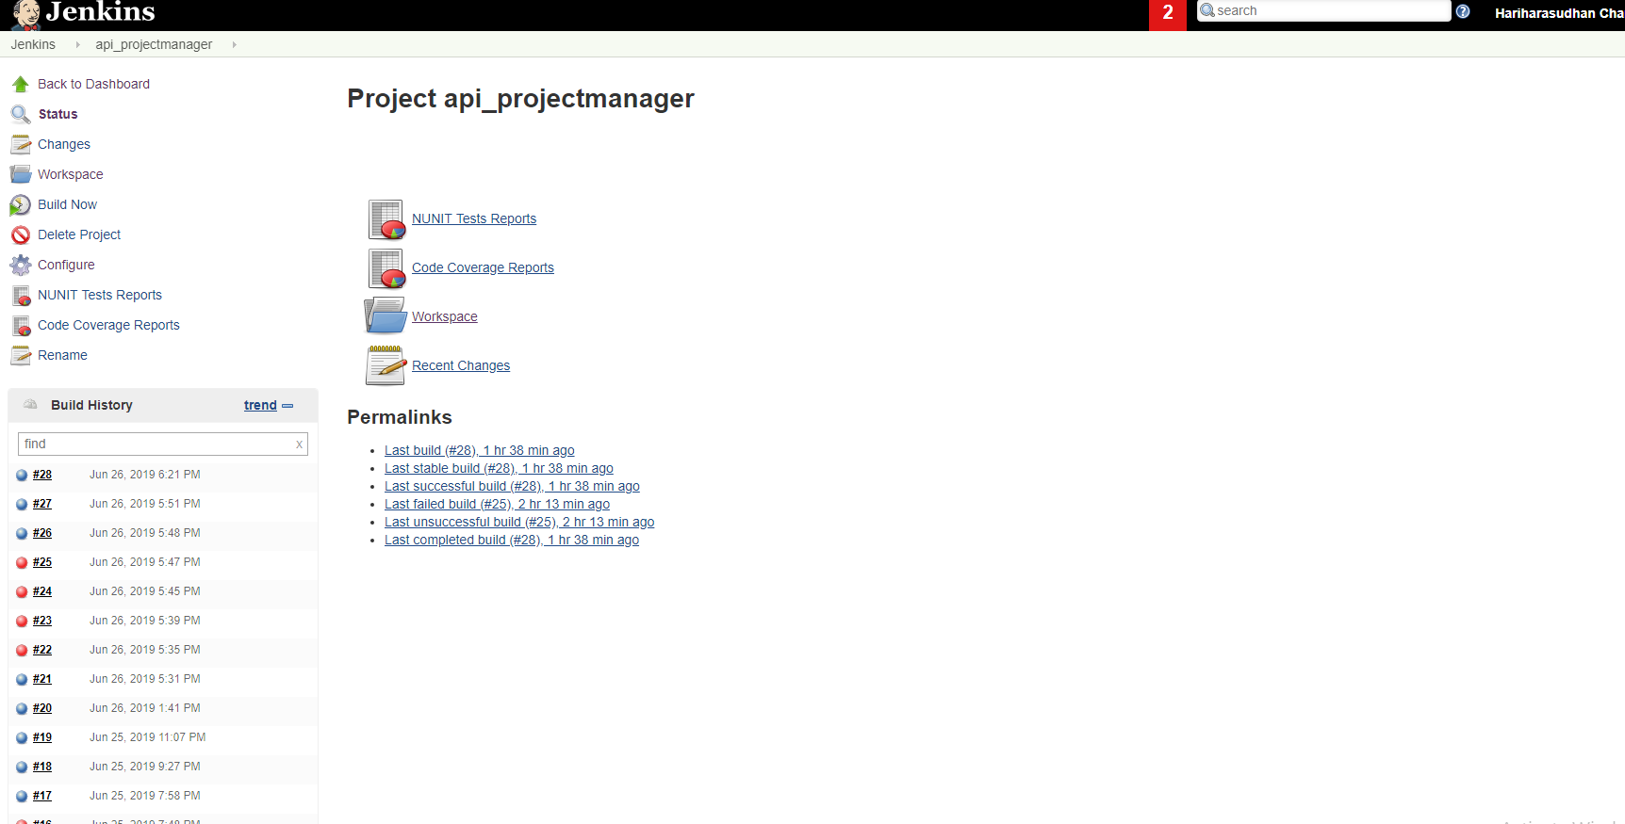

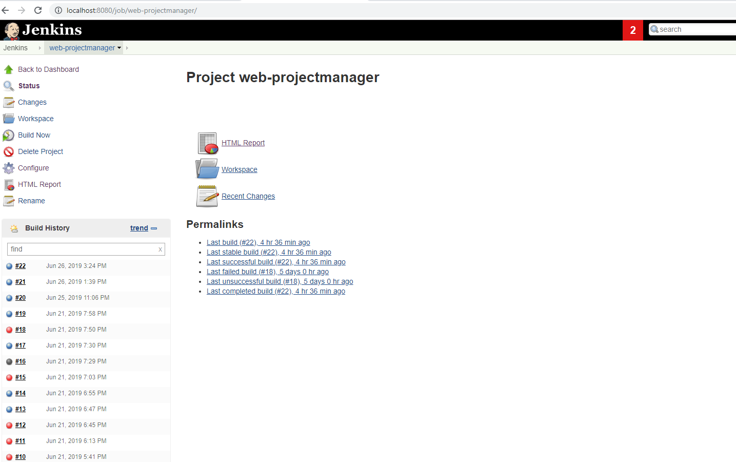

**Test / Coverage Reports**

