**Database Project (Fall 2023)**

**Homework #10 (50pts, Due date: Dec 6)**

**Student ID**: 2020315798

**Student Name**: Choi Jin Woo

**Instruction:** In this homework, we provide a jupyter notebook file (DBP_Homework10.ipynb). You should follow the instructions in these documents. Only the provided code's ‘*EDIT HERE*’ sections must be edited. You must *DELETE* your *GOOGLE_API_KEY* before submitting.

**Submission Guide:** Submit two files as follows:

-DBP_Homwork10_StudentID.zip

- DBP_Homwork10_StudentID.ipynb

- DBP_Homwork10_StudentID.pdf

**1. [20pts]** **You want to provide a Question Answering service based on Retrieval-Augmented Generation (RAG) for a given webpage. To raise the satisfaction of users, you have to do prompt engineering.** Prompt engineering is to make an optimal prompt for a given task.

So, you should implement the RAG pipeline as given parameters.

|  |
| --- |
| **Parameters** |
| Splitter: RecursiveCharacterTextSplitter  Chunk size for splitter: 800  Chunk overlap size for splitter: 100  Vector store: Chromadb  Embedding for vector store: GooglePalmEmbeddings  Retriever: Same as vector store  Retriever search type: similarity  Retriever search kwargs k: 6 |

Next, you should do prompt engineering for the given query string *“What is Task Decomposition?”*. **You should apply three prompts to the RAG pipeline: two prompts from Langchain hub (**[**https://smith.langchain.com/hub**](https://smith.langchain.com/hub)**) and one prompt on your own.**

1. Langchian hub - rlm/rag-prompt

**[Answer]**

Enter your code and result here. You must show your result (captured image or string).

|  |
| --- |
|  |

1. Langchain hub – gregkamradt/test-question-making

**[Answer]**

Enter your code and result here. You must show your result (captured image or string).

|  |
| --- |
|  |

1. Create a new prompt to help your QA service.

**[Answer]**

Enter your code and result here. You must show your result (captured image or string).

|  |
| --- |
|  |

**2. [30pts]** **Implement a RAG multiple chain pipeline.** The purpose of this pipeline is to find information about stakeholders for a given project. **The pipeline contains five chains.** The details of the chains are shown in the below figure.

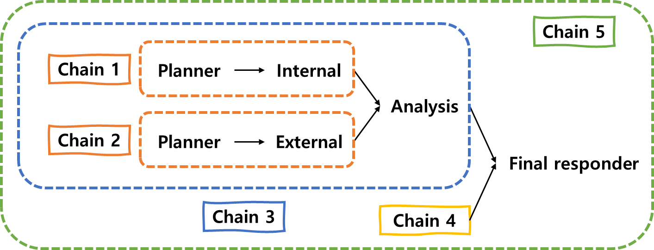

The implementation parameters are same as question 1 in text_splitter, vectorstore, retriever, llm variables. The prompts for planner, internal and external are in the given ipynb file. You can use from_tempate() method for them. But you have to use from_messages() method for analysis and final_responder. The specific messages are shown in the table below.

|  |  |
| --- | --- |
| analysis | ("system", "Generate a stakeholder analysis map for a given project."),  ("human", "The details of a given project is following: {result3}"),  ("ai", "Internal stakeholders:\n{result1}\n\nExternal stakeholders:\n{result2}") |
| final_responder | ("system", "Generate a final response given the information."),  ("ai", "{a_response}"),  ("human", "Common pitfalls:\n{a_pitfalls}") |

**Read the given ipynb file carefully and write all your codes and results here.**

**[Answer]**

Enter your code and result here. You must show your result (captured image or string).

|  |
| --- |
|  |