ENSF-381: Full Stack Web Development Laboratory
Lab04

GitHub Link:
https://github.com/c-khoo/ENSF381-lab04.git

Group Information:
Chloe Khoo (30247640)
Nayha Rehman (30250126)

Exercise 1:

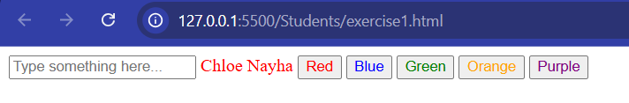

Exercise 2:

Screenshot from Step 9:
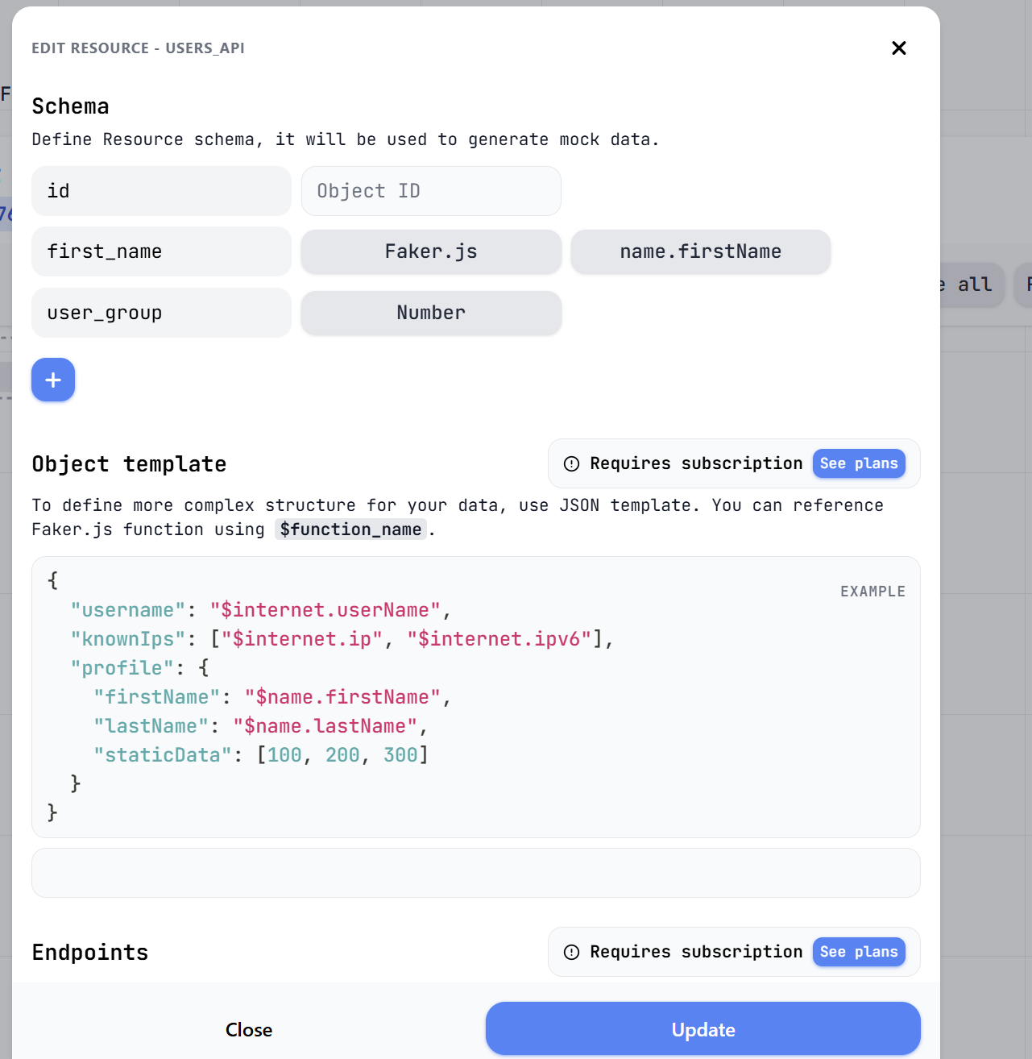

Screenshot from Step 12:
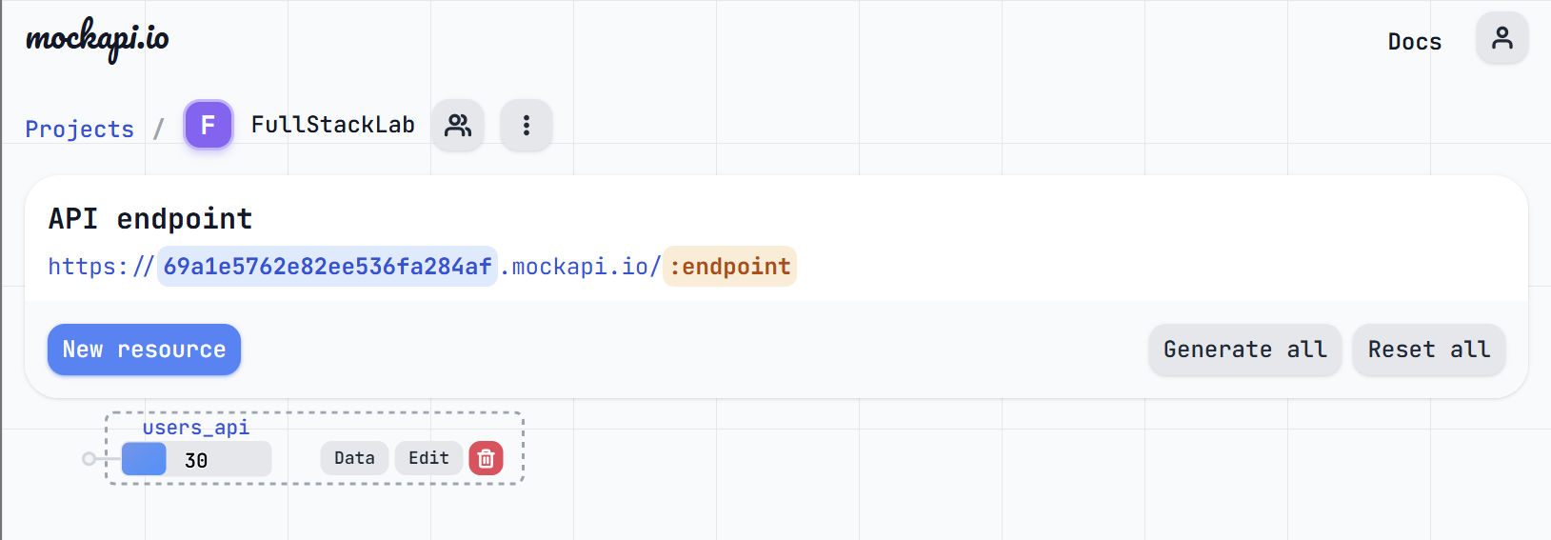

Screenshot from Step 14:
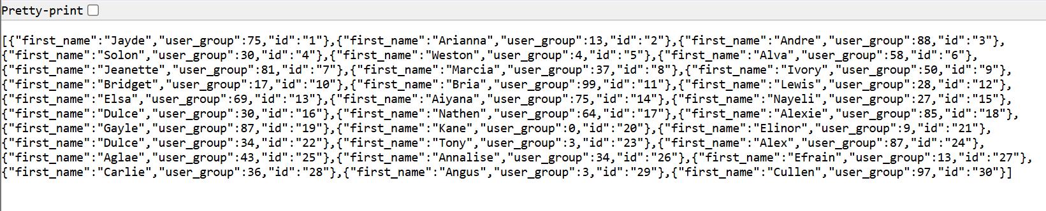

Exercise 3:
*NOTE: Screenshots were taken AFTER all steps were completed and testing data deletion was done.

Screenshot A:
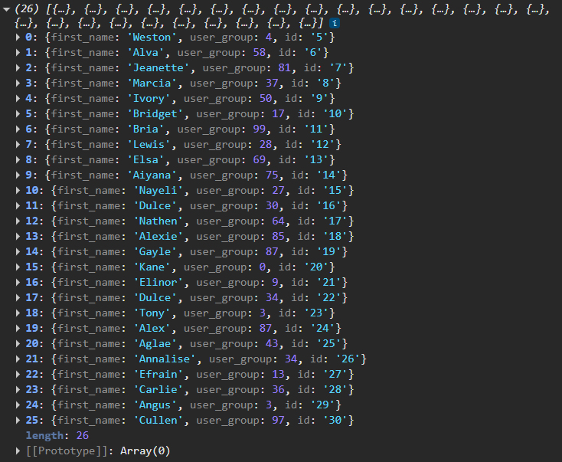

Screenshot B:
