ShelfLife: A Smart Pantry App for Reducing Household Food Waste

A capstone project
Presented to the faculty
of College of Computer Studies
Lyceum of San Pedro

In Partial Fulfillment of the
Requirements of the Degree of
Bachelor of Science in Information Technology

By.
Alogon, Jhan Raphael
Lamano, Josh
Leong, Lea
Villafranca, King

March 2026

CHAPTER 1
Background of the Study
‎Project context
In the present digital and technology-driven era, smart systems are increasingly integrated into various aspects of everyday life, particularly in household management and environmental sustainability. Through automation, real-time data tracking, and interconnected notification mechanisms, modern homes are evolving into “smart kitchens” where resources are efficiently monitored and controlled. These innovations aim to enhance operational efficiency, reduce unnecessary waste, and improve overall resource utilization. Within this framework, inventory monitoring systems play a crucial role, as they significantly influence both household financial efficiency and broader food sustainability concerns.
‎
‎Despite these advancements, many households still rely on traditional methods for managing grocery inventories. Food tracking is often done manually using memory or handwritten lists, which can lead to frequent inaccuracies and inefficiencies. One of the most common issues is the oversight of expiration dates, where perishable goods are forgotten and left unused until they become unsafe for consumption. This not only contributes to significant food waste and financial loss but also disrupts household planning, as individuals may repurchase items they already own but cannot easily locate. In addition, the absence of a centralized tracking system complicates meal preparation, often resulting in last-minute changes and increased dependence on less sustainable food options.
‎
‎These challenges highlight the growing necessity for a digital solution in inventory management. Manual processes are not only time-consuming but also highly prone to human error, contributing to substantial amounts of edible food being discarded globally each year. This situation further raises concerns regarding household sustainability and the environmental impact of organic waste accumulating in landfills.
‎
‎Drawing inspiration from industrial inventory management systems that utilize real-time tracking to maintain efficiency and quality control, ShelfLife: A Smart Pantry Manager introduces a similar concept adapted for household use. Through a friendly web application, users transition from manual record-keeping to a centralized digital database. The system enables users to input food items along with their corresponding expiration dates, offering a clear and organized overview of pantry contents. With the integration of automated alerts, households can improve resource utilization, manage grocery spending more effectively, and minimize food waste through timely notifications as products approach their expiration dates.
‎
‎ The project is built around a robust notification mechanism and a structured database system. It allows users to log inventory items, monitor real-time expiration countdowns, and receive reminders that encourage timely decision-making—such as consumption or proper storage. In doing so, it establishes a “smart pantry” environment that is beneficial for both budget-conscious students and families seeking better household management.
‎
‎ Beyond its core functionality, the system also contributes to broader sustainability initiatives. The development of ShelfLife aligns with the United Nations Sustainable Development Goals (SDGs), particularly SDG 12: Responsible Consumption and Production, which aims to “halve per capital global food waste at the retail and consumer levels” (UN, 2015). It also supports SDG 2: Zero Hunger by promoting efficient resource use and reducing the loss of edible food. Furthermore, it is consistent with the Philippine Development Plan (PDP) 2023–2028, which emphasizes the role of “innovation and technology adoption” in strengthening food security and recognizes that “digitalization and smart systems” are key drivers in improving quality of life and shaping more sustainable consumption behaviors (NEDA, 2023).
‎

Objectives of the Study
The primary objective of this study is to design and develop ShelfLife: A Smart Pantry Manager, a web application that provides automated expiration tracking and notification features. The system aims to help users efficiently monitor grocery inventories and reduce food waste through a centralized digital notification engine.
Specifically, the study aims to:
1. To develop and implement a smart pantry management system integrated with an automated tracking and notification mechanism that:
1.1. Allows users to register and manage a digital inventory of grocery items including names, categories, and quantities.
1.2. Maintains a database of registered users and their specific pantry inventories.
1.3. Automates the monitoring of food shelf life by calculating days remaining until expiration.
1.4. Provides a Web-Based Dashboard for the user interface to manage and view inventory status.
1.5. Provides real-time tracking of item status (e.g., Fresh, Expiring Soon, or Expired).
1.6. Generates automated email or push notifications as expiration dates approach.
2. To construct a system that integrates functions of inventory logging and automated alerting into a unified model, ensuring consistency and seamless operation.
3. To test the system using Alpha and Beta testing tool:
3.1. User authentication and inventory data persistence.
3.2. Accuracy of the notification engine in triggering alerts at specified intervals.
3.3. Proper storing and retrieval of grocery logs for user monitoring.
4. To evaluate the performance of the system using the ISO/IEC 25010:2011, measuring the following evaluation criteria:
4.1. Efficiency – The ability of the system to process inventory updates and send notifications without significant delay.
4.2. Usability – The ease with which users can navigate the interface to add, edit, or remove pantry items.
4.3. Reliability – The consistency of the system in tracking dates and delivering alerts accurately without data loss.

Scope
The study focuses on the design and development of ShelfLife: A Smart Pantry Manager, a web application designed to track grocery inventory and automate expiry notifications. The system will be demonstrated through a functional web-based platform that simulates a digital pantry environment, allowing users to manage household supplies and receive proactive alerts.
The system will consist of the following modules and functionalities:

1. Inventory Management Module
1.1. Captures and stores grocery item data, including item name, category (e.g., dairy, meat, grains), and quantity.
1.2. Inputs and records specific expiration dates for each item added to the virtual pantry.
1.3. Updates existing inventory records when items are consumed, replenished, or discarded.
1.4. Organizes the digital pantry into searchable categories for easier navigation and resource tracking.
1.5. Automatically calculates the remaining shelf life of each item relative to the current date.
1.6. Functions as the primary data entry layer that bridges physical grocery items to the digital database.
2. Notification and Logic Module
2.1. Validates current inventory data by checking the database for upcoming or passed expiration dates.
2.2. Categorizes item status based on remaining time (e.g., "Safe," "Expiring Soon," or "Expired").
2.3. Triggers automated alerts based on pre-defined system rules (e.g., notification sent 3 days before expiry).
2.4. Manages the delivery of notifications:
2.4.1. Sends notifications or emails to the registered user’s device.
2.4.2. Updates the visual status indicators on the user dashboard in real-time.
2.5. Records a history of consumed versus wasted items to provide users with insights into their consumption habits.
2.6. Transmits real-time inventory updates to the Dashboard Module for immediate display and monitoring.
3. User and Administrator Dashboard Module
3.1. User Account Management
3.1.1. Registers and manages user accounts within the system.
3.1.2. Updates, recovers, or deletes user profiles and preference settings.
3.1.3. Defines notification preferences (e.g., how many days before expiry an alert should be sent).
3.1.4. Links specific pantry databases to individual user accounts for personalized tracking.
3.2. Pantry and Item Monitoring
3.2.1. Adds, edits, and removes grocery information from the active database.
3.2.2. Updates item quantities to reflect real-time household stock levels.
3.3. System Logging and Status
3.3.1. Displays and monitors all recorded notification events, including date, time, and item name.
3.3.2. Displays real-time status of the entire pantry inventory.
3.3.3. Allows filtering and searching of inventory logs for specific items, categories, or expiry periods.

Limitations
- The system is developed to demonstrate pantry management and notification functions within a simulated web-based environment. It focuses on showcasing the core logic of the application rather than connecting to actual smart kitchen devices such as smart refrigerators or IoT-enabled appliances.
- ‎The system is limited to fundamental operations such as manual entry of items, storage of data in a database, and automated reminder generation.
- The application depends on a stable internet connection since it uses a cloud-based system architecture for data storage and for delivering email or push notification services.
- The application is primarily intended for demonstration and controlled usage environments, meaning it has not been optimized for deployment in large-scale commercial systems or integrated retail inventory infrastructures. Such expansion is considered outside the current scope of the study.
- Although the system provides useful alerts and information to assist users in managing food items, the final decision regarding consumption and safety of products still depends entirely on user discretion and cannot be fully automated by the system.

Significance of the Study
The development of this study will be beneficial to various stakeholders.
Specifically, it provides the following benefits:
Homeowners and Individuals – The application serves as a practical digital assistant for monitoring household groceries. By keeping track of stored items and their expiration timelines, users can better organize consumption, avoid unnecessary spoilage, and reduce repeated or wasteful purchases, ultimately supporting more efficient household budgeting.
Environment – Reducing the amount of food discarded at the household level has a direct positive impact on environmental conditions. Lower organic waste means fewer greenhouse gas emissions from landfills, particularly methane, while also encouraging more mindful consumption habits among users.
Advocacy Groups and NGOs – Groups focused on sustainability and food distribution may use this study as a simple model showing how digital tools can influence consumer behavior and reduce avoidable food waste at the household level.
Researchers – For the proponents, this project provides hands-on exposure to designing a full-stack web application, managing structured databases, and implementing automated notification systems. It also strengthens problem-solving skills applicable to real-world software development scenarios.
Future Researchers – This work can serve as a foundation for further system enhancement. Future studies may build upon this framework by introducing automation features such as barcode scanning, AI-assisted food tracking, or integration with smart home devices for improved accuracy and usability.

CHAPTER 2
Review of Related Literature and Systems
This chapter discusses the body of literature and existing systems related to the study. It looks into existing ideas, concepts, and technologies that are relevant to the research and may influence how the system is designed. The review focuses on materials that address similar problems, allowing the researchers to better understand how such issues are currently handled. It includes both foreign and local studies, as well as related systems, technical background, and the tools and technologies used in development. A synthesis of the gathered information is also presented, together with the definition of key terms. Altogether, these sections provide the foundation for the design and development of the proposed ShelfLife platform.

Technical Background
The proposed project, entitled as ShelfLife: An Automated Tracking and Notification Platform for Reducing Domestic Food Waste and Optimizing Resource Efficiency, seeks to improve the way households monitor and manage stored food items. Currently, monitoring food inventory in most households depends on manual checking of product labels, memory-based tracking, or visual inspection of stored items. This process often causes food items to be forgotten, unmanaged, or consumed beyond their recommended storage period. As a result, households experience food spoilage, unnecessary expenses, and inefficient resource utilization.

Food waste often occurs because household members are unaware of expiration timelines and lack a systematic method for tracking stored food. Food items stored inside refrigerators, freezers, or kitchen cabinets are often overlooked, especially when multiple products are stored at the same time. This condition leads to over-purchasing and poor inventory management. Furthermore, the absence of automated monitoring prevents users from receiving reminders regarding food expiration, resulting in delayed consumption or disposal of still consumable food products. These challenges highlight the need for a system that can automate food inventory tracking and expiration monitoring within a household environment.

By adopting web-based automation combined with inventory monitoring and notification technology, the proposed ShelfLife system introduces an automated and organized approach to food inventory management. The system allows users to input food item details including product name, quantity, storage location, and expiration date through a web-based platform. Once the information is stored, the system continuously monitors each food item’s shelf life and updates its status based on expiration timelines.

When food items approach expiration, the system generates automated notifications to alert users. These alerts enable household members to take immediate action such as consuming, reorganizing, or disposing of food items when necessary. The system also records inventory activities in a database, allowing users to track food usage patterns and monitor stored products efficiently. In addition, the system provides a dashboard interface that presents an overview of stored food items, expiration countdowns, and food status indicators. This dashboard helps users easily visualize food conditions and supports better household planning and decision-making.

The system consists of interrelated features, each serving a specific purpose to achieve the objectives of the project:

Food Inventory Management – This feature allows users to store and manage food item information such as product name, quantity, storage location, and expiration date.

Expiration Monitoring – The system automatically tracks the shelf life of each stored food item and updates its status based on remaining storage duration.

Automated Notification – This feature sends alerts to users when food items are nearing expiration or have already expired.

User Dashboard – The system provides a monitoring interface that displays food inventory, expiration countdowns, and item status indicators.

Database Management – The system stores inventory records and user data, allowing organized storage and retrieval of information.

Through the integration of these features, the ShelfLife system improves monitoring efficiency, promotes responsible consumption practices, and reduces domestic food waste. The system enhances user awareness, minimizes reliance on manual monitoring, and supports efficient household resource management.

Software, Programs, and Technologies Used
The development of the proposed ShelfLife system requires the use of several software tools, programming languages, and development environments to support system functionality, user interaction, database management, and automated notification processes. These technologies work together to ensure that the system operates efficiently and provides an accurate monitoring of food inventory and expiration tracking. The following software programs and technologies were utilized in the development of the system:

HTML (HyperText Markup Language) – This technology is used to create the structural layout of the web-based system. It provides the proper foundation for designing system pages including the dashboard, food inventory input, monitoring tables, and notification panels. HTML organizes system elements such as text fields, buttons, labels, and navigation menu to ensure proper content presentation.

CSS (Cascading Style Sheets) – CSS is used to enhance the visual appearance and layout design of the system interface. It helps format components such as colors, fonts, spacing, alignment, and screen responsiveness. The use of CSS improves user experience by providing a clean, organized, and user-friendly interface that allows users to easily interact with the system.

PHP – These programming languages are used to process system logic and handle communication between the user interface and the database. They manage user authentication, data validation, record storage, and retrieval operations. These technologies also supports automated processes such as monitoring expiration dates and triggering notification alerts.

MySQL Database Management System – MySQL is used to store, organize, and manage system data including food inventory records, expiration details, user account information, and notification logs. It allows efficient retrieval and updating of stored data while ensuring structured and secure data management within the system.

Visual Studio Code – This software serves as the primary development environment used in coding and system construction. It supports multiple programming languages and provides features such as syntax highlighting, debugging tools, and extension support that improve development efficiency and accuracy.

XAMPP Local Server Environment – XAMPP is used to simulate a web server environment during system development and testing. It provides Apache server services for hosting the system locally and includes MySQL services for database testing. This environment allows developers to test system functions and identify errors before deployment.

Email or Application Notification Services – These services are integrated into the system to provide automated alerts to users. The notification feature informs users when food items are approaching expiration or have already expired. This functionality supports the main objective of the system, which is to promote timely food consumption and reduce household food waste.

Web Browsers – Web browsers such as Google Chrome, Mozilla Firefox, and Microsoft Edge are used to run, test, and evaluate the system. These browsers help verify system compatibility, interface responsiveness, and functional performance across different platforms.

Related Literature
Automation in Food Inventory Monitoring
Automation plays a significant role in improving monitoring and tracking systems across various industries, including household resource management. Studies emphasize that automated monitoring systems reduce human error and improve efficiency by minimizing reliance on manual tracking processes. In food management, automation allows systems to continuously monitor stored food items and provide real-time updates regarding their condition and shelf life.

Research indicates that automated tracking technologies help households manage food storage more effectively by maintaining organized records and providing system-generated alerts. These automated solutions support timely decision-making and help reduce food spoilage. The integration of automation in inventory monitoring demonstrates its effectiveness in improving resource efficiency and minimizing unnecessary waste.

Recent studies highlight the integration of Internet of Things (IoT) technology in food inventory management systems. IoT-enabled devices allow real-time monitoring of food storage conditions such as temperature and humidity, which directly affect food shelf life. These systems can automatically update inventory data and send alerts when irregular conditions are detected or when food items are nearing expiration. According to recent research, IoT-based food monitoring improves accuracy, reduces human intervention, and enhances decision-making in food consumption and storage practices. This advancement strengthens the efficiency of automated food management systems and supports waste reduction efforts.[29]

Automation improves monitoring accuracy and reduces human error by minimizing manual intervention in tracking systems. Studies show that automated inventory systems enhance efficiency and ensure real-time updates of stored items. [1] Additionally, modern automation technologies further strengthen these systems by integrating intelligent tracking and predictive features that enhance overall monitoring performance [20].

Expiration Monitoring and Notification-Based Systems
Several studies highlight the importance of expiration monitoring systems in managing perishable goods. Notification-based technologies are widely used to inform users about time-sensitive conditions, allowing individuals to respond promptly to important events. Research shows that reminder systems significantly improve user awareness and encourage timely consumption of perishable items.

Digital expiration monitoring systems use stored data to calculate product shelf life and generate alerts when items are approaching expiration. These systems reduce the likelihood of forgotten food items and support better consumption planning. The effectiveness of automated notifications demonstrates the importance of integrating monitoring and alert mechanisms in household food management platforms.

Notification-based systems play a critical role in alerting users about time-sensitive events. Research indicates that automated reminders significantly improve user response to expiration timelines and reduce waste. [2] Recent studies also confirm that digital notification systems significantly influence user behavior and increase responsiveness to alerts. [21]

Web-Based Household Resource Management Systems
Web-based information systems are widely recognized for their ability to manage records, process data, and provide user interaction in real time. Studies show that web-based platforms improve accessibility and allow users to monitor stored information through centralized dashboards. These systems integrate front-end interfaces, back-end processing, and database management to provide efficient monitoring functions.

Research involving household management applications demonstrates that web-based systems improve monitoring accuracy and support data-driven decision-making. These systems provide users with organized data visualization and monitoring tools, which enhance awareness and promote responsible resource utilization. The application of web-based technologies supports the development of digital platforms designed to monitor food inventory and expiration tracking.

Web-based systems provide centralized platforms for managing data and enable users to monitor information in real time. These systems improve accessibility, organization, and decision-making processes. [3] Recent developments further highlight that modern web-based platforms enhance real-time monitoring and system efficiency. [22]

Food Waste Reduction and Sustainability Awareness
Food waste reduction has become a global concern due to its environmental, economic, and social impact. Studies emphasize that household food waste contributes significantly to overall food loss, often caused by poor storage practices and lack of monitoring awareness. Research suggests that increasing consumer awareness through digital monitoring systems helps reduce food waste and promotes sustainable consumption behavior.

Literature related to sustainability highlights the importance of combining education and technology to influence responsible consumption habits. Digital food monitoring platforms help households manage resources more efficiently by providing information regarding food status and storage duration. These technologies contribute to sustainability efforts by encouraging proper food management and reducing unnecessary disposal of consumable products.

Food waste is a global issue driven by poor monitoring and lack of awareness. Studies emphasize that digital tools can influence responsible consumption and reduce unnecessary disposal of food. [4] More recent global reports indicate that households account for a significant portion of food waste, reinforcing the need for monitoring systems. [23]

Integrating technology with sustainability practices helps households manage resources efficiently and contributes to environmental conservation efforts. [5] Modern smart food management systems further support sustainability by improving consumption behavior through intelligent monitoring. [24]

Technology Adoption and Digital Solutions in the Philippines
Local studies indicate that the adoption of digital monitoring systems in the Philippines continues to increase due to improved internet accessibility and growing reliance on technology for daily activities. Research involving locally developed web-based systems shows that digital platforms are effective tools for monitoring resources and managing records in both academic and household environments.

In the Philippines, the adoption of digital systems has increased due to improved internet access and technological awareness. Web-based platforms are widely used for monitoring and managing data in various sectors. [6] Recent reports further support that digital transformation continues to expand across different sectors in the country. [25]

Local studies show that inventory monitoring systems improve efficiency in managing records and resources in both academic and household environments. [7] These findings are supported by recent innovations highlighting improved tracking accuracy through digital systems. [26]

Digital solutions in the Philippines support sustainability initiatives by promoting responsible consumption and efficient resource management. [8] National development plans further emphasize the role of technology in improving food security and sustainability. [27]

Government-supported digital projects demonstrate the effectiveness of technology in improving monitoring systems and enhancing data accuracy. [9] Recent national statistics also indicate that households still face challenges in managing food waste efficiently, highlighting the need for digital solutions. [28]

The continuous growth of information systems in the country highlights the importance of adopting digital platforms for everyday resource management. [6]

Local studies in the Philippines also emphasize the effectiveness of inventory systems in improving resource management. These systems allow users to monitor items through smartphones, providing convenience and accessibility for everyday use. Research shows that inventory applications enhance user engagement, improve tracking accuracy, and support real-time updates of stored items. Additionally, these systems contribute to better consumption habits by providing timely information and reminders, making them suitable tools for household-level food management.[30]

Furthermore, studies related to local sustainability initiatives emphasize the importance of technological support in promoting responsible consumption and waste reduction. The development of household monitoring platforms aligns with national efforts to improve resource efficiency and environmental awareness. These findings support the feasibility and relevance of implementing automated food inventory monitoring systems within the Philippine setting.

RELATED SYSTEMS
Foreign Systems
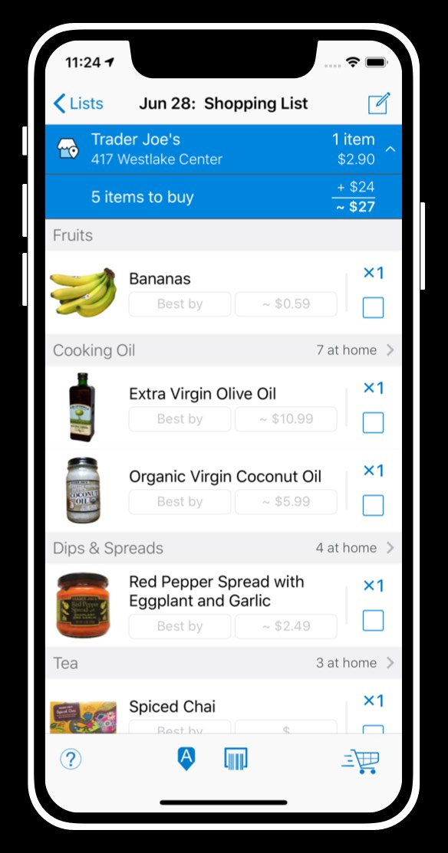

Figure Source: https://pantrycheck.com
1. Screenshot of Pantry Check User Interface
Pantry Check is a food inventory application that allows users to record pantry items and monitor expiration dates. The system provides reminder notifications when food items are nearing expiration, helping users track stored products effectively. This system demonstrates how automated monitoring and alert mechanisms can improve household food management and reduce food spoilage. The application supports the concept of digital food inventory tracking, which is relevant to the development of the ShelfLife platform.[10]

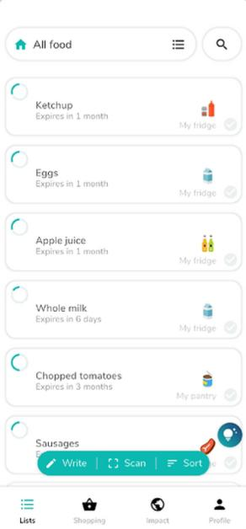

Source: https://nowasteapp.com
Figure 2. Screenshot of NoWaste User Interface
NoWaste is a mobile-based food inventory application designed to reduce food waste by allowing users to monitor grocery items and expiration dates. The system provides consumption tracking and statistical monitoring features that help users analyze food usage patterns. The integration of monitoring and notification functions in NoWaste supports the effectiveness of automation in managing perishable food items and serves as a reference for inventory visualization features in the proposed system.[11]

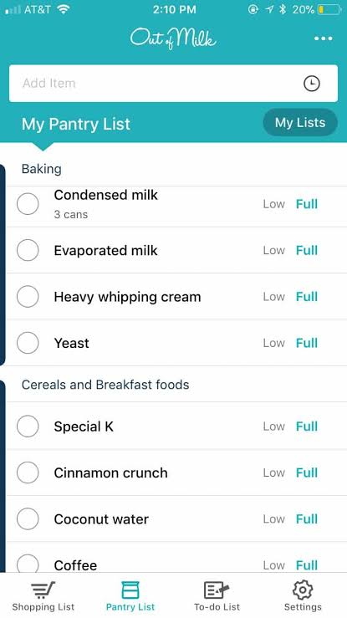

Source: https://www.outofmilk.com
Figure 3. Screenshot of Out of Milk User Interface
Out of Milk is a digital grocery and pantry management system that helps users organize food-related information. The application provides grocery listing and inventory organization features, allowing users to maintain records of stored food items. Although the system provides limited expiration monitoring, it demonstrates the usefulness of digital platforms in improving household organization and record management.[12]
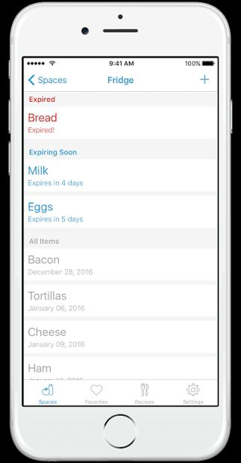

Source: https://www.fridgely.com
Figure 4. Screenshot of Fridgely User Interface
Fridgely is a food tracking application that focuses on monitoring refrigerator and pantry contents. The system provides expiration alerts and food status monitoring, allowing users to consume perishable goods before spoilage occurs. The monitoring and notification features of Fridgely demonstrate how automated expiration tracking can improve food storage management and reduce household food waste.[13]

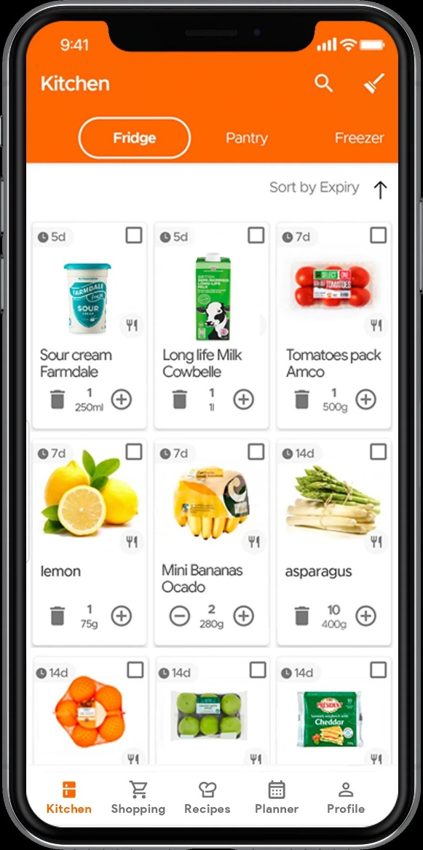
Source: https://kitchenpalapp.com
Figure 5. Screenshot of KitchenPal User Interface
KitchenPal is a pantry management system that integrates food inventory tracking with meal planning and recipe suggestions. The system helps users manage available food resources and suggests meal preparation based on stored ingredients. This feature demonstrates how digital food inventory systems can enhance resource utilization and support efficient food consumption planning.[14]
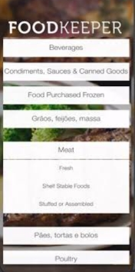

Source: https://www.foodsafety.gov/foodkeeper
Figure 6. Screenshot of FoodKeeper User Interface
FoodKeeper is a food safety application that provides food storage guidelines and shelf-life references for different types of food products. The system helps users determine recommended storage duration and proper storage methods. FoodKeeper supports the development of expiration monitoring logic by providing reliable shelf-life reference data, which can be applied in automated monitoring systems such as ShelfLife.[15]

Local Systems
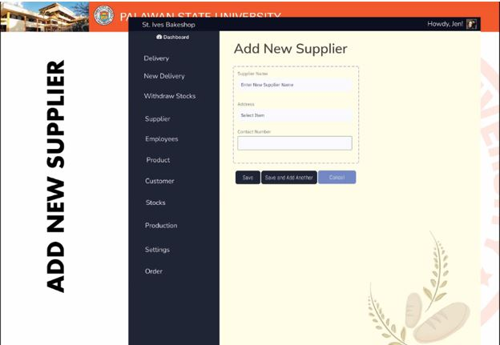
Source: https://www.dost.gov.ph
Figure 7. Screenshot of Local Web-Based Inventory System (DOST-Supported Project)

Local inventory monitoring systems supported by Philippine institutions demonstrate the feasibility of implementing web-based platforms for resource management within the local context. These systems provide record monitoring, database storage, and user interaction features that support efficient data handling and resource tracking. The structure and functionality of these systems serve as references in developing locally adaptable monitoring platforms.[9]

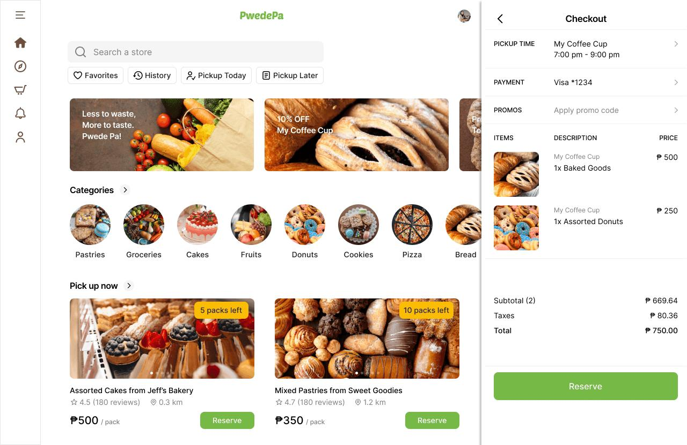
Source: https://pwedepa.com
Figure 8.Screenshot of PwedePa User Interface
PwedePa is a Philippine-based platform focused on reducing food waste by connecting surplus food from businesses such as restaurants and hotels to consumers at discounted prices. The system promotes sustainability by redistributing excess food that would otherwise be discarded. It demonstrates how digital platforms can manage time-sensitive food availability through listing, tracking, and transaction features. This is relevant to the proposed ShelfLife system as it highlights the importance of monitoring food items and reducing waste through digital coordination.[16]
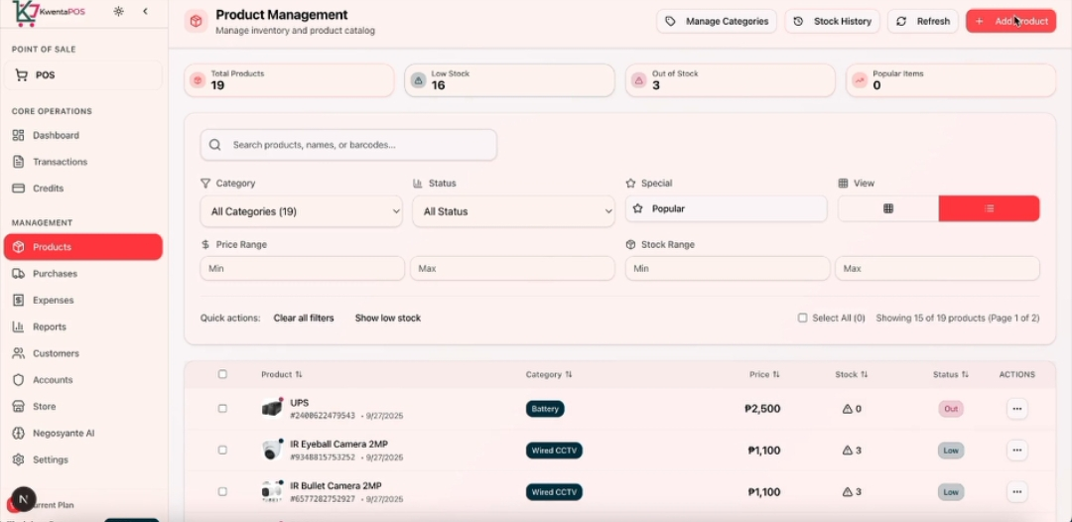
Source: https://kwentapos.com
Figure 9.Screenshot of KwentaPOS User Interface

KwentaPOS is a Filipino-developed point-of-sale and inventory management system designed for small businesses such as sari-sari stores and local retailers. It enables users to monitor product sales, track inventory levels, and generate reports for business operations. The system provides real-time updates on stock movement, helping business owners manage supplies efficiently. Its inventory tracking and monitoring features are relevant to ShelfLife, particularly in terms of database management and automated stock visibility.[17]

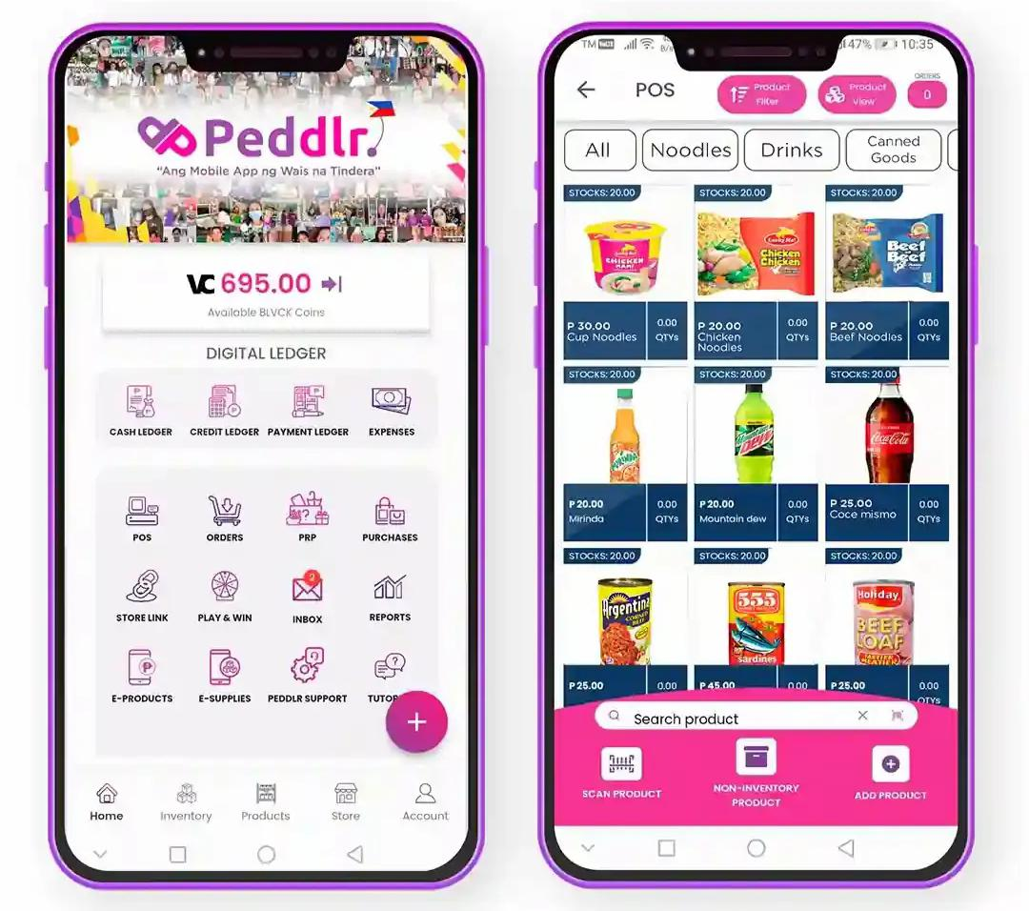
Source: https://peddlr.io
Figure 10. Screenshot of Peddlr User Interface

Peddlr is a mobile-based point-of-sale and business management application widely used by micro and small enterprises in the Philippines. It allows users to record sales, monitor inventory, and analyze business performance through a centralized dashboard. The system supports real-time tracking of products and generates reports that help in decision-making. Its inventory monitoring and automated record-keeping functions are relevant to ShelfLife, especially in managing item quantities and tracking product status over time.[18]

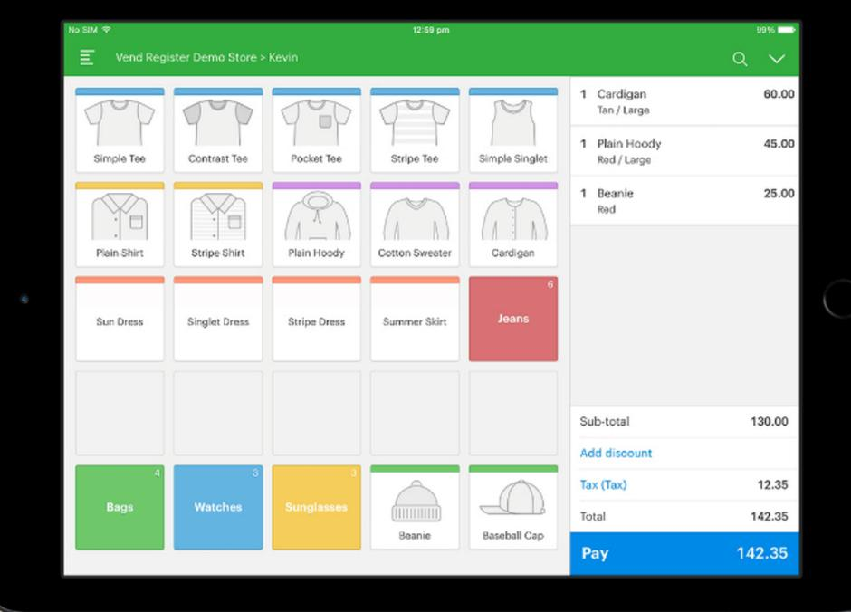
Source: https://www.vendpos.ph
Figure 11.Screenshot of VendPOS User Interface

VendPOS is a cloud-based retail point-of-sale and inventory management system used by various businesses, including those operating in the Philippines. It provides tools for tracking inventory, managing product listings, and generating sales and stock reports through a centralized dashboard. The system supports real-time data synchronization and automated inventory updates, allowing businesses to efficiently monitor stock levels. Its features are relevant to ShelfLife in terms of real-time monitoring, database management, and automated tracking systems.[19]

Synthesis of Related Literature and Systems
The reviewed literature and related systems provide essential concepts and technological foundations relevant to the development of the proposed system. The literature emphasizes that food waste is a prevalent issue caused by improper monitoring practices, lack of awareness regarding food expiration, and ineffective inventory management. Studies highlight the importance of automation and digital monitoring technologies in improving resource tracking, minimizing human error, and promoting efficient consumption behavior.

Foreign literature discusses the effectiveness of notification-based monitoring systems in assisting users to respond to time-sensitive information. These studies demonstrate that automated alert mechanisms improve monitoring efficiency by providing timely reminders regarding expiration schedules of perishable goods. Furthermore, foreign systems present practical implementations of digital food inventory tracking platforms that allow users to record stored food items and monitor expiration timelines. However, these systems commonly provide limited functionalities and often focus on selected monitoring features rather than offering a fully integrated platform.

Local literature supports the feasibility of implementing web-based monitoring systems within the Philippine context. Studies involving locally developed information systems demonstrate that database-driven platforms are effective in managing stored records and monitoring resources. Local related systems also illustrate the successful application of web-based inventory monitoring in institutional environments. Despite these developments, most local systems focus on academic or organizational resource management and do not specifically address household food inventory monitoring and expiration tracking.

Based on the analysis of the reviewed literature and systems, there is a need for a comprehensive monitoring platform that integrates inventory management, automated expiration monitoring, and notification mechanisms into a single web-based system. The proposed ShelfLife system addresses this need by providing a centralized monitoring platform designed to enhance household awareness, improve food storage management, and reduce domestic food waste through automation and real-time monitoring features.

Definition of Terms
Automated Monitoring System – A digital system designed to track and monitor stored items automatically without requiring manual inspection.
Database Management System – Software that stores, organizes, retrieves, and manages structured data used by an information system.
Expiration Date – The specified date that indicates the period during which a food product remains safe and suitable for consumption.
Food Inventory – A collection of stored food items maintained and monitored within a storage environment.
Food Inventory Management – The process of recording, organizing, and monitoring stored food items and their related information.
Food Waste – The disposal or loss of edible food due to spoilage, expiration, or improper management practices.
Notification System – A system feature that automatically sends alerts or reminders to inform users about important conditions or events.
Shelf Life – The length of time for which an item remains usable, fit for consumption, or saleable
Web-Based Application – A software application that operates through a web browser and allows users to access system features without installing dedicated software, supporting accessibility across multiple devices.
Real-Time Monitoring – The ability of a system to continuously track and update data instantly as changes occur, allowing users to view the most current status of their food inventory.
Sustainability – The practice of using resources responsibly to reduce waste and environmental impact while meeting present needs without compromising future generations.
User Dashboard – The main interface of the system where users can view, manage, and monitor their food inventory and notifications in an organized manner.
Inventory Tracking – The process of monitoring the movement, status, and quantity of stored items within a system to maintain accurate and updated records.
Digital Transformation – The integration of digital technologies into everyday processes to improve efficiency, accuracy, and accessibility in managing tasks such as food inventory monitoring.

CHAPTER 3
METHODOLOGY
(change RAD to Agile(Scrum))
This chapter presents the methodologies used in the development of the proposed system, ShelfLife: An Automated Tracking and Notification Platform for Reducing Domestic Food Waste and Optimizing Resource Efficiency. It describes the systematic procedures followed by the researchers in analyzing household food management practices and in designing and developing a technological solution to address the identified problems. The development of the system follows the Rapid Application Development (RAD) model, which emphasizes iterative development, rapid prototyping, continuous user feedback, and flexible adaptation of requirements throughout the system lifecycle.
The chapter includes the following sections: requirement analysis, requirement documentation, system design, system development, testing procedures, research evaluation instrument, respondents of the study, statistical treatment of data, and implementation plan. Each section is structured to ensure that the system satisfies both functional and non-functional requirements while maintaining efficiency, usability, reliability, and overall system quality.
The methodology begins with requirement analysis, which examines existing household food management practices and identifies common issues such as poor inventory tracking, forgotten food items, and inefficient consumption habits. This phase establishes the need for an automated solution.
This is followed by requirement documentation, where the functional and non-functional requirements of the system are clearly specified, including system constraints, user needs, and operational expectations.
The system design phase presents the overall architecture of the ShelfLife system, including the presentation layer, application layer, and data layer. It also illustrates how these components interact to support core functionalities such as inventory tracking, expiration monitoring, and notification services. Supporting diagrams are used to visualize system behavior and user interaction flows.
The system development phase follows the RAD approach, where the system is built through iterative cycles of rapid prototyping, user feedback, and refinement. This phase includes the construction of system modules such as food item entry, expiration tracking, reminder notifications, and database integration. Continuous improvements are made based on stakeholder input to ensure that the system aligns with user needs.
The testing procedures involve verifying system functionality, performance, and reliability through structured testing methods. These ensure that the system operates correctly under different conditions and that all features perform as intended.
Furthermore, the chapter discusses the evaluation of the system using the ISO/IEC 25010:2011 Software Quality Model, ensuring that ShelfLife meets international standards in terms of functionality, reliability, usability, performance efficiency, security, compatibility, maintainability, and portability.
‎Lastly, the implementation plan outlines the steps for deploying the system and preparing it for actual use. Overall, this chapter provides a clear understanding of how the ShelfLife system was designed, developed, tested, and prepared for implementation in order to improve household food inventory management and reduce food waste.
1. REQUIREMENT ANALYSIS
The requirement analysis phase focuses on understanding the current household food management practices and identifying the specific needs that the proposed ShelfLife system must address. This section presents the existing manual processes, the proposed automated solution, and the comparative analysis between traditional and digital approaches.
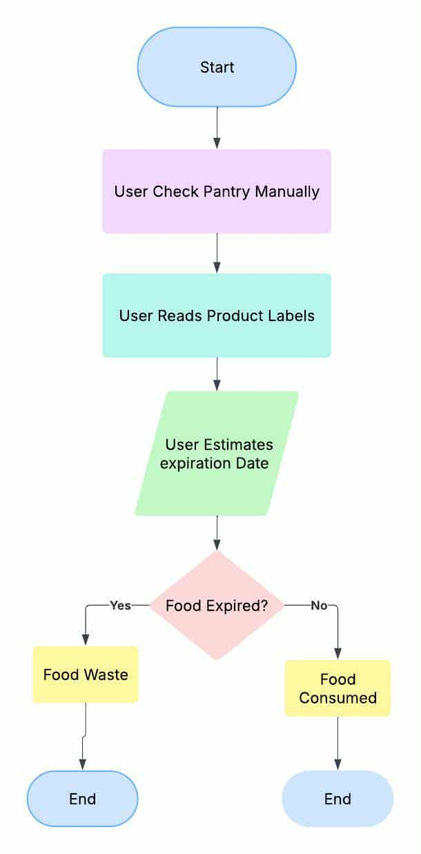

Figure 12. Current System Analysis Workflow
The proposed ShelfLife system is designed as a centralized web-based platform that digitizes household pantry management. Unlike manual tracking methods, the system introduces automation through database-driven monitoring and programmed expiration logic. The system architecture integrates user interface components, backend processing modules, and a structured database management system.
The system workflow begins when the user registers and creates a personal account. Upon successful authentication, the user gains access to a digital dashboard where pantry items can be added and managed. Each food entry requires essential information such as product name, category, quantity, and expiration date. Once stored in the database, the system continuously compares the stored expiration dates with the server’s current date.
Through this automated comparison process, the system dynamically assigns item status indicators such as “Fresh,” “Expiring Soon,” and “Expired.” These classifications are not static but are recalculated in real-time whenever the user accesses the system.
In addition, the monitoring engine is integrated with a notification module. When predefined thresholds are met (e.g., a day before expiration), the system automatically triggers alerts via email or push notification. This eliminates the dependency on manual checking and improves proactive food consumption behavior.
The automation of tracking, monitoring, and alerting functions transforms traditional pantry management into a smart and data-driven process. This solution directly addresses the inefficiencies identified in the current manual system and supports improved household resource optimization.
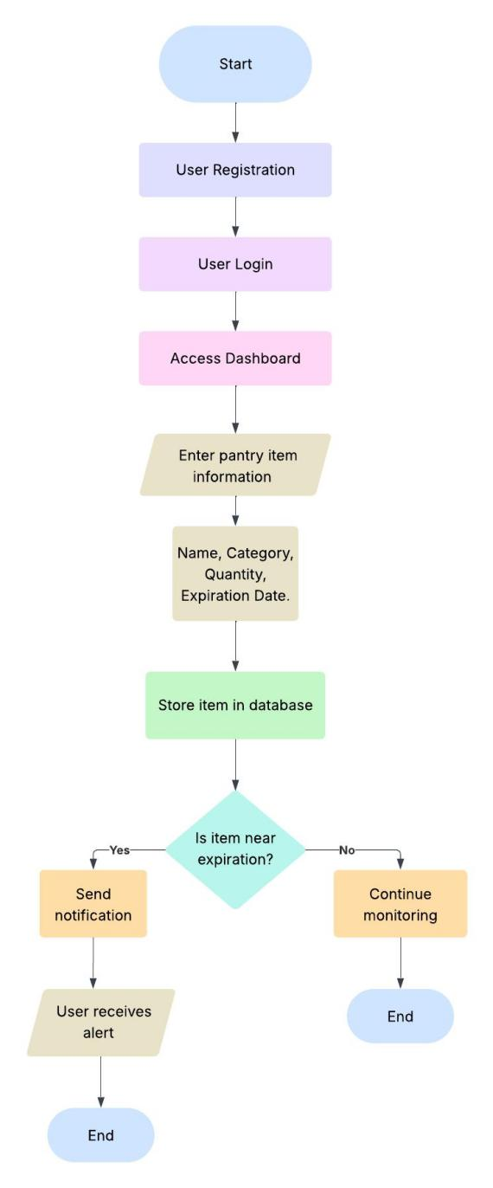
Figure 13. Flowchart of the Proposed ShelfLife System Workflow
2.REQUIREMENT DOCUMENTATION
Non-Functional Requirements
In addition to functional features, the ShelfLife system must satisfy the following non-functional requirements:
Performance Requirement: The system must process user requests, inventory updates, and notification triggers without significant delay. Page loading time should not exceed three seconds under normal internet conditions.
Security Requirements: User data must be protected through password encryption and secure database configuration. The system must restrict unauthorized access through proper authentication and session management mechanisms.
Usability Requirements: The interface must remain intuitive and easy to navigate, even for users with minimal technical experience. Buttons, forms, and dashboard elements must be clearly labeled to ensure ease of operation.
Compatibility Requirements: The system must be accessible across multiple web browsers such as Google Chrome, Mozilla, Firefox, and Microsoft Edge.
Reliability Requirements: The expiration monitoring engine must consistently and accurately calculate remaining shelf life. Notification triggers must operate according to predefined system logic without skipping scheduled alerts.
Maintainability Requirements: The system must allow future enhancements such as barcode integration, receipt scanning, or AI-based meal recommendations without requiring major architectural redesign.

- DESIGN OF SOFTWARE, SYSTEM, PRODUCT AND/OR PROCESS.

Conceptual Model of the Study

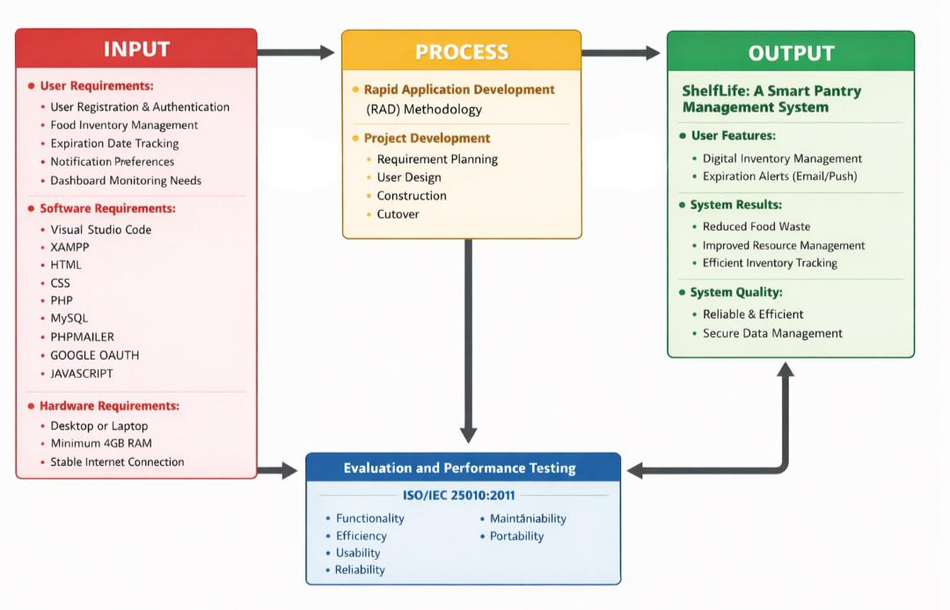

Figure 14. Conceptual Model of the Study
The conceptual model of the study illustrates the relationship between the input, process, and output components in the development of the proposed system, ShelfLife: A Smart Pantry Management System. This model serves as the framework that guides the overall design, implementation, and evaluation of the system.
The input phase consists of the requirements necessary for system development. These include user requirements, such as user registration and authentication, food inventory management, expiration date tracking, notification preferences, and dashboard monitoring needs. In addition, software requirements are identified, including development tools and technologies such as Visual Studio Code, XAMPP, HTML, CSS, PHP, MySQL, PHPMailer, and JavaScript. Hardware requirements are also considered, including a desktop or laptop device, a minimum of 4GB RAM, and a stable internet connection. These inputs provide the foundation for building the system.
The process phase follows the Rapid Application Development (RAD) methodology, which emphasizes iterative design, rapid prototyping, and continuous user feedback. This phase includes key stages of project development, namely requirement planning, user design, construction, and cutover. During this stage, the system is designed, developed, and refined to ensure that it meets the specified requirements and functions effectively.
The output phase presents the completed system, ShelfLife: A Smart Pantry Management System. The system delivers key user features, including digital inventory management and automated expiration alerts through email or push notifications. It also produces significant system results, such as reduced food waste, improved resource management, and efficient inventory tracking. Furthermore, the system ensures high system quality, characterized by reliability, efficiency, and secure data management.
Finally, the model includes evaluation and performance testing, which is conducted based on the ISO/IEC 25010:2011 software quality standards. The system is assessed in terms of functionality, efficiency, usability, reliability, maintainability, and portability. The results of this evaluation provide feedback for system improvement and validation of its effectiveness.
Overall, the conceptual model demonstrates how the integration of inputs, structured development processes, and quality evaluation leads to the successful implementation of the ShelfLife system.

Behavioral Modeling: Use Case Diagram
The use case diagram illustrates the interaction between the users and the ShelfLife system. It presents the system functionalities and how different actors engage with the system processes. The primary actors identified are the User and the Administrator, each having specific roles and system access.
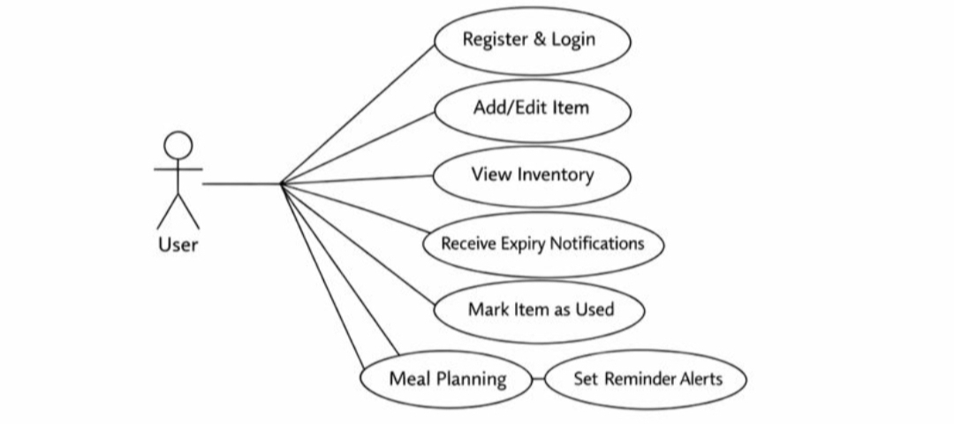
Figure 15.Use Case Diagram for User Functions
The use case diagram for the user illustrates the primary interactions between the household user and the ShelfLife system. The user is responsible for managing food inventory and monitoring item status.
The user can register and log into the system to access the dashboard. Once authenticated, the user can add, edit, and delete food items, as well as view the current inventory. The system allows the user to receive expiration notifications, helping them take action before items spoil. Additionally, the user can mark items as used or consumed and optionally plan meals based on available ingredients.
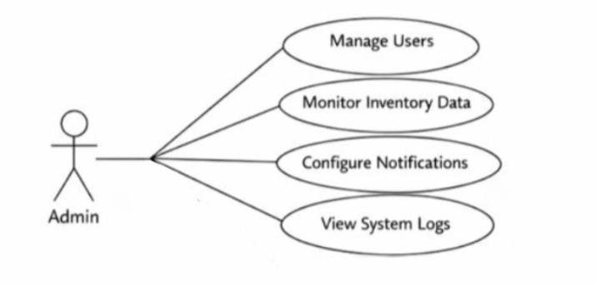
This diagram highlights how the system supports users in maintaining an organized and efficient pantry while reducing food waste.

Figure 16. Use Case Diagram for Admin Functions
The use case diagram for the administrator presents the interactions between the admin and the ShelfLife system. The administrator is responsible for overseeing system operations and ensuring proper functionality.
The administrator can manage user accounts, monitor inventory data, and configure notification settings. The system also allows the administrator to access system logs related to food consumption and waste patterns. This diagram demonstrates the administrative capabilities that support system maintenance, monitoring and management.

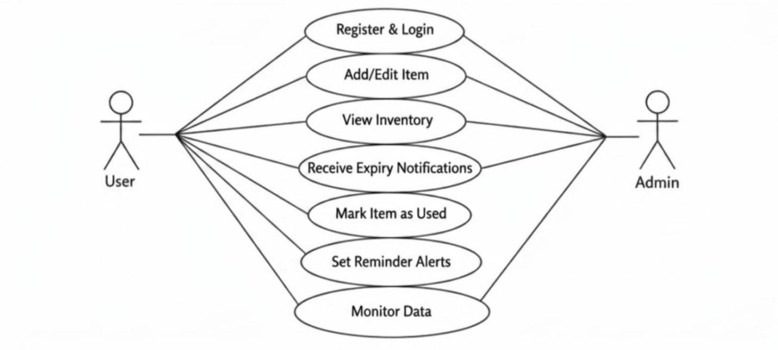
Figure 17.Use Case Diagram for ShelfLife System
The overall use case diagram presents the complete interaction between the user, administrator, and the ShelfLife system. It combines all system functionalities into a unified view.
Both actors interact with core system features such as inventory management, notification handling, and data monitoring. The user focuses on operational tasks such as managing food items and receiving alerts, while the administrator focuses on system control, monitoring data and user management.
This diagram provides a comprehensive overview of how the system operates as an integrated platform, supporting both user-level and administrative functions.

The ShelfLife system follows a three-tier architecture composed of:
- Presentation Layer – This includes the web-based user interface developed using HTML, CSS, and PHP. It handles user interaction and data input.
- Application Layer – This layer processes business logic, including expiration calculation, notification triggering, and data validation. Server-side programming languages such as PHP manage communication between the interface and the database.
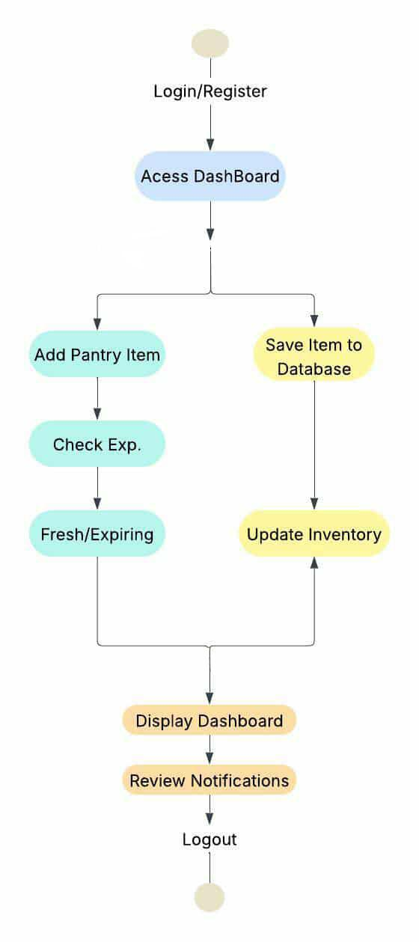
- Data Layer – This consists of a MySQL database that stores user profiles, inventory records, notification logs, and usage history. The Interaction between these layers ensures that data entered by the user is validated, stored, processed, and displayed accurately. The separation of concerns enhances system maintainability and scalability.
Figure 18. Activity Diagram of Software Design Process
4.DEVELOPMENT AND TESTING
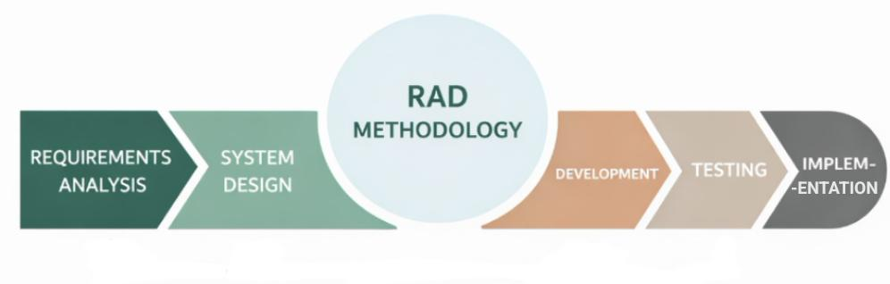
Rapid Application Development (RAD) is an adaptive software development methodology that prioritizes rapid prototyping and quick feedback over long-drawn-out planning and development cycles. Unlike traditional models, RAD focuses on iterative processes and software construction rather than following a rigid set of specifications. This allows teams to adjust to requirements in real-time, significantly reducing the time-to-market while maintaining high quality through continuous user involvement.
Figure 19. RAD Methodology
Phase 1: Requirements Analysis
In this initial phase, stakeholders, users, and team members meet to define the project's objectives, expectations, and scope. Unlike the extensive documentation found in Agile or Waterfall, RAD focuses on a high-level understanding of the business needs.
Key activities include:
Identifying the core business problems the software must solve.
Defining the project scope and potential constraints.
Gaining consensus from stakeholders on the overall vision and requirements.
Phase 2: System Design
This is the heart of the RAD methodology. During this phase, users work close with developers to create several models of the system. This is a continuous, interactive process where the design is refined based on immediate feedback. Activities include:
Building functional Model that represent various system components.
Using Computer-Aided Software Engineering (CASE) tools to quickly generate visual representations.
Conducting walkthroughs with users to identify missing features or design flaws early.

Phase 3: Development
Once the user design is approved, the project moves into construction. In RAD, this phase is characterized by intensive coding and system building. Because many of the design issues were resolved during the System Design stage, developers can build the final system more quickly. Key focuses include:
Rapid Development: Utilizing application generators and reusable code libraries to speed up the process.
Incremental Building: Developing the system in modules that can be integrated as they are completed.
Integration: Connecting the front-end interfaces developed during prototyping with the back-end databases and external APIs.
During development, The process was divided into the following module stages:
Inventory Module Development
This module focused on database table creation, item CRUD operations (Create, Read, Update, Delete), and real-time shelf life calculations.
Notification Engine Development
This stage involved programming the date comparison algorithm and integrating email services for alert delivery.
Authentication Module Development
User login, registration, password encryption, and session management were developed and tested.
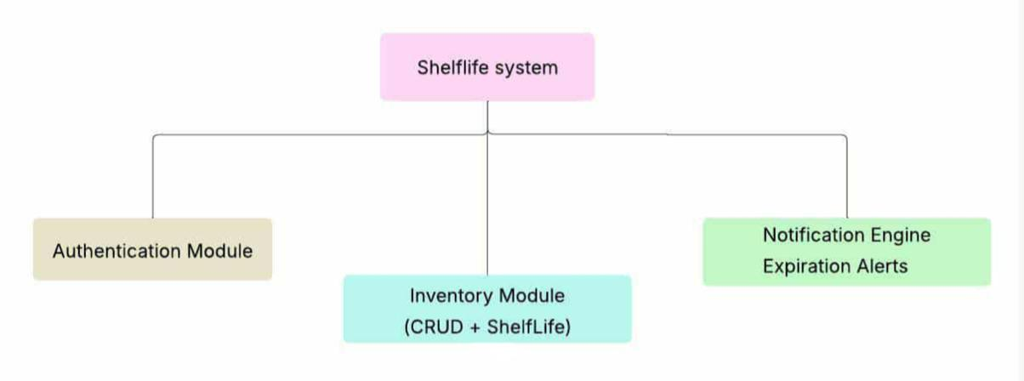
Each module underwent iterative refinement to ensure proper integration and seamless communication across the entire system.
Figure 20. UML Diagram of System Architecture
Phase 4: Testing
Testing in RAD is not a separate, final step but is integrated throughout the construction phase. Since the software is built in increments and prototypes are frequently reviewed, many bugs are caught early. Testing efforts include:

Unit Testing: Testing individual modules or functions as they are coded.

Integration Testing: Ensuring that new components work seamlessly with existing ones and external systems.
User Acceptance Testing (UAT): Having end-users interact with the working system to ensure it meets the defined business requirements and usability standards.

Phase 5: Implementation
The cutover phase is the final transition of the developed system into the live production environment. This includes data conversion and full-scale testing. Because the users have been involved since the design phase, the transition is usually smoother than in other methodologies.

5.TESTING PROCEDURE
Functional Testing
Verifies whether all system features operate according to the defined requirements.
Performance Testing
Evaluates system responsiveness and load handling during multiple user interactions.
Security Testing
Tests authentication processes and ensures data protection against unauthorized access.
Usability Testing
Assesses ease of navigation and clarity of dashboard layout among selected users.
Regression Testing
Ensures that newly added features do not disrupt previously functioning modules.

6.RESEARCH EVALUATION INSTRUMENT
The evaluation of the developed system, ShelfLife: An Automated Tracking and Notification Platform for Reducing Domestic Food Waste and Optimizing Resource Efficiency, will be conducted using the ISO/IEC 25010:2011 Software Quality Model. This international standard provides a structured framework for assessing software product quality through defined characteristics and sub-characteristics.
The ISO 25010 model evaluates software systems based on eight primary quality characteristics:
Functional Suitability – Measures whether the system provides functions that meet stated and implied needs under specified conditions. This includes functional completeness, correctness, and appropriateness of the inventory tracking, expiration monitoring, and notification engine.
Reliability – Assesses the system’s ability to perform specified functions consistently under normal usage conditions. This includes system stability, error tolerance, and recoverability in case of unexpected interruptions.
Usability – Evaluates how easy and intuitive the system is for users. This includes interface clarity, ease of navigation, learnability, and overall user satisfaction.
Performance Efficiency – Measures system responsiveness and processing speed. This includes loading time, database response time, and notification triggering speed.
Compatibility – Assesses the system’s ability to operate across different browsers and devices without functional issues.
Security – Evaluates data protection mechanisms including authentication controls, password encryption, and restricted access to user data.
Maintainability – Measures how easily the system can be modified, updated, or enhanced in the future.
Portability – Assesses how easily the system can be transferred to different hosting environments or platforms.
A structured questionnaire will be used as the primary evaluation tool. The questionnaire will contain statements related to each ISO 25010 quality characteristic. Respondents will rate each statement using a four-point Likert scale.
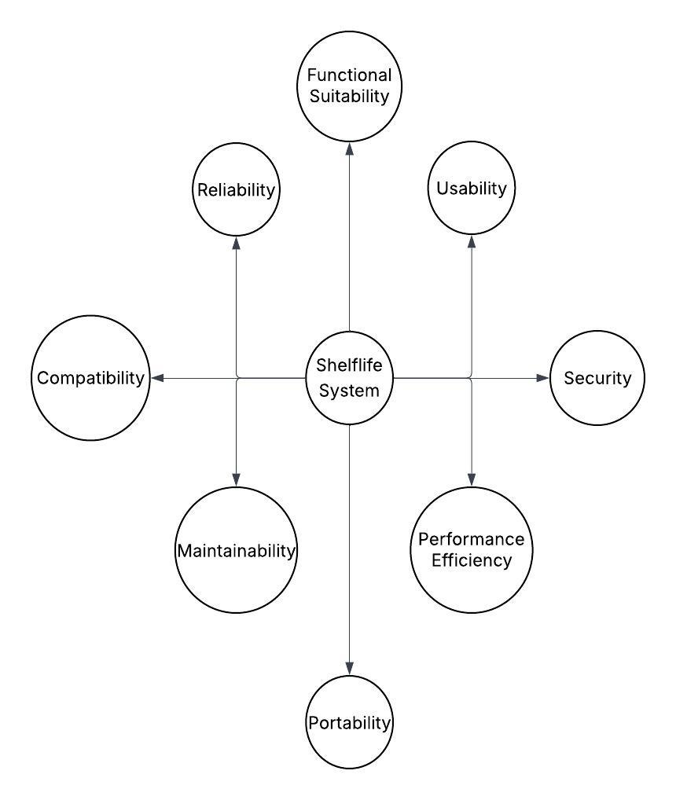
The evaluation results will determine the overall quality and acceptability of the ShelfLife system.
Figure 21. Radial Diagram of ISO 25010 Quality Characteristics

7.RESPONDENTS OF THE STUDY
The respondents of the study consist of two primary groups: end-users and information technology experts.
End-Users – The end-users include selected individuals such as students and household members who regularly manage grocery inventory. These users will evaluate the system based on usability, functionality, and overall user experience.
IT Experts – The IT experts consist of programmers, system developers, technical support personnel, and information technology instructors. Their role is to evaluate the technical aspects of the system, including performance efficiency, reliability, security, maintainability, and compatibility

A total of 60 respondents will participate in the evaluation process:
Students and Household Users – 50
IT Experts – 10
Total – 60
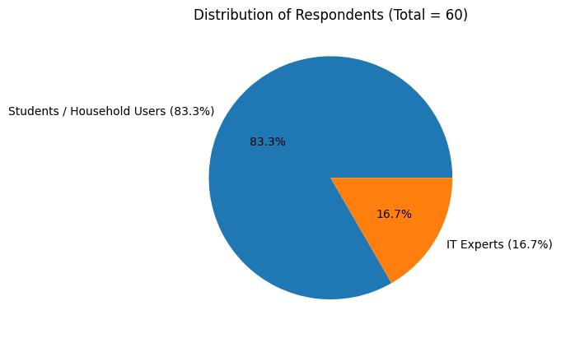
Figure 22. Distribution of Respondents
The researchers will use purposive sampling in selecting respondents. Purposive sampling is a non-probability sampling technique where participants are selected based on specific characteristics relevant to the research objectives. This method is appropriate because the system requires evaluation from individuals who have direct experience in household inventory management and technical system assessment.

The respondents will be given access to the system for testing before answering the evaluation questionnaire. Their responses will be collected, summarized, and analyzed using statistical tools.

8.STATISTICAL TREATMENT OF DATA
The researchers will use the weighted mean formula to analyze the responses gathered from the evaluation questionnaire.
The weighted mean is appropriate because it provides a summarized numerical interpretation of the respondents’ perceptions of system quality.

Formula:
Where:
Xw = Weighted Mean
W = Weight assigned to each response
X = Frequency of responses
∑w = Total number of responses
A four-point Likert scale will be used to measure the respondents’ level of agreement with each evaluation statement.
Scale Interpretation:
4 – Excellent
3 – Very Good
2 – Good
1 – Poor
The computed weighted mean for each criterion will be interpreted using the following range:
3.51 – 4.00 : Excellent
2.51 – 3.50 : Very Good
1.51 – 2.50 : Good
- – 1.50 : Poor

The overall system quality will be determined by computing the average weighted mean across all ISO 25010 quality characteristics.
This statistical approach ensures an objective and measurable evaluation of the system’s effectiveness and performance.

References
[1] SSRG International Journal, “Automation Monitoring Systems,” [Online]. Available: https://www.internationaljournalssrg.org/IJEEE
[2] ResearchGate, “Notification-Based Reminder Systems,” [Online]. Available: https://www.researchgate.net
[3]SimpleAccess, “Web-Based Monitoring Systems,” [Online]. Available: https://simpleaccess.com/access-control-systems
[4] United Nations Environment Programme, “Food Waste Index Report,” [Online]. Available: https://www.unep.org/resources/report/unep-food-waste-index-report
[5] World Health Organization, “Food Safety and Sustainability,” [Online]. Available: https://www.who.int/health-topics/food-safety
[6] Department of Information and Communications Technology (DICT), “Digital Adoption in the Philippines,” [Online]. Available: https://dict.gov.ph
[7] ResearchGate, “Inventory Monitoring Systems Studies,” [Online]. Available: https://www.researchgate.net
[8] Food and Agriculture Organization, “Food Waste and Sustainability,” [Online]. Available: https://www.fao.org/food-loss-and-food-waste
[9] Department of Science and Technology, “Web-Based Inventory Monitoring Systems,” [Online]. Available: https://www.dost.gov.ph.
[10] Pantry Check, “Pantry Check Food Inventory Application,” [Online]. Available: https://pantrycheck.com.
[11] NoWaste, “NoWaste Food Inventory and Expiration Tracking Application,” [Online]. Available: https://nowasteapp.com.
[12] Out of Milk, “Out of Milk Grocery and Pantry Management Application,” [Online]. Available: https://www.outofmilk.com.
[13] Fridgely, “Fridgely Food Inventory and Expiration Monitoring Application,” [Online]. Available: https://www.fridgely.com.
[14] KitchenPal, “KitchenPal Pantry Management and Meal Planning Application,” [Online]. Available: https://kitchenpalapp.com.
[15] FoodSafety.gov, “FoodKeeper Application: Food Storage and Shelf-Life Guide,” [Online]. Available: https://www.foodsafety.gov/foodkeeper.
[16] PwedePa, “PwedePa Food Waste Reduction Platform.” [Online]. Available: https://pwedepa.com
[17] KwentaPOS, “KwentaPOS Inventory and Point-of-Sale System.” [Online]. Available: https://kwentapos.com
[18] Peddlr, “Peddlr Mobile POS and Inventory Management Application.” [Online]. Available: https://peddlr.io
[19] VendPOS, “VendPOS Cloud-Based POS and Inventory System.” [Online]. Available: https://www.vendpos.ph
Foreign
‎‎[20] Kumar, R., Singh, P., & Patel, V. (2022). “Automation in inventory management systems”. IEEE Access. [Online]. Available: https://ieeexplore.ieee.org/
‎[21] Alharthi, A., & Krotov, V. (2022). “The role of notifications in user behavior”. Information Systems Frontiers. [Online]. Available: https://link.springer.com/
‎[22] Santos, D., & Ali, M. (2023). “Web-based platforms for real-time monitoring systems”. International Journal of Information Systems. [Online]. Available: https://www.researchgate.net/
‎[23] United Nations Environment Programme. (2024). “Food Waste Index Report 2024”. [Online]. Available: https://www.unep.org/resources/report/food-waste-index-report-2024
‎[24] Zhang, Y., Liu, H., & Chen, X. (2023). “Smart food management systems using IoT and AI”. Journal of Cleaner Production. [Online]. Available: https://www.sciencedirect.com/
‎[25] Department of Information and Communications Technology. (2022). “Philippine Digital Transformation Strategy”. [Online]. Available: https://dict.gov.ph
‎[26] Department of Science and Technology. (2022). “Science and Technology Innovations Report”. [Online]. Available: https://www.dost.gov.ph
‎[27] National Economic and Development Authority. (2023). “Philippine Development Plan 2023–2028”. [Online]. Available: https://pdp.neda.gov.ph
‎[28] Philippine Statistics Authority. (2024). “Household Consumption and Waste Report”. [Online]. Available: https://psa.gov.ph
[29] Lee, J., Kim, S., & Park, H. (2023). IoT-based smart food inventory monitoring systems. Journal of Smart Technology. [Online]. Available: https://www.sciencedirect.com
[30] Cruz, M., & Reyes, L. (2022). Mobile-based inventory systems for household resource management in the Philippines. Philippine Journal of Information Technology. [Online]. Available: https://ejournals.ph

