Solution Architecture Document
Payments Platform
A multinational payments, wallets and lending platform built around a double-entry ledger
Item | Detail
Author | Collins Kiplimo, Solution Architect and Backend Engineer
Version | 1.0
Date | 1 October 2026
Status | Baseline for build (learning and portfolio project; not for real money)
Repository | payments-platform (Maven multi-module, Java 21, Spring Boot 3.4)

Contents

Word fills this table when the document opens (choose Yes to update fields). In other editors, refresh the field manually.

1. Executive summary
The Payments Platform lets merchants accept card and mobile-money payments, lets individuals hold multi-currency wallets and send money, pays both out to banks and mobile money, lends to merchants and individuals, and keeps every shilling accounted for. It operates through one legal entity per country and produces group financial statements.
The design rests on one decision: a double-entry ledger is the only place balances change. Seven business services orchestrate payments, pricing, accounts, payouts, lending and reconciliation, and every money movement they perform ends as a balanced journal transaction posted to ledger-service over gRPC. Everything else (events, sagas, idempotency, reconciliation, reporting) protects that invariant.
Decision | Choice
Style | Microservices by bounded context: 9 contexts, 7 business services, plus gateway and rails simulator
Source of truth for money | ledger-service: double entry, append-only, balances derived from entries
Communication | gRPC (ledger.v1) for postings; REST with {payload} / {meta, payload} envelope; Kafka events via transactional outbox
Data | PostgreSQL, one database per service, JdbcTemplate, Flyway; money as integer minor units
Consistency | Idempotency keys, sagas with compensation, row locks in fixed order, continuous invariant checks
Platform | Docker, Kubernetes (Deployments, migration Jobs, HPA, Ingress), GitHub Actions

2. Scope and goals

2.1 Goals
- Model the money flows of a Stripe-style platform correctly, from authorization to financial statements.
- Support several countries: legal entities, functional currencies, taxes per jurisdiction, FX and consolidation.
- Demonstrate production practices: contracts, idempotency, sagas, observability, automated end-to-end tests.
- Teach the accounting behind each feature (see docs/accounting/ACCOUNTING_GUIDE.md).

2.2 Out of scope
- Real card data and PCI DSS scope; real banks and schemes (a simulator stands in).
- Identity verification (KYC/KYB), sanctions screening and fraud scoring beyond extension points.
- Payroll, inventory, fixed assets and tax filing.

3. Requirements

3.1 Functional
Capability | Requirements
Payments | Create, authorize, capture, cancel, refund (full/partial), chargebacks (open, won, lost), network settlement
Pricing | Quote every transaction: fees, VAT/GST/excise per jurisdiction, FX spread, interest rules; quotes used once before expiry
Accounts | Onboard merchants (rolling reserves) and individuals; several wallets per person; top-up, own transfers, P2P, FX conversion, pay merchants, merchant-to-individual payments
Payouts | Merchant payouts and wallet withdrawals to bank or mobile money with hold, confirmation, failure and retry
Lending | Merchant financing repaid from sales; instalment loans with amortization, daily accrual, late fees, IFRS 9 staging, write-off, restructuring, early repayment
Collections | Recover debts across all of a debtor's accounts in policy order, including other currencies; write-off and recovery after write-off
Ledger and reporting | Balanced postings per entity and currency; balances at any date; statements; trial balance; balance sheet; income statement; period close; revaluation; consolidation
Reconciliation | Match bank statements to the ledger; exceptions; suspense; safeguarding check; AI-assisted explanations

3.2 Non-functional
Quality | Target
Correctness | Books balance after every transaction, per entity and currency; zero tolerance for drift between balances and entries
Idempotency | Every money-moving request and event is safe to retry
Auditability | Append-only journal; every transaction linked to a business reference and request id; reversals instead of edits
Latency (SLO) | 99.9% of PostTransaction calls under 200 ms; 99% of payment captures under 1 s
Availability (SLO) | Ledger and payments 99.9% monthly; payouts confirmed within 1 hour for 99.5%
Scalability | Stateless services scale horizontally; ledger hot accounts protected by ordered row locks
Security | JWT at the edge, least-privilege database users, secrets outside Git, no personal data in logs
Operability | Health probes, Prometheus metrics, traces with correlation ids, runbooks per alert

4. Architecture overview
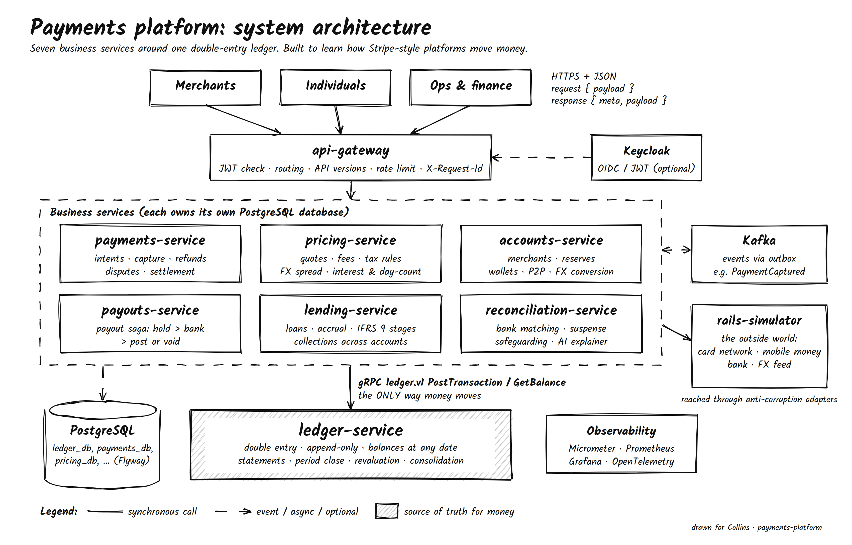
Figure 1. System architecture (editable source: docs/architecture/system-architecture.drawio).

4.1 Architecture principles
- Only the ledger changes balances. Services hold business state and post balanced transactions.
- Every money movement is priced first. pricing-service quotes fees, taxes and FX; the quote id is consumed once.
- Retries are always safe. Idempotency keys on APIs, ledger transactions and Kafka consumers.
- No distributed transactions. Sagas with compensating steps; unknown outcomes become visible states.
- Rules are data. Fees, taxes, interest and day-count rules are versioned rows with effective dates.
- The outside world sits behind adapters. Anti-corruption layers translate network, bank and FX formats.
- Prove health continuously. Invariant checks and end-to-end tests assert the books balance.

5. Logical view

5.1 Service catalogue
Service | Modules | Owns | Interfaces
ledger-service | ledger, entities, close | Entities, chart of accounts, transactions, entries, balances, periods | gRPC ledger.v1; REST /v1/entities, /v1/transactions, /v1/consolidation
payments-service | payments, disputes | Payment intents, refunds, disputes, settlement batches | REST /v1/payment-intents, /v1/disputes, /v1/settlements; event PaymentCaptured
pricing-service | fees, tax, fx, interest | Fee plans, tax rules, FX rates, quotes, interest rules | REST /v1/quotes, /v1/tax-rules, /v1/fx-rates, /v1/interest
accounts-service | merchants, wallets | Merchants, reserve holds, individuals, wallets, transfers | REST /v1/merchants, /v1/individuals, /v1/wallets, /v1/transfers; consumes PaymentCaptured
payouts-service | payouts | Payouts and their saga state | REST /v1/payouts; events PayoutCompleted, PayoutFailed
lending-service | loans, collections | Products, loans, schedules, repayments, recovery cases | REST /v1/loans, /v1/recovery-cases; consumes PaymentCaptured, LoanInstalmentMissed
reconciliation-service | matching, AI | Reconciliation runs and statement lines | REST /v1/reconciliation-runs, /v1/statement-lines, /v1/safeguarding
rails-simulator | card, bank, FX | In-memory test state | REST /sim/** with failure modes
api-gateway | edge | None | Routes /v1/** to services

5.2 Domain-driven design
Bounded contexts decide the model; deployables decide how it runs. Each aggregate is changed in one database transaction and protects one rule.
Context | Aggregate root | Invariant
Ledger | JournalTransaction | Debits equal credits per currency; never changed after posting
Ledger | AccountingPeriod | No postings into a closed period
Payments | PaymentIntent | Only allowed state transitions; refunds never exceed captured amount
Pricing | Quote / TaxRule | Quote used once before expiry; rule versions never overlap
Wallets | Wallet | No overdraft without a recovery case
Payouts | Payout | Never sent twice; hold always committed or voided
Loans | Loan (with schedule) | Repayment waterfall; stage follows days past due
Collections | RecoveryCase | Never recover more than is owed

Upstream | Downstream | Relationship
Ledger | All money-moving contexts | Open host service with published language (ledger.v1)
Pricing | Payments, wallets, payouts, loans | Customer-supplier
Payments | Loans, merchants | Published events (PaymentCaptured)
Loans | Collections | Shared kernel (same service)
Rails (external) | Payments, payouts, reconciliation | Anti-corruption layer
Ledger | Reconciliation | Conformist (reads the ledger model as is)

6. Integration view

6.1 Synchronous
Public and service-to-service REST calls use one envelope. Requests carry the business data under payload; responses carry meta (request id, timestamp, status, errors) and payload. Every POST that moves money requires an Idempotency-Key header. Postings to the ledger use gRPC (binary over HTTP/2) because they sit on every money path; ledger.v1 messages follow the same meta/payload shape.
POST /v1/payment-intents
Idempotency-Key: 6f1c…
{ "payload": { "merchantId": "mer_…", "amountMinor": 100000, "currency": "KES", "method": "CARD" } }
→ 201 { "meta": { "requestId": "…", "status": "SUCCESS", "errors": [] }, "payload": { "id": "pi_…", "status": "AUTHORIZED" } }

6.2 Asynchronous events
Topic | Producer | Consumers | Effect
payments.payment-captured.v1 | payments-service | accounts-service, lending-service | Rolling reserve hold; merchant-financing withholding
payments.payment-refunded.v1 | payments-service | reserved for notifications | -
payments.dispute-opened.v1 | payments-service | reserved for risk | -
payouts.payout-completed.v1 / payout-failed.v1 | payouts-service | reserved for notifications | -
lending.loan-instalment-missed.v1 | lending-service (loans) | lending-service (collections) | Open recovery case and recover across accounts
ledger.transaction-posted.v1 | ledger-service | reserved for analytics | -
Events are written to an outbox table in the same transaction as the change and relayed to Kafka; consumers record processed event ids, so at-least-once delivery has exactly-once effects.

7. Data view
- One PostgreSQL database per service; no service reads another's tables.
- Money is a long number of minor units plus an ISO 4217 code; rates are BigDecimal; rounding is half-even per currency.
- Flyway migrations live inside each service (src/main/resources/db/migration); in Kubernetes they run as Jobs before rollout.
- Shared tables in every service: idempotency_keys, outbox_events, processed_events.

7.1 Ledger data model
Table | Purpose
legal_entities | One row per licensed company: country, functional currency, time zone
chart_accounts | Chart of accounts per entity with type and normal side
ledger_accounts | Accounts created on first use: base code + optional sub-ledger key, per currency
ledger_transactions | Journal header: idempotency key, type, effective date, reference, status (PENDING, POSTED, VOIDED)
ledger_entries | Debit and credit lines; append-only, enforced by a database trigger
account_balances | Projection of posted and pending balances; rebuildable and checked against entries
accounting_periods | Open and closed months per entity
fx_revaluation_state | Last rate used to revalue each foreign-currency account

8. Key flows

8.1 Card payment capture
- payments-service loads the intent (AUTHORIZED) and requests a CARD_PAYMENT quote; consumes it with reference payment:{id}.
- Calls the card network adapter to capture.
- Posts to the ledger: Dr 1100 Settlement receivable (gross) / Cr 2000 Merchant payable (net) / Cr 4000 Fee revenue / Cr 2510 VAT payable.
- Marks the intent CAPTURED and writes PaymentCaptured to the outbox in one transaction.
- accounts-service holds a reserve; lending-service withholds merchant-financing repayments.

8.2 Payout saga
- Quote (fee and tax) and consume it.
- Pending ledger hold: Dr source (amount + fee + tax, no overdraft) / Cr 2300 Payout clearing / Cr 4300 fee / Cr tax.
- Send to the bank adapter.
- PAID: commit the hold, then Dr 2300 / Cr 1000 Cash. FAILED: void the hold (compensation). TIMEOUT: keep SENT; a retry job queries the bank.

8.3 Instalment loan lifecycle
- Apply (eligibility specification) and disburse: Dr 1230 Loan receivable / Cr 2010 Wallet; schedule from pricing-service.
- Daily job: accrue interest (Dr 1240 / Cr 4110) by the jurisdiction's day-count convention.
- Auto-debit due instalments using the waterfall: fees, then interest, then principal.
- Missed instalment: days past due, late fee (Dr 1250 / Cr 4120), LoanInstalmentMissed event, recovery case.
- Restage by DPD (IFRS 9 stages 1-3) and adjust the allowance (Dr 5100 / Cr 1220); write off when recovery fails.

8.4 Reconciliation
- Import the bank statement (file, CSV or bank API).
- Match each line to a posted ledger transaction with the same reference and the same movement through cash (1000).
- Exceptions are explained (rules or Spring AI, read-only) and may be parked in suspense (2900) by a person, then resolved.

9. Accounting design
The ledger implements double-entry bookkeeping on the accrual basis, with one chart of accounts per legal entity. Sub-ledgers (for example 2000:{merchantId}, 2010:{walletId}, 2510:{country}) are created on first use. Principles map to design as follows; the full explanation with journal entries is in the accounting guide.
Principle | Design consequence
Duality | Every posting balances per currency or is rejected
Entity concept | Books per legal entity; intercompany accounts between entities
Accrual and revenue recognition | Fees at capture; interest accrued daily; financing fee earned as it is repaid
Prudence | Expected credit loss allowance from day one, staged by days past due
Periodicity | Month-end close with closing entries to retained earnings; closed periods are locked
Remeasurement | Foreign-currency balances revalued at month-end (unrealized FX gain or loss)
Audit trail | Append-only entries; reversals; references and request ids on every transaction

10. Multinational design
- Entities: one per country (KE, UK, US) with functional currency and time zone; reporting currency chosen at consolidation.
- Tax engine: rules per jurisdiction and product (VAT/GST, excise, withholding, reverse charge for cross-border B2B), versioned with effective dates. Kenya rules follow published 2026 figures; others are labelled examples.
- FX: quotes with mid rate, customer rate and spread; conversions balanced through FX clearing in both currencies; month-end revaluation.
- Interest: day-count conventions (ACT/365, ACT/360, 30/360) and rate caps per jurisdiction.
- Consolidation: translate (closing rates for balance sheet, average rates for P&L), eliminate intercompany, report translation reserve.

11. Security
- Gateway validates JWTs from an OIDC provider (Keycloak) when enabled; health endpoints stay public.
- Each service connects with its own database credentials; secrets come from Kubernetes Secrets (or an external secret manager), never from Git.
- Containers run as non-root with a read-only root filesystem; no privilege escalation.
- No card numbers are processed; personal data and account numbers are kept out of logs; every money action is auditable.
- Threat model per service (light STRIDE) is a planned addition before any real-money use.

12. Reliability and consistency
Mechanism | Protects against
Idempotency keys (API, ledger, consumers) | Double charges and double postings on retries
Transactional outbox | Lost events and events for rolled-back changes
Sagas with compensation | Half-finished multi-step operations across services and banks
Row locks in ascending account order | Overdrafts from concurrent requests; deadlocks
Pending vs posted transactions | Spending money that is on its way out
Invariant checks | Unbalanced books, projection drift, stale pending holds
Timeouts, retries, circuit breaking at adapters | Slow or failing external rails

13. Deployment view
Component | Kubernetes object | Replicas
api-gateway | Deployment + Service + Ingress + HPA | 2-5
ledger-service | Deployment + Service (HTTP and gRPC) + HPA + migration Job | 2-5
payments-service, accounts-service | Deployment + Service + HPA + migration Job | 2-5
pricing-service | Deployment + Service + migration Job | 2
payouts-service, lending-service | Deployment + Service + migration Job | 1 (scheduled jobs; ShedLock before scale-out)
reconciliation-service | Deployment + Service + migration Job | 1
PostgreSQL, Kafka | StatefulSets with persistent volumes | 1 each (learning setup)
Images are built from per-service multi-stage Dockerfiles and pushed to a private registry; kustomize sets image names and tags. GitHub Actions builds, runs unit tests, starts the platform with Docker Compose and runs the end-to-end suite on every pull request.

14. Observability and operations
- Metrics: Micrometer to Prometheus (/actuator/prometheus); dashboards in Grafana for rate, errors, duration and business metrics (captures, failed payouts, loans past due).
- Tracing and logs: X-Request-Id on every request and log line; OpenTelemetry as the next step.
- Alerts on invariants, not just errors: trial balance not zero, payout clearing older than 24 hours, safeguarding shortfall, stale pending transactions.
- Runbooks per alert in docs/runbooks: meaning, checks, fix.

15. Testing strategy
Level | Scope | Tools
Unit | Journal rules, money, pricing, interest, lending rules | JUnit 5, AssertJ
Property-style | Random balanced transactions always pass | JUnit 5 (jqwik planned)
Integration | Repositories and migrations on real Postgres | Testcontainers (planned per service)
Contract | ledger.v1 and event schemas stay compatible | buf breaking / schema checks (planned)
End to end | 11 scenarios through the gateway; books checked after each | scripts/e2e-smoke.sh, Docker Compose
Resilience | Declines, bank failures and timeouts | rails-simulator failure modes

16. Architecture decisions
ADR | Decision
0001 | Seven business services for nine bounded contexts
0002 | The ledger is the only writer of balances
0003 | gRPC for ledger postings, REST with an envelope elsewhere
0004 | JdbcTemplate instead of JPA
0005 | Money as integer minor units
0006 | Transactional outbox for events
0007 | Sagas instead of distributed transactions
0008 | Tax and fee rules as versioned data
0009 | AI may explain, never post

17. Risks, limitations and roadmap
Item | Impact | Mitigation / next step
Ledger is on every money path | Ledger outage stops money movement | Scale horizontally, strict SLOs, read replicas for reports
Scheduled jobs not cluster-locked | Cannot scale lending/payouts beyond one replica | Add ShedLock
Single-node Postgres and Kafka | No high availability | Managed services or operators (CloudNativePG, Strimzi)
Payment currency must match merchant currency | No cross-currency acquiring yet | Add FX at capture through pricing quotes
Tax rules are learning data | Not legally reliable | Tax provider integration and expert review
Limited integration and contract tests | Regressions found late | Testcontainers per service, schema checks in CI
This document describes a learning and portfolio system. It is not legal, tax or accounting advice.

