HOMEWORK 2 GRAPHICS FILE

Problem 3(a): Check of linearity for the pollution variable. On the Y axis are the coefficients for dummy variables corresponding to the quartiles of pollution and on the X axis are the midpoints of the resulting pollution bins. The points fall roughly on a straight line, suggesting that a linear term in pollution is adequate for this model.

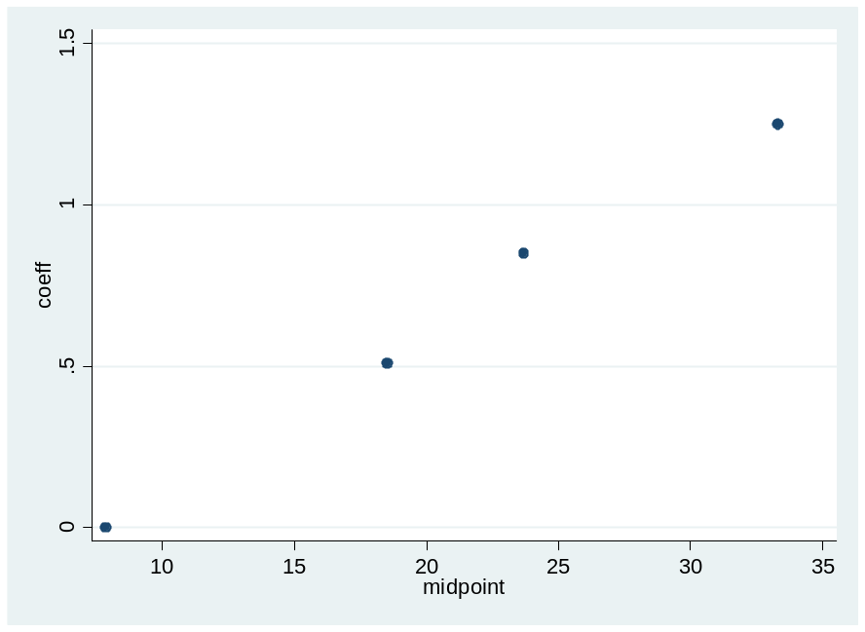
(d) Plots of sensitivity, specificity, total fraction correct and ROC curve
