m6A Peak Calling Reproduction - Dominissini et al (2012)
Charlie Lonergan
Introduction
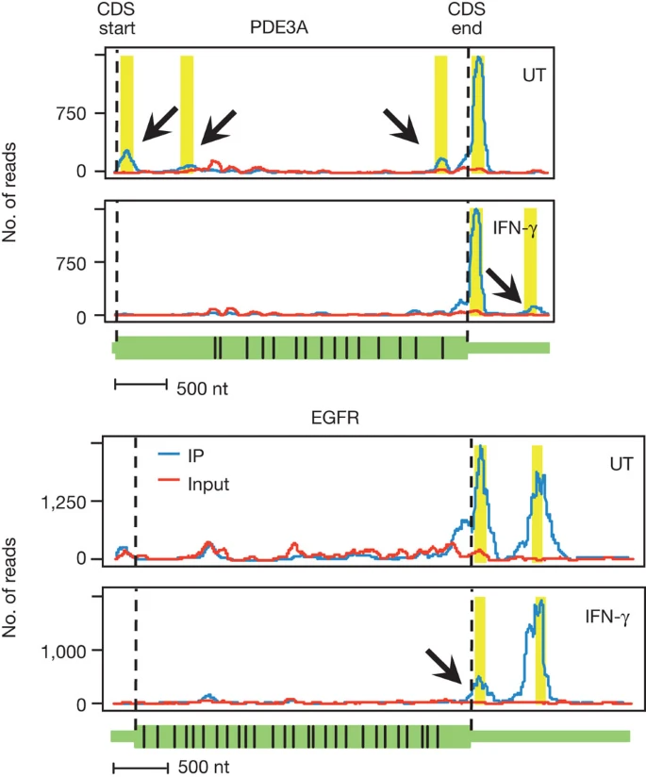
I was tasked with reproducing Figure 4 from Dominissini et al (2012) (nature.com/articles/nature11112):

The article is very vague on the details of how this figure was created. The article mentions use of an "in-house" script several times with minimum detail, so reproducing Fig 4 is a considerable challenge.

To attempt this, I made use of 'meripseqpipe' (github.com/ssun1116/meripseqpipe), a MeRIP-seq analysis pipeline that is still being developed for the nf-core Nextflow suite, with the hope that the results could be used to recreate Fig 4.
Troubleshooting
Initially, a lot of time was wasted when I made the mistake of pulling an outdated version of the pipeline, which itself has many moving parts and is not particularly easy to troubleshoot for a newcomer. The authors could improve this by making more extensive comments in their code, as the code itself is very elegant but can be hard to interpret.
Once I had written a design file and comparison file as instructed by the authors, created appropriate config files, and downloaded the relevant sample/genome data, the pipeline was run with the following command:

nextflow run meripseqpipe -profile m6a,docker --star_index index/star/ --designfile design.tsv --comparefile compare.txt --outdir results/
It should be noted that the preprocessing step of building a new index was very demanding in terms of computational resources, so I used a pre-built STAR index from a previous study, hence the ` --star_index index/star/` command..
Troubleshooting notes for the outdated version are as follows:

=======================================================================

1. StarIndex process requires lots of resources. Instead of making a new one, used Barry's index from the same genome as in the m6a study (NCBI36.54).
2. Process `RenameByDesignfile` terminated with an error exit status (1) - don't include file suffixes in design file.
3. Error executing process > 'EdgeR (UT_vs_IFN)'
Warning message:
In estimateDisp.default(y = y$counts, design = design, group = group, :
No residual df: setting dispersion to NA

github.com/tgirke/systemPipeR/issues/4
If needed you can use run_DESeq2 without replicates but the p/fdr values obtained remain questionable.
The run_edgeR function will not work out the box without replicates.
Caused by:
Process `DESeq2 (UT_vs_IFN)` terminated with an error exit status
Rscript /home/ec2-user/charlie/meripseqpipe/bin/DESeq2.R formatted_designfile.txt UT_vs_IFN
estimating size factors
estimating dispersions
Error in checkForExperimentalReplicates(object, modelMatrix) :

The design matrix has the same number of samples and coefficients to fit,
The design matrix has the same number of samples and coefficients to fit,
so estimation of dispersion is not possible. Treating samples
as replicates was deprecated in v1.20 and no longer supported since v1.22.

Calls: DESeq ... estimateDispersions -> .local -> checkForExperimentalReplicates
Execution halted

Work dir:
/home/ec2-user/charlie/work/13/18ebfa717a014a29543b717d0d99e8

Can't remember how this resolved

4. MergePeaks issue. Was using old version of meripseqpipe, resulted in errors. Pulled new. Still contained old main.nf for some reason (/old_meripseqpipe). Pulled again.

5. No such variable: format_design

-- Check script 'meripseqpipe/main.nf' at line: 341 or see '.nextflow.log' file for more details

Changed line 341 from
val design_info from format_design.collect()
to
val design_info from formatted_design.collect()

didn't work, doesn't seem to recognise any format_design, formatted_design, formatted_designfile, formatted_design_info for .collect() in CheckDesignCompare process.

Going back to the old way.

rename.sh and rename_for_resume.sh missing - copying from leipzig/m6a

6. No rseqc.sh - skip_rseqc = true

7. main.nf was compromised - fresh pull from kingzhuky.
updated m6a.config, nextflow.config, moved test_data in home directory

8. Error executing process > 'EdgeR (UT_vs_IFN)'

Caused by:
Process `EdgeR (UT_vs_IFN)` terminated with an error exit status (1)

Command executed:

Rscript /home/ec2-user/charlie/meripseqpipe/bin/edgeR.R formatted_designfile.txt UT_vs_IFN

Command exit status:
1

Command output:
(empty)

Command error:
Loading required package: limma
Warning message:
In estimateDisp.default(y = y$counts, design = design, group = group, :
No residual df: setting dispersion to NA
Error in glmFit.default(y = y$counts, design = design, dispersion = dispersion, :

Command output:
(empty)

Command error:
Loading required package: limma
Warning message:
In estimateDisp.default(y = y$counts, design = design, group = group, :
No residual df: setting dispersion to NA
Error in glmFit.default(y = y$counts, design = design, dispersion = dispersion, :
dispersion must be numeric
Calls: glmFit -> glmFit.DGEList -> glmFit -> glmFit.default
Execution halted

Work dir:
/home/ec2-user/charlie/work/47/e30ad2033f53316a55e62e6ac44a3d

Tip: you can replicate the issue by changing to the process work dir and entering the command `bash .command.run

Resolved with skip_edger = true
=======================================================================
Once I knew I had used the wrong version, the next attempt was much more successful. The pipeline ran smoothly until the 'QCPeaksReport' step at the end of the pipeline:

Caused by:
Process `QCPeaksReport` terminated with an error exit status (1)

Command executed:

cp /home/ec2-user/charlie/meripseqpipe/bin/QC_Peaks_Report.rmd ./
Rscript /home/ec2-user/charlie/meripseqpipe/bin/QC_Peaks_Report.R formatted_desi>
R -e "load(\"QCPeakPlot.RData\");rmarkdown::render('QC_Peaks_Report.rmd',output_>

Command exit status:
1
This was resolved by updating the GTF file’s “gene type” using the command:
awk 'BEGIN{FS=OFS="\t"}{$9=$9" gene_type \""$2"\";"}1' old_Homo_sapiens.NCBI36.54.gtf > outfile.gtf

The old GTF contained the following gene types:
awk '{print $3}' Homo_sapiens.NCBI36.54.gtf | sort -u
CDS
exon
start_codon
stop_codon

This was changed to:
awk '{print $3}' final.gtf | sort -u

CDS
exon
five_prime_utr
gene
start_codon
stop_codon
three_prime_utr
transcript
The pipeline then failed at the ‘DiffReport’ process:
Caused by:
Process `DiffReport` terminated with an error exit status (1)

Command executed:

cp /home/ec2-user/charlie/meripseqpipe/bin/DiffReport.rmd ./
if [ "[UT_vs_IFN]" != "[two_group]" ]; then
echo [UT_vs_IFN] | sed 's/^\[//g' | sed 's/\]$//g' | sed s/[[:space:]]//g > compare_info
else
echo $(awk 'BEGIN{FS=","}NR>1{print $4}' formatted_designfile.txt |sort|uniq|awk 'NR==1{printf $0"_vs_"}NR==2{print $0}') > compare_info
fi
Rscript /home/ec2-user/charlie/meripseqpipe/bin/arranged_results.R formatted_designfile.txt compare_info Wilcox-test edgeR rank
Rscript /home/ec2-user/charlie/meripseqpipe/bin/DiffReport.R *.m6APipe DiffReport.RData
R -e "load(\"DiffReport.RData\");rmarkdown::render('DiffReport.rmd',output_file='DiffReport_rank_Wilcox-test_edgeR.html')"
rm Rplots.pdf

Command exit status:
1

Command output:
(empty)
Command error:
Error in file(file, "rt") : invalid 'description' argument
Calls: read.csv -> read.table -> file
Execution halted
This was resolved by setting the EDITOR to use R. Once this was done, meripseqpipe completed without any errors, however more work is required to visualise the results in a way that replicates Figure 4.
Recommendations
This task would have been made significantly simpler if the original authors had provided more detail on their “in-house” peak calling pipeline, ideally by providing the pipeline script and any dependent scripts / software.
While descriptions of the software used (e.g. MACS, DESeq, Cufflinks, etc.) and the main parameters were provided, this is not ideal when replicating a study due to compatibility issues, dependencies, etc. In order to fully scrutinise the processes used, a full script should be provided and, ideally, a markdown script to walk through the analysis.

