REPORT SAMPLE
GRAPHICS

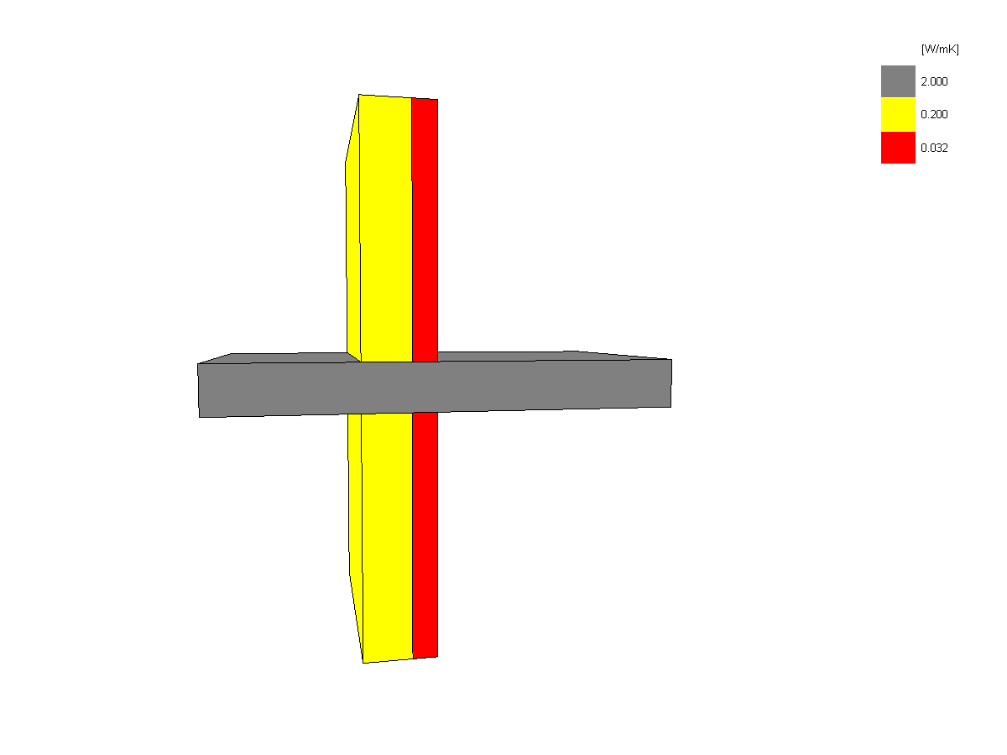

Figure 1. Object geometry
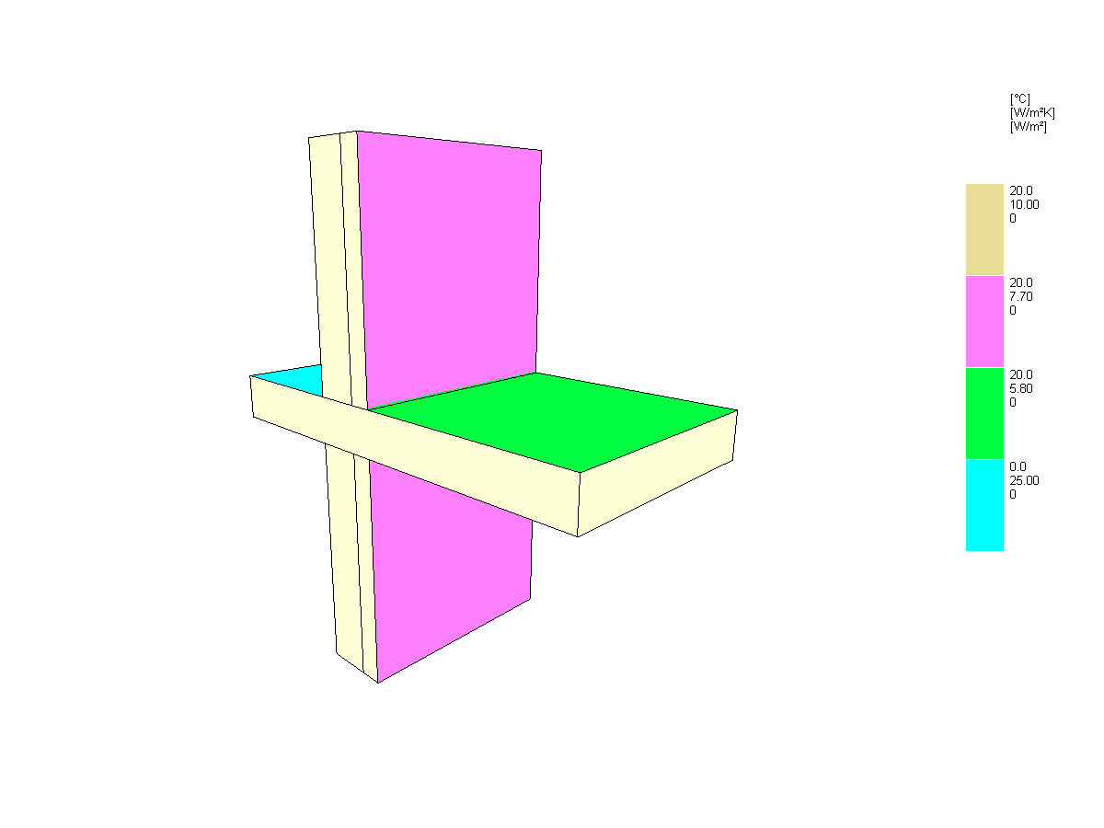
Figure 2. Isotherms
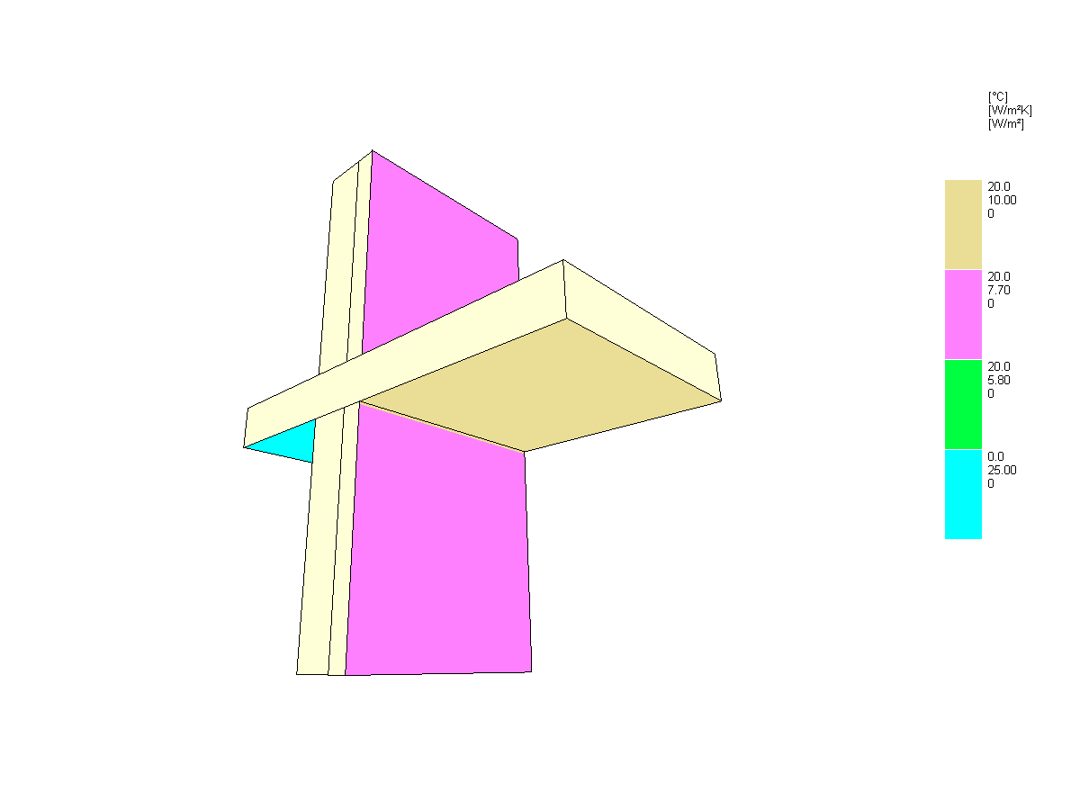
Figure 3. Flanking elements
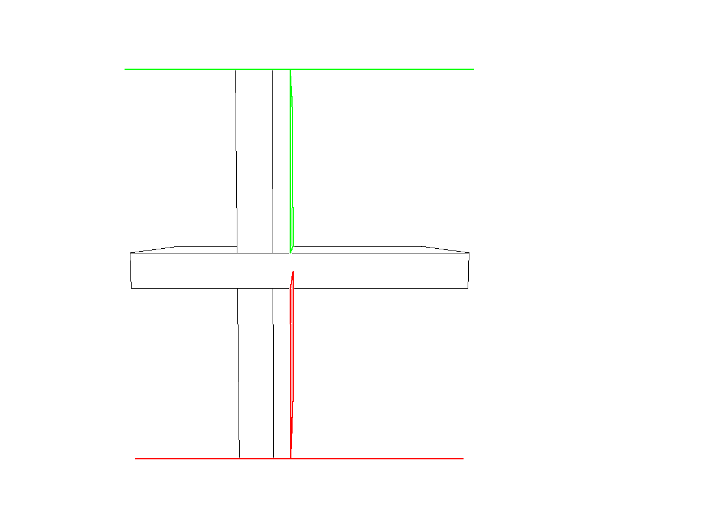
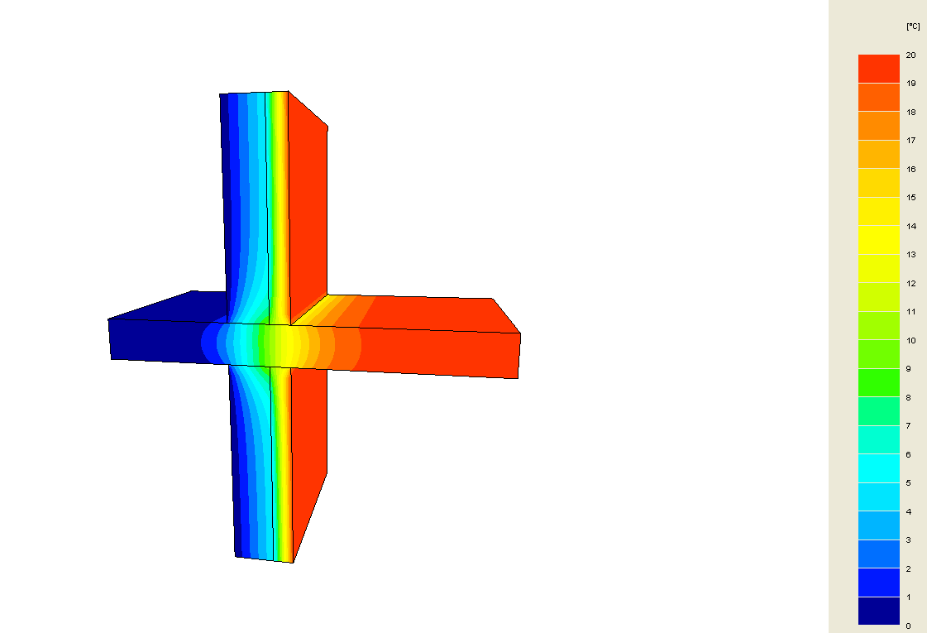
TRISCO DATA SUMMARY
TRISCO data file POba_BRIQUE_INT.trc
Number of nodes 2582

Material properties table
Coul. Nom lambda eps
[W/mK] [-]
4 TH32 0.032
7 Brique 0.200
8 B騁on 2.000

Boundary condition table
Coul. Nom t h q ta tr hc Pc
[ｰC] [W/mｲK] [W/mｲ] [ｰC] [ｰC] [W/mｲK] [W]
5 Exterieur 0.0 25.00 0
6 Interieur descendant 20.0 5.80 0
14 Interieur horizonat 20.0 7.70 0
15 Interieur montant 20.0 10.00 0

TRISCO MAIN RESULTS
Temperature factor

Linear thermal transmittance
Coefficient de transmission thermique linéique (EN ISO 10211)
psi = (Q/(ti-te) - U1*A1 - U2*A2)/l = 0.757 W/(m.K)
Coefficient de transmission thermique équivalent
Ueq = Q/((ti-te)*(A1+A2)) = 0.611 W/(m².K)
Q = 24.456 W
ti = 20.00°C
te = 0.00°C
U1 = 0.233 W/(m².K)
Xmin=0 Xmax=40 Ymin=0 Ymax=0 Zmin=0 Zmax=0
A1 = 1 m²
Xmin=30 Xmax=30 Ymin=0 Ymax=1 Zmin=0 Zmax=20
U2 = 0.233 W/(m².K)
Xmin=0 Xmax=40 Ymin=0 Ymax=0 Zmin=50 Zmax=50
A2 = 1 m²
Xmin=30 Xmax=30 Ymin=0 Ymax=1 Zmin=30 Zmax=50
l = 1 m

