This quick start guide presents, in under 10 minutes, how to model the thermal bridge shown below.
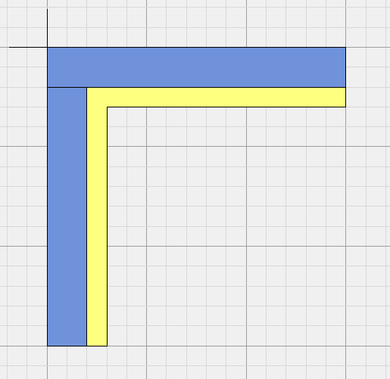
200 mm
100 mm
Plaster
Glass wool

The thermal bridge is modeled in the “Model” tab.
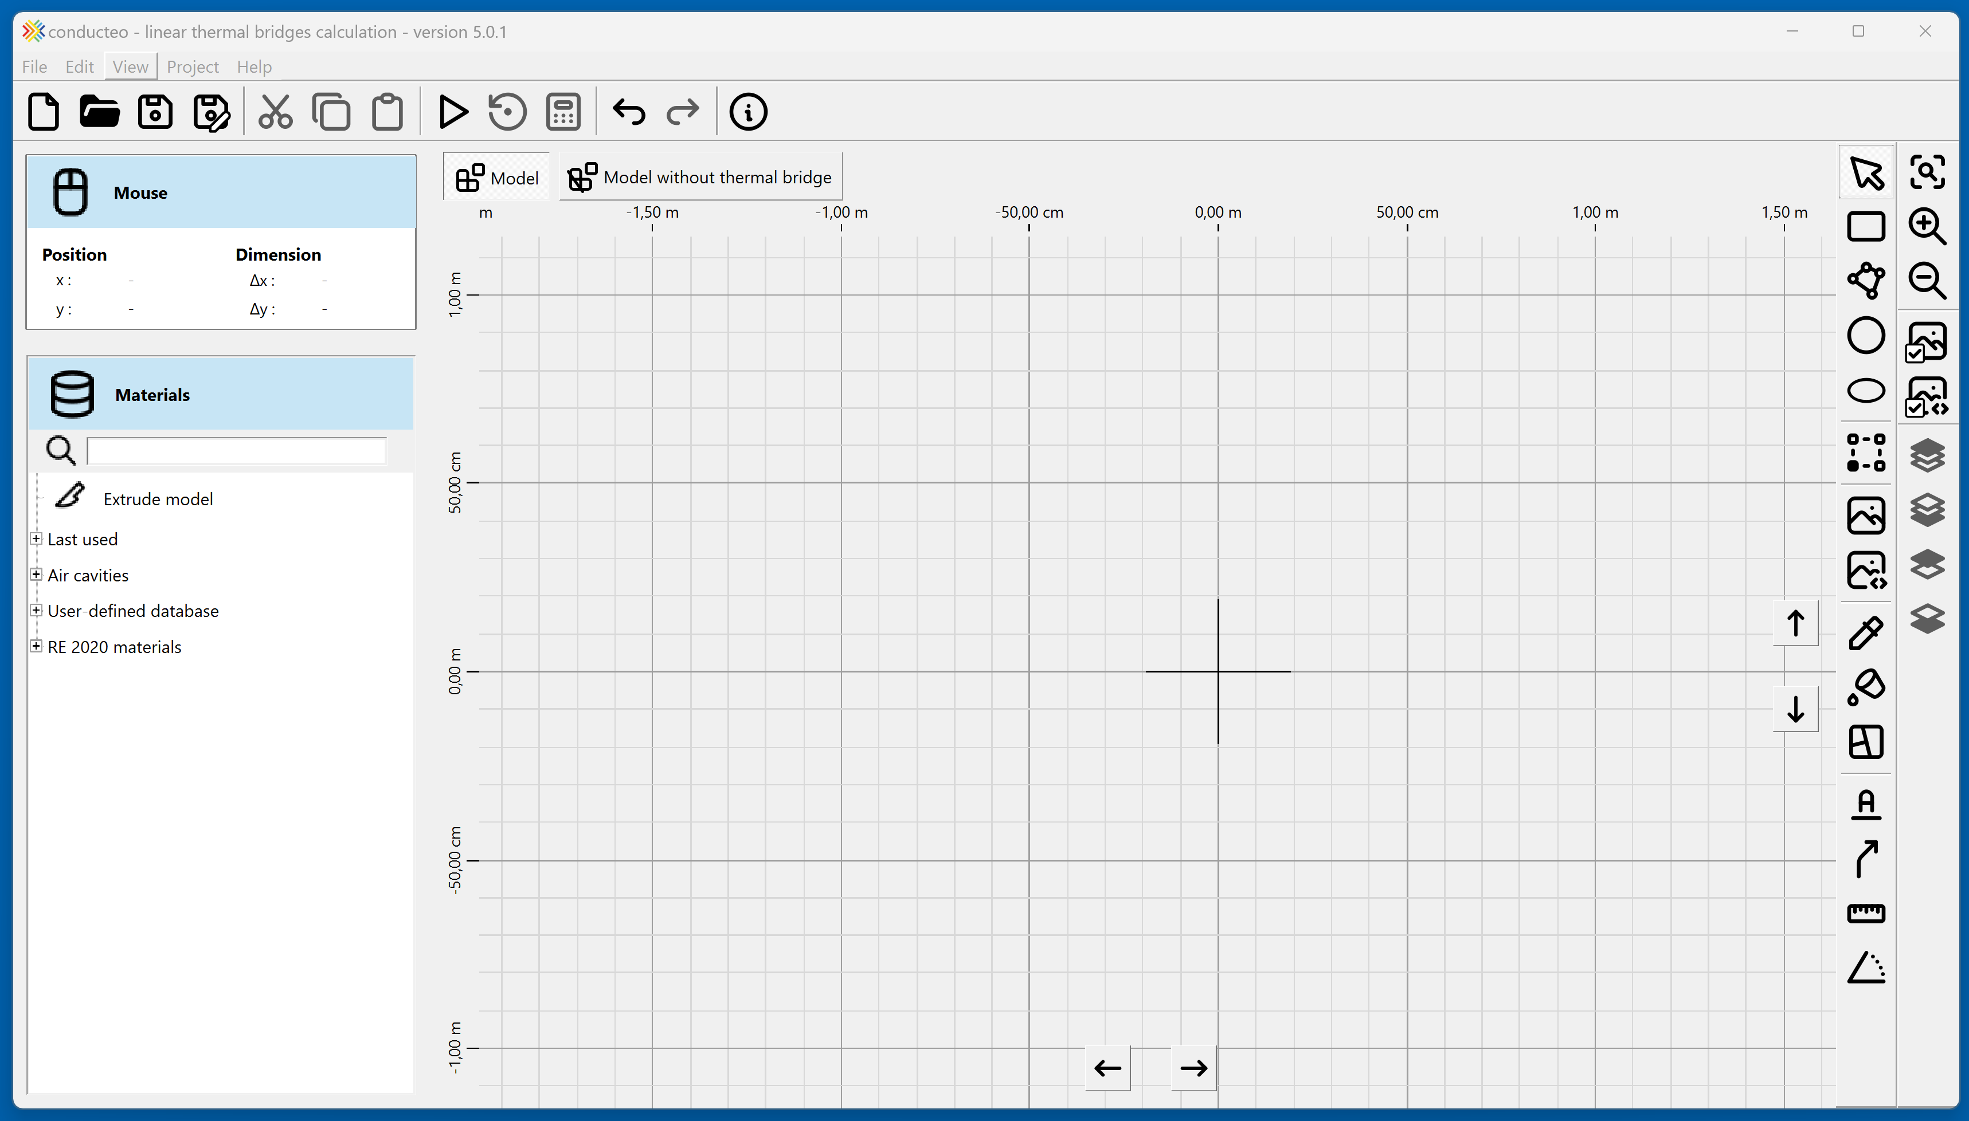

The “Materials” tab provides several libraries, with a search field.

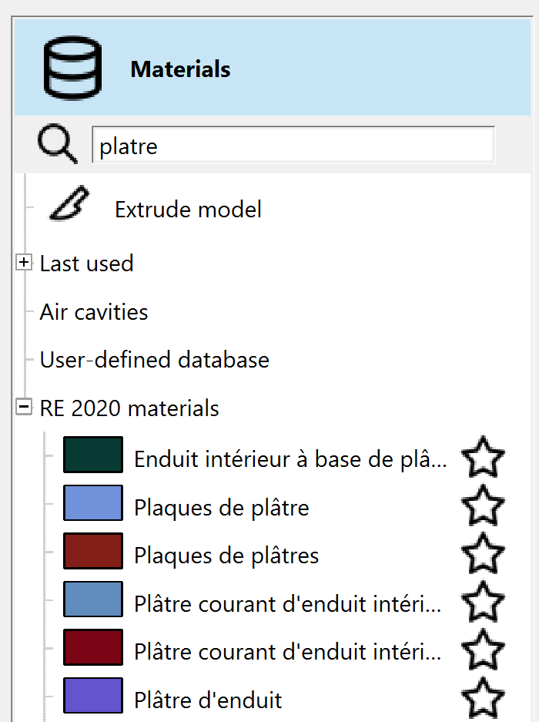
Filtered materials list
Search for the material “Plaster”

Double-clicking a material allows you to edit its properties.
Double-clicking the color opens a dialog to modify the material color.
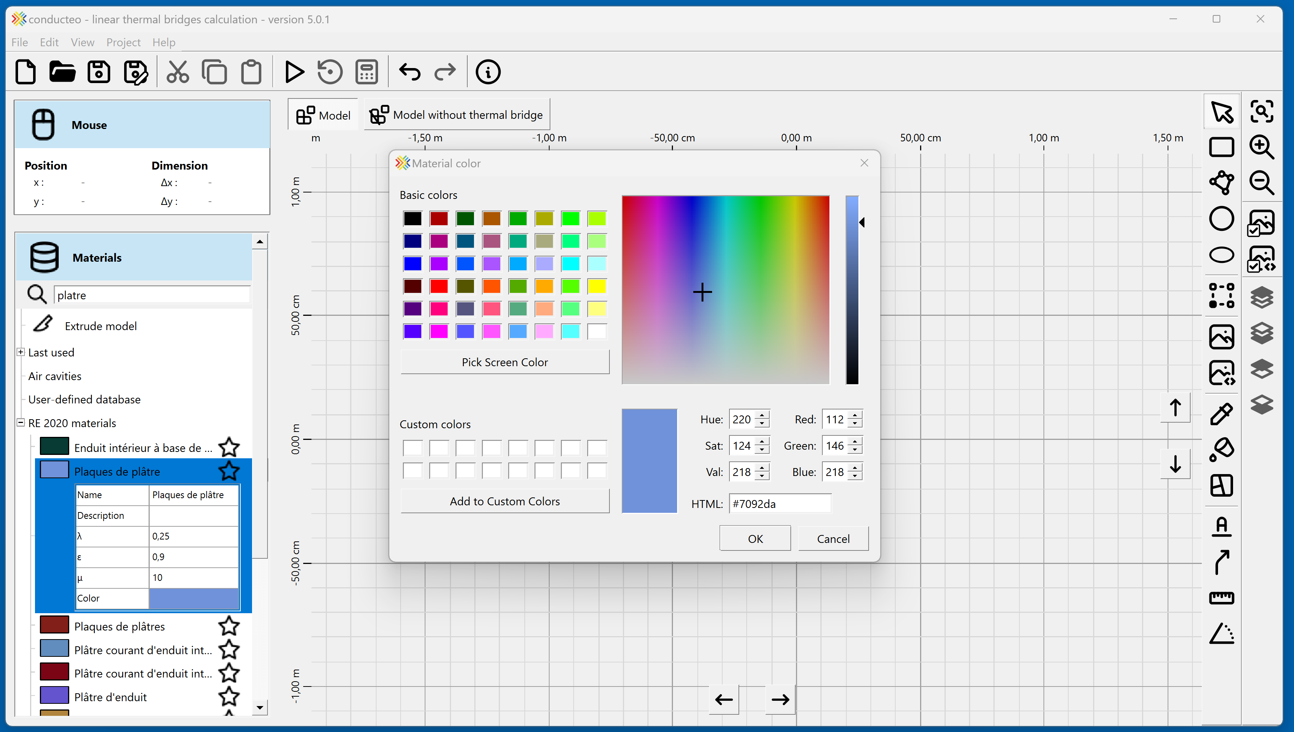
Material color selection
Material
properties

Les

Clicking the star of a material marks it as a favorite.
Favorite materials are displayed at the top of the list.

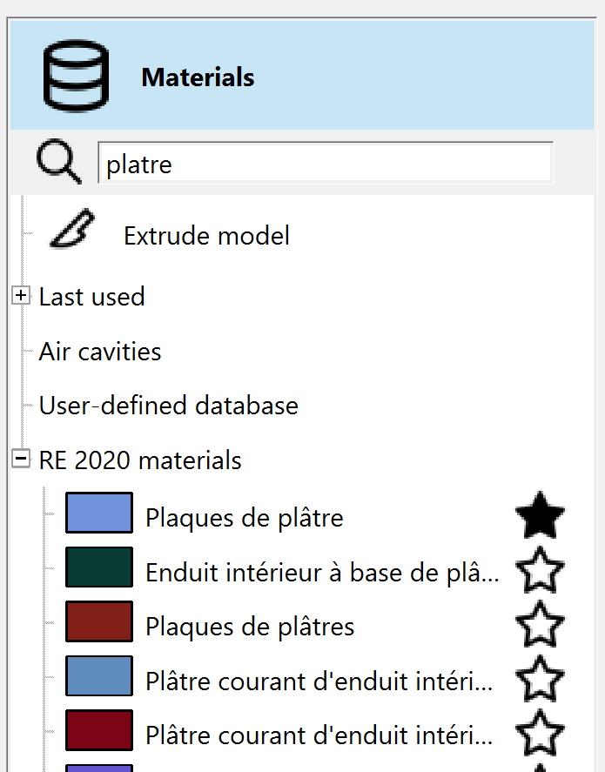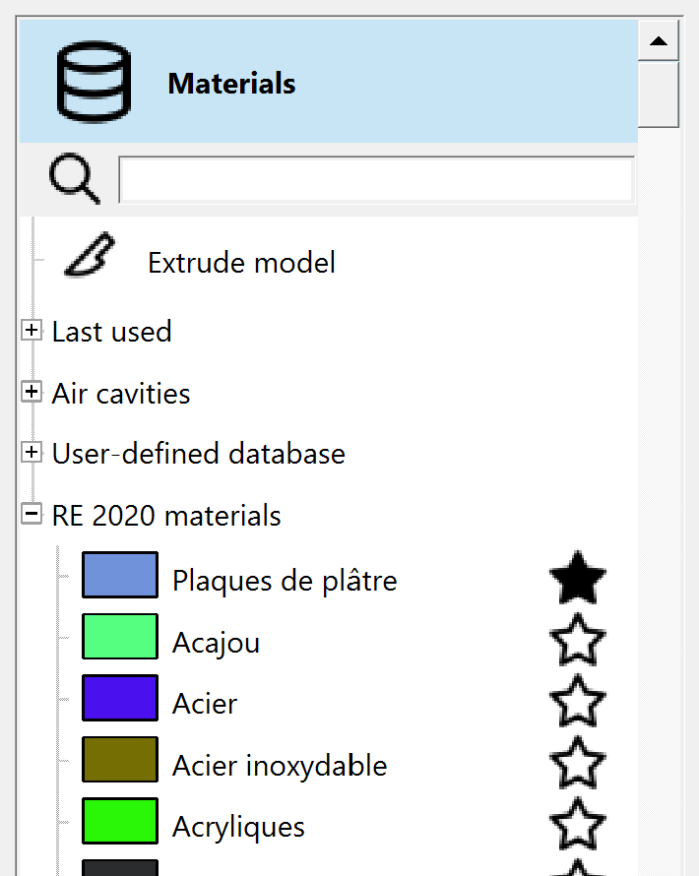
Favorite materials at the top of the list
Clear search field
Material marked
as favorite

By selecting the “Draw rectangle” option, it is possible to add rectangular volumes with the mouse in the model.
Rectangular volume drawn with the mouse
Rectangle
dimensions
Draw rectangle
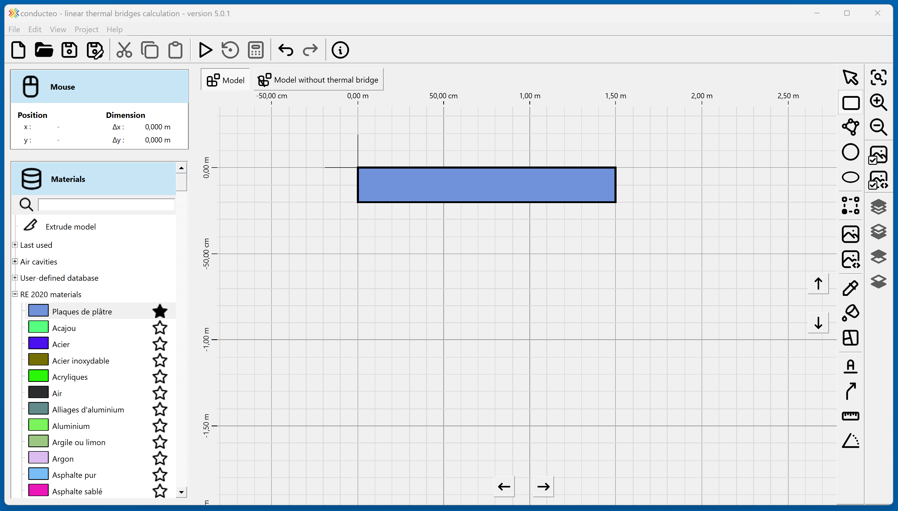

Right-clicking the user library allows you to add materials and categories.
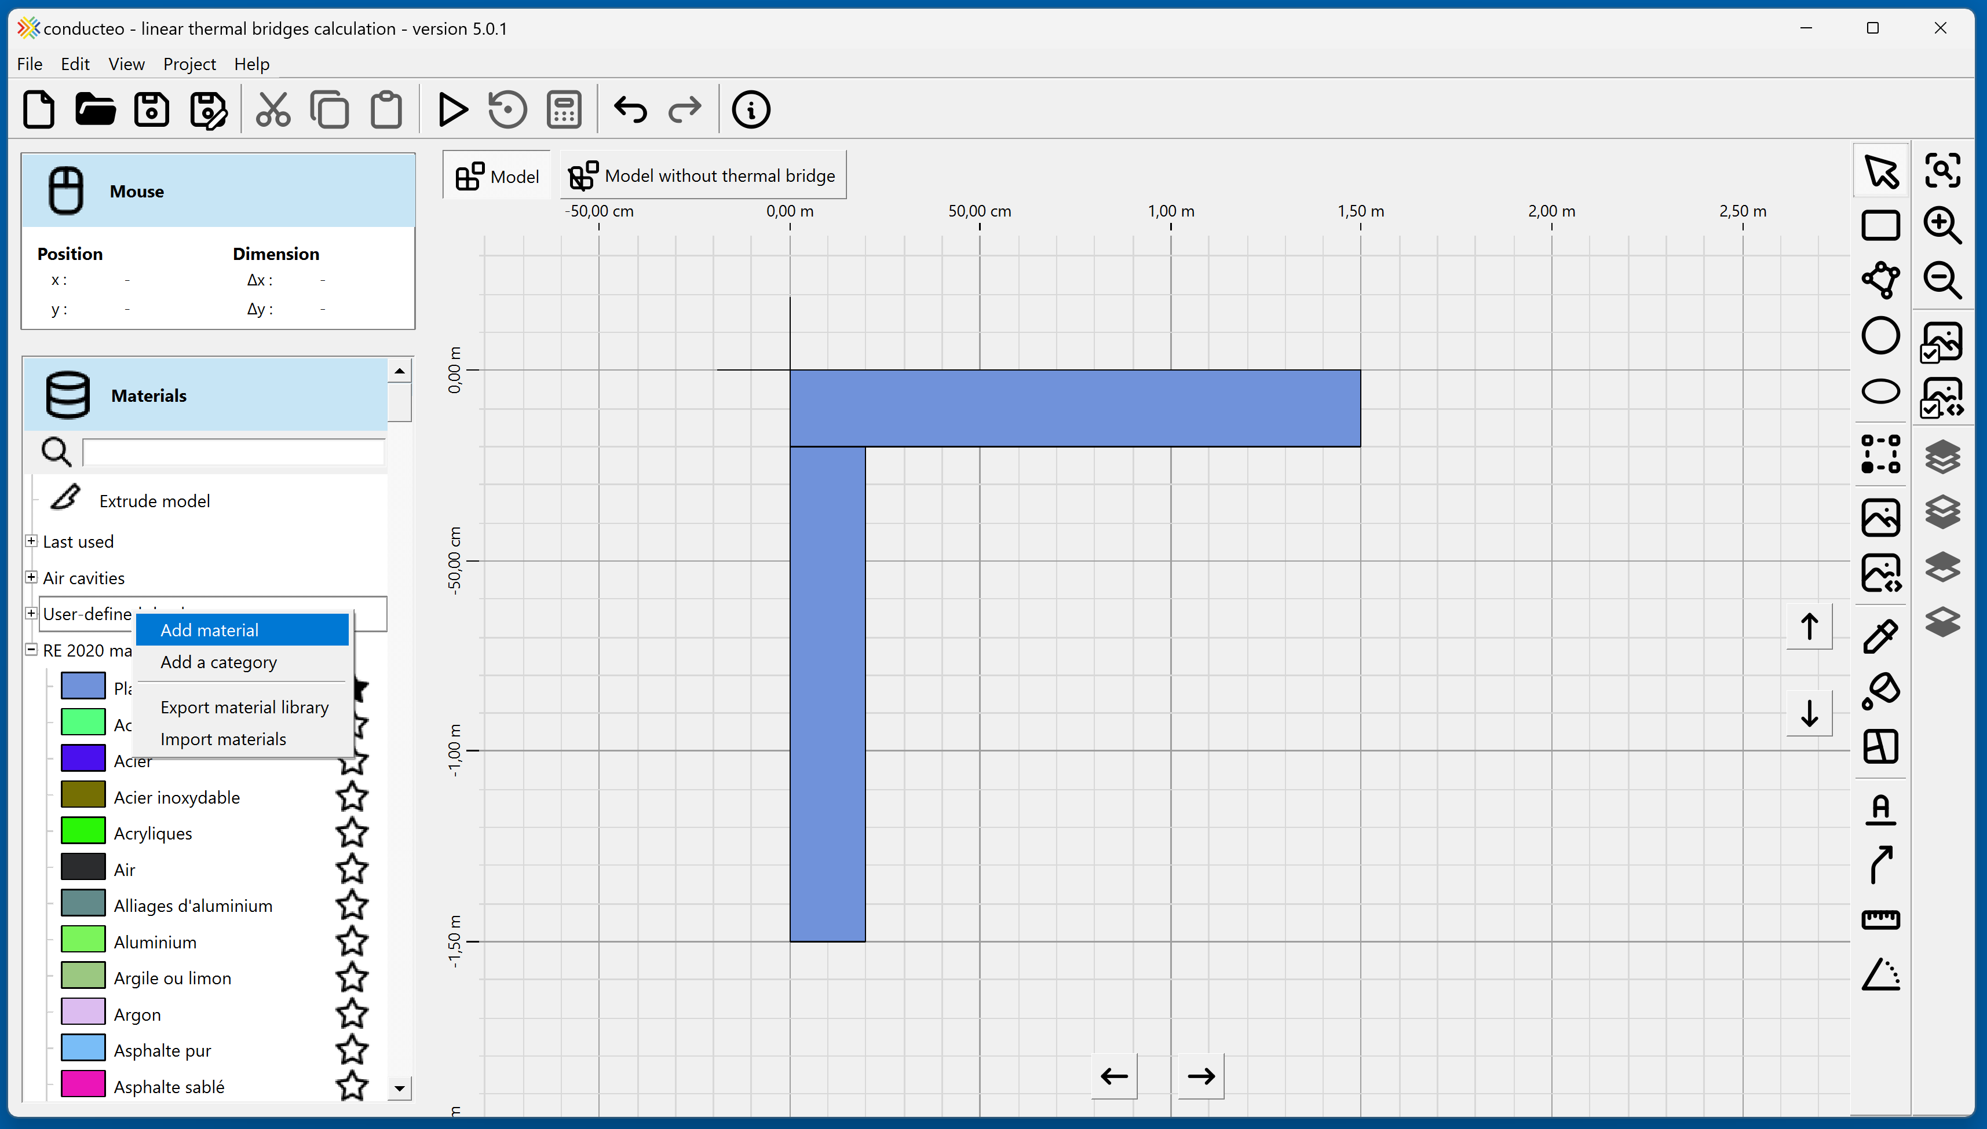

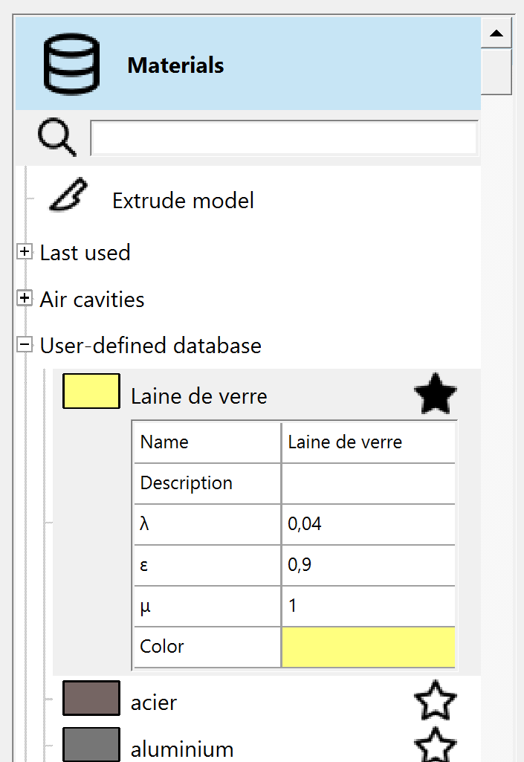
Add a material
Glass wool added

By selecting the “Draw closed polyline” option, it is possible to draw a non-rectangular volume. The volume is completed when returning to the starting point.
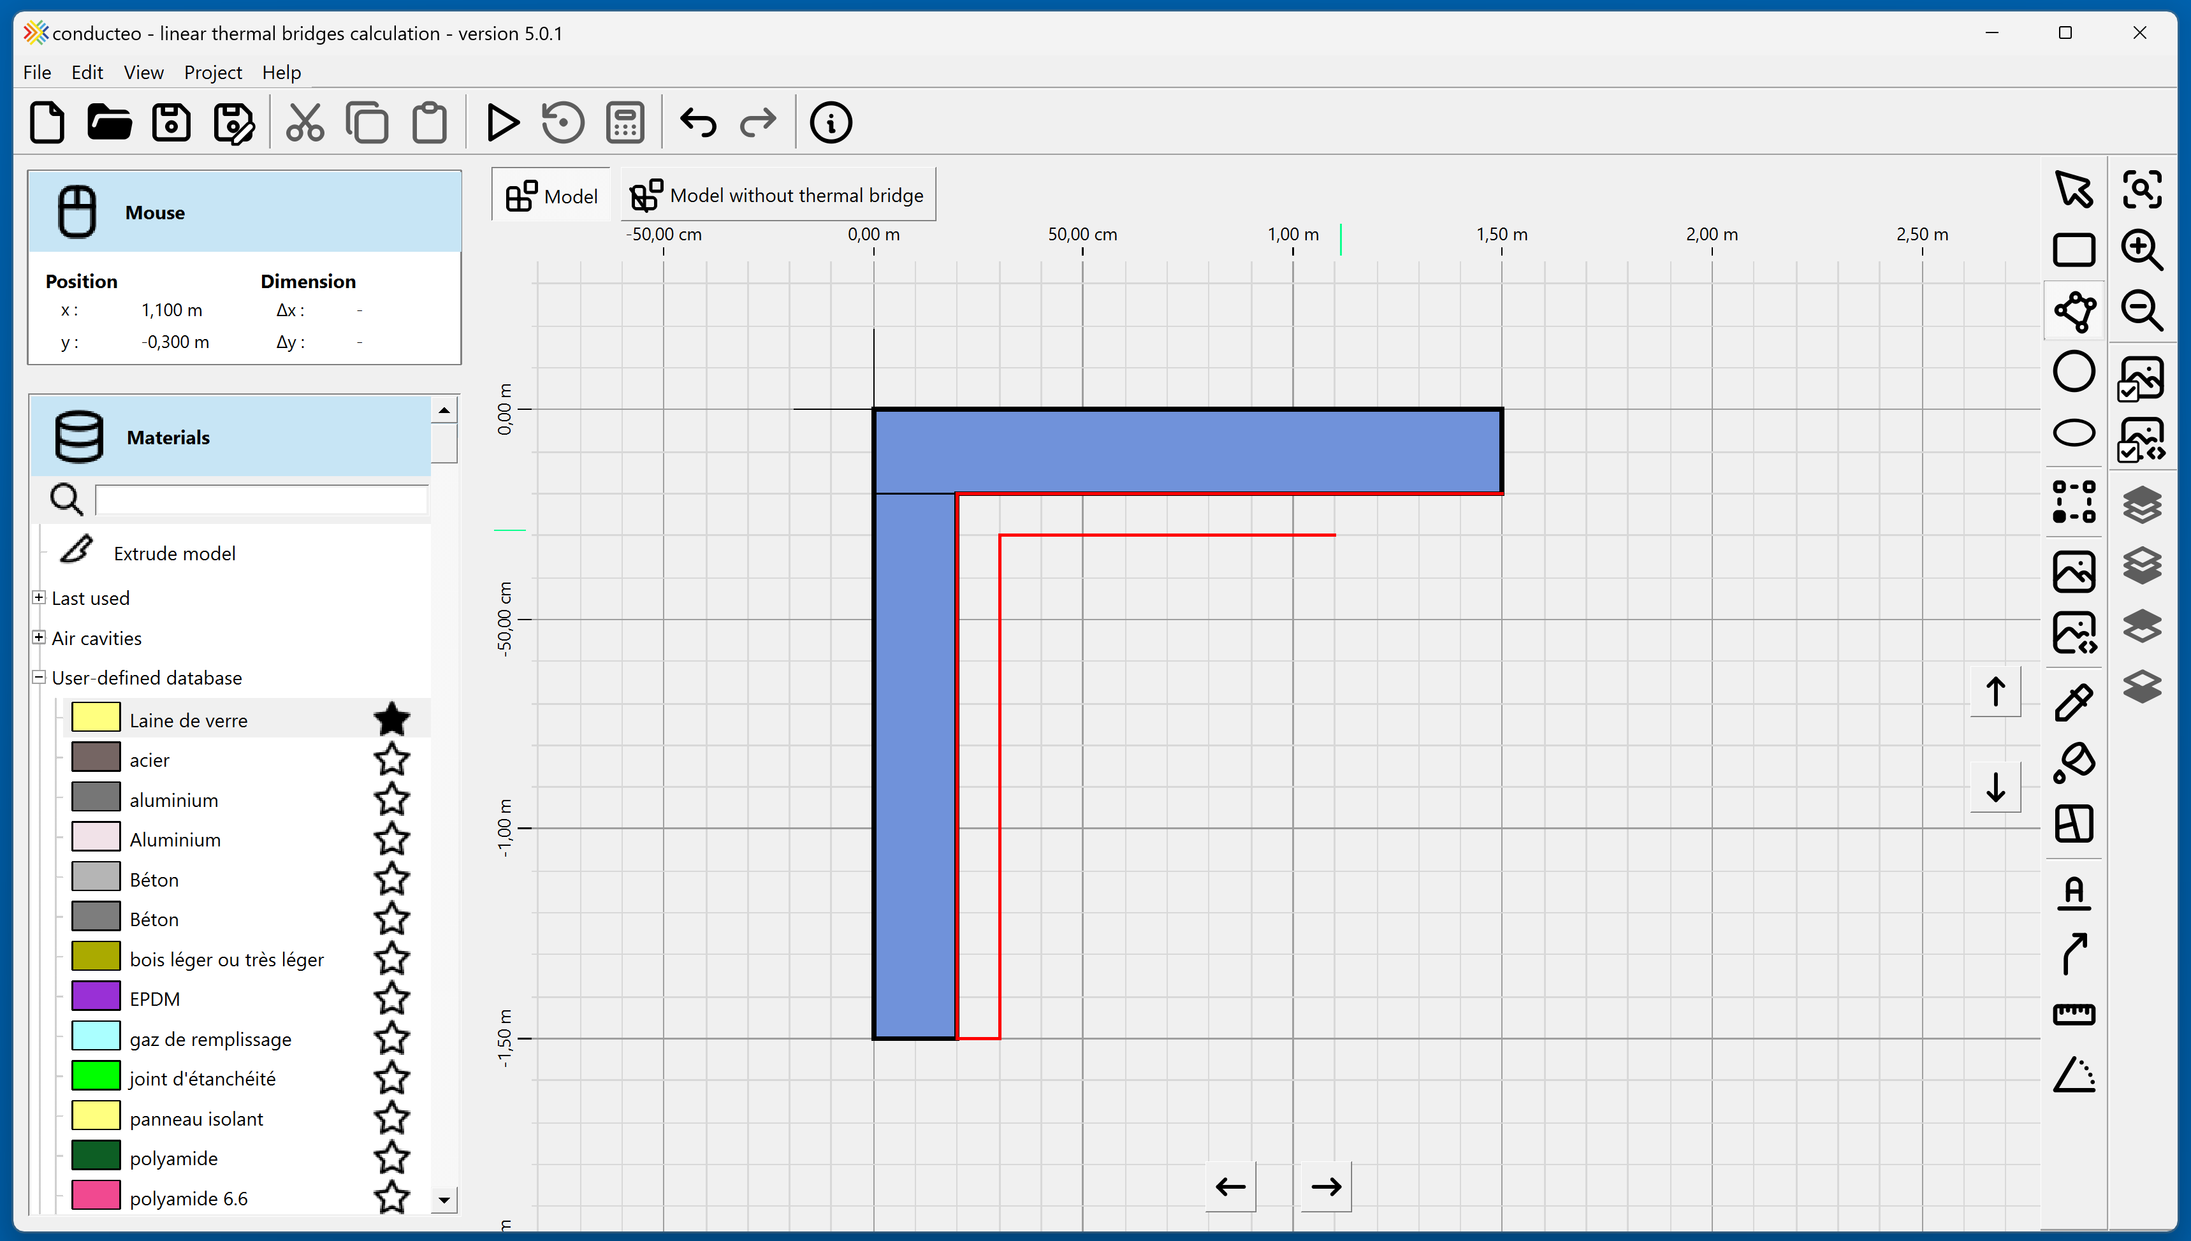
Closed polyline drawn with the mouse
Draw closed polyline

It is possible to adjust the zoom and the view position. The mouse wheel allows you to change the zoom level. The view can be moved by dragging the mouse while holding the wheel button down.
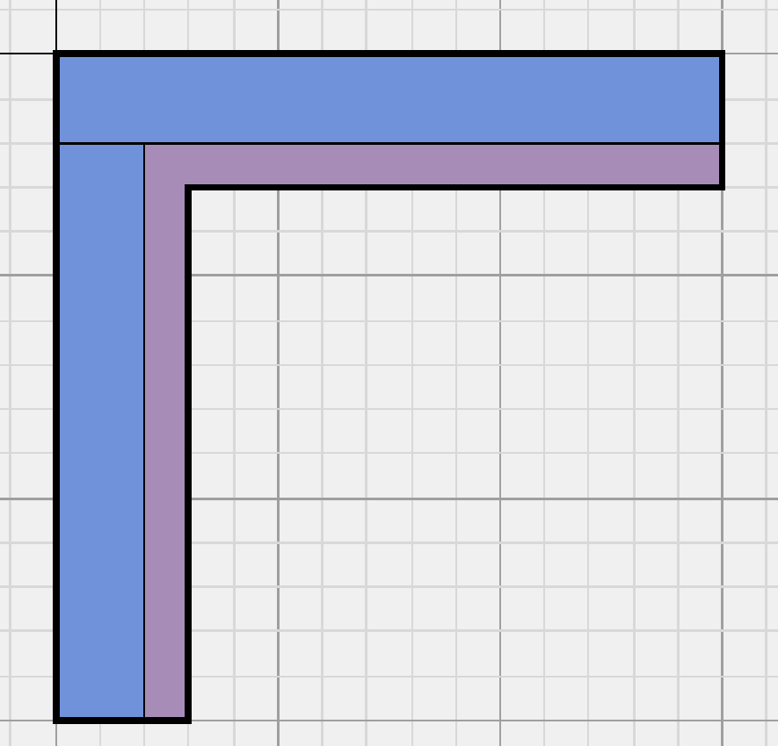

Fit view
Zoom in/out

The “Materials and boundary conditions” button allows you to define boundary conditions on surfaces. The list of boundary conditions is displayed on the left.

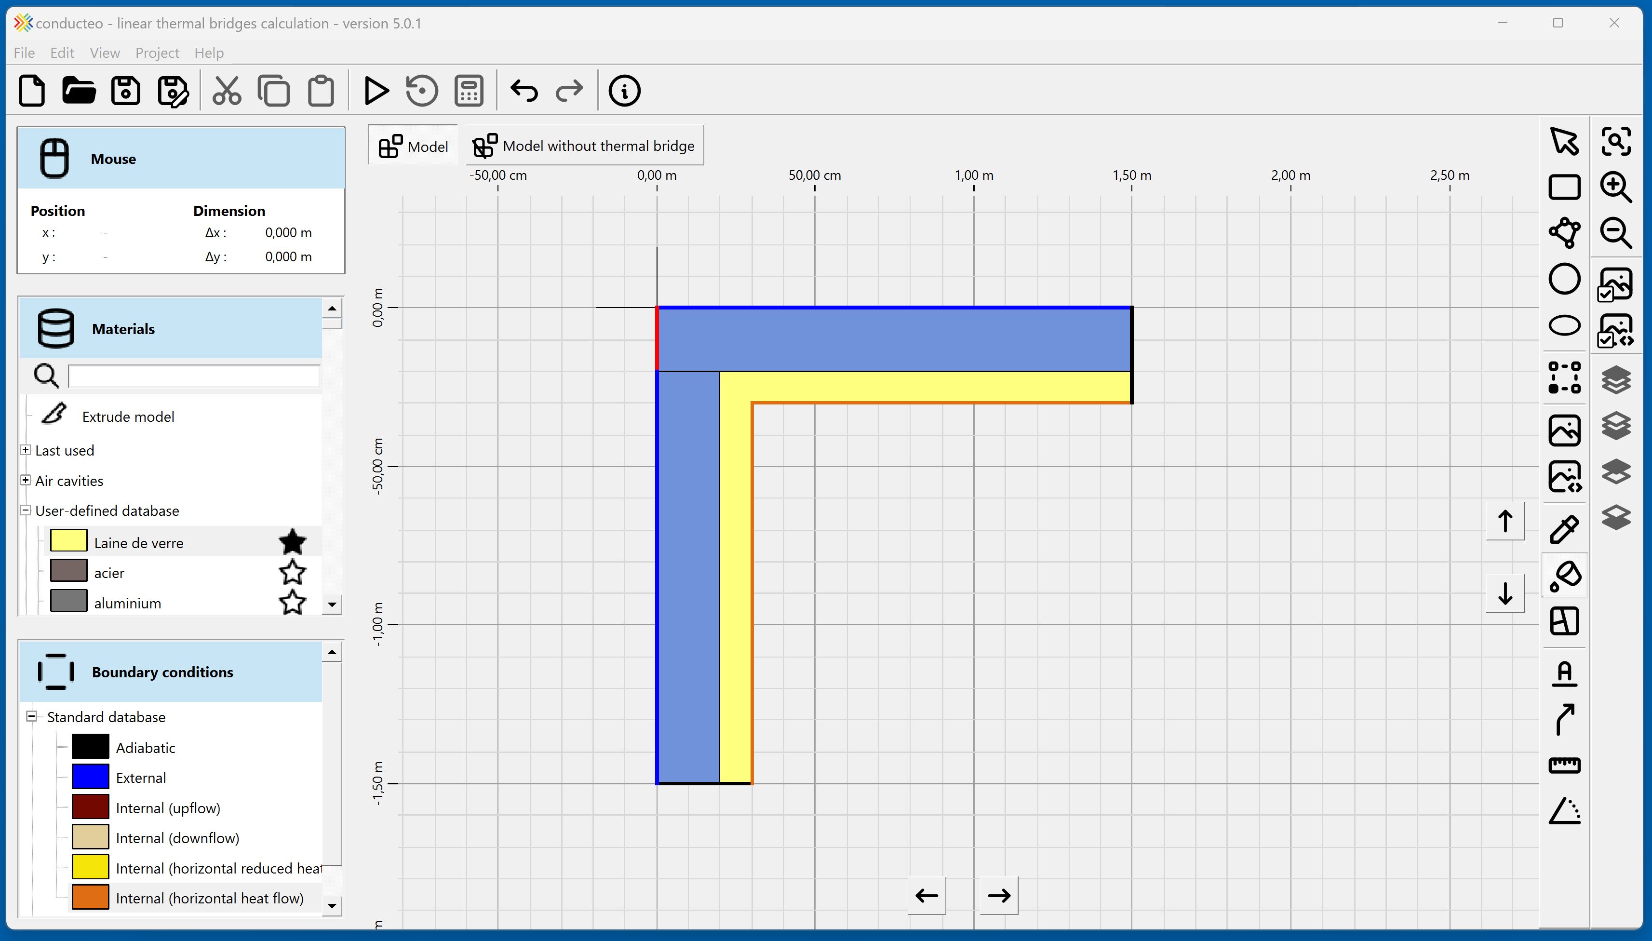
Boundary conditions list

Define boundary conditions with the mouse
Materials and boundary conditions

The modeling of the element with a thermal bridge is complete.
It is now necessary to model the element without a thermal bridge.
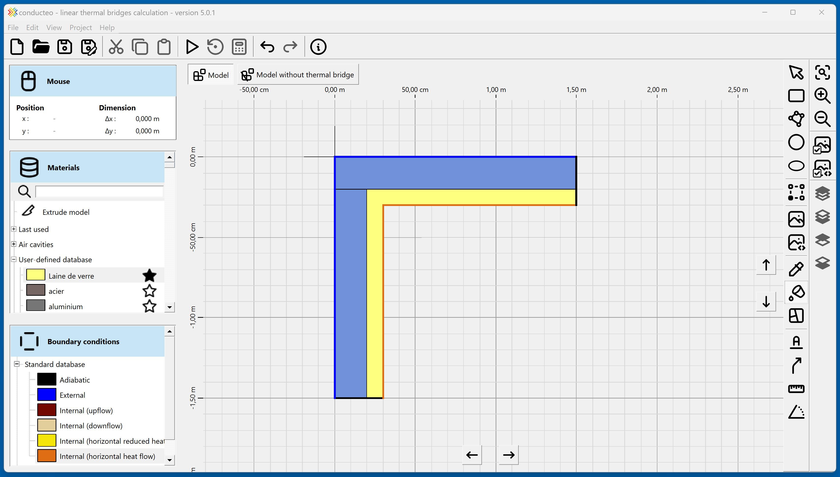

“Model without thermal bridge” tab

The “Duplicate model” option allows you to copy the model with a thermal bridge into the “Model without thermal bridge” tab.
“Extrude model” allows you to add extrusions to remove the junction creating the thermal bridge.
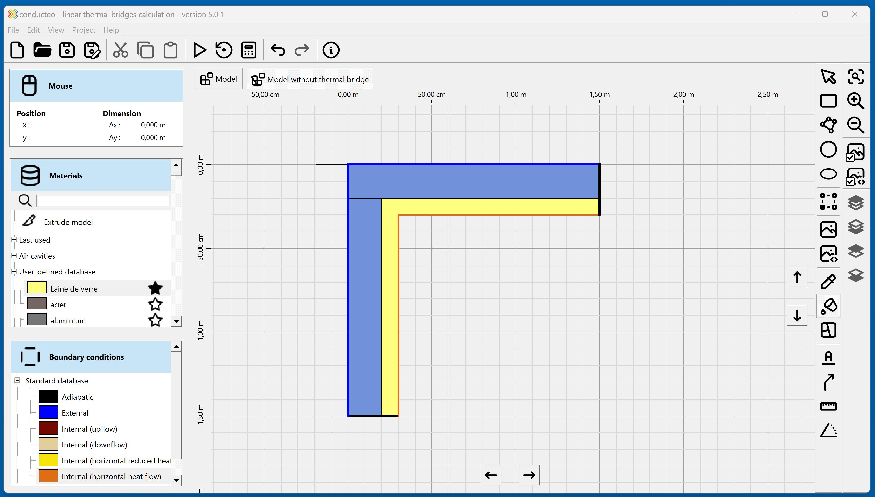

Duplicate model
Extrude model

The junction between the two walls (creating the thermal bridge) is removed by extrusion: drawing a rectangular volume without material.
Final result
Extrusion
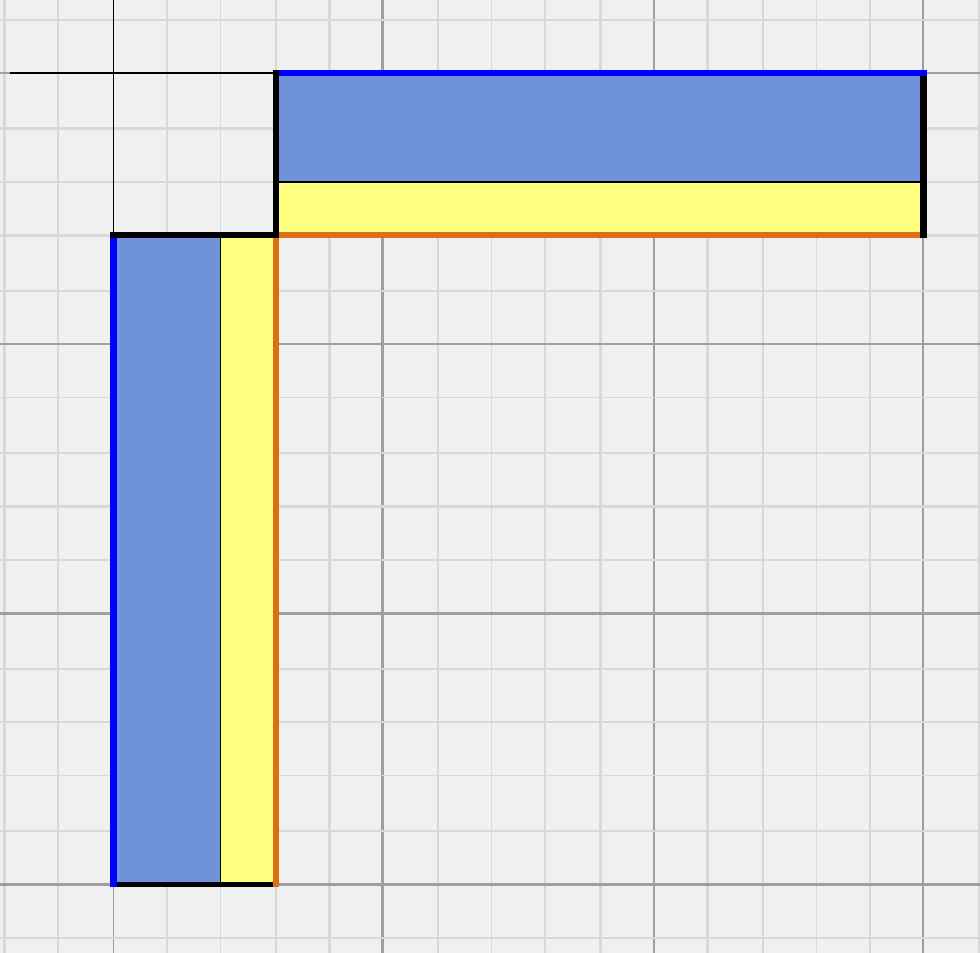
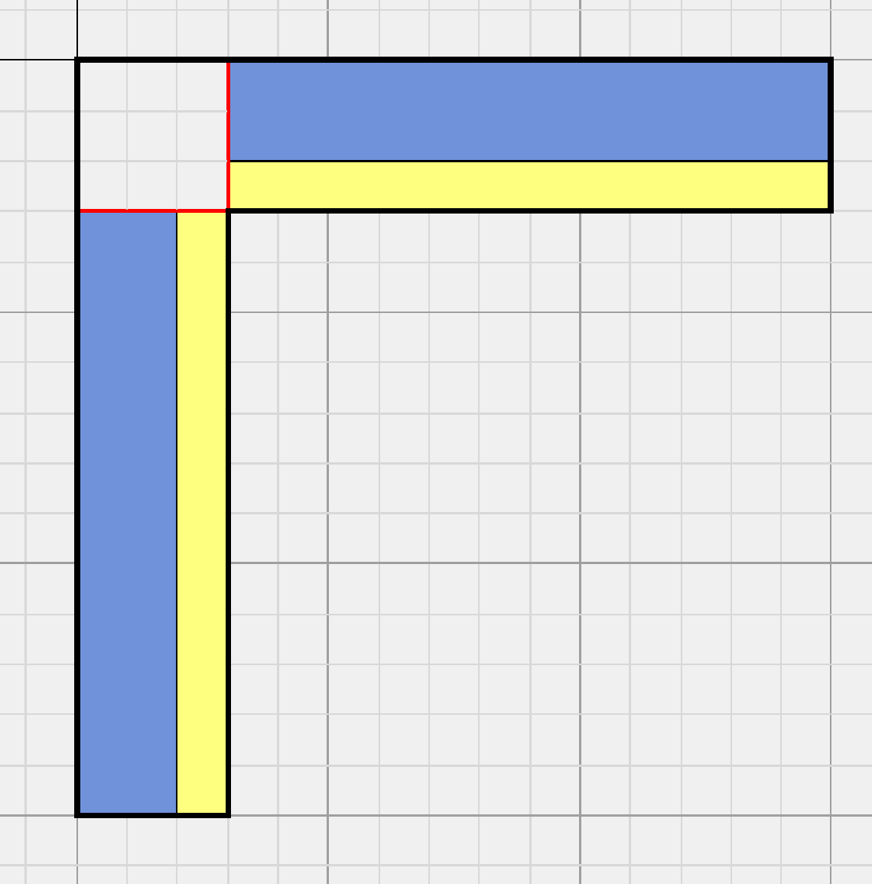

The simulation can now be started.
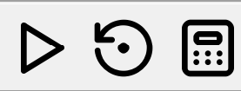
Start simulation

The “Results” tab allows you to display the temperature field.
The temperature under the cursor is shown on the left.
The heat flows for the models with and without a thermal bridge, as well as the thermal bridge value, are displayed.
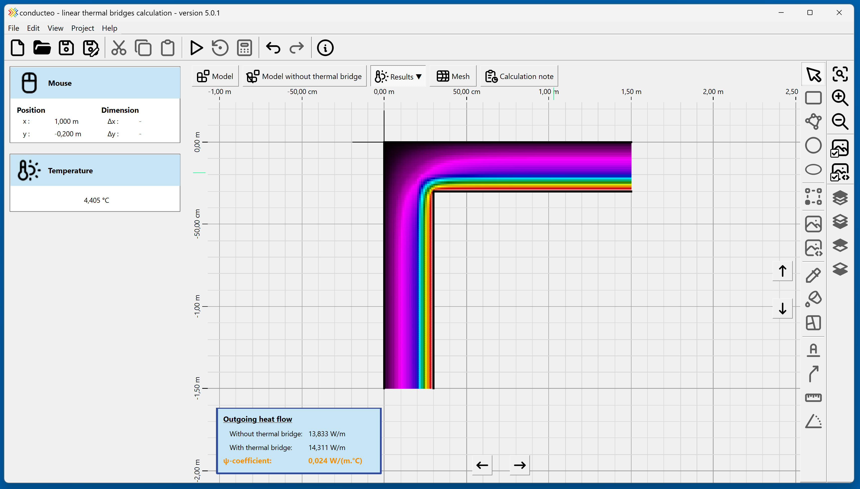
Display results

Temperature under the cursor
Temperature field
Heat flows and thermal bridge

The “Results” tab allows you to display the temperature field for the model without a thermal bridge.

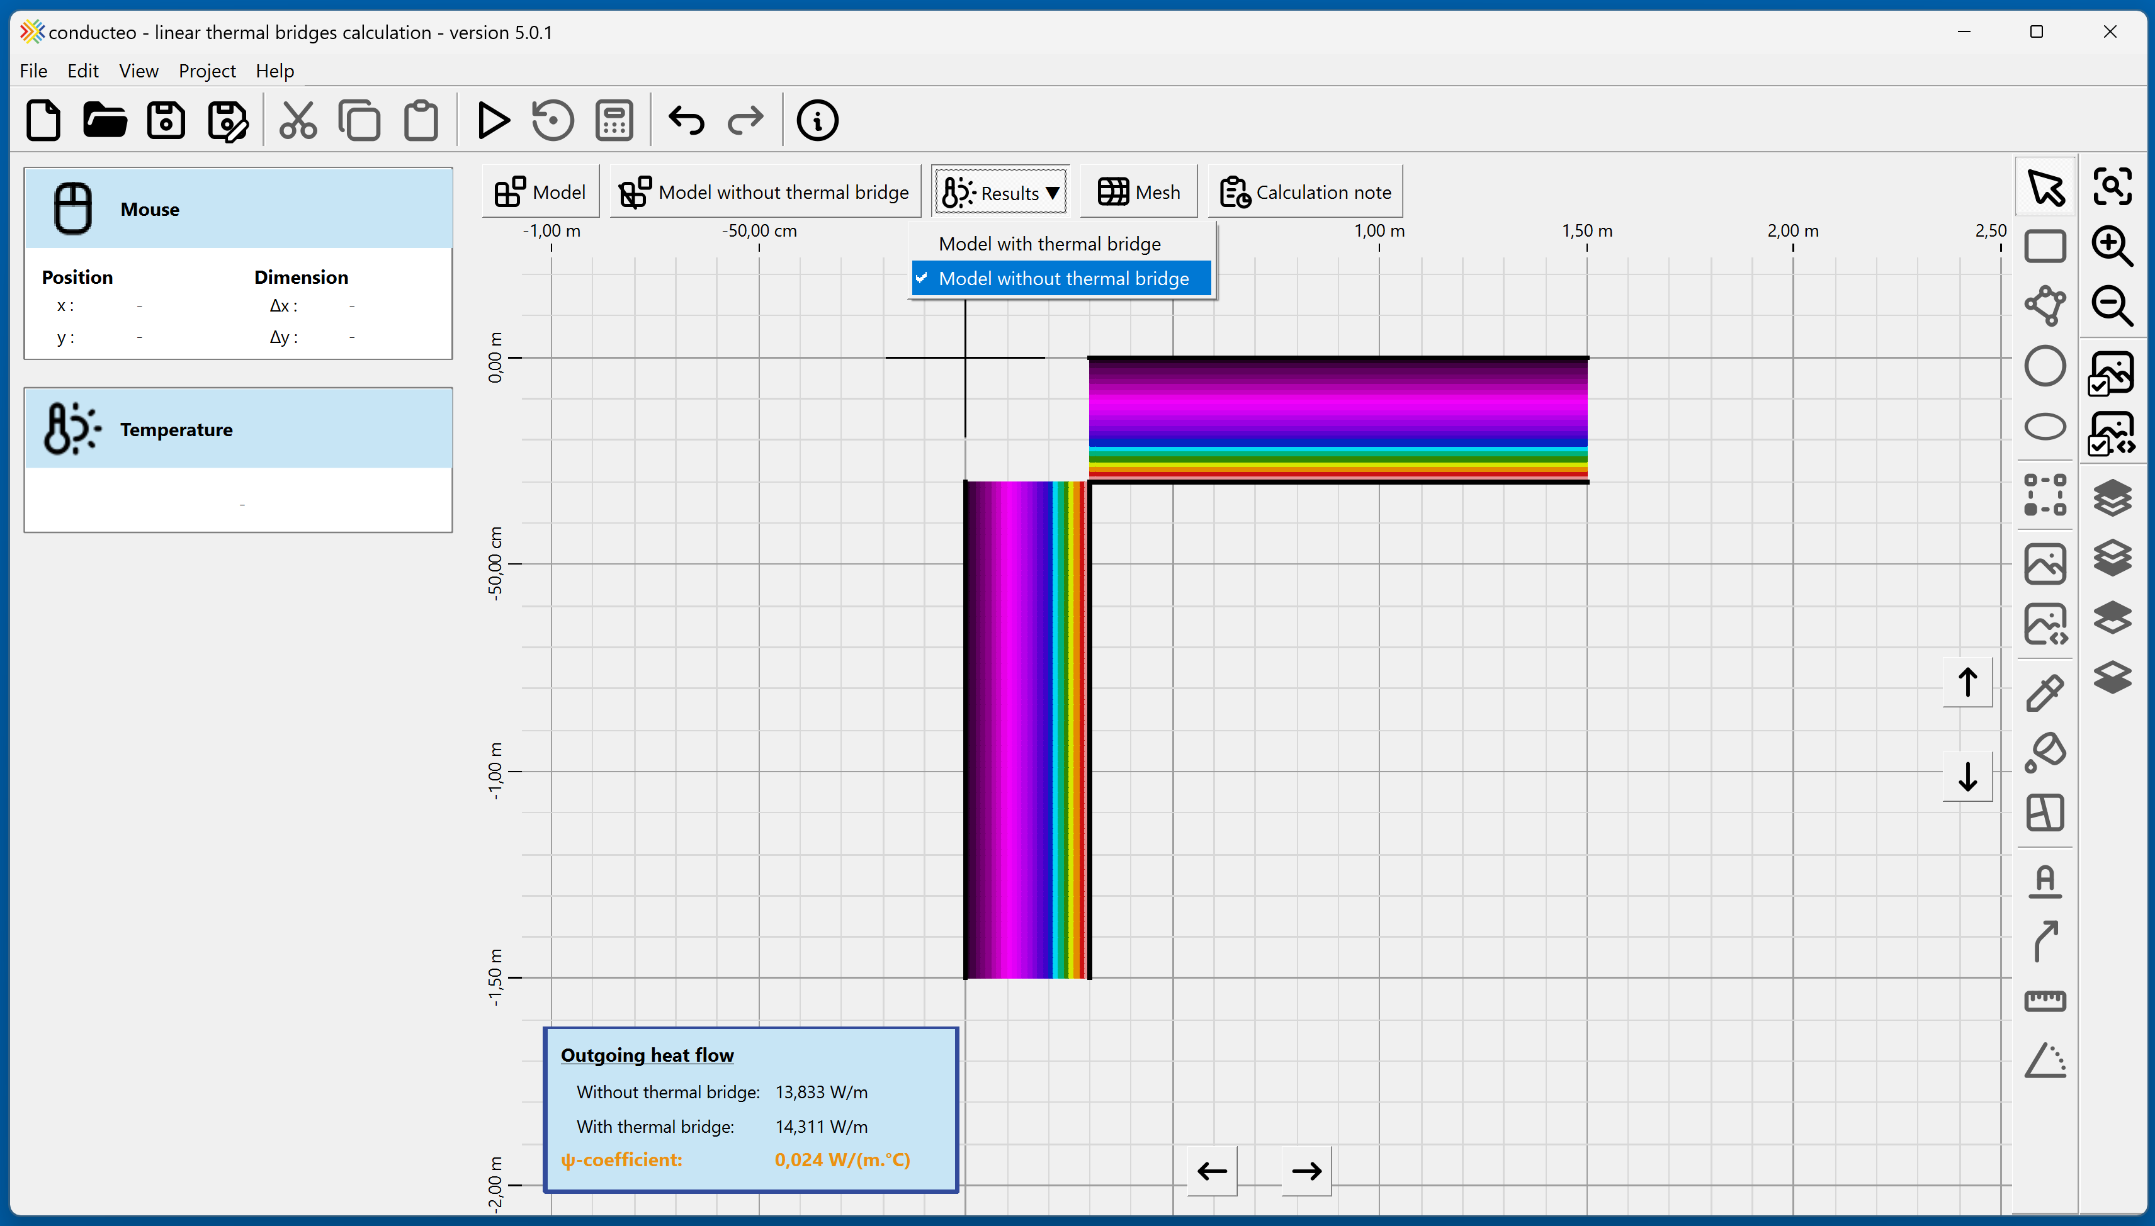
Temperatures of the model without a thermal bridge

By selecting surfaces, the heat flow and surface temperatures are displayed on the left side of the software.

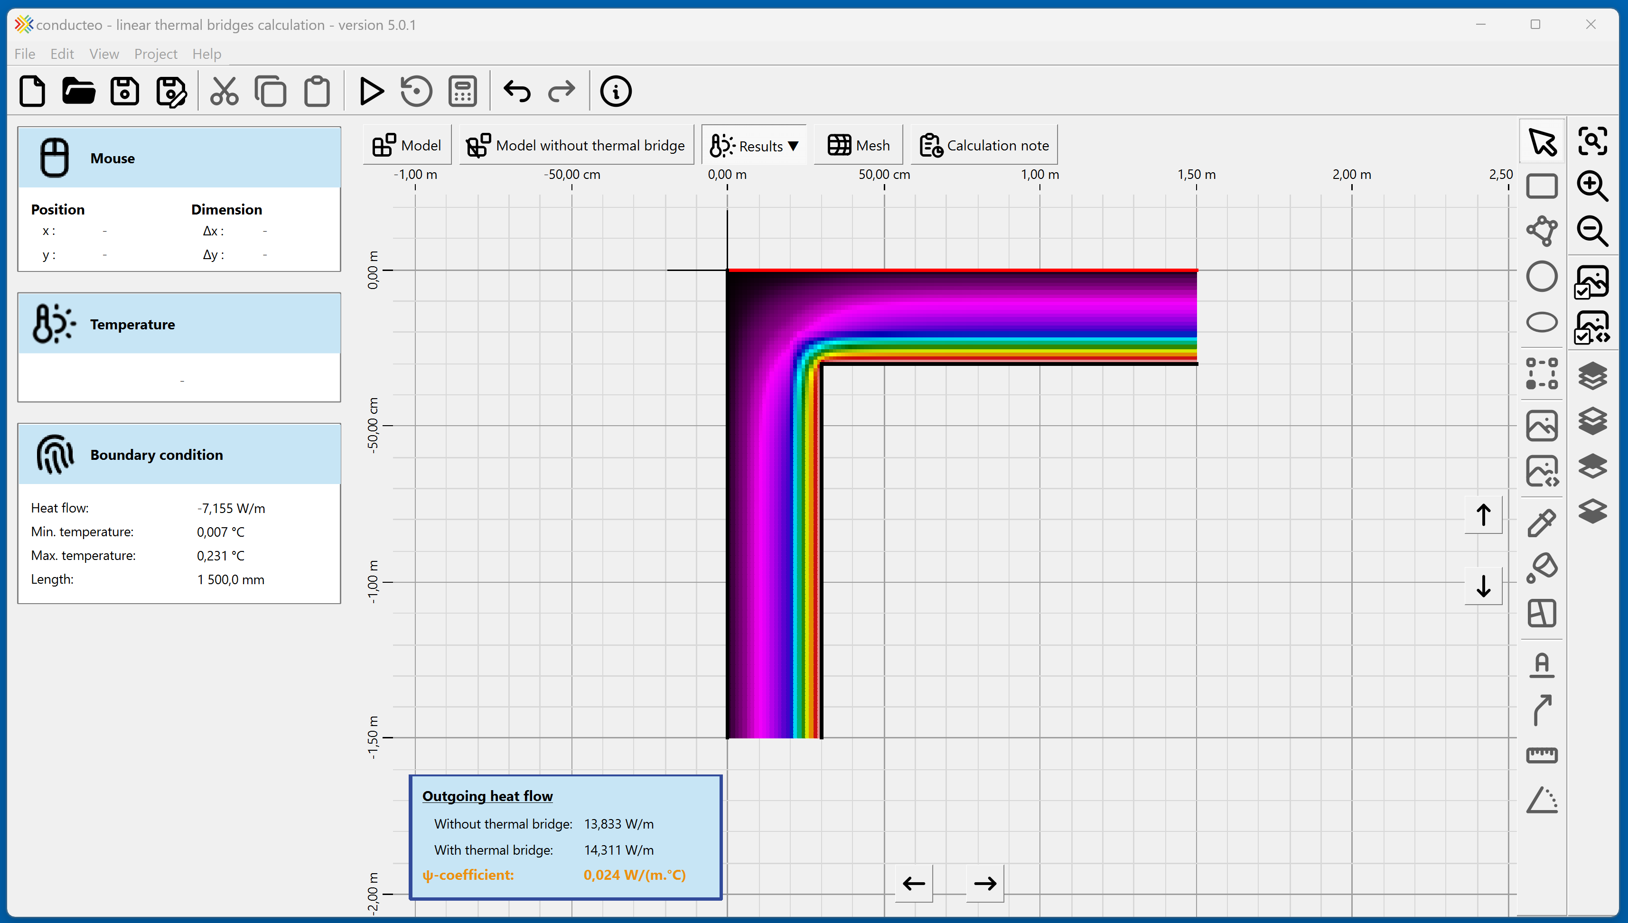
Surface heat flow,
surface temperatures
Surface selection

The “Calculation report” tab allows you to display an automatically generated report.
The model views can be adjusted with the mouse (wheel to zoom, middle-click to move the view).
The “Export report” button allows you to save it as a PDF or DocX file.

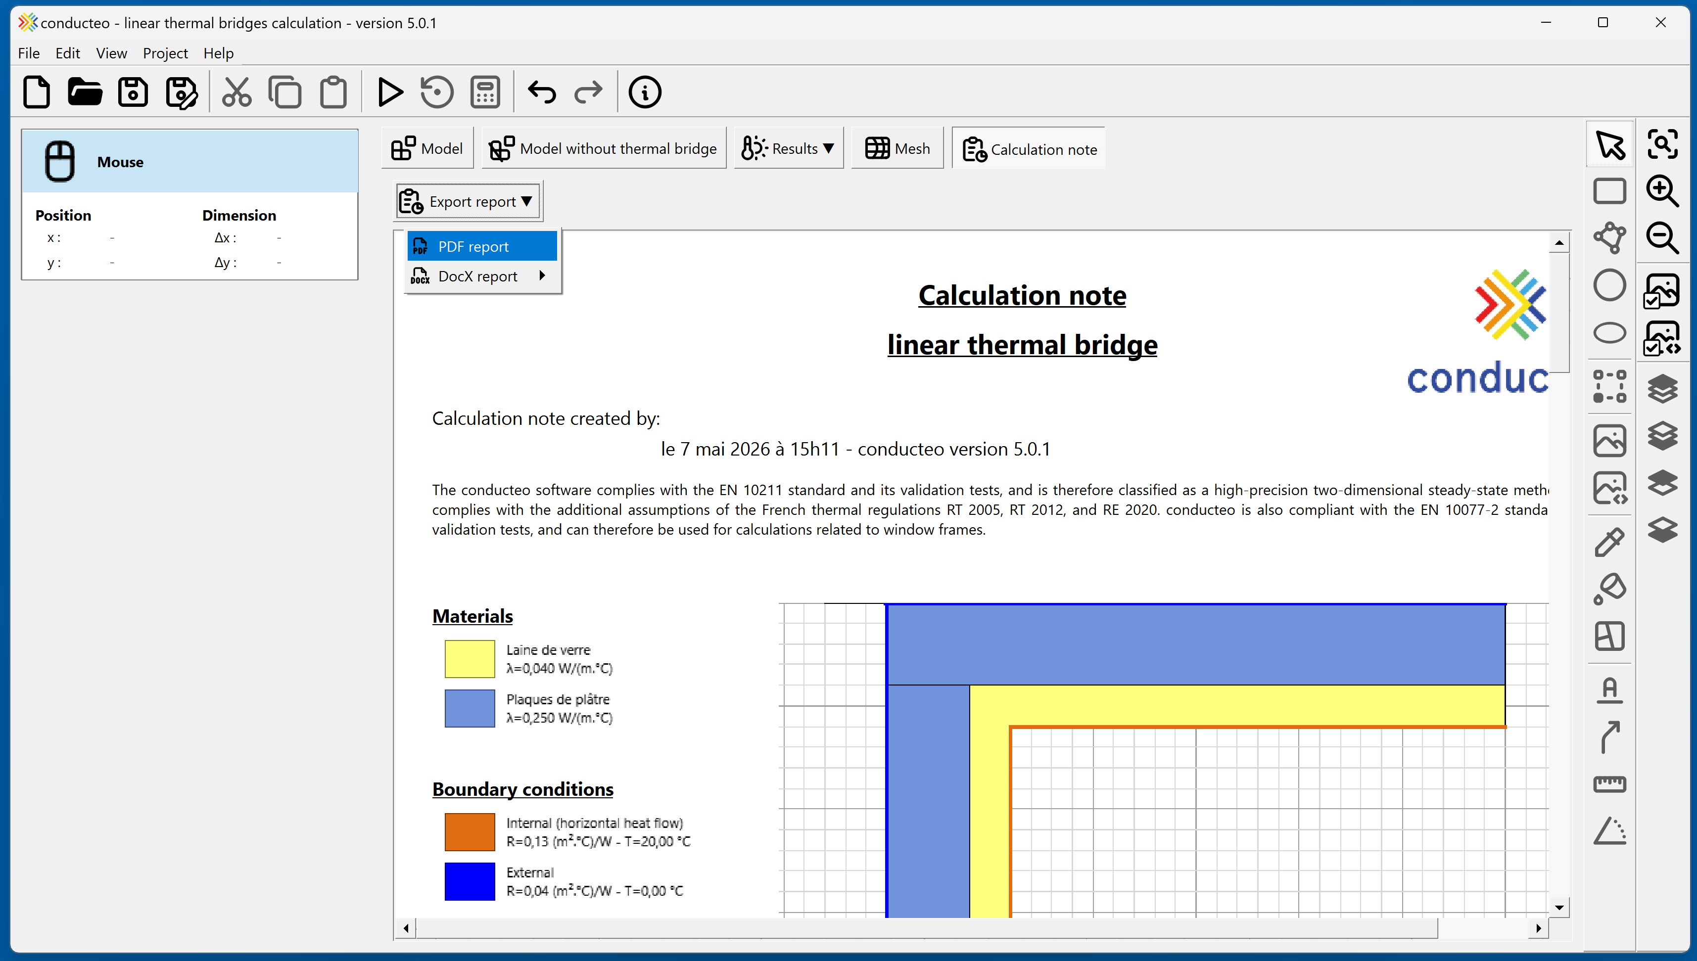
Calculation report
(adjustable views)
Export report as PDF

You are now ready to get started!

