ShutUp

Thomas Brown

Lauren Aberle

Colorado School of Mines – CSCI 498

Fall 2012

Project Declaration

ShutUp is an Android application that allows you to adjust your ring volume based on calendar events, your location, and what time it is.

Project Definition

ShutUp will run in the background, synthesizing calendar events, location, and time to correctly set the phone's ring volume. It will sync with Google Calendar to allow the user to adjust volume for each event. The user can change the volume setting based on the time of day. The user can also specify a volume based on his or her location (the app will use coarse location, not GPS). Locations will be defined by either the user entering an address for a location, having a "learn the location I'm currently in" button, or allowing the user to draw locations on a map (time permitting). Additionally, the user may define his or her own profiles with more than just a "volume" setting (e.g. changing ringtone song), time permitting.

User Stories

Complex mathematical formulas fill Marvin the Miner's head as he works furiously to finish his math test. He has studied for weeks, and it's all paying off. As he confidently boxes his last answer on a particularly nasty fourth order partial differential equation, the worst thing happens. Justin Bieber's "Baby" pierces the ears of everyone in the exam room. Marvin's face turns bright red as he fumbles with his cell phone, pressing every button his pudgy fingers can find. The ringing finally stops, but it's too late. The test moderator walks over, takes his test, rips it up, and throws it in the trash. "Per departmental procedure, you will receive zero credit..." Marvin wakes up, heart pounding, sweat lining his forehead. It was all a dream.  
He quickly grabs his phone and immediately downloads the aptly named ShutUp application for his Android device. He enters the date and time of his math test into Google calendar, knowing that his new ShutUp app will recognize this event and ensure that Justin will remain silent for the entire specified time period. While he's awake, he decides to configure some other ringer options. He selects the "location" button and indicates that he would like to set his ringer to vibrate while he is at work. He then navigates to the "time" screen. This allows him to set his phone to loud every weekday after 3pm ensuring he never misses a call after class is out. With this new found piece of mind, Marvin falls back to sleep and gets a good night's rest.

Use Case List

1. Busy student sees calendar events
2. Busy student selects ring volume for calendar events
3. Ring volume adjusts when calendar event occurs
4. Busy student sees time ranges
5. Busy student adds time range
6. Busy student selects ring volume for time range
7. Ring volume adjusts when time range changes
8. Busy student sees locations
9. Busy student adds location
10. Busy student selects ring volume for location
11. Ring volume adjusts when location changes

Use Case Diagram

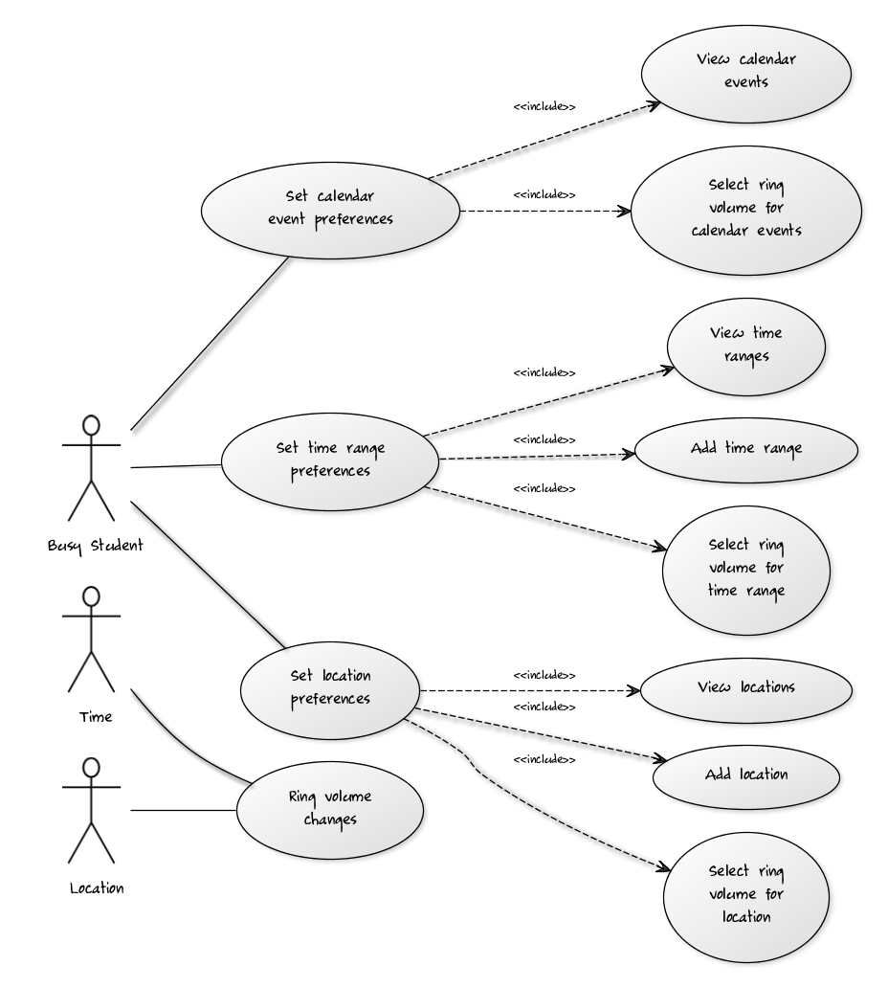

http://yuml.me/edit/f03414da

Use Case 1: Busy student sees calendar events

**Main Success Scenario**

Busy student Billy has added several important events to his Google Calendar application. He indicates he would like to adjust the ring volume for these events. The ShutUp application displays all of his calendar events. Billy sorts them by either start time of the event, recurring/single event type, or alphabetically.

**Alternate Scenarios**

**No Events Created**

Billy has not entered any Google Calendar events into his phone. When he indicates he would like to view these events in the ShutUp application, he receives a message that he has not added any events and is given the option to open Google Calendar.

**Problem Communicating With Google Calendar**

The application cannot communicate with Google Calendar to display Billy’s events. Billy sees a message that there was a problem communicating with Google Calendar.

**Google Calendar Not Installed**

Google Calendar is not installed on Billy’s phone. When he indicates he would like to view these events in the ShutUp application, he receives a message that he has not installed Google Calendar, and is given the option to open the Google Play store to install it.

Use Case 2: Busy student selects ring volume for calendar events

**Main Success Scenario**

Busy student Billy wants to specify what the ring volume should be for each calendar event. He sees calendar events, and he picks a ring volume for each event.

Use Case 3: Ring volume adjusts when calendar event occurs

**TITLE** As a busy student I want to turn my phone ringer on or off during my calendar events so that I will not be embarrassed

**PRIMARY ACTOR** Busy Student

**STAKEHOLDERS** Busy student wants phone to turn on when he wants to receive a phone call.

**& INTEREST** Peers don’t want to be interrupted during class.

**PRECONDITIONS** Busy student has calendar events for which he has specified a ring volume.

**POSTCONDITIONS** Phone ring volume is properly adjusted at the beginning of the calendar event.

**MAIN SUCCESS** 1. Calendar event occurs

**SCENARIO** 2. Ring volume adjusts according to user’s preference

**EXTENSIONS**  1.1 User manually adjusts ring volume during calendar event

* + 1. Ring volume changes according to user’s preference

**SPECIAL** Phone must be powered on.

**REQUIREMENTS**

**TECHNOLOGY &** Must have permission to adjust system ring volume.

**VARIATION LIST**

**FREQUENCY** Many times per day, depending on how many calendar events the user has specified.

**OPEN ISSUES** What happens when events overlap? Which volume gets selected?