Assignment 7: Bayesian Classification
Note: All data generated for this report can be made using the included testing.m file. I used a Jupyter notebook file in order to easily prototype and get the data summarized in this report.

The objective of this assignment was to develop a Bayes classifier that would be used for vehicle pattern recognition. A Bayes Classifier is a type of probabilistic model that assigns class labels to problem instances, where these problems are represented as vectors of feature values. This classifier uses Bayes theorem to calculate decision functions for each class based on the conditional probability that a pattern comes from a certain class. The class that yields the largest value of the decision function is the class that is assigned to that specific pattern, or problem.
A few assumptions must be made in the formulation of this Bayesian Classifier. For one, the underlying patterns of each class are assumed to be sampled from a Gaussian distribution. For our problem of vehicle pattern recognition, this assumption does not seem to hurt our results.
In order to calculate the conditional probabilities needed to find the decision functions we must first find the mean and covariance of the sampled features. The mean represents the expected value of a feature for a certain class, where as the covariance represents how much each pair of features is correlated.

Data Collection
One of the most important factors in achieving useful results in this assignment was collecting useful input data. Starting with the segmented moving objects generated in previous assignments, I found it necessary to go back and improve my old functions to get better data to use in the following steps. After tweaking my CS6640_MM function, the next step was to pass this on to the object_data function.
Once the object data was collected, I then had to filter these objects to remove unwanted objects and leave only the moving vehicle of interest. This was achieved first by filtering out all but the largest of the segmented moving objects. I then found the line of best-fit for the remaining objects by using linear least-squares regression. This resulted in giving me the approximate track of the vehicle of interest, which coincides with the road in the videos. Using this line, I filtered out any objects whose centroid’s distance to this line was outside of a certain threshold. The key here was to find a threshold that would remove unwanted objects but not keep the moving vehicle of interest. This filtering resulting in removing most, if not all, of the noise from the segmented objects, but due to the results from my CS6640_MM function, there were some false negatives where good objects were filtered out. This did not affect my results too much, although it did lower the number of good samples to be used in the following steps.

Feature Selection
After the input data was collected and pruned, the next step was to select the features and create the feature vectors needed for the classifier. I started with a single feature that was the object size, or the number of pixels in the object. This turned out to be very useful, as the size difference between cars, trucks, and busses is quite large. Using this feature alone, I was able to get surprisingly good results for the training and test videos.
Model Generation
Using the first two videos from each class as training data, I ran the above filtering and feature selection steps to get feature vectors for each class. I then passed these feature vectors to my build_bayes function for each of the three classes. This function returned the means of each feature as well as the covariance matrix for all the features. Not surprisingly, the means showed the Car as the smallest and the Bus class as the largest, with Truck being in the middle. Due to a large variance in sizes of objects, the covariances were quite large for each of the three classes, up to 3 orders of magnitude larger than the means. I believe with more refining on the pre-processing and data filtering I could lower these values and improve my results further. The plot below shows the probability distributions for each model. The means can be seen on the X-axis for each class.
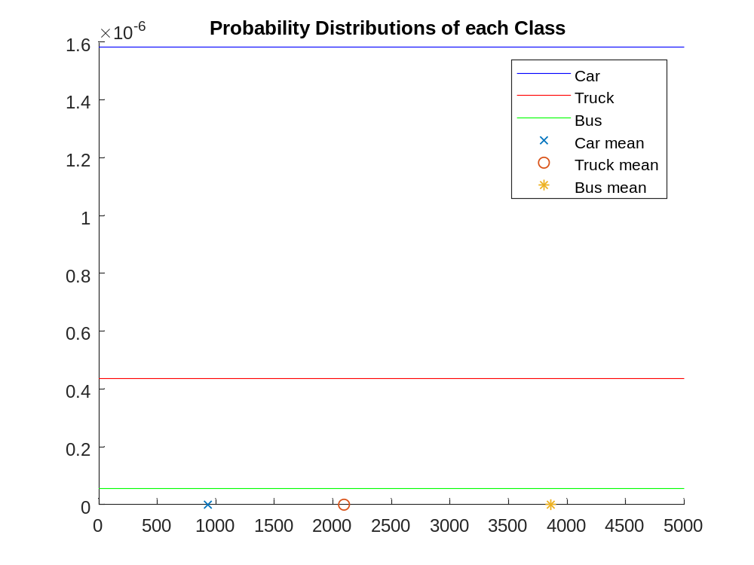
Figure 1: Probability Distributions of each class
As can be seen and as stated above, the large variances have the effect of making the distribution lines very flat looking. Another interesting feature is that the Car values are much higher than both the Truck and Bus values. My only explanation for this is that it is due to the larger percentage of cars compared to busses and trucks.
Model Evaluation
After generating the above models, it became time to test the accuracy of the models on both the original training videos and the previously unused test videos. This is where the function CS6640_bayes was used. This function takes a single feature vector from one frame and computes the best class for it based on the class probabilities and models generated previously. The class probabilities used where 1/3 for all three classes, summing to one. I evaluated this function for each sample in the training data for each of the three classes. I evaluated the results by comparing the actual sample class to the class found from the Bayes function and calculating a percentage correct for all the training samples of that class. These results are shown below.
Class | % Correct
Car | 89.36%
Truck | 58.03%
Bus | 48.20%
Figure 2: Accuracy of model on Training Data
Not surprisingly, the car classes were the easiest to classify due to the larger size difference between cars and trucks/busses compared to the size difference between trucks and busses. Changing the classifier to only the two classes of cars and large vehicles, by combining trucks and busses, should give much more accurate results. Shown below is a table showing the calculated classes for each set of training data. The row headers indicate the training data set while the column headers indicated the calculated class. Each cell shows the number of samples belonging to that class.
 | Car | Truck | Bus
Car | 294 | 35 | 0
Truck | 96 | 177 | 32
Bus | 108 | 151 | 241
Figure 3: Evaluated Classes for each sample class on Training data

As can be seen above, many samples from both the truck and bus data were incorrectly classified as cars. I believe this is due to my pre-processing stages and how the original data is collected using the CS6640_MM function. The results of this function have many objects throughout the video where the object size of the moving vehicle shrinks down very small. When this happens, the underlying truck or bus is seen to look like a car. I believe this can be improved by more refinement of the MM function.
Next, I used the same models as above to evaluate the test videos, car3.avi, truck3.avi and bus3.avi. The same evaluations were performed as above, calculating the percentage correctly classified and showing the relative classes classified. These results are summarized below.
Class | % Correct
Car | 92.86%
Truck | 29.91%
Bus | 89.41%
Figure 4: Accuracy of model on Test Data

 | Car | Truck | Bus
Car | 104 | 8 | 0
Truck | 48 | 67 | 109
Bus | 0 | 27 | 228

Figure 3: Evaluated Classes for each sample class on Test Data

Surprisingly, the testing data performed better than the training data for both the Car and the Bus. Another interesting point was that no Cars were incorrectly labels Busses, and no Busses were incorrectly labeled Cars. This time, the Truck test data performed the worst, with many of the trucks being incorrectly labeled busses.
Overall, these results were very promising for only using a single feature, but I believe they could be improved even further by going back and improving the object segmentation functions to more accurately segment the moving vehicles. Along those lines, I think using the results from the active contours function could improve the results seen here. Improved data collection and filtering could also help me achieve more accurate results. Lowering the threshold for the line track filter would help remove more unwanted data samples.
Time permitting, I would have liked to study the generation of more features. By adding more features to the feature vectors, I believe the Bayes Classifier could more easily classify these vehicles. One possible feature to consider would be vehicle speed. By comparing the movement of the vehicle centroids between frames, a number representing vehicle speed could be made. It would make sense for cars to be moving faster than trucks, and trucks to be moving faster than busses.
Another possible feature could be vehicle colors. By taking histograms of the vehicle’s HSV values, a small number of histogram regions could be used as features. Due to most Utah busses being similar colors, I think this would help the classifier distinguish between busses and other vehicles. Using HSV instead of RGB values would also be an improvement due to the HSV colorspace having more invariance in lighting conditions when trying to distinguish colors.
Another feature I would have liked to try is the ratio between height and width of the bounding box surrounding the vehicle. This could help distinguish busses easier because the busses should be more elongated than most cars and trucks.
With the addition of the above, and possibly more features, I believe I could greatly improve the accuracy of my Bayes Classifier. Another way to improve the results would be to use much more training data. If we collected tens or even hundreds of videos of vehicles in different conditions, this could greatly increase the accuracy of the classifier. Given time constraints this was not possible, but I and still happy with my results thus far with an accuracy of about 90% for both cars and busses on the training data.

