**Conor Peckham**

**import** java.util.Scanner;

**public** **class** ExerciseO5 {

**public** **static** **void** main(String args[])

{

Employee [] array = **new** Employee[5];

Scanner S = **new** Scanner(System.***in***);

**for**(**int** i = 0; i < 5; i++)

{

array[i] = **new** Employee();

}

**for**(**int** i = 0; i < 5; i++)

{

array[i].readPInfo(S);

array[i].readPayInfo(S);

System.***out***.println();

}

**for**(**int** i = 0; i < 5; i++)

{

System.***out***.println(array[i].getPInfoString());

System.***out***.println(array[i].getPayInfoString());

System.***out***.println();

}

}

}

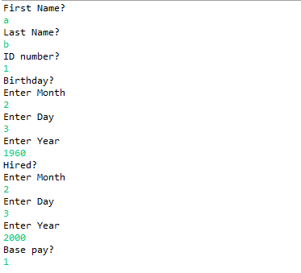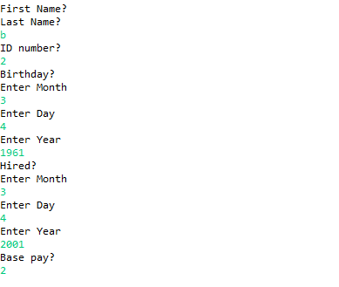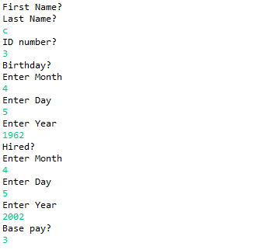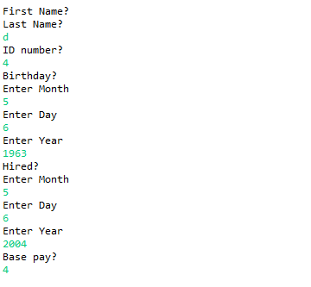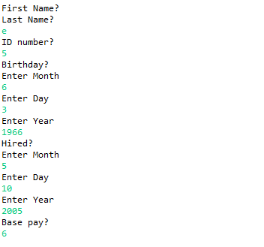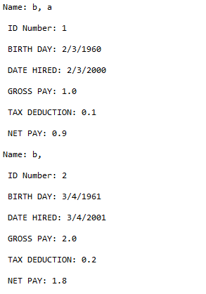

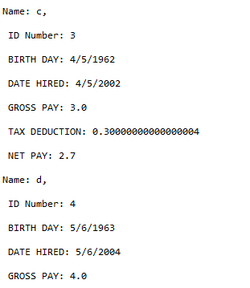

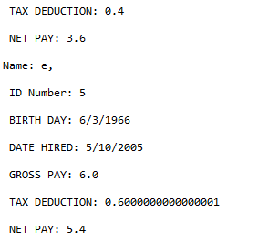

**import** java.util.Scanner;

**public** **class** Score1 {

Scanner S = **new** Scanner(System.***in***);

Score1(){

FirstName = **null**;

LastName = **null**;

Course = **null**;

}

Score1(String fname, String lname, String courseNum, **double**[] list)

{

FirstName = fname;

LastName = lname;

Course = courseNum;

**for**(**int** i = 0; i < 5; i++)

{

TestScores[i] = list[i];

}

}

**private** String FirstName;

**private** String LastName;

**private** String Course;

**private** **double**[] TestScores = **new** **double**[5];

**double** computeAverage()

{

**double** Avg;

**double** total = 0;

**for**(**int** i = 0; i < 5; i++)

{

total += TestScores[i];

}

Avg = total/5;

**return** Avg;

}

**void** read(Scanner Scan)

{

System.***out***.println("First Name?");

FirstName = Scan.nextLine();

System.***out***.println("Last Name?");

LastName = Scan.nextLine();

System.***out***.println("Course Name?");

Course = Scan.nextLine();

System.***out***.println("Test Score?");

**for**(**int** i = 0; i < 5; i++)

{

TestScores[i] = Scan.nextInt();

}

}

**void** print()

{

System.***out***.println(FirstName);

System.***out***.println(LastName);

System.***out***.println(Course);

**for**(**int** i = 0; i < 5; i++)

{

System.***out***.print(TestScores[i] + ", ");

}

System.***out***.println();

System.***out***.println(computeAverage());

}

}

**import** java.util.Scanner;

**public** **class** ExerciseO6 {

**public** **static** **void** main(String args[])

{

Scanner S = **new** Scanner(System.***in***);

Score1 Score1 = **new** Score1();

Score1.read(S);

Score1.print();

}

}

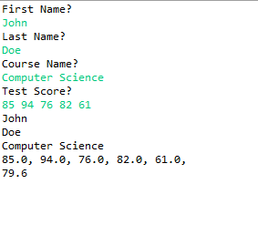

**import** java.util.Scanner;

**public** **class** Score2 {

Scanner S = **new** Scanner(System.***in***);

Score2(){

FirstName = **null**;

LastName = **null**;

Course = **null**;

NumberOfScores = 0;

TestScores = **new** **double**[5];

}

Score2(**int** numElt){

FirstName = **null**;

LastName = **null**;

Course = **null**;

NumberOfScores = numElt;

TestScores = **new** **double**[numElt];

}

Score2( String fname, String lname, String courseNum, **double**[ ] list) {

FirstName = fname;

LastName = lname;

Course = courseNum;

NumberOfScores = list.length;

TestScores = **new** **double**[list.length];

**for**(**int** i = 0; i < list.length; i++)

{

TestScores[i] = list[i];

}

}

**private** String FirstName;

**private** String LastName;

**private** String Course;

**private** **int** NumberOfScores;

**private** **double**[] TestScores;

**private** String pause;

**double** computeAverage()

{

**double** Avg;

**double** total = 0;

**for**(**int** i = 0; i < TestScores.length; i++)

{

total += TestScores[i];

}

Avg = total/TestScores.length;

**return** Avg;

}

**void** read(Scanner Scan)

{

System.***out***.println("First Name?");

FirstName = Scan.nextLine();

System.***out***.println("Last Name?");

LastName = Scan.nextLine();

System.***out***.println("Course Name?");

Course = Scan.nextLine();

System.***out***.println("Test Score?");

**for**(**int** i = 0; i < TestScores.length; i++)

{

TestScores[i] = Scan.nextInt();

}

}

**void** print()

{

System.***out***.println(LastName + ", " + FirstName);

System.***out***.println(Course);

**for**(**int** i = 0; i < TestScores.length; i++)

{

System.***out***.print(TestScores[i] + ", ");

}

System.***out***.println();

System.***out***.println(computeAverage());

}

}

**import** java.util.Scanner;

**public** **class** ExerciseO7 {

**public** **static** **void** main(String args[])

{

String FName;

String LName;

String course;

**double**[] Scores = **new** **double**[10];

**int** numberofscores;

Scanner S = **new** Scanner(System.***in***);

Score2 Default = **new** Score2();

Default.read(S);

Default.print();

System.***out***.println("How many scores?");

numberofscores = S.nextInt();

System.***out***.println(" ");

Score2 Number = **new** Score2(numberofscores);

Number.read(S);

Number.print();

System.***out***.println("First Name?");

FName = S.nextLine();

System.***out***.println("Last Name?");

LName = S.nextLine();

System.***out***.println("Course Name?");

course = S.nextLine();

System.***out***.println("Test Score?");

**for**(**int** i = 0; i < 10; i++)

{

Scores[i] = S.nextInt();

}

Score2 All = **new** Score2(FName, LName, course, Scores);

All.print();

}

}

