Conor Peckham
CS4051

Exercise I3
import java.util.Scanner;
public class ExerciseI3 {
public static void main(String []args){
Scanner S = new Scanner(System.in);
int TestNumber;
double[] scores;
System.out.println("How many Scores?");
TestNumber = S.nextInt();
scores = ExerciseI3Methods.readTestScores(TestNumber);
ExerciseI3Methods.printTestResults(scores);

}
}

public class ExerciseI3Methods {

static void printComment(char grade) {
switch(grade) {
case 'A': System.out.println(" very good");
break;
case 'B': System.out.println(" good");
break;
case 'C': System.out.println(" satisfactory");
break;
case 'D': System.out.println(" need improvement");
break;
case 'F': System.out.println(" poor");
break;
default : System.out.println(" ");
break;
}
}

static double[] readTestScores(int size)
{
Scanner S = new Scanner(System.in);
double[] Scores = new double[size];
System.out.println("Input Test Scores");
for(int i = 0; i < size; i++)
{
Scores[i] = S.nextDouble();
}
return Scores;
}

static char getLetterGrade(double score)
{
if(score >= 90)
return 'A';
else if (score >= 80 && score <90)
return 'B';
else if (score >= 70 && score <80)
return 'C';
else if (score >= 60 && score <70)
return 'D';
else
return 'F';
}

static void printTestResults(double[] testList)
{

System.out.printf("%-10s %-10s %-10s\n", "Test Score", "Letter Grade", "Comment");
for(int i = 0; i < testList.length; i++)
{
System.out.printf("%-10.2f %-10C", testList[i], getLetterGrade(testList[i]));
printComment(getLetterGrade(testList[i]));
}
}
}

Input/Output
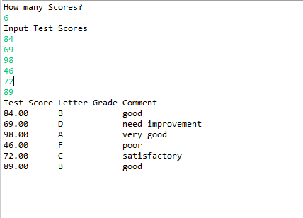

Exercise I4
import java.util.Scanner;
public class ExerciseI4 {
public static void main(String []args){
Scanner S = new Scanner(System.in);
int TestNumber;
double[] scores;
System.out.println("How many Scores?");
TestNumber = S.nextInt();
scores = ExerciseI4Methods.readTestScores(TestNumber);
ExerciseI4Methods.printTestResults(scores);

}
}

public class ExerciseI4Methods {

static void printComment(char grade) {
switch(grade) {
case 'A': System.out.println(" very good");
break;
case 'B': System.out.println(" good");
break;
case 'C': System.out.println(" satisfactory");
break;
case 'D': System.out.println(" need improvement");
break;
case 'F': System.out.println(" poor");
break;
default : System.out.println(" ");
break;
}
}

static double[] readTestScores(int size)
{
Scanner S = new Scanner(System.in);
double[] Scores = new double[size];
System.out.println("Input Test Scores");
for(int i = 0; i < size; i++)
{
Scores[i] = S.nextDouble();
}
return Scores;
}

static char getLetterGrade(double score)
{
if(score >= 90)
return 'A';
else if (score >= 80 && score <90)
return 'B';
else if (score >= 70 && score <80)
return 'C';
else if (score >= 60 && score <70)
return 'D';
else
return 'F';
}

static void printTestResults(double[] testList)
{

System.out.printf("%-10s %-10s %-10s\n", "Test Score", "Letter Grade", "Comment");
for(int i = 0; i < testList.length; i++)
{
System.out.printf("%-10.2f %-10C", testList[i], getLetterGrade(testList[i]));
printComment(getLetterGrade(testList[i]));
}
}
}

Input/Output
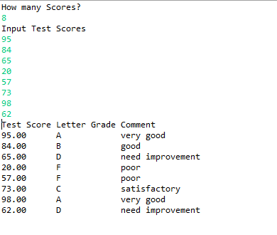

Exercise O1
The class Demo is defined as follows:
class Demo
{
private double val1; // the first data member
private double val2; // the second data member

public void setValues(double num1, double num2)
{
val1 = num1;
val2 = num2;
}
public double getValue1(void)
{
return (val1);
}
public double getValue2(void)
{
return (val2);
}
public double getAverage(void)
{
return( (valu1 + valu2) / 2);
}
}

import java.util.Scanner;
public class ExerciseO1 {
static Demo addDemo(Demo item1, Demo item2)
{
Demo Sum = new Demo();
Sum.setValues(item1.getValue1() + item2.getValue2(), item1.getValue1() + item2.getValue2());
return Sum;
}
static void incrDemo2(Demo item)
{
item.setValues(item.getValue1() + 5, item.getValue2() + 5);
}

public static void main(String args[])
{
Demo demo = new Demo();
Scanner input = new Scanner(System.in);
System.out.println("Enter val1");
double num1 = input.nextDouble();
System.out.println("Enter val2");
double num2 = input.nextDouble();
demo.setValues(num1, num2);
System.out.println("Average = " + demo.getAverage());
Demo obj1 = new Demo();
obj1.setValues(5, 7);
Demo obj2 = new Demo();
obj2.setValues(14, 9);
Demo objR = addDemo(obj1,obj2);
incrDemo2(obj1);
System.out.println("objR = " + objR.getValue1() + objR.getValue2());
System.out.println("obj1 = " + obj1.getValue1() + obj1.getValue2());
}
}

Input/Output:
