



Arendi Pharmacy Requirements Specifications

**Department:** Computer Engineering

**Semester:** Spring 2021-2022

**Course:** SWE 202 / SWE - SOFTWARE MODELING AND DESIGN

**Lecturers:** Dr. Igli Hakrama, M.Sc. Ari Gjerazi

**Date:** 14. 06. 2022

**Name & surname:** Enxhi Roci, Rubin Canaj

**Topic:** Arendi Pharmacy.

***1. Executive Summary***

*Project Overview*

Arendi Pharmacy was founded in 1995 and is located in Tirana,Albania. For many years this business has run on family grounds and has made a loyal customers due to their assests.

Constantly attending to the patients requirements with an uplifting attitude has build a stong foundation and high trust in providing the best there is in the best way possible.

*Actors*

**Administrator (pharmacy manager):**The administrator is the owner of the pharmacy for more than 25 years, mr.H.R. Having all access to the entries other admins will provide as well as all user information,below you can find tasks that can be preformed by him:

* Checking all the database for drug entries(if there is need for update or not)
* Control all the deliveries
* Check the daily inventory system
* Verify every prescription if it fills every lawful requirement
* Check on the pharmacists and their performance
* Fulfill all the billings presented from the finance manager

**Other Managers (admin-s):**

**Finance manager:**The individual E.H is responsible for all details on the finance department, fulfilling tasks such as:

* Sends the bills (with/without TVSH) to the tax sector.
* Conclude the inventory for the pharmacy as well as the application
* Local taxes ->printing and sending them to the administrator

**Transport manager**

Deals with deliveries, and arranges them to transport companies. Can also check purchases done by other members

**Pharmacists:**Pharmacists are required to complete the customer services for all the patients that chose the simplifyed version of interaction with the app.It is important tostate that these pharmacist will only be required to fulfill their duties to the app, they will not be working at the pharmacy in order to have quick and efficent responses for the user.

Some of the tasks they will perform:

* Succssesfuly give all the medicine as prescribed form the doctor
* Notify the user for medicine that has been out of stock but now has made another entry(only the ones that are benefitial to their health status)
* Respond to every request on medicine the user who has chosen the simplified version will make.

*Assumptions*

* The administrator will have all around access for all data entered form users and other admins.
* Knowledge regarding computer usage will determine your personalised experience with the app.
* The pharmacist has a time span of 1-5 minutes on giving feedback to the patient when presented with the [inquiry.](https://www.merriam-webster.com/dictionary/inquiry" \l ":~:text=Definition%20of%20inquiry,into%20facts%20or%20principles%20%3A%20research)

*Constraints*

* Logging in through credentials is a criteria that must be filled by every user/patients.
* It has a 24/7 usage as the pharmacy working also applies the 24 hour working day.

*Dependencies*

* Only the administrator gets to see the financial and transport reports coming from each manager.
* In cases of approval from the administrator,the pharmacists can exchange their assigned patients.
* Every drug must first be approved from the pharmacist before given, it doesn’t matter if the prescription has it.
* In the case of an illegal drug prescription, the legal format(approved by”Urdheri I Farmacisteve” )will be given to the patient.

***2. Requirements***

*Functional Requirements*

|  |  |  |  |  |  |
| --- | --- | --- | --- | --- | --- |
| Req# | Requirements | Comments | Priority | Date | SME  (approved/reviewed) |
| BR_1 | The software should support inventory management system. |  | 1 |  |  |
| BR_2 | The softwaremust interact with the other systems as such [Billing and invoicing](https://www.capterra.com/billing-and-invoicing-software/) and [electronic medical records (EMR). e](https://www.capterra.com/electronic-medical-records-software/) |  | 2 |  |  |
| BR_3 | The software must incorporate functionality to support the documentation and monitoring of pharmacists’ clinical interventions as well as adverse drug reaction or event reporting. |  | 2 |  |  |
| BR_4 | The software must provide a means to reconcile doses from medication administration systems and the order fulfillment and preparation processes with the pharmacy’s inventory management systems. |  | 1 |  |  |
| BR_5 | The pharmacymanager must run ad hoc or planned detailed reports helps identify trends in intervention acceptance, time spent on clinical activities, and drug costs avoided. |  | 1 |  |  |
| BR_6 | Pharmacy manager must have access to key financial data to quantify and to improve their clinical programs. |  | 2 |  |  |
| BR_7 | The software must have The ability to support mobile solutions for simplified layout or normal layout;when the user chooses one as an option. |  | 2 |  |  |

|  |  |  |  |  |  |
| --- | --- | --- | --- | --- | --- |
| BR_8 | A delivery management system should be supported by the software. |  | 1 |  |  |
| BR_9 | The software must be able to send specific medication administration instructions directly to an infusion device to deliver a particular medicine over a specified period of time. |  | 2 |  |  |
| BR_10 | The software Real-time, on-hand inventory information at the time of patient-specific medication ordering and/or verification and fulfillment |  | 1 |  |  |
| BR_11 | The pharmacy manager must receive Electronic notification or alerting of interventions, adverse drug reactions, and/or medication errors. |  | 1 |  |  |
| BR_12 | The pharmacy manager and finance manager must have access in the financial records of the company. They can add/delete and also edit financial records related with the business. |  | 1 |  |  |
| BR_13 | The software must provide customizable order views, triaging capabilities, and the ability to communicate delivery or availability time of a particular order to others involved in the medication-use process. |  | 2 |  |  |
| BR_14 |  |  | 2 |  |  |
| BR_15 |  |  | 1 |  |  |

*2.2 Non-Functional Requirements*

**Product Requirements**

*User Interface Requirements*

* *PharmaOn Pocket* will be an application available for pc & laptop with WINDOWS/LINUX operating system and also for mobile phone, android/IOS.
* The aim of the application is for it to be as user friendly as possible.For mobile use:when opening the app there will be a choice to either select a simplified layout(the patient is going to get walked through with the pharmacist while a questionare on what his needs for medicine is done) or if you are very familiar with technology and use it on a daily basics than click on normal layout(choosing to purchase on the counter drugs or if you have a prescription by a doctor,this pop up will show->”Please enter all the information from your prescription!”)
* The pharmacy manager page will be separated into sections on all the raports coming from the financial manager the transportation manager and also any specifications the pharmacist might have to highlight from their contact with patients.
* The pharmacists page is going to be separated into personalized parts for every patient they need to assist and after clicking on one of them the patient’s information and all of the requirements they need to fulfill to satisfy the patient will be shown.

**Accessibility:**

The application can only be accessed if the user has a safe internet connection.

**Responsiveness:**

The application should use minimum time to respond and give feedback to the user(less than 2 seconds).

**Reliability:**

* The application is available based on the user needs,it can work properly and do transactions efficiently including safe management of the pharmacy.
* The application is password protected to change things on the system. Here the pharmacist Manager control over the system by login to the pharmacy system.
* Any user cannot use the system(application) without registered by the Administrator and all result data is protected and controlled by the Administrator.

**Performance Requirements**

* The application is thought to operate its function in small amount of time which is less than two seconds and can be accessed by one user at a time or concurrently.
* To access the user must first login to the system which must have the pharmacy system privileged and also the system can store data up to 40 GB data.
* When the system may be busy due to malfunction operation it may wait up to one minute other ways the pharmacy system restarts.

**Implementation:**

* The system is implemented in Intel(R) Core(TM) i5 processor with 4 GB RAM,64-bit computer. And it is implemented through testing on both Black and White testing.
* The language we use implement the system is NetBeans IDE, JDK, MYSQL database.

**Integrity:**

* All information uploaded by the user(patient) must be visible to the pharmacy manager and partially, to the pharmacists.
* All users must provide the software their individual data to log in, so that it can be authenticated before having access to profile.

**Supportability:**

* This application operates in any version of windows operating system. Such as windows xp, windows 2003, windows 7, windows 8 and other related versions.
* The application is thought to be easily maintained by the manager of the pharmacy system by using the prepared documents of the system for easy maintenance.
* Other ways it is maintained by the system developers for corrective and other heavy problems.

**Security:**

* **In case of cyber attack, the application will immediately shutdown.**
* After a certain number of login attempts, the account will get locked to protect a user's information from potential hackers.
* To unlock their account, a user can typically call the company to verify their identity and set a new password.

***Erd diagram***

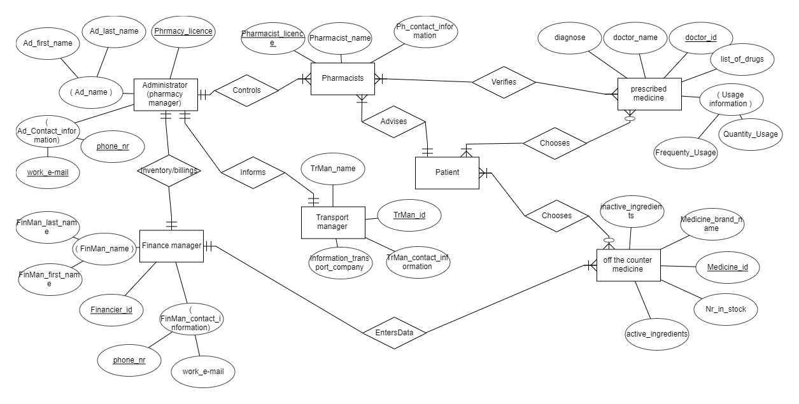

***BPMN***

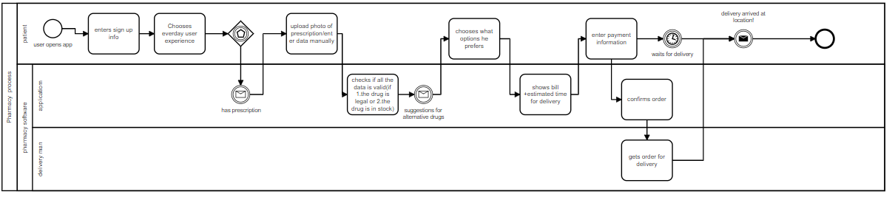

***DFD***

Level 0

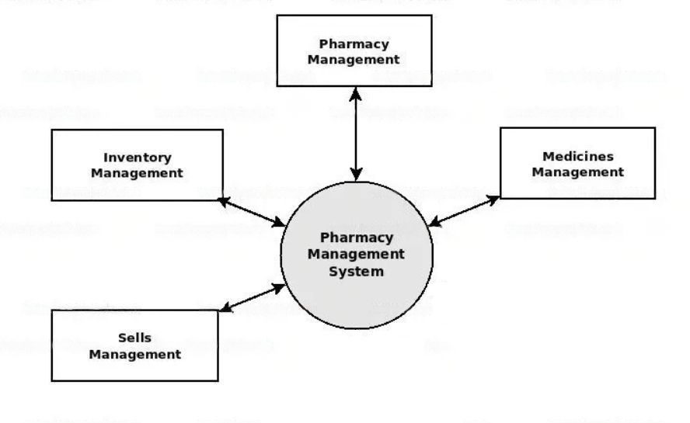

Level 1

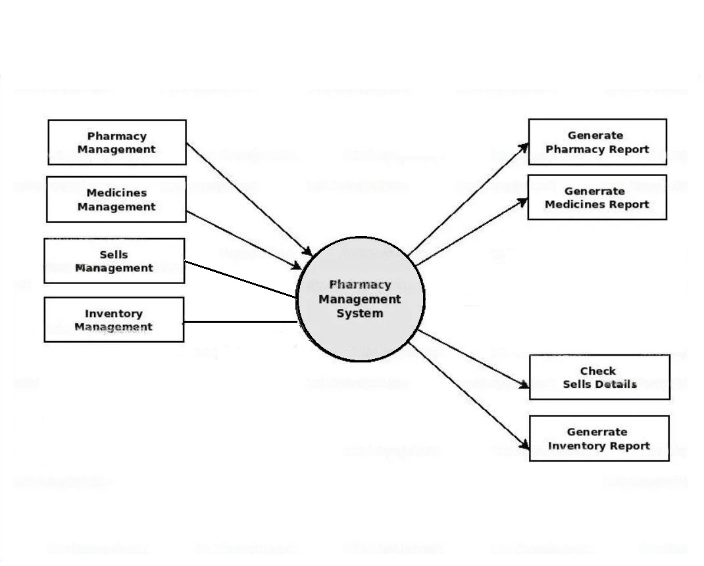

Level 2

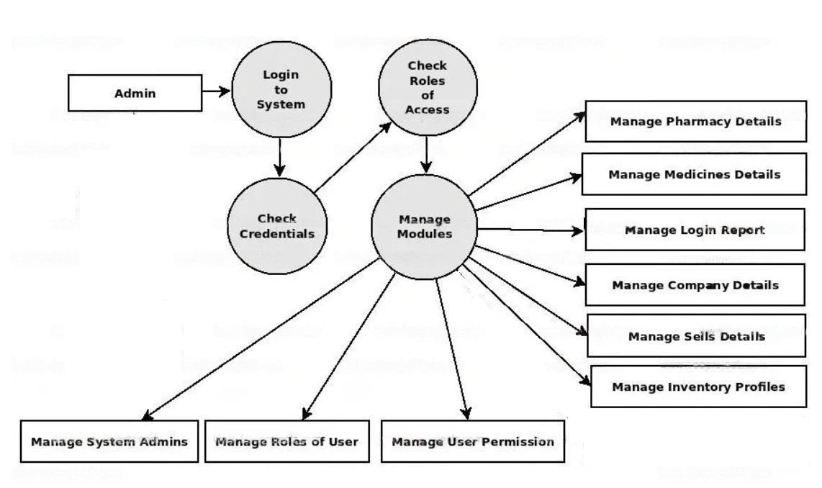

1. ***User Scenarios***
2. Successful Login
   1. User manually enters email at the email input box.
   2. User manually enters password at the password input box.
   3. If the credentials are correct from the database, the user is logged in.
   4. The user is redirected to the homepage.
3. Unsuccessful Login
   1. User manually enters email at the email input box.
   2. User manually enters password at the password input box.
   3. If the credentials are not correct from the database, the user is not logged in.
   4. The user is shown an error message.
   5. The user is redirected to the login page.
4. Successful Everyday Use with Prescription
   1. User logs in.
   2. User selects the "Everyday Use" option.
   3. User selects the "Prescription" option.
   4. User either uploads a picture of his recipe or manually fills a recipe form.
   5. Prescription is sent for review.
   6. After successful review, the system sends the user a form for billing information.
   7. User submits the billing form.
5. Unsuccessful Everyday Use with Prescription
   1. User logs in.
   2. User selects the "Everyday Use" option.
   3. User selects the "Prescription" option.
   4. User either uploads a picture of his prescription or manually fills a prescription form.
   5. Prescription is sent for review.
   6. After unsuccessful review, the system sends the user corrected suggestions, based on the original prescription.
   7. User selects either "Accept" or "Reject" option.
   8. If user accepts, the system sends the user a form for billing information.
   9. User submits the billing form.
6. Everyday Use without Prescription
   1. User logs in.
   2. User selects the "Everyday Use" option.
   3. User selects the "No Prescription " option.
   4. User is presented with the medicines that he/she can buy from the pharmacy without a Prescription.
   5. User selects all of the medicines that he/she wants.
   6. The system sends the user a form for billing information.
   7. User submits the billing form.
7. Successful Simplified Use with Prescription
   1. User logs in.
   2. User selects "Simplified Use" option.
   3. The system sends the user a form for symptoms.
   4. User submits the form.
   5. Between 1-5 minutes a pharmacist enters the chat with pharmacist.
   6. User selects the "Prescription" option.
   7. User either uploads a picture of his prescription or manually fills a prescription form.
   8. Prescription is sent for review.
   9. After successful review, the system sends the user a form for billing information.
   10. User submits the billing form.
8. Unsuccessful Simplified Use withPrescription
   1. User logs in.
   2. User selects "Simplified Use" option.
   3. The system sends the user a form for symptoms.
   4. User submits the form.
   5. Between 1-5 minutes a pharmacist enters the chat with pharmacist.
   6. User selects the "Prescription" option.
   7. User either uploads a picture of his prescription or manually fills a prescription form.
   8. Prescription is sent for review.
   9. After unsuccessful review, the system sends the user corrected suggestions, based on the original prescription.
   10. User selects either "Accept" or "Reject" option.
   11. If user accepts, the system sends the user a form for billing information.
   12. User submits the billing form.
9. Simplified Use without Prescription
   1. User logs in.
   2. User selects "Simplified Use" option.
   3. The system sends the user a form for symptoms.
   4. User submits the form.
   5. Between 1-5 minutes a pharmacist enters the chat with pharmacist.
   6. User selects the "No Prescription " option.
   7. User is presented with the medicines that he/she can buy from the pharmacy without a prescription.
   8. User selects all of the medicines that he/she wants.
   9. The system sends the user a form for billing information.
   10. User submits the billing form.

*Pharmacist Scenarios:*

1. Editing user Prescription.
   1. Pharmacist logs in.
   2. Pharmacist selects the "Prescription" option.
   3. The system sends the pharmacist the prescription, which have been previously reviewed by the system,
   4. Pharmacist edits the prescription.
   5. Pharmacist submits the edited prescription.
2. Helping active users
   1. Pharmacist logs in.
   2. Pharmacist selects the "Active users" option.
   3. Pharmacist selects one of the active users.
   4. Pharmacist reads the symptoms form, filled by the user selected.
   5. Pharmacist starts chatting with the user.
   6. If needed, pharmacist remotely controls the user's PC.

*Transport Manager Scenarios:*

1. Check new purchases
   1. Manager logs in.
   2. Manager selects the "Check new purchases" option.
   3. Manager views the new purchases details.
2. Update deliveries
   1. Manager logs in.
   2. Manager selects the "Update deliveries" option.
   3. Manager is given a form for the delivery.
   4. Manager fills the form and submits it.

*Administrator Scenarios:*

1. Creating an account
   1. Admin logs in.
   2. Admin goes to the accounts page.
   3. Admin selects the "Create" option from the accounts page.
   4. Admin enters the details for the new account.
   5. Admin clicks on the "Submit" button.
   6. A message is shown on the screen which requires the admin to confirm the submission.
   7. Admin selects the "Confirm" button.
   8. Account is successfully created.
2. Deleting an account
   1. Admin logs in.
   2. Admin goes to the accounts page.
   3. Admin selects the "Delete" option from the accounts page.
   4. Admin writes the information needed to find the account which is to be deleted.
   5. When the account is found, the admin selects the "Delete account" button.
   6. A message is shown on the screen which requires the admin to confirm the deletion.
   7. Admin selects the "Confirm" button.
   8. Account is moved to bin.
3. Check Transports
   1. Admin logs in.
   2. Admin goes to the transport page.
   3. The system sends to the admin all of the schedules set by the Transport Manager and the transport companies.
   4. Admin views the transport schedules.
4. Check Recipe
   1. Admin logs in.
   2. Admin goes to the customer service page.
   3. The system sends to the adminall of therecipe sent by the users.

***4. Use cases***

**1) User use case**

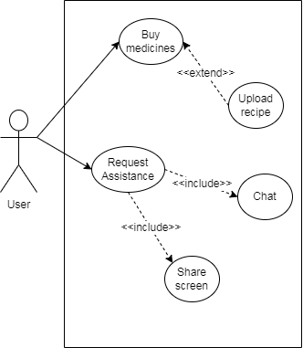

**2) Pharmacist use case**

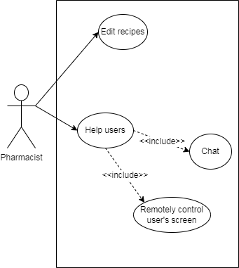

**3) Transport manager use case**

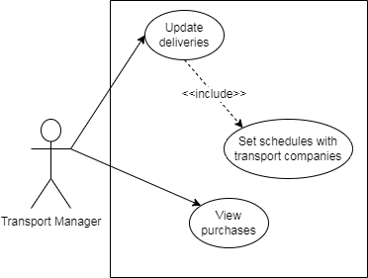

**4) Admin use case**

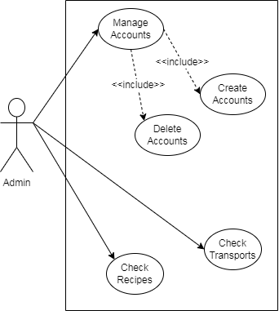

**5) General use case**

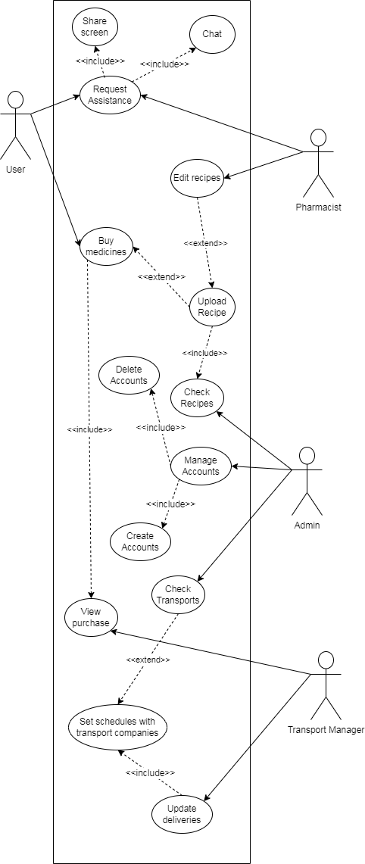

***5.Use cases Extended***

|  |  |
| --- | --- |
| Use Case (UC_1.1 ) | Buy medicines |
| Scope: | Arendi Pharmacy Application |
| Level: | User Level |
| Intention Context: | User buys medicines |
| Minimum Guarantees: | Page is loaded, but the user doesn't search anything. |
| Success Guarantees: | The user searches for the desired product(s) and the available medicines are showed to him/her. |
| Primary Actor: | User |
| Stakeholder's Interest: | Sell medicines. |
| Precondition: | User is logged in, has selected either simplified or everyday use, has selected either no recipe or has selected recipe and has uploaded his/her recipe. |

|  |  |
| --- | --- |
| Use Case (UC_1.1.1 ) | Upload recipe |
| Scope: | Arendi Pharmacy Application |
| Level: | User Level |
| Intention Context: | The user uploads his/her recipe, if he has one |
| Minimum Guarantees: | The page loads, but the user doesn't upload his/her recipe |
| Success Guarantees: | The user uploads his/her recipe and submits it. Recipe is uploaded to the system. |
| Primary Actor: | User |
| Stakeholder's Interest: | After getting recipe, medicines which require a recipe can be legally sold. |
| Precondition: | User is logged in, has selected everyday or simplified use, has selected recipe. |

|  |  |
| --- | --- |
| Use Case (UC_1.2 ) | Request Assistance |
| Scope: | Arendi Pharmacy Application |
| Level: | User Level |
| Intention Context: | Some users (e.g.: elder people) might not be used to technology, or maybe they are confused over by the recipe and/or medicines, so they might need assistance. |
| Minimum Guarantees: | Page loads, but user doesn't do anything. |
| Success Guarantees: | Page loads, user communicates with assistant until he finishes his/her task(s). |
| Primary Actor: | User |
| Stakeholder's Interest: | Make it easier for some people to use the application. |
| Precondition: | User is logged in, has selected simplified use. |

|  |  |
| --- | --- |
| Use Case (UC_1.2.1 ) | Chat |
| Scope: | Arendi Pharmacy Application |
| Level: | User Level |
| Intention Context: | Lets user chat with assistant. |
| Minimum Guarantees: | Chat box pops up, but user doesn't use it. |
| Success Guarantees: | Chat box pops up, user enters messages and communicates with assistant. |
| Primary Actor: | User |
| Stakeholder's Interest: | Make it easier for some people to use the application. |
| Precondition: | User is logged in, has selected simplified use. |

|  |  |
| --- | --- |
| Use Case (UC_1.2.2 ) | Share Screen |
| Scope: | Arendi Pharmacy Application |
| Level: | User Level |
| Intention Context: | Lets user share his/her screen to the assistant. |
| Minimum Guarantees: | Shares user's screen. |
| Success Guarantees: | Shares user's screen. |
| Primary Actor: | User |
| Stakeholder's Interest: | Make it easier for some people to use the application. |
| Precondition: | User is logged in, has selected simplified use. |

|  |  |
| --- | --- |
| Use Case (UC_2.1 ) | Edit recipes |
| Scope: | Arendi Pharmacy Application |
| Level: | User Level |
| Intention Context: | Some recipes might need changes (out-of-stock medicines, illegal medicines, etc.). Pharmacist makes suggestions for the user. |
| Minimum Guarantees: | Page loads, but pharmacist doesn't edit the recipe at all. |
| Success Guarantees: | Pharmacist makes the necessary edits. |
| Primary Actor: | Pharmacist |
| Stakeholder's Interest: | Offers alternatives to users with incompatible recipes. |
| Precondition: | Pharmacist logs in, user has submitted a recipe. |

|  |  |
| --- | --- |
| Use Case (UC_2.2 ) | Help users |
| Scope: | Arendi Pharmacy Application |
| Level: | User Level |
| Intention Context: | Pharmacist helps users who need assistance. |
| Minimum Guarantees: | Page loads, but pharmacist doesn't select any user to help. |
| Success Guarantees: | Pharmacist selects a user and helps him/her. |
| Primary Actor: | Pharmacist |
| Stakeholder's Interest: | Make it easier for some people to use the application. |
| Precondition: | Pharmacist logs in, user has requested assistance. |

|  |  |
| --- | --- |
| Use Case (UC_2.2.1 ) | Chat |
| Scope: | Arendi Pharmacy Application |
| Level: | User Level |
| Intention Context: | Pharmacist chats with user who requested assistance. |
| Minimum Guarantees: | Chat box pops up, but pharmacist doesn't use it. |
| Success Guarantees: | Chat box pops up, pharmacist enters messages and communicates with user. |
| Primary Actor: | Pharmacist |
| Stakeholder's Interest: | Make it easier for some people to use the application. |
| Precondition: | Pharmacist logs in, user has requested assistance, pharmacist has selected the user. |

|  |  |
| --- | --- |
| Use Case (UC_ ) | Remotely control user's screen |
| Scope: | Arendi Pharmacy Application |
| Level: | User Level |
| Intention Context: | Pharmacist views/controls user's screen. |
| Minimum Guarantees: | Page loads, but pharmacist doesn't select the option to view/control the user's screen. |
| Success Guarantees: | Pharmacist views/controls the user's screen, helping him/her proceed. |
| Primary Actor: | Pharmacist |
| Stakeholder's Interest: | Make it easier for some people to use the application. |
| Precondition: | Pharmacist logs in, user has requested assistance, pharmacist has selected the user. |

|  |  |
| --- | --- |
| Use Case (UC_3.1 ) | Update deliveries |
| Scope: | Arendi Pharmacy Application |
| Level: | User Level |
| Intention Context: | Transport manager schedules a new delivery with the hired transport company. |
| Minimum Guarantees: | Page loads, but the manager doesn't do anything. |
| Success Guarantees: | Manager successfully schedules a new delivery. |
| Primary Actor: | Transport Manager |
| Stakeholder's Interest: | Allows delivery of products to the clients. |
| Precondition: | Manager logs in, has selected update deliveries. |

|  |  |
| --- | --- |
| Use Case (UC_3.1.1 ) | Set schedules with transport companies |
| Scope: | Arendi Pharmacy Application |
| Level: | User Level |
| Intention Context: | Transport manager schedules a new delivery with the hired transport company. |
| Minimum Guarantees: | Page loads, but the manager doesn't do anything. |
| Success Guarantees: | Manager successfully schedules a new delivery. |
| Primary Actor: | Transport Manager |
| Stakeholder's Interest: | Allows delivery of products to the clients. |
| Precondition: | Manager logs in, has selected update deliveries. |

|  |  |
| --- | --- |
| Use Case (UC_3.2 ) | View purchases |
| Scope: | Arendi Pharmacy Application |
| Level: | User Level |
| Intention Context: | Transport manager views the purchases done, in order to get information for new delivery schedules. |
| Minimum Guarantees: | Page loads, but the manager doesn't do anything. |
| Success Guarantees: | Manager selects the purchases he wants and views their details. |
| Primary Actor: | Transport Manager |
| Stakeholder's Interest: | Allows delivery of products to the clients. |
| Precondition: | Manager logs in, has selected view purchases. |

|  |  |
| --- | --- |
| Use Case (UC_4.1 ) | Manage Accounts |
| Scope: | Arendi Pharmacy Application |
| Level: | User Level |
| Intention Context: | Admin can create new accounts or delete existing ones. |
| Minimum Guarantees: | Page loads, but the admin doesn't do anything. |
| Success Guarantees: | Admin creates/deletes accounts. |
| Primary Actor: | Admin |
| Stakeholder's Interest: | Makes it possible to add or remove users or workers to the app. |
| Precondition: | Admin has logged in, has selected accounts. |

|  |  |
| --- | --- |
| Use Case (UC_4.1.1 ) | Create accounts |
| Scope: | Arendi Pharmacy Application |
| Level: | User Level |
| Intention Context: | Admin creates a new account. |
| Minimum Guarantees: | Page loads, but the admin doesn't do anything. |
| Success Guarantees: | Admin creates a new account with the information that he has filled the form with. |
| Primary Actor: | Admin |
| Stakeholder's Interest: | Makes it possible to add new users or workers to the app. |
| Precondition: | Admin has logged in, has selected accounts, has selected create new account. |

|  |  |
| --- | --- |
| Use Case (UC_4.1.2 ) | Delete Accounts |
| Scope: | Arendi Pharmacy Application |
| Level: | User Level |
| Intention Context: | Admin deletes an account, which satisfies the info that he has written. |
| Minimum Guarantees: | Page loads, but the admin doesn't do anything. |
| Success Guarantees: | Admin deletes the account with the corresponding details that he has written. |
| Primary Actor: | Admin |
| Stakeholder's Interest: | Makes it possible to remove users or workers to the app. |
| Precondition: | Admin has logged in, has selected accounts, has selected delete account. |

|  |  |
| --- | --- |
| Use Case (UC_4.2 ) | Check transports |
| Scope: | Arendi Pharmacy Application |
| Level: | User Level |
| Intention Context: | Admin checks the deliveries that the transport managers has scheduled with the transport company. |
| Minimum Guarantees: | Page loads, but the admin doesn't do anything. |
| Success Guarantees: | Admin selects the desired delivery and views its details. |
| Primary Actor: | Admin |
| Stakeholder's Interest: | Makes it possible to check the deliveries that the transport managers has scheduled with the transport company. |
| Precondition: | Admin has logged in, has selected view transports. |

|  |  |
| --- | --- |
| Use Case (UC_4.3 ) | Check recipes |
| Scope: | Arendi Pharmacy Application |
| Level: | User Level |
| Intention Context: | Admin checks the recipes that users have uploaded. |
| Minimum Guarantees: | Page loads, but the admin doesn't do anything. |
| Success Guarantees: | Admin selects the desired recipe and views its details. |
| Primary Actor: | Admin |
| Stakeholder's Interest: | Makes it possible to check the recipes that users have uploaded. |
| Precondition: | Admin has logged in, has selected view recipes. |

***6. Activity Diagram***

***User Activity Diagram***

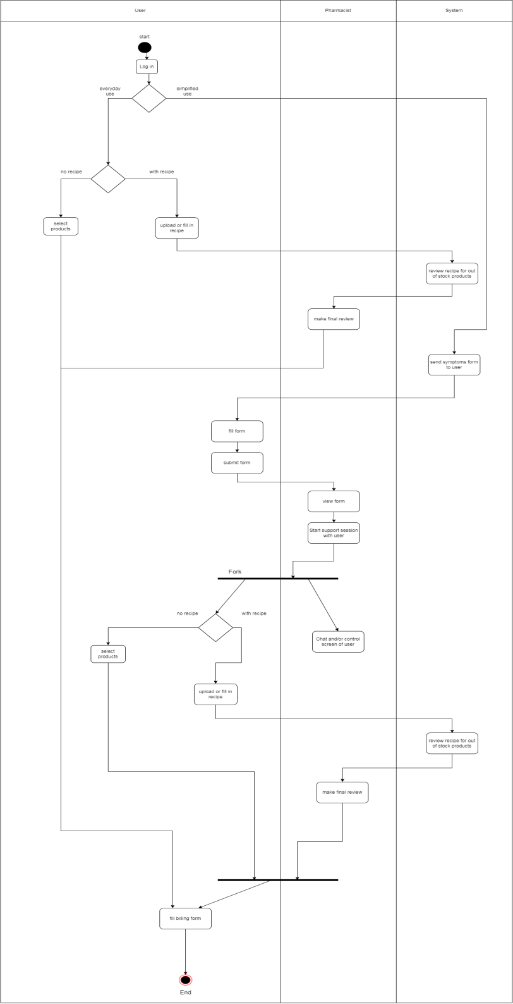

***Pharmacist Activity Diagram***

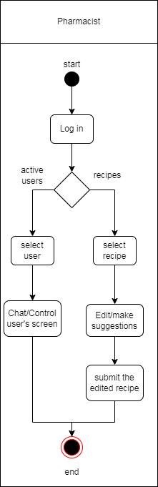

***Transport Manager Activity Diagram***

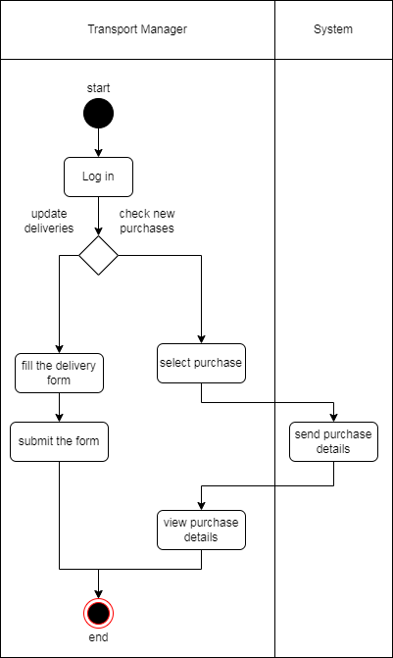

***Admin Activity Diagram***

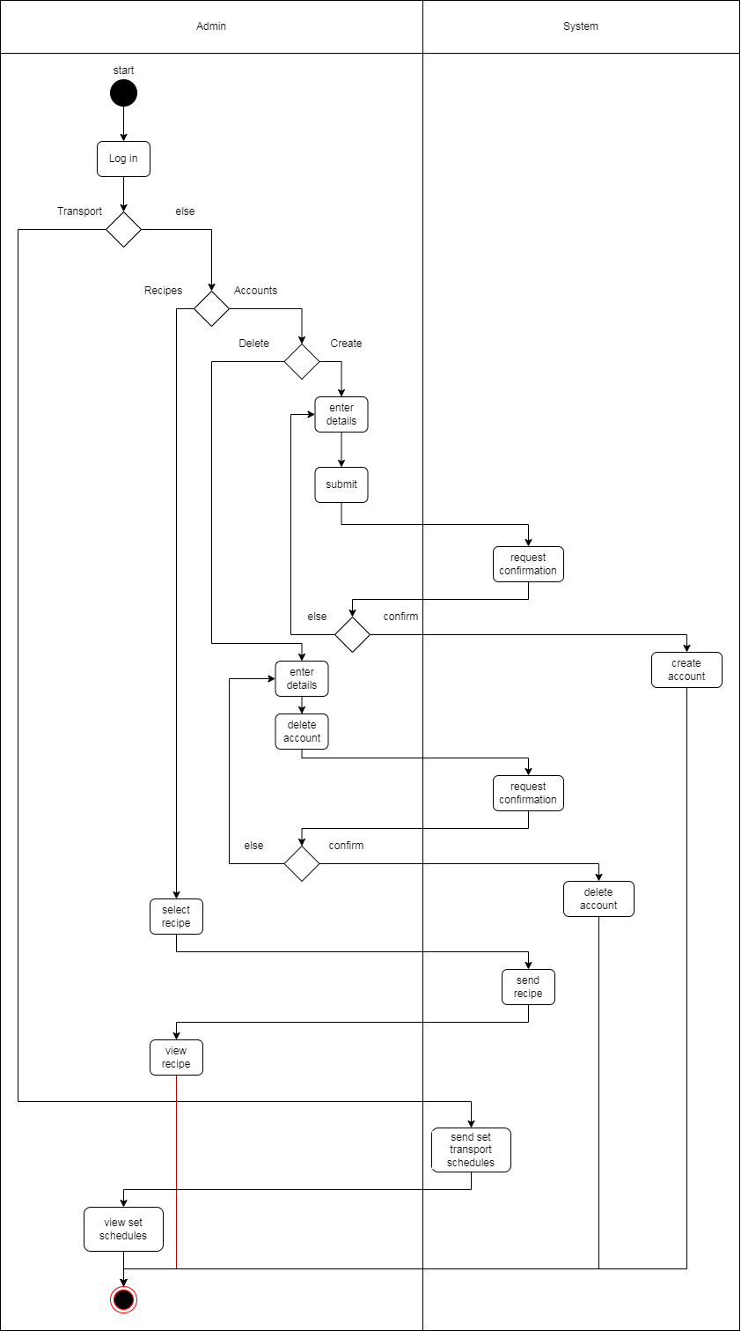

***7.State charts***

***User State chart***

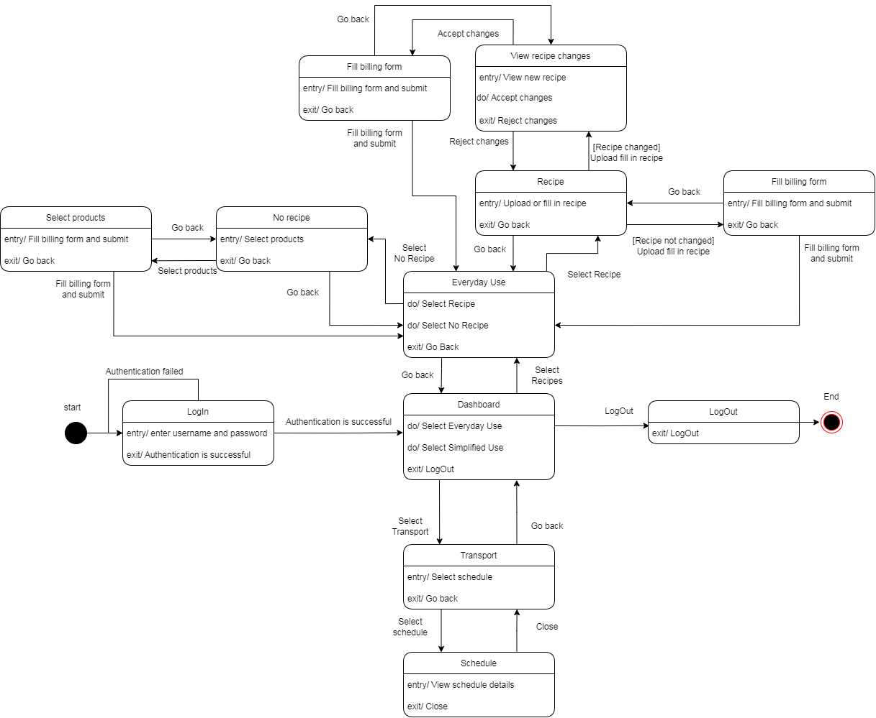

***Pharmacist State chart***

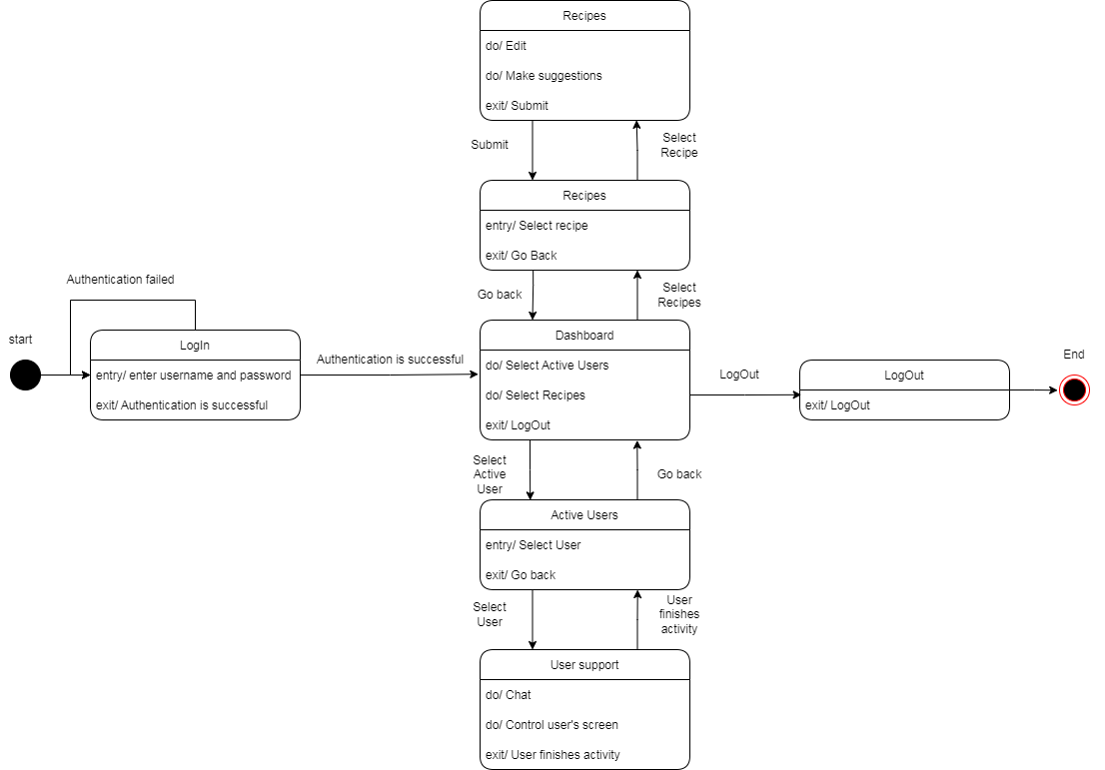

***Transport Manager State chart***

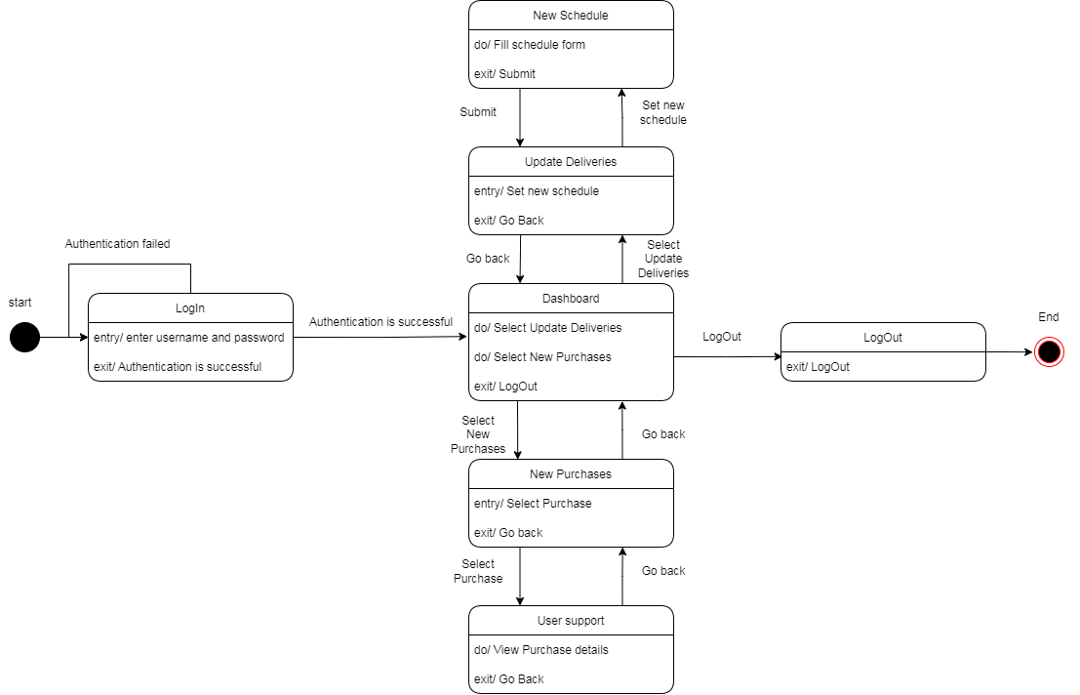

***Admin State chart***

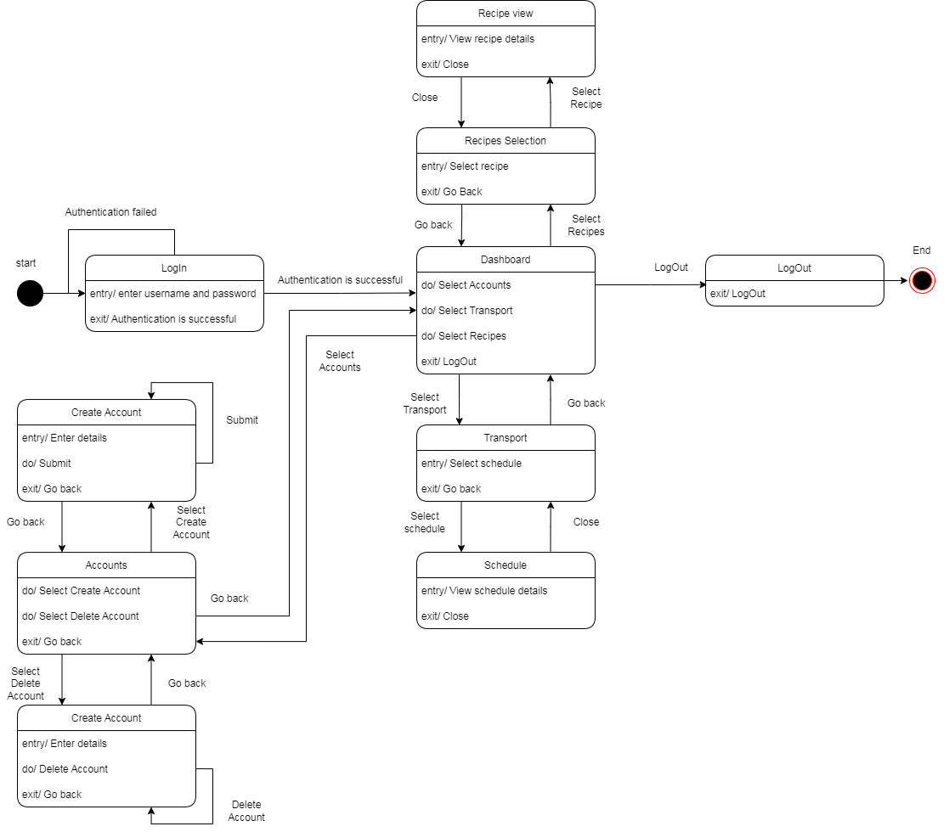

***8.Sequence diagrams***

1.User login successful

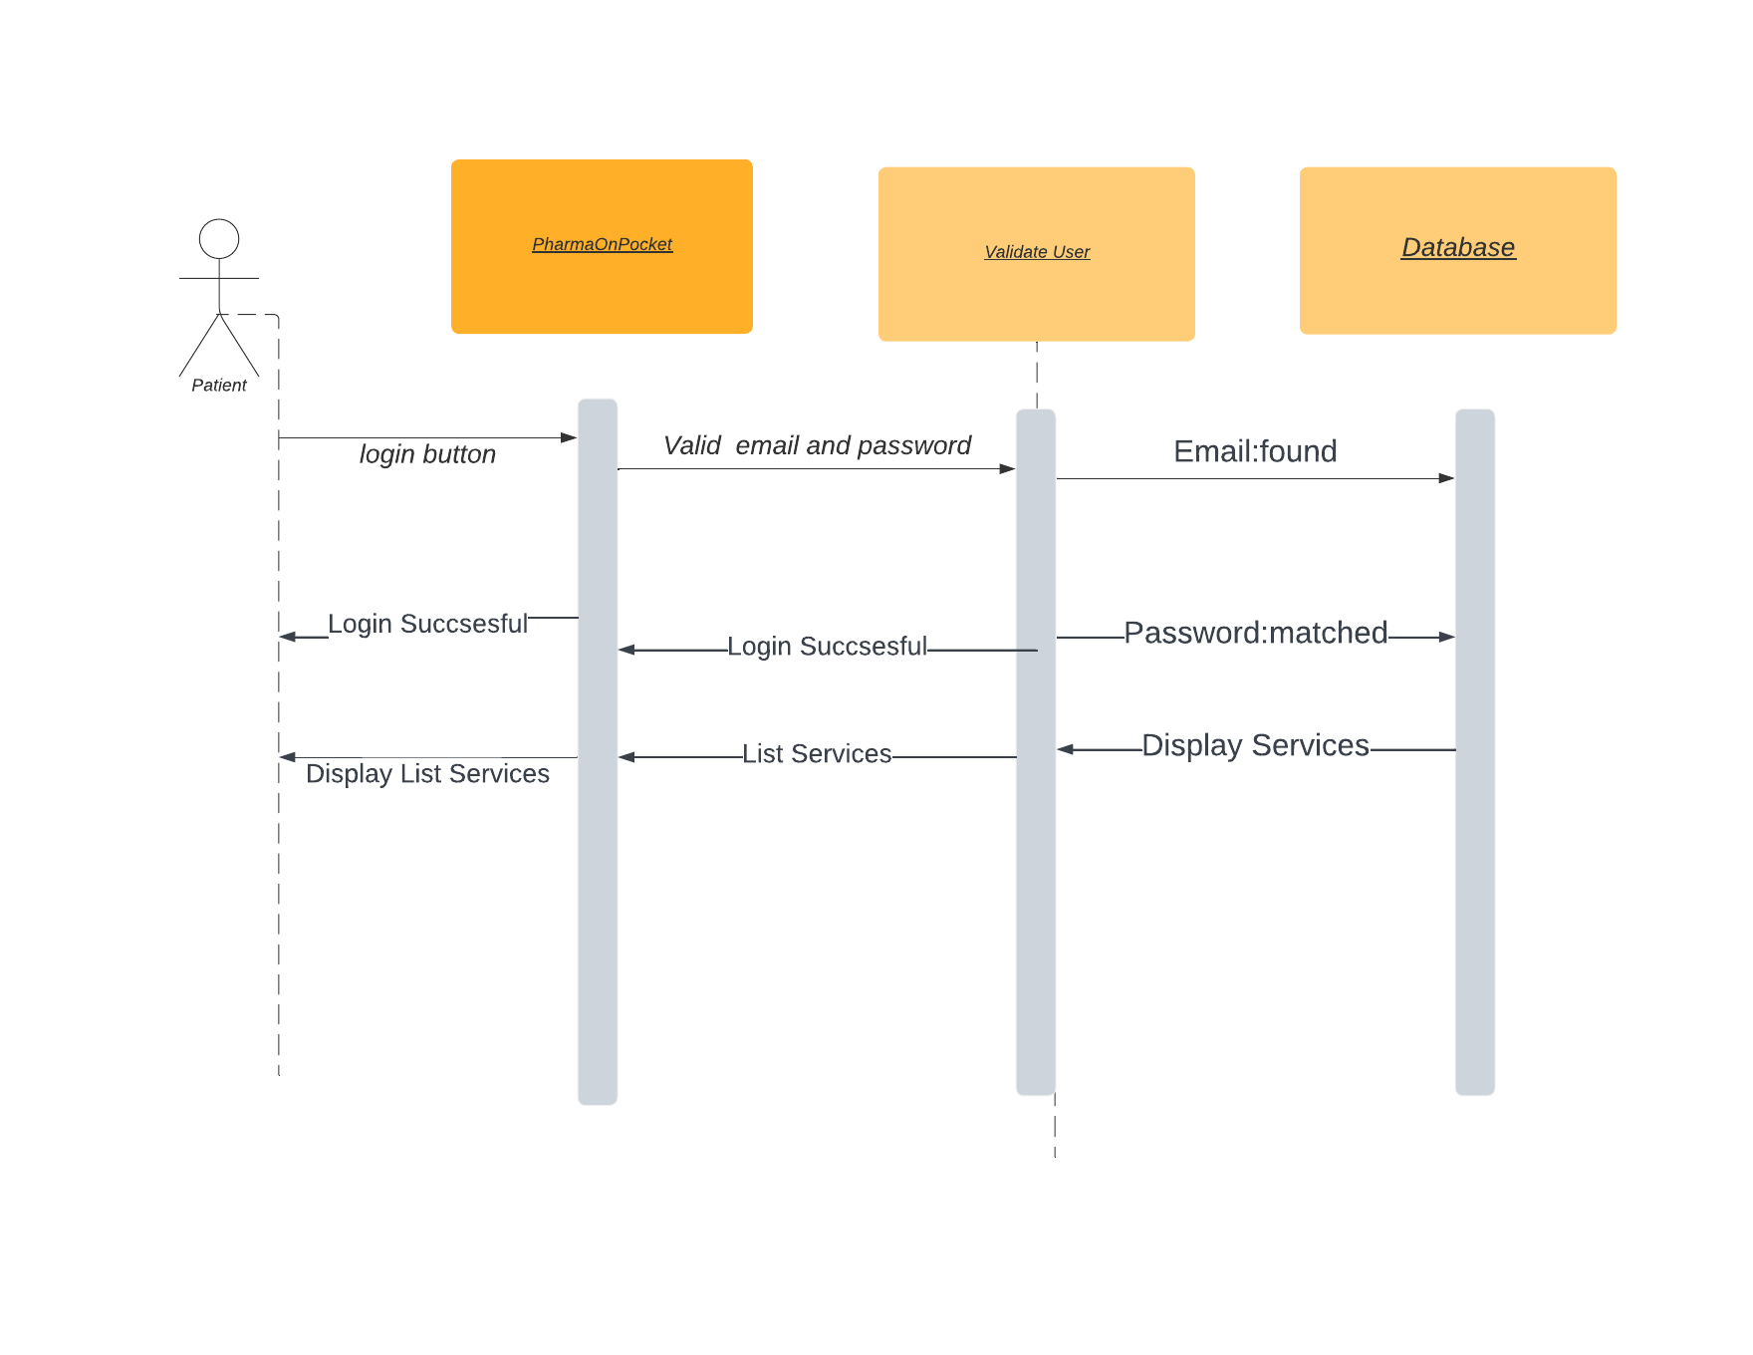

2.Use case #3

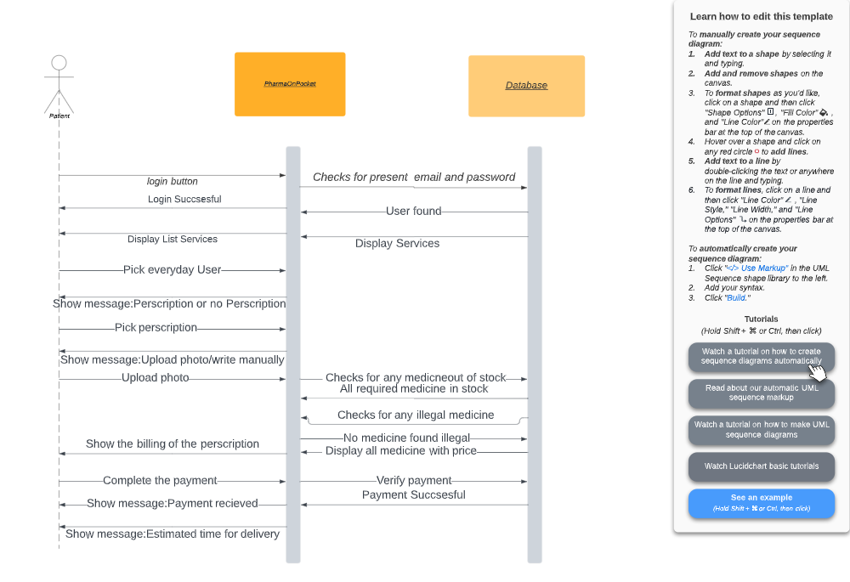

3.Use case #4

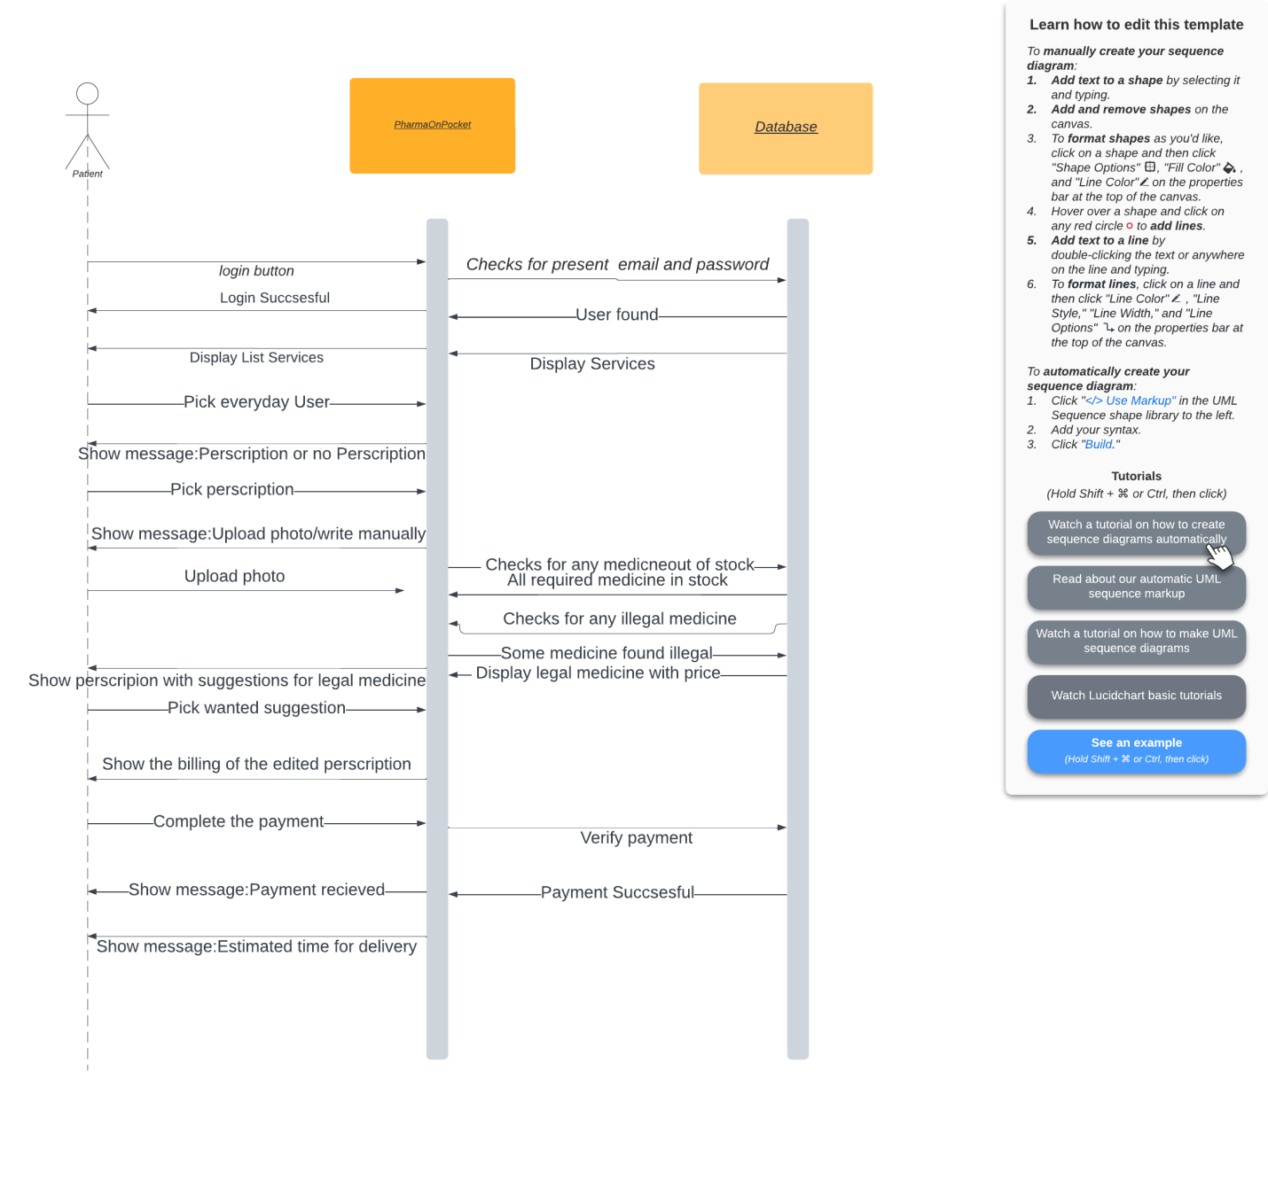

4.Use Case #5

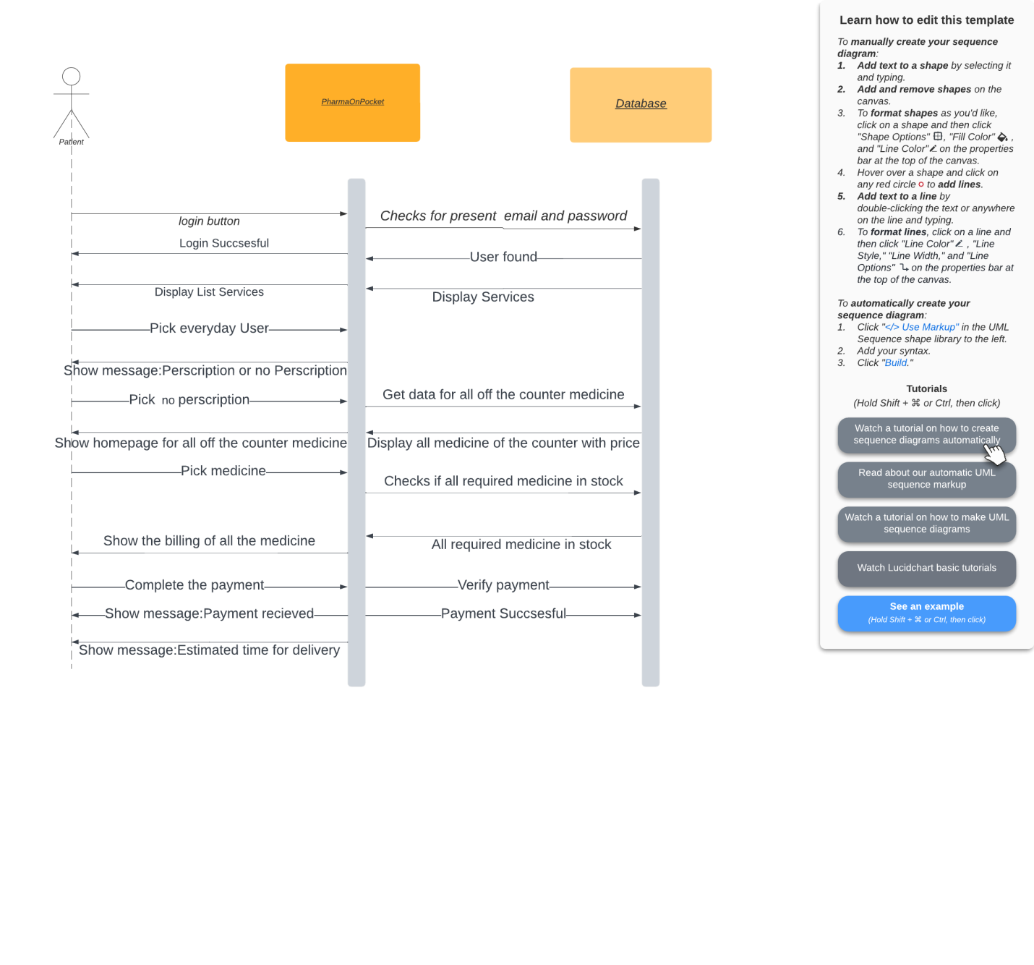

5.Use Case #6

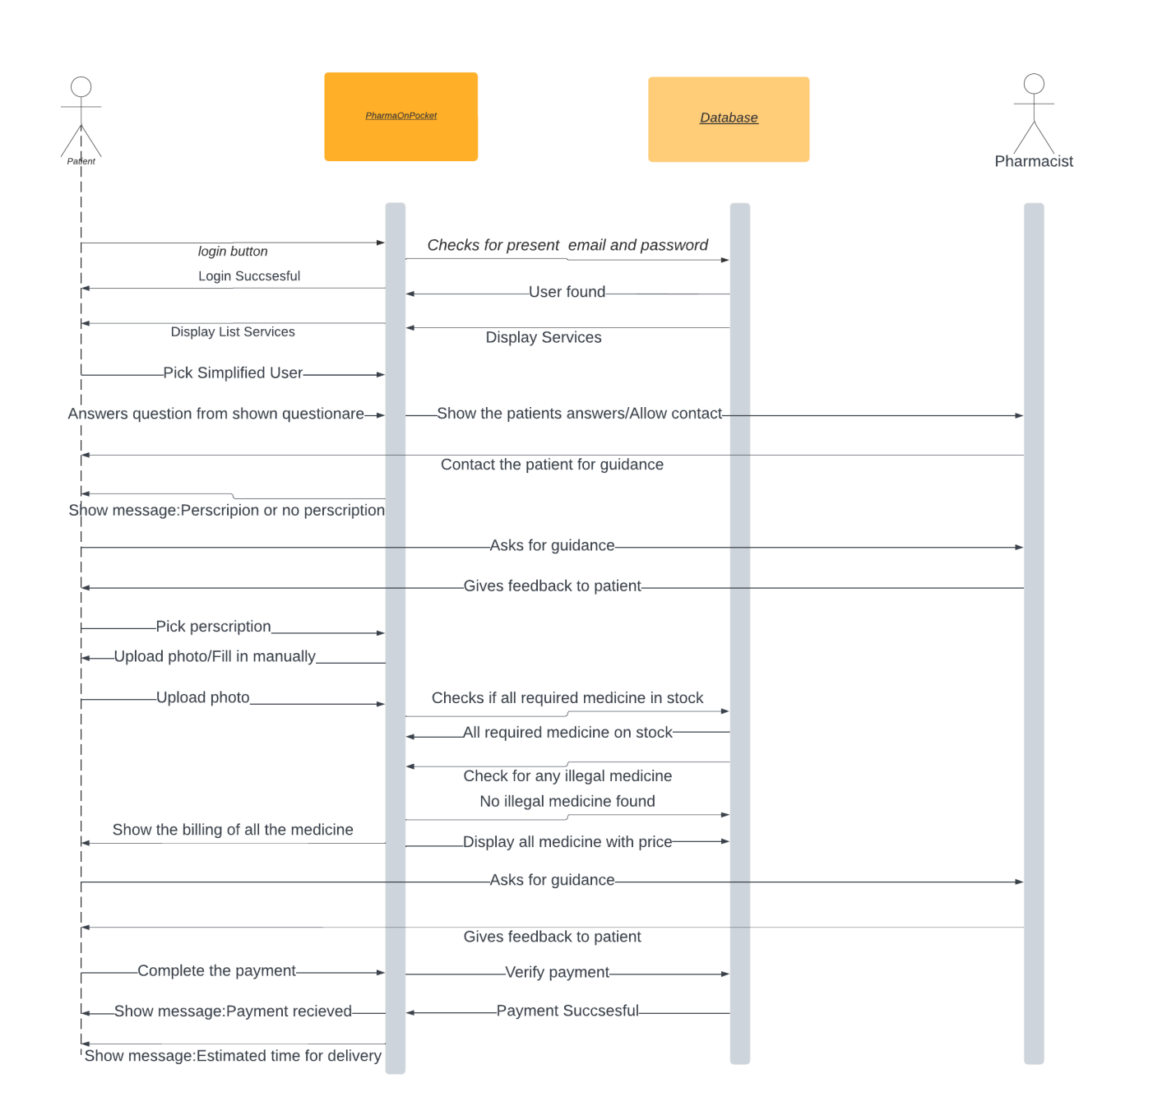

6.Use Case #7

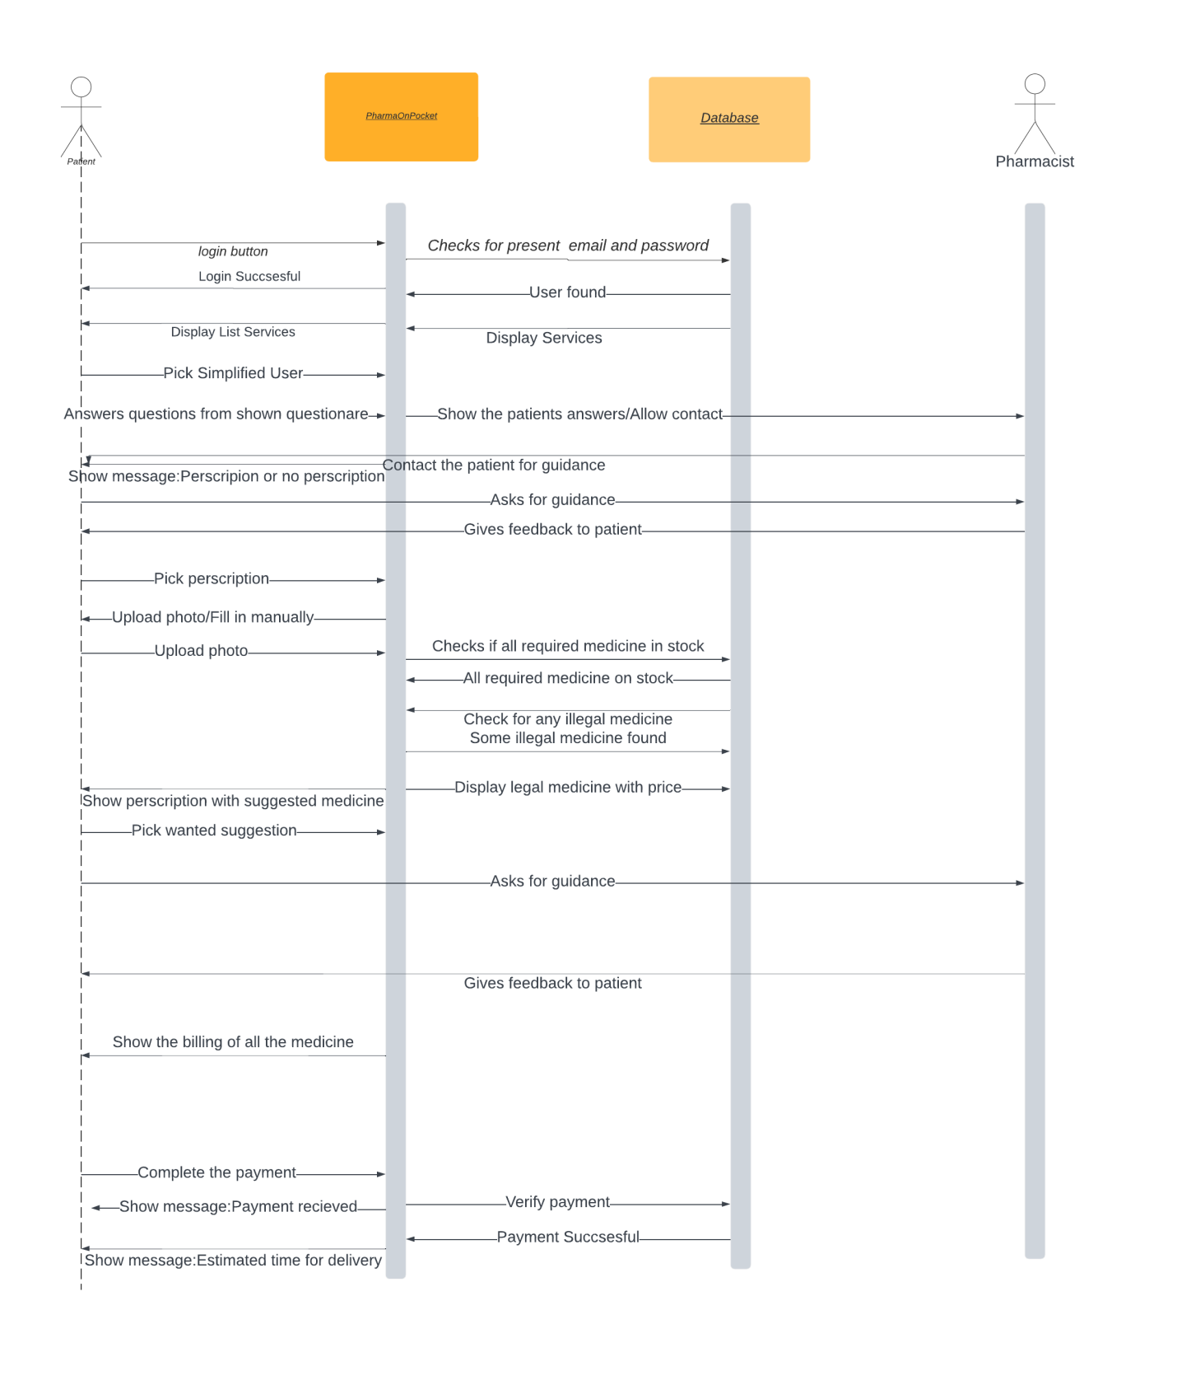

7.Use case #8

