SmartBus Intercity Bus Terminal Management & Fleet Reservation System
System Engineering Proposal & High-Fidelity UI Wireframe Blueprint
Target Sector: Transportation & Transit Fleet Logistics | Institution: Parañaque Integrated Terminal Exchange (PITX)

1. Introduction
The Parañaque Integrated Terminal Exchange (PITX) is the premier flagship multimodal public transport landport in the Philippines, operating under a 35-year concession agreement between the Department of Transportation (DOTr) and MWM Terminals, Inc. Serving as the primary transit gateway between Metro Manila and Southern Tagalog (Cavite, Batangas, Laguna, Quezon), Bicol, Visayas, Mindanao, and northern Luzon, PITX accommodates over 100,000 daily commuters across dozens of platform departure gates and multi-level terminal concourses.
Despite high passenger volumes, terminal ticket operations remain heavily manual. Ticketing cashiers rely on physical pre-printed ticket rolls, handwritten manifest clipboards, and uncoordinated verbal confirmation of seat availability across separate ticket booths.
Digitizing terminal operations through the SmartBus Intercity Bus Terminal Management & Fleet Reservation System introduces vital improvements: mathematical double-booking prevention in SQLite, interactive visual 2x2 cabin seat maps with designated priority seating, automated 20% concession discount computation (Senior Citizen, PWD, Student), instant tamper-resistant boarding pass generation, and automated standby chance passenger queueing with instant priority auto-bumping.

2. Background of the Study
The current workflow at the terminal requires walk-in passengers to line up at crowded platform ticket windows without real-time visibility of seat vacancy. Cashiers mark physical paper seating charts with ink pencils and calculate fares using handheld calculators.
Key operational pain points include: (1) Severe ticket counter congestion (8 to 12 minutes per transaction during holiday rushes), (2) Up to 3.5% seat collisions when multiple booths simultaneously sell the same bus seats, (3) Revenue discrepancies from unverified concession discounts, and (4) 15-to-30-minute departure delays while dispatchers manually count passengers and verify handwritten paper manifests.

3. Problem Statement
The system intends to address four primary operational problems:
• Manual Processing of Bookings Causes Delays: Commuters face prolonged ticket queues; cashiers manually calculating fares and verifying IDs create severe terminal congestion.
• Data Retrieval is Inefficient & Prone to Double-Bookings: Disconnected ticket registers cannot share real-time seat inventory, causing duplicate seat assignments on high-demand intercity trips.
• Reports are Difficult to Generate: Reconciling end-of-shift cash drawer balances, concession discounts, and bus operator remittances requires hours of manual ledger auditing.
• Data Security and Verification are Insufficient: Physical paper tickets lack tamper-evident verification codes and can be forged or duplicated without audit logging.

4. Project Objectives
General Objective:
To engineer, validate, and deploy the SmartBus Intercity Bus Terminal Management and Fleet Reservation System to automate route schedule browsing, interactive 2x2 seat selection, concession discount calculation, ticket cancellation, passenger manifest logging, and terminal revenue analytics.
Specific Objectives:
• Automate Existing Processes: Digitize walk-in seat reservations, real-time cabin layout visualization, passenger classification, and thermal boarding pass printing.
• Eliminate Double-Booking Collisions: Enforce ACID-compliant SQLite constraints and partial unique indexes to mathematically guarantee zero seat assignment conflicts.
• Improve Concession Verification Accuracy: Automate statutory 20% discount calculations for Senior Citizens, PWDs, and Students while mandating official ID record-keeping.
• Dynamic Inventory Lifecycle Management: Support ticket cancellations with instant seat inventory restoration and audit logging.
• Generate Real-Time Terminal Intelligence: Provide instant analytical reporting on corridor revenues, passenger volume trends, bay utilization, and concession compliance.
• Strengthen Ticket Security: Generate an 8-character cryptographically salted SHA-256 verification hash (BTK-[HEX]) on every boarding pass.

5. Scope and Limitations
System Scope:
• Officer Authentication Module with Role-Based Access Control (Ticketing Cashier, Terminal Dispatcher, Supervisor).
• Terminal Operations Dashboard tracking daily ticket sales, active departures, platform bay status, and hourly commuter intake.
• Main Transaction Engine featuring interactive 2x2 cabin seat maps (24 seats), Row 1 Priority seating validation, 20% concession calculation, and boarding pass printing.
• Master Bookings & Manifest Repository supporting sub-second ticket searches, lifecycle cancellations, and departure manifests.
• Transit Analytics & Reports Engine tracking corridor revenues, fleet load factors, and LTFRB concession compliance with PDF/CSV export.
• Officer Profile & POS Register Security module for shift cash drawer reconciliations and terminal verification seed keys.
System Limitations:
• Phase 1 focuses on high-speed Local Area Network (LAN) operations within terminal ticket booths and dispatch offices using an embedded database (SQLite); multi-terminal cloud syncing is slated for Phase 2.
• The visual seat grid is configured for standard 24-passenger 2x2 single-deck intercity coaches; multi-level sleeper coaches require custom layout templates in future iterations.

6. Target Users
• Ticketing Cashiers / Booth Clerks: Select routes, guide commuters through interactive seat maps, verify concession ID credentials, collect fares, and issue thermal boarding passes.
• Terminal Dispatchers / Bay Officers: Inspect trip manifests, verify passenger boarding codes (BTK-[HEX]), monitor departure countdowns, and clear buses for bay exit.
• Fleet & Finance Managers: Track daily terminal revenues, reconcile cash drawers, audit concession discount reimbursements, and monitor fleet load factors.
• System Administrators: Manage user accounts, configure intercity routes, assign fleet buses, and monitor database integrity.
• Commuters & Passengers: Select preferred window/aisle seats, present Senior/PWD/Student IDs for statutory discounts, and receive verified boarding passes.

7. Proposed System Description
SmartBus is an enterprise-grade transit reservation system built on a Model-View-Controller (MVC) architectural pattern. It unifies ticket issuance, interactive 2x2 visual seat selection, booking cancellations with immediate seat inventory release, trip manifest auditing, and real-time revenue analytics.
The system features an interactive visual 2x2 seating grid, mathematical double-booking prevention via SQLite partial indexing, automated calculation of statutory 20% Senior Citizen/PWD/Student discounts, and cryptographically salted SHA-256 ticket verification codes.

8. Functional Requirements
• FR-01: Multi-Tier User Authentication & Cash Register Session Control.
• FR-02: Route Schedule Browsing & Dynamic Bus Fleet Allocation (origin, destination, departure, fare).
• FR-03: Interactive 2x2 Visual Cabin Seat Selection (Seats 01-24 with dynamic state color coding).
• FR-04: Priority Seating Verification & Concession Discount Engine (20% statutory discount calculation).
• FR-05: Boarding Pass Generation with Tamper-Resistant Salted SHA-256 Code (BTK-[HEX]).
• FR-06: Booking Cancellation & Immediate Seat Inventory Release.
• FR-07: Trip Manifest Querying & Multi-Criteria Filtering across 1,800+ stored tickets.
• FR-08: Route Revenue & Fleet Analytics Reporting with PDF/CSV export.
• FR-09: Immutable System Audit Logging tracking all ticket issuances and cancellations.

9. Non-Functional Requirements
• Security: Salted SHA-256 ticket verification hashes, strict input sanitization for phone numbers (09XXXXXXXXX) and concession IDs.
• Reliability: Zero double-booking guarantee via SQLite partial unique indexing; atomic transactions with automatic rollback on error.
• Performance: Seat map render time under 50ms; ticket lookup and committing under 100ms across 50,000+ relational records.
• Scalability: Clean OOP architecture with encapsulated models ready to scale to multi-terminal network deployments.
• Usability: Ergonomic 2x2 bus layout matching real vehicle ergonomics; color-coded seat statuses and high-contrast terminal theme.
• Maintainability: PEP 8 compliance, private attributes, validated property setters, and comprehensive unit test coverage.

10. Wireframe Design
The user interface of SmartBus comprises six dedicated screens designed for clarity, high contrast, and rapid terminal ticketing throughput. Detailed wireframes and component breakdowns are provided below:

Screen 1: Login Page (Officer & POS Authentication Portal)
The entry screen enforces role-based login (Cashier, Dispatcher, Admin), username/password credentials, departure terminal wing selection, and thermal POS ticket printer initialization.
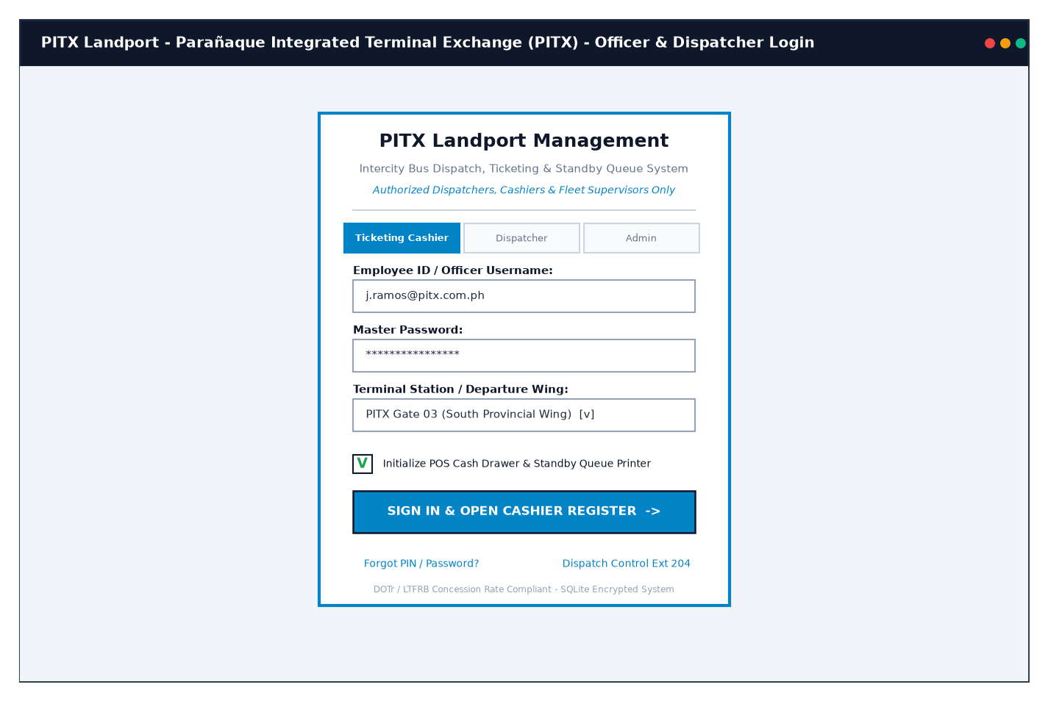
Figure: Wireframe layout schematic for Screen 1: Login Page (Officer & POS Authentication Portal)

Screen 2: Terminal Operations Dashboard
Displays real-time terminal KPIs (Today's Sales: PHP 142,680.00, Scheduled Departures: 18, Fleet Capacity Load: 86%, Platform Bays: 6 of 8 In Use), hourly commuter booking charts, corridor load factors, and active departures.
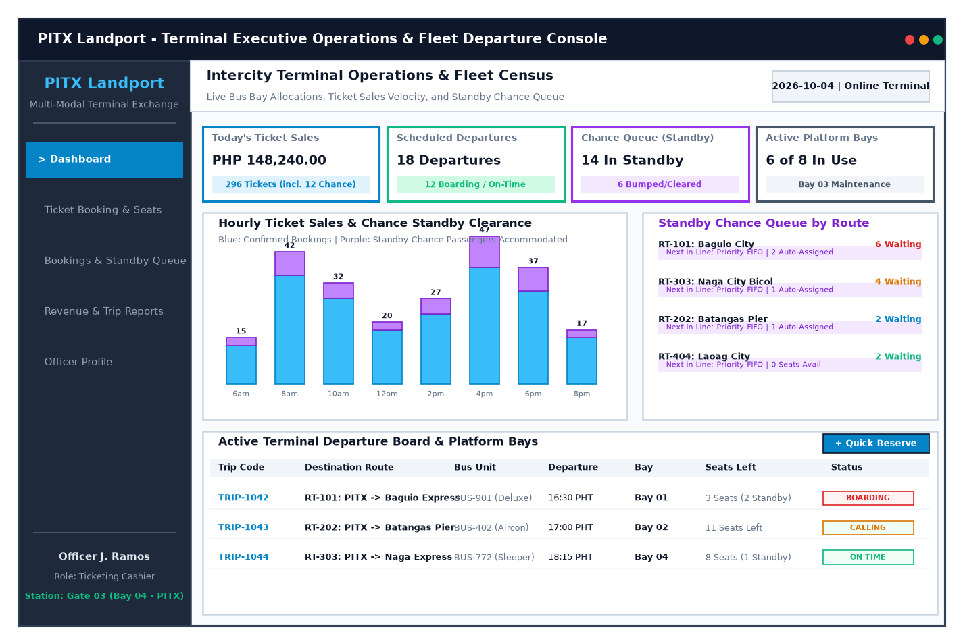
Figure: Wireframe layout schematic for Screen 2: Terminal Operations Dashboard

Screen 3: Main Transaction Page (Interactive 2x2 Cabin Seat Matrix & Booking)
The primary booking interface featuring route selection, an interactive 2x2 bus cabin seating matrix (Seats 01-24), Row 1 Senior/PWD priority validation, passenger demographic capture, statutory 20% discount calculation, and boarding pass printing.
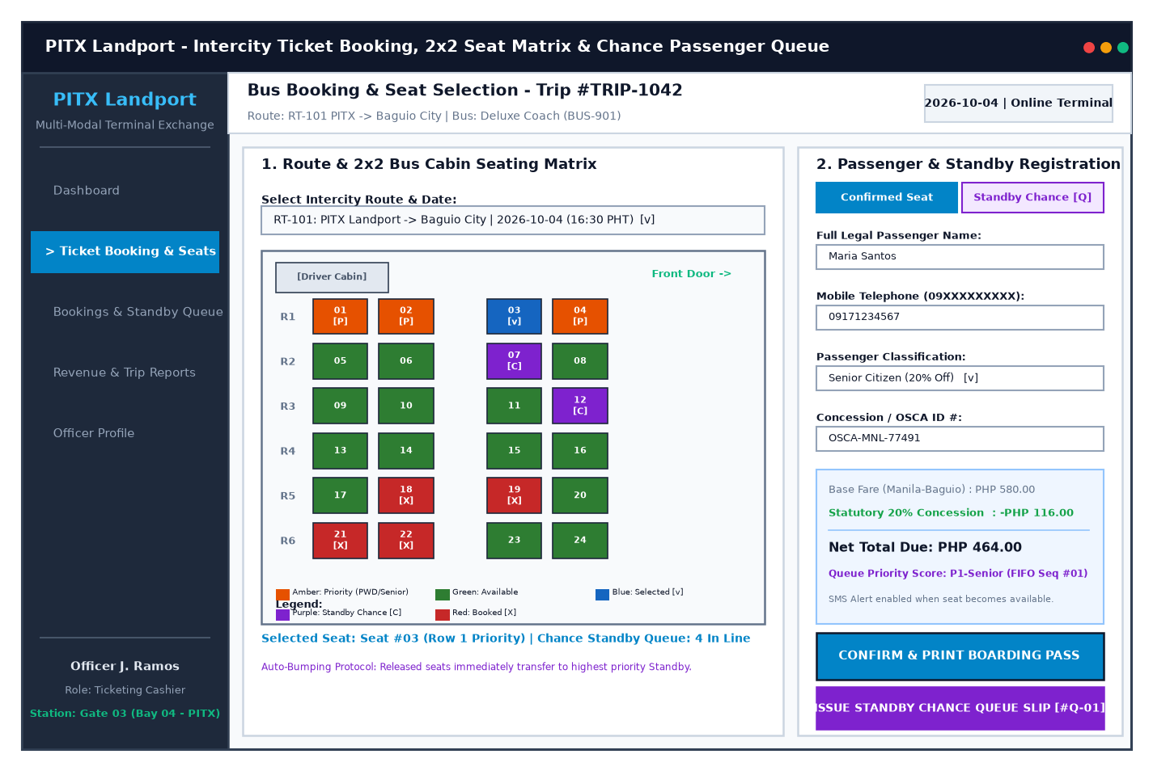
Figure: Wireframe layout schematic for Screen 3: Main Transaction Page (Interactive 2x2 Cabin Seat Matrix & Booking)

Screen 4: Master Bookings & Manifest Management Page
The central reservation archive allowing cashiers and dispatchers to look up tickets by code or passenger name, filter by corridor, inspect trip manifests, and execute ticket cancellations with immediate seat inventory release.
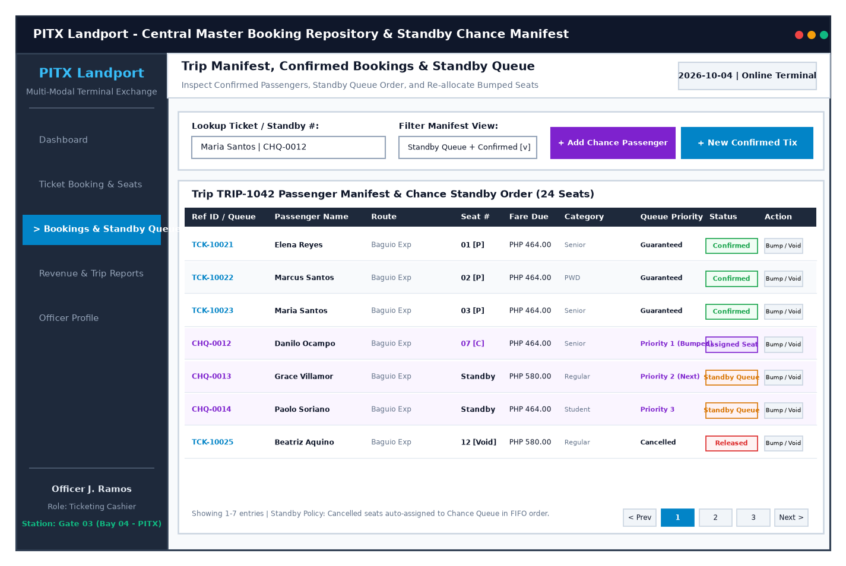
Figure: Wireframe layout schematic for Screen 4: Master Bookings & Manifest Management Page

Screen 5: Revenue & Trip Analytical Reports Page
The transit intelligence portal illustrating top intercity routes by volume (Baguio, Naga, Batangas, Laoag), monthly revenue vs 20% concession subsidies, and corridor load factor audit tables with export options.
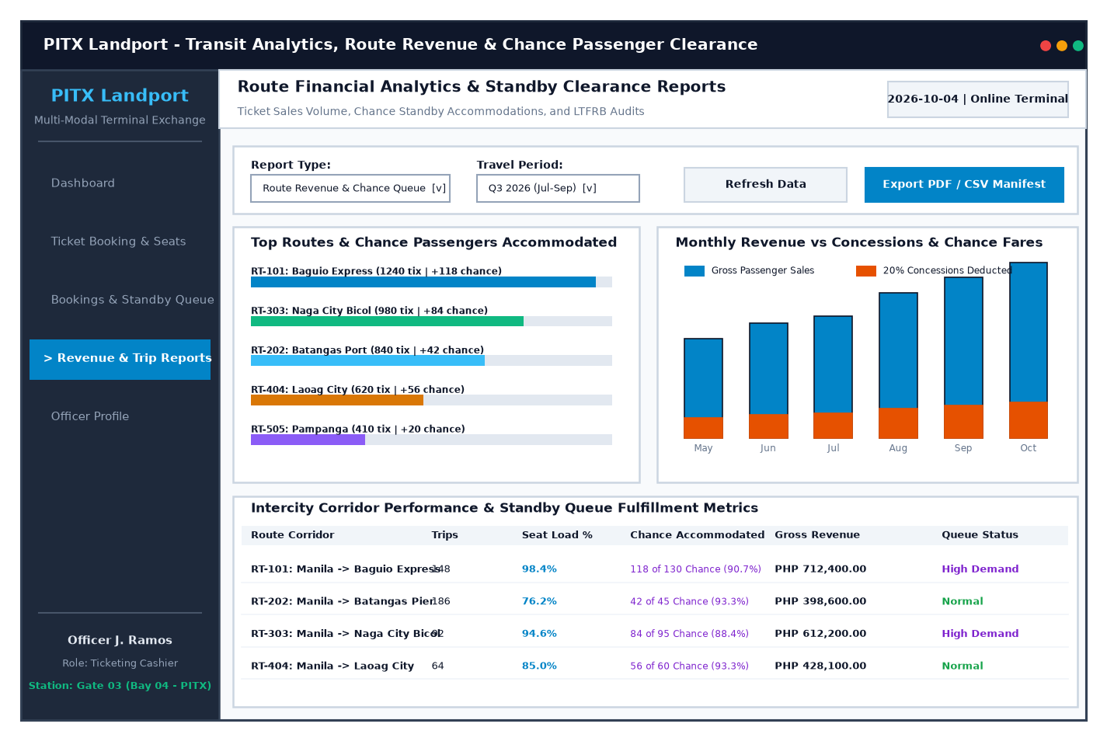
Figure: Wireframe layout schematic for Screen 5: Revenue & Trip Analytical Reports Page

Screen 6: User Profile & Transit Officer Credentials Page
Staff credential portal displaying officer identity, active POS register shift status, cash drawer balance reconciliation, ticket verification hash certificate keys, and recent audit activity logs.
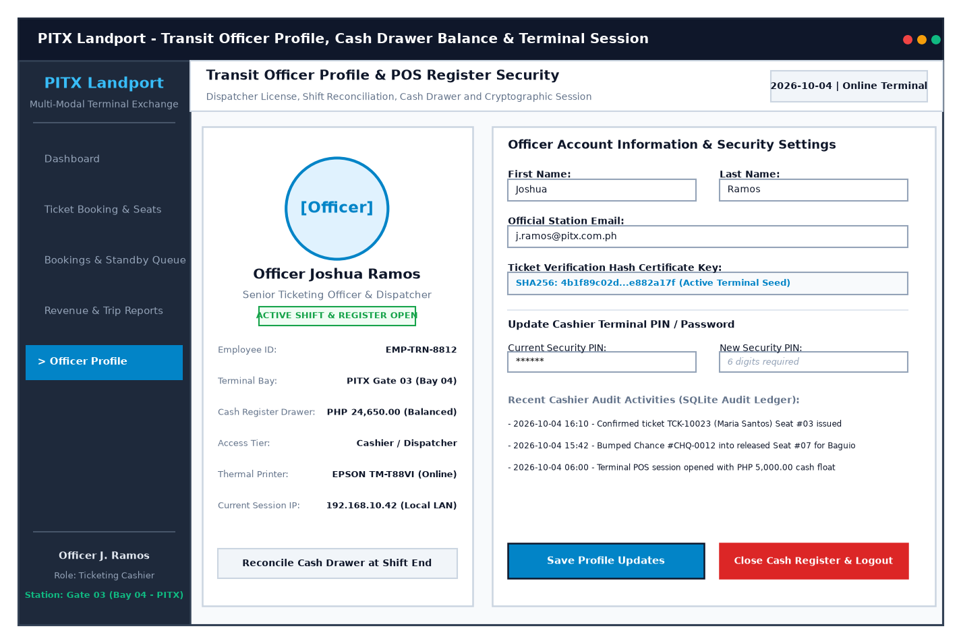
Figure: Wireframe layout schematic for Screen 6: User Profile & Transit Officer Credentials Page

11. Use Case Diagram
The SmartBus UML Use Case Diagram models the functional interactions between five transit actors (Ticketing Cashier, Terminal Dispatcher, Commuter, Administrator, Fleet/Finance Manager) and nine core system use cases:
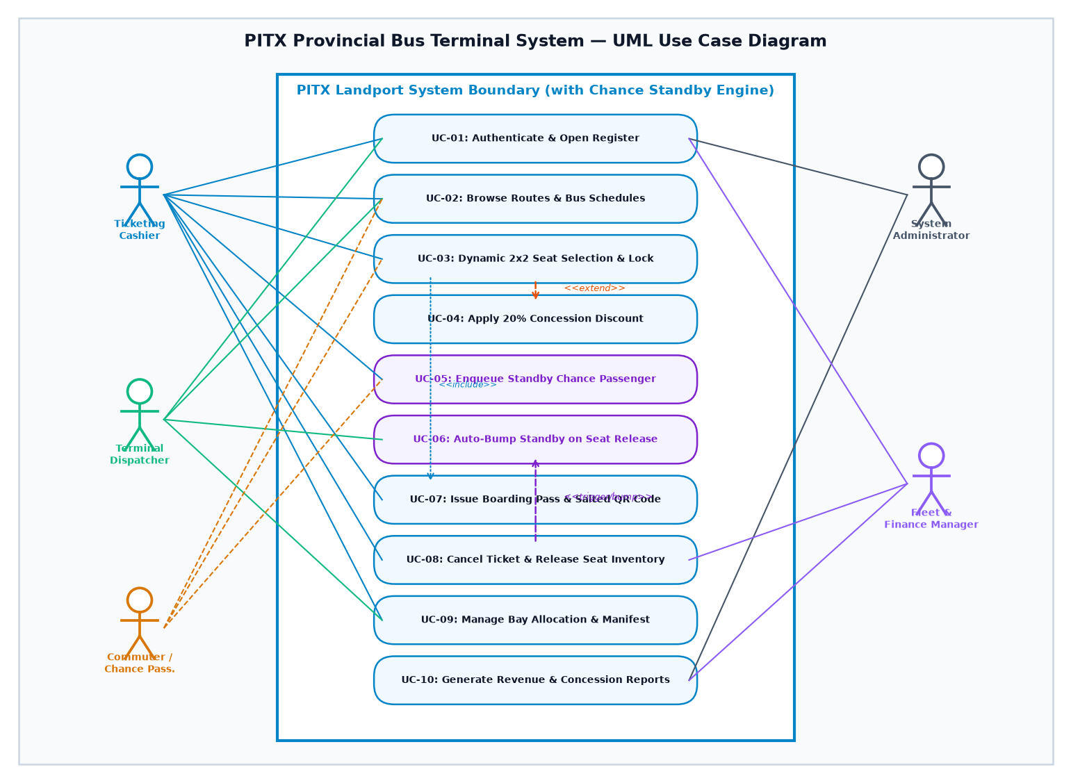
Figure: SmartBus Intercity Bus Terminal Management System UML Use Case Diagram

12. Data Requirements
SmartBus requires structured data management across five core relational entities:
• Routes: route_id (PK), origin, destination, departure_time, base_fare, is_active.
• Fleet Buses: bus_id (PK), bus_number, bus_type (Deluxe/Aircon/Sleeper), total_seats (24), plate_number, is_active.
• Passengers: passenger_id (PK), full_name, contact_number, passenger_type (Regular/Senior/PWD/Student), concession_id_proof.
• Tickets: ticket_id (PK), route_id (FK), bus_id (FK), passenger_id (FK), travel_date, seat_number (1-24), base_fare, discount_amount, final_fare, status (Confirmed/Cancelled), verification_code, created_at.
• Audit Logs: log_id (PK), action_type, entity_name, entity_id, performed_by, timestamp, notes.

13. Expected Benefits
Implementing the proposed SmartBus system delivers tangible institutional gains:
• Faster Booking Time: Reduces ticket booth transactions from 8-12 minutes to under 60 seconds with automated fare and concession calculations.
• Zero Double-Booking Collisions: Partial unique indexing in SQLite mathematically eliminates seat collisions across all ticket windows.
• Concession Revenue Accuracy: 100% auditable recording of Senior/PWD/Student IDs prevents revenue leakage and ensures LTFRB statutory compliance.
• Faster Platform Bay Turnaround: Instant digital trip manifest generation eliminates 20-minute manual dispatch delays, optimizing bay utilization.
• Fraud Prevention: Cryptographically salted 8-character verification hashes (BTK-[HEX]) prevent counterfeit ticket duplicates.
• Data-Driven Fleet Scheduling: Real-time route load factor analytics guide operators on adding buses to high-demand corridors during peak holiday rushes.

14. Conclusion
The proposed SmartBus Intercity Bus Terminal Management & Fleet Reservation System directly resolves the long ticket queues, double-booking collisions, manual manifest bottlenecks, and revenue tracking challenges experienced by intercity bus terminals.
Building directly upon the Object-Oriented design, visual seat map architecture, and ACID persistence patterns established in the course laboratory and practical exercises, SmartBus provides a robust, practical, and deployment-ready software solution. The wireframes, architecture specifications, and use case diagrams presented in this proposal establish a complete roadmap for streamlining terminal operations and elevating the public transit experience.

