Heart Disease Prediction
This report compares
Logistic Regression and
Random Forest models for
Heart Disease Prediction.
Analysis includes:
• Model Evaluation
• Decile Analysis
• Lift Analysis
• Threshold Optimization
• Business Profit Analysis

Model Evaluation Metrics

Logistic Regression Metrics
Accuracy | Precision | Recall | F1 | ROC_AUC | PR_AUC
0.8146341463414634 | 0.7637795275590551 | 0.923809523809524 | 0.8362068965517241 | 0.926095238095238 | 0.9239974129485962

Random Forest Metrics
Accuracy | Precision | Recall | F1 | ROC_AUC | PR_AUC
1.0 | 1.0 | 1.0 | 1.0 | 1.0 | 1.0

Decile Analysis

Logistic Regression Deciles
Decile | Records | Actual_Positives | Avg_Probability | Event_Rate | Cumulative_Events | Cumulative_Gain | Lift
1 | 21 | 21 | 0.906432369271472 | 1.0 | 21 | 20.0 | 1.9523809523809523
2 | 20 | 18 | 0.8576381260786052 | 0.9 | 39 | 37.142857142857146 | 1.7571428571428571
3 | 21 | 20 | 0.7847232816898743 | 0.9523809523809524 | 59 | 56.19047619047619 | 1.859410430839002
4 | 20 | 17 | 0.6973026676923334 | 0.85 | 76 | 72.38095238095238 | 1.6595238095238094
5 | 21 | 13 | 0.6414937975223567 | 0.6190476190476191 | 89 | 84.76190476190476 | 1.2086167800453516
6 | 20 | 6 | 0.5602075220786891 | 0.3 | 95 | 90.47619047619048 | 0.5857142857142856
7 | 20 | 7 | 0.451529787899876 | 0.35 | 102 | 97.14285714285714 | 0.6833333333333332
8 | 21 | 3 | 0.2727266800297453 | 0.1428571428571428 | 105 | 100.0 | 0.2789115646258503
9 | 20 | 0 | 0.1571963046447057 | 0.0 | 105 | 100.0 | 0.0
10 | 21 | 0 | 0.0728334138766629 | 0.0 | 105 | 100.0 | 0.0

Random Forest Deciles
Decile | Records | Actual_Positives | Avg_Probability | Event_Rate | Cumulative_Events | Cumulative_Gain | Lift
1 | 21 | 21 | 0.9966666666666668 | 1.0 | 21 | 20.0 | 1.9523809523809523
2 | 20 | 20 | 0.9891666666666664 | 1.0 | 41 | 39.04761904761905 | 1.9523809523809523
3 | 21 | 21 | 0.9726984126984126 | 1.0 | 62 | 59.04761904761905 | 1.9523809523809523
4 | 20 | 20 | 0.9383333333333332 | 1.0 | 82 | 78.0952380952381 | 1.9523809523809523
5 | 21 | 21 | 0.8598412698412697 | 1.0 | 103 | 98.09523809523807 | 1.9523809523809523
6 | 20 | 2 | 0.2303333333333333 | 0.1 | 105 | 100.0 | 0.1952380952380952
7 | 20 | 0 | 0.0686666666666666 | 0.0 | 105 | 100.0 | 0.0
8 | 21 | 0 | 0.0253968253968253 | 0.0 | 105 | 100.0 | 0.0
9 | 20 | 0 | 0.0108333333333333 | 0.0 | 105 | 100.0 | 0.0
10 | 21 | 0 | 0.0011111111111111 | 0.0 | 105 | 100.0 | 0.0

Threshold Optimization

Optimal Threshold Summary
Model | Threshold | Profit
Logistic Regression | 0.21 | 46500.0
Random Forest | 0.27 | 52500.0

Visualizations
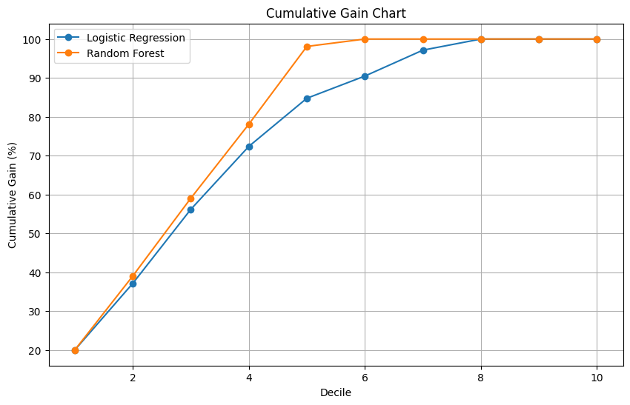
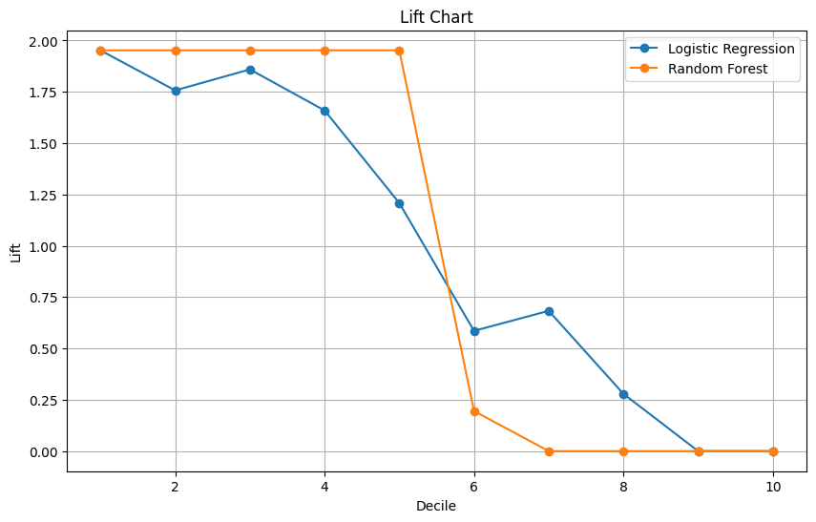
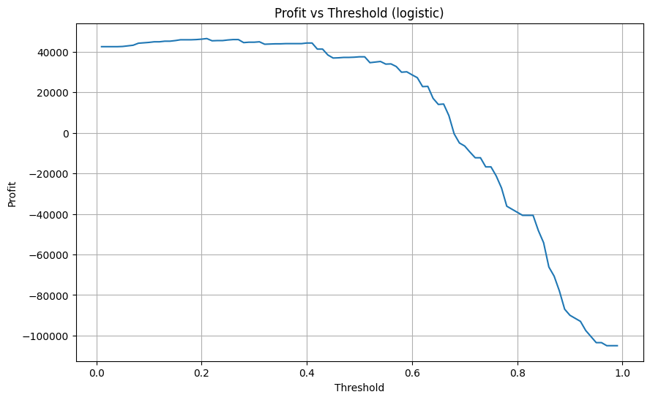
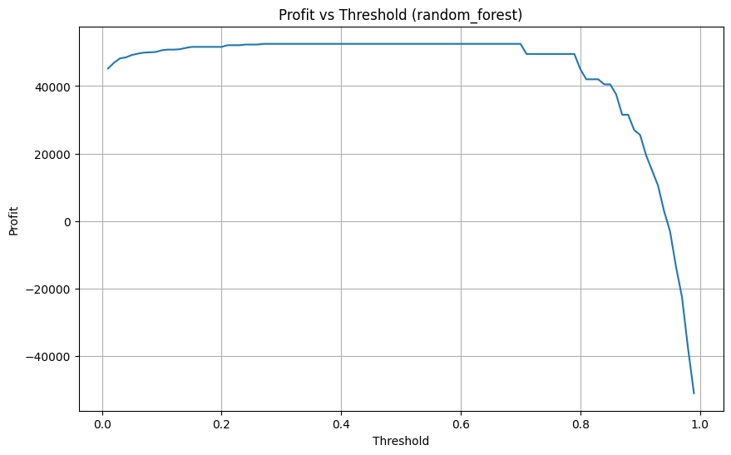
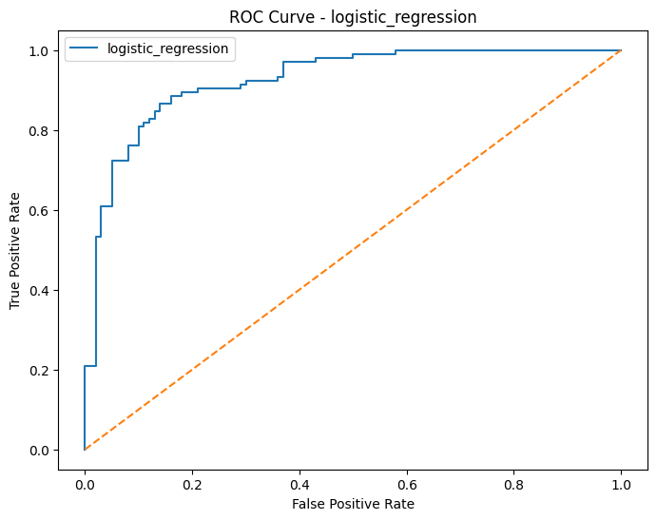
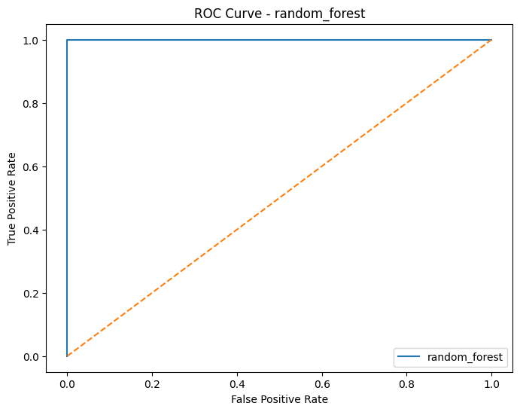

Business Recommendation
Recommended Model:
Random Forest
Reason:
This model generated the
highest business profit after
threshold optimization.
The recommendation is based
on business value rather than
accuracy alone.
The selected threshold
maximizes:
- True Positives
- Cost Savings
- Event Capture
while minimizing expensive
False Negatives.

