Project 2: Morse Code

Cs303-kuhail

Chris Swayne, Michael Cu, Ny Tran, Justin Pfau

# *PROBLEM*

We created a program that will build a Morse code tree, simply put it should decode a message using the Morse tree that will be built. We’ll read in the given file to build the tree.

## *Solution*

In the .h (header file):

* We built a struct that will contain the data, left, and right node.
* This will be used to build the tree

In the .cpp:

* Gets date from the file and imports it to the tree
* Creates a map of the char and string

In the main .cpp:

* Created the function placeNode to put the Node within the tree
  + If the tree is only one character, return that data
  + If char is “-“ go to the left of the tree and place the node
  + If char is “_” go to the right of the tree and place the node
  + Else returns -1
* Created the function createTree
  + Creates the tree for each piece of data given
  + Iterates through the entire file to create the tree
* Created searchMorse
  + Searches to find the decoded character
  + If found, return that data
  + If the character is “.“ go left in the tree
  + If the character is “_” go right in the tree
* The main will:
  + Open and read the data from morse.txt
  + Sets the variables and delimiter
  + Takes the spaces out of the encoded string and pushes them to the encoder string, along with the token, and a breakpoint and watch variables.
  + Adds all the converted letters to the encoded vector
  + Reverses the order of the encoded vector
  + Prints out the Morse code
  + Creates a tree based on the given string
  + Decodes the string from the encoded vector
  + Reverses the string from the encoded vector
  + Prints out the decoded vector correctly

Algorithm Efficiencies:

* placeNode:
  + Worst Case: O(N)
  + Best Case: O(N)
  + Goes to every node and ends at the right most, so goes through N nodes
* searchMorse:
  + Worst Case: O(N)
  + Best Case: O(logN)
  + Goes to every node

The UML Diagram:

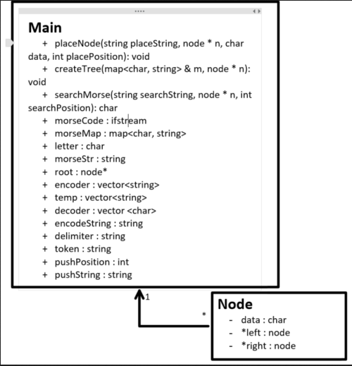

References:

CodeForGeeks:

<https://www.geeksforgeeks.org/binary-search-tree-set-1-search-and-insertion/>

<https://www.geeksforgeeks.org/linked-complete-binary-tree-its-creation/>

C++ Reference:

<http://www.cplusplus.com/reference/map/map/>

<http://www.cplusplus.com/reference/vector/vector/?kw=vector>