

SCHOOL OF ADVANCED TECHNOLOGY

ICT - Applications & Programming

Computer Engineering Technology – Computing Science



A21
Model Definitions (RE/Automaton)

Lab Professor / Lab Session:
Paulo Sousa / 011

Team:
Henry Forget - Id: 041023812 / Colin Tapp – Id: 040774946

Language Name [Mouse]

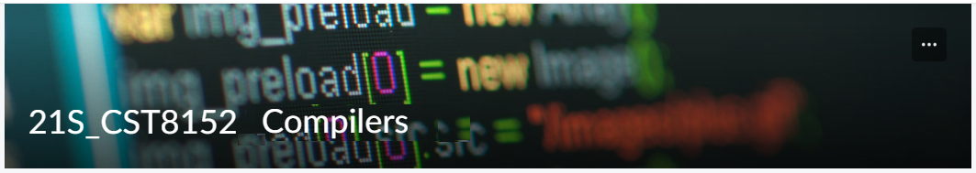

MODEL TASK FOR ASSIGNMENT 2.1 – Mouse

Task 1: Language Symbols (2.0 marks)

KEYWORDS
and break class continue def
elif else False for if
or pass return True while

DATATYPES
str int float bool NoneType

SPECIAL SYMBOLS
+ - * / % ** //
= += -= *= /= %= //=
**= &= |= ^= == != >
< >= <= : ; ! #
'' () [] . ,

VARIABLES
A letter followed by any combination of letters, digits and underscores. Ex: var, Var, var1, var_1
Constant variables will be in all uppercase letters. Ex: VAR, VAR1, VAR_1

FUNCTIONS
Functions will follow the same convention as variables, followed by parentheses. Ex: func(), Func(), func1(), func_1()
LITERALS
Integer = 0, 10, -4, …
Float = 0.0, 3.14, -1.5, …
String = "Any sequence of valid chars"
Boolean = True, False

COMMENTS
# - single line comment

Task 2: RE – Regular Expression (3.0 mark)

Lexeme Classes:

A1 = < (Angle bracket open)
A2 = > (Angle bracket close)
B1 = ( (Bracket open)
B2 = ) (Bracket close)
C = : (Colon)
D = (0…9) (Digits)
E = ‘=’ (Equals sign)
H = # (Hash symbol, comments)
L = (A…Z|a…z) (Letters)
N = ‘\n’ (New line char)
O1 = + (Addition operator)
O2 = - (Subtraction operator
O3 = * (Multiplication operator)
O4 = / (Division operator)
O5 = ! (Negation operator)
P1 = . (Period, dot operator)
P2 = , (Comma)
Q1 = " (Double quotation mark)
Q2 = ‘ (Single quotation mark)
S1 = [ (Square bracket open)
S2 = ] (Square bracket close)
T = ‘\t’ (Tab space)
U = ‘_’ (Underscore)
V = ‘\0’ (Void, NULL)
Z = (^[A1…V]) (Other)

Regular Expressions:

* Comments: H(^N)*N
* Variables: L(L|D|U)*
* Functions: L(L|D|U)*B1
* Literals
- Integer: (O1|O2)?D+
- Float: (O1|O2)?D*PD+
- String: Q(^Q)*Q
- Bool: L+ (Note: Matching “True” or “False”)
* Keywords: L+ (Note: Matching any keyword defined in task 1)

Task 3: TD – Transition Diagram (3.0 marks)

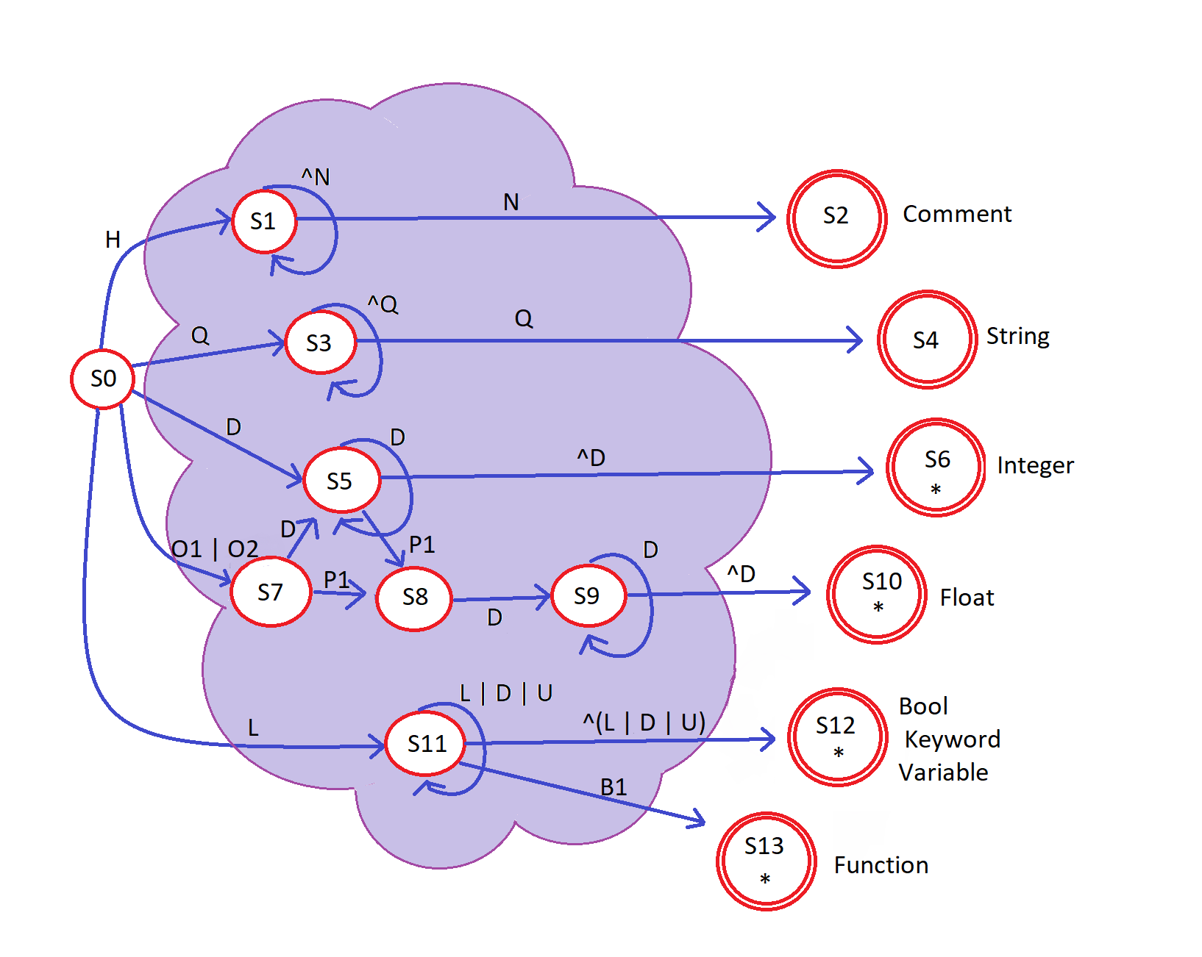

Task 4: TT – Transition Table (2.0 marks)

Input | Input Symbol |  |  |  |  |  |  |  |  |  |  |  |  |  |  |  |  |  |  |  |  |  |  |  |  | Output
State / Classes | 0 | 1 | 2 | 3 | 4 | 5 | 6 | 7 | 8 | 9 | 10 | 11 | 12 | 13 | 14 | 15 | 16 | 17 | 18 | 19 | 20 | 21 | 22 | 23 | 24 | Type
- | A1 | A2 | B1 | B2 | C | D | E | H | L | N | O1 | O2 | O3 | O4 | O5 | O6 | P1 | P2 | Q | S1 | S2 | T | U | V | Z | -
S0 | ES | ES | ES | ES | ES | 5 | ES | 1 | 11 | ES | 7 | 7 | ES | ES | ES | ES | ES | ES | 3 | ES | ES | ES | ES | ES | ES | NOFS [0]
S1 | 1 | 1 | 1 | 1 | 1 | 1 | 1 | 1 | 1 | 2 | 1 | 1 | 1 | 1 | 1 | 1 | 1 | 1 | 1 | 1 | 1 | 1 | 1 | 1 | 1 | NOFS [1]
S2 | FS | FS | FS | FS | FS | FS | FS | FS | FS | FS | FS | FS | FS | FS | FS | FS | FS | FS | FS | FS | FS | FS | FS | FS | FS | FSNR (Comment) [2]
S3 | 3 | 3 | 3 | 3 | 3 | 3 | 3 | 3 | 3 | 3 | 3 | 3 | 3 | 3 | 3 | 3 | 3 | 3 | 4 | 3 | 3 | 3 | 3 | 3 | 3 | NOFS [3]
S4 | FS | FS | FS | FS | FS | FS | FS | FS | FS | FS | FS | FS | FS | FS | FS | FS | FS | FS | FS | FS | FS | FS | FS | FS | FS | FSNR (String) [4]
S5 | 6 | 6 | 6 | 6 | 6 | 5 | 6 | 6 | 6 | 6 | 6 | 6 | 6 | 6 | 6 | 6 | 8 | 6 | 6 | 6 | 6 | 6 | 6 | 6 | 6 | NOFS [5]
S6 | FS | FS | FS | FS | FS | FS | FS | FS | FS | FS | FS | FS | FS | FS | FS | FS | FS | FS | FS | FS | FS | FS | FS | FS | FS | FSWR (Integer) [6]
S7 | ES | ES | ES | ES | ES | 5 | ES | ES | ES | ES | ES | ES | ES | ES | ES | ES | 8 | ES | ES | ES | ES | ES | ES | ES | ES | NOFS [7]
S8 | ES | ES | ES | ES | ES | 9 | ES | ES | ES | ES | ES | ES | ES | ES | ES | ES | ES | ES | ES | ES | ES | ES | ES | ES | ES | NOFS [8]
S9 | 10 | 10 | 10 | 10 | 10 | 9 | 10 | 10 | 10 | 10 | 10 | 10 | 10 | 10 | 10 | 10 | 10 | 10 | 10 | 10 | 10 | 10 | 10 | 10 | 10 | NOFS [9]
S10 | FS | FS | FS | FS | FS | FS | FS | FS | FS | FS | FS | FS | FS | FS | FS | FS | FS | FS | FS | FS | FS | FS | FS | FS | FS | FSWR (Float) [10]
S11 | 12 | 12 | 13 | 12 | 12 | 11 | 12 | 12 | 11 | 12 | 12 | 12 | 12 | 12 | 12 | 12 | 12 | 12 | 12 | 12 | 12 | 12 | 11 | 12 | 12 | NOFS [11]
S12 | FS | FS | FS | FS | FS | FS | FS | FS | FS | FS | FS | FS | FS | FS | FS | FS | FS | FS | FS | FS | FS | FS | FS | FS | FS | FSWR (Bool/Keyword/Var) [12]
S13 | FS | FS | FS | FS | FS | FS | FS | FS | FS | FS | FS | FS | FS | FS | FS | FS | FS | FS | FS | FS | FS | FS | FS | FS | FS | FSWR (Function) [13]
Legend:
Red: Error State
Green: Valid exit
Blue: Loops into itself
Purple: Final State

Github Usage (1.0 bonus marks)

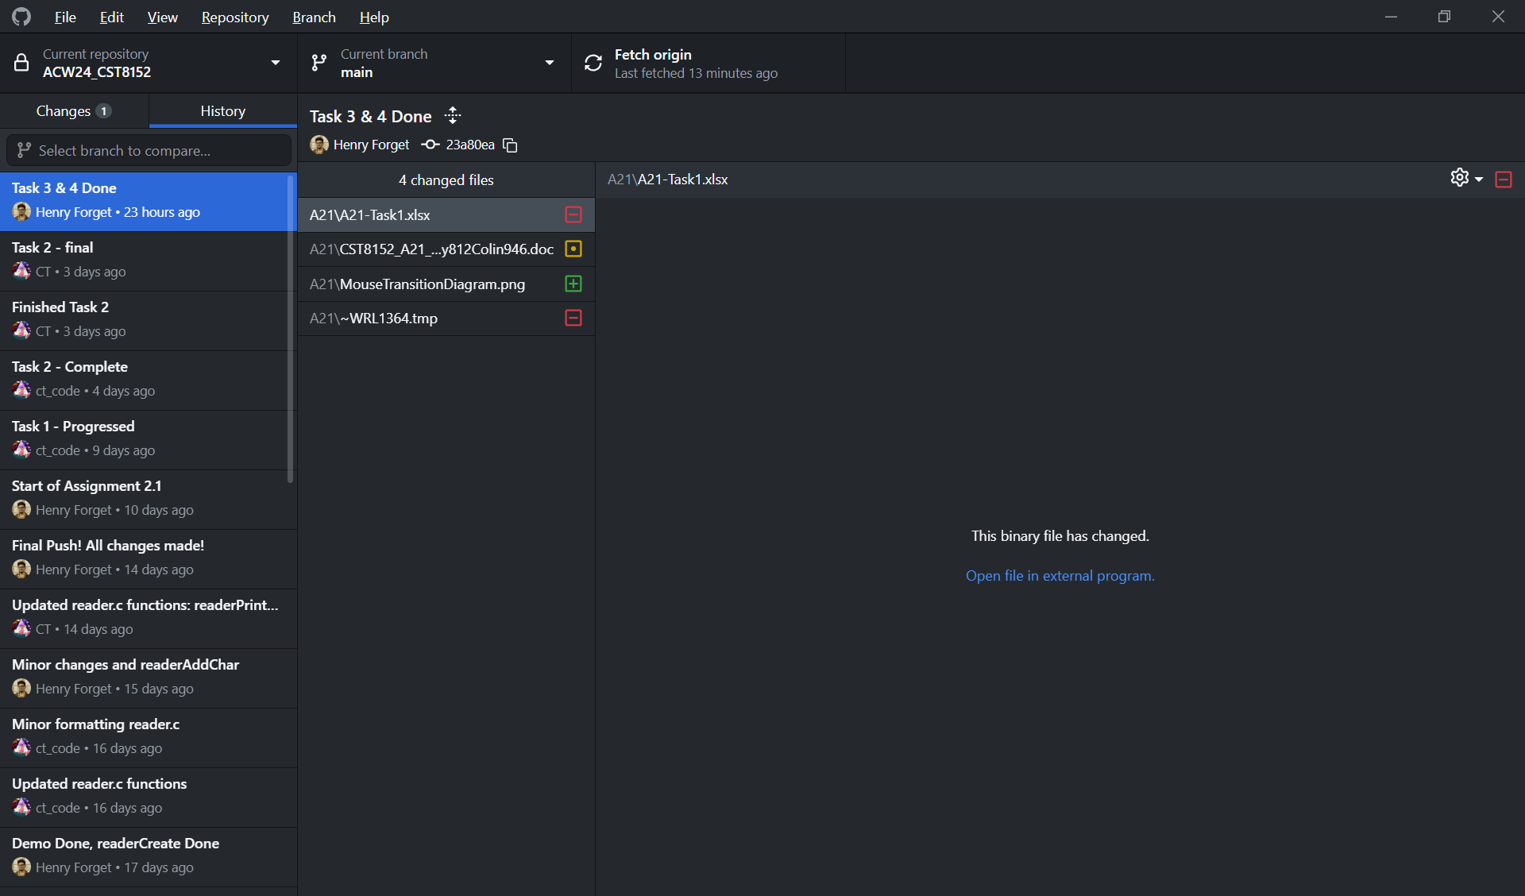

Adapted from resources developed by Prof. Svillen Ranev (Algonquin College, 2019)

