FEEDBACK – MAY 15, 2012
1. Excellent start
2. 2.2.1 Product Perspective
* 2nd paragraph "Underneath the diagram..."; This whole paragraph needs more detail. It is not clear at all.
* Expand this section and go into more detail about the entities involved ... You should consider breaking down the main entities as sub sections and explain how they all connect.
* Use workflows, UML, sequence diagrams as necessary if they help make things clearer

3. 2.2.1 Product Functions
* Add more to this section.
* Quote: "The middleware API methods provide the middleware with the ability to access and recognize data sent from the drivers." ---> Does not make sense

4. 2.2.4 Constraints
* There are more constraints to your program other than those inherited by Ciscos Smart Connected Communities project

* Think more about them and add more detail

5. 2.3 Specific Requirements
* Usecases for each requirement, refer to the sample SRS document that I emailed.
* Kinect Gesture Recognition Requirements Section --- why not combine that w/ Specific requirements??? Or have them as 2 seperate subsections

6. 3.1.2 Product Scope
* Add more to this by thinking of more features and deciding what is in/out of scope
* Refer to what I taught during the 1st 2 weeks of class

7. 3.1.3 Section Overview
* Whats the point of this section???

* half of section 3 should have been in the 1st half of your document and not down this far. Revise all of section 3

8. 3.3.2 Functional Requirements and 2.3 Specific Requirements can be merged together.
* 3.3.2 is a good start, however usecases should be presented with that level of description for each requirement. Please add more

Cisco Kinect Team 2 Requirements Specification

Jonathan Chan, Axel Colin de Verdiere, Greg Clark, Sunghoon “Ivan” Lee, Nancy Hsieh, Richard Yu

Table of Contents

1. Introduction 3
1.1 Glossary 3
2. Unifying API Requirements 3
2.1 Introduction 3
2.1.1 Section Purpose 3
2.1.2 Product Scope 3
2.1.3 Section Overview 4
2.2 Overall Description 4
2.2.1 Product Perspective 4
2.2.1 Product Functions 4
2.2.3 User Characteristics 5
2.2.4 Constraints 5
2.3 Specific Requirements 5
2.4 Non-Functional Requirements 6
3. Kinect Gesture Recognition Requirements 6
3.1 Introduction 6
3.1.1 Section Purpose 6
3.1.2 Product Scope 7
3.1.3 Section Overview 7
3.2 Overall Description 7
3.2.1 Product Perspective 7
3.2.2 Product Functions 7
3.2.3 User Characteristics 8
3.2.4 Constraints 8
3.3 Specific Requirements 8
3.3 Non-Functional Requirements 10
4. References 11

1. Introduction
This project is concerned with two distinct products: a unifying application programming interface (unifying API) for communicating between middleware and driver software and gesture recognition software using the Microsoft Kinect. This document will be separated into two sections. The first will describe requirements for the unifying API and the second will list requirements for the Kinect gesture recognition software.

1.1 Glossary
The following common terms will be used extensively in this document. They are defined as follows:

API - Application Programming Interface
Shall - Must have requirements
Should - Optional requirements that Cisco prefers
User - In Section 3, the user is the performer of a gesture

2. Unifying API Requirements

2.1 Introduction

2.1.1 Section Purpose
Section 2 of this document describes the requirements for the unifying API as it sits between the driver and the Cisco middleware. This section describes only the unifying API and does not describe the rest of the driver and the middleware, nor the application layer.

This section only applies to the development phase of the product as a part of the CS130 course by the Cisco Kinect 2 team. It does not cover requirements for work done outside the span of the Spring 2012 CS130 course nor does it cover requirements for teams other than the Cisco Kinect 2 team.

2.1.2 Product Scope
The unifying API product shall consist of:

- A standard communication format that sends information from the driver to the middleware.
- APIs to be implemented by the driver.
- Program modules that can be called by the middleware to access data from the driver.

The unifying API shall be developed for a Java-based middleware and for drivers already capable of interfacing with Java-based middleware.

2.1.3 Section Overview
Section 2 of this document is intended for use by the Cisco team leads, Raghuram Sudhaakar and Kevin Lee; the CS130 professor and teaching assistant, Dr. Paul Eggert and Jerrid Matthews respectively; and the CS 130 Cisco Kinect 2 team.

The rest of the section is organized with the overall description next followed by specific and non-functional requirements respectively.

2.2 Overall Description

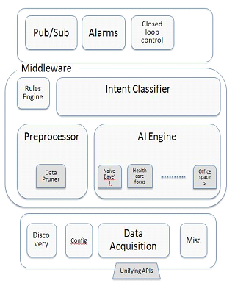
2.2.1 Product Perspective
The unifying API is part of Cisco’s Smart Connected Communities project [1]. The unifying API is the southbound interface for the middleware. The figure to the right shows the middleware architecture of Cisco’s Smart Connected Communities project and the location of the Unifying APIs [1].

Underneath the diagram sits any number of sensor drivers. Each of these sensor drivers will have an implementation of the unifying API whose methods can be called by the middleware to extract data.

The unifying API consists of three separate parts:
- A set of methods to be implemented by the driver manufacturers
- A set of methods that can be called by the rest of the middleware
- Documentation describing the data transfer formats from the driver to the middleware.
Figure 1 Middleware architecture for Cisco’s Connected
Communities project [1]

2.2.1 Product Functions
The driver-side portion of the API is intended to provide the driver programmers with an easy-to-use structure that can be used to develop code conforming to the unifying API specifications. The following requirements are built with the intention of providing the aforementioned functionality.

The middleware API methods provide the middleware with the ability to access and recognize data sent from the drivers.

The documentation describes the API on both the driver and middleware sides. The documentation also provides information on the transfer protocol and formats.

2.2.3 User Characteristics
The expected users for the unifying API will be divided into driver and middleware programmers.

Driver programmers are expected to have full knowledge of the driver software and to have a high level of technical competency. They are responsible for implementing the driver-side API and integrating it with their driver software. They are also expected to be able to read and understand technical documents and packet diagrams. These programmers will interact with the driver API and documentation while designing their drivers.

Middleware programmers are also expected to be highly technically competent. They are expected to understand technical documents and APIs. They are responsible for integrating the API into the middleware and using the middleware API calls to retrieve data.

2.2.4 Constraints
The APIs are currently developed independently from Cisco’s Smart Connected Communities project. However, if the APIs are to further developed, they will be constrained to be compatible with the Smart Connected Communities project middleware.

The API and products of this project will be maintained by Cisco. Any documentation or products of this project should be easy for inexperienced parties to maintain.

2.3 Specific Requirements

The middleware API shall allow access to all data sent by the driver software. Data should not be lost between the driver and the middleware.

The middleware shall have the ability to identify the device it is communicating with.

The middleware shall have the ability to identify the format and nature of the data it is receiving.

The API shall not impose a restriction on the type of data the driver may send to the middleware. However, the format of the data may be specified by the API.

The driver-side API shall provide a set containing all methods to be implemented by the driver programmers.

The driver method set shall be all-inclusive. No driver-side functionality shall be required outside of what is specified to work with the system.

The middleware API shall be independent of the driver as long as the driver contains a correct implementation of the driver-side API.

The middleware API shall provide the rest of the middleware with access to data sent from the driver.

The documentation shall contain information on the data transfer protocol and assumptions made so that the API can be adequately maintained.

The transfer protocol shall allow for data transmission from the driver to the middleware.

2.4 Non-Functional Requirements

The documentation should adequately describe the data transfer process. The intended users of the documentation should be able to understand the transfer protocol and data formats after reading the documentation.

The API should have as little impact as reasonably possible on the driver code.

The driver-side API should be easy to implement. Easy means that implementing the driver-side API should not be so difficult that more than 10% of manufacturers refuse to implement. This percentage is subject to change in the future.

The API should have a minimal impact on memory usage.

The API should have a minimal impact on speed.

Middleware access of data should be done in an intuitive way conforming to Java programming standards.

3. Kinect Gesture Recognition Requirements

3.1 Introduction

3.1.1 Section Purpose
Section 3 of this document describes the requirements for the Microsoft Kinect gesture recognition software. It only describes the gesture recognition product. It does not cover requirements for the unifying API.

This section only applies to the development phase of the product as a part of the CS130 course by the Cisco Kinect 2 team. It does not cover requirements for work done outside the span of the Spring 2012 CS130 course nor does it cover requirements for teams other than the Cisco Kinect 2 team.

3.1.2 Product Scope
The gesture recognition software shall consist of:
- An implementation of the unifying API
- A connection to a Microsoft Kinect device for data input
- A gesture recognition algorithm

3.1.3 Section Overview
Section 3 of this document is intended for use by the Cisco team leads, Raghuram Sudhaakar and Kevin Lee; the CS130 professor and teaching assistant, Dr. Paul Eggert and Jerrid Matthews respectively; and the CS 130 Cisco Kinect 2 team.

The rest of the section is organized with the overall description next followed by specific and non-functional requirements respectively.

3.2 Overall Description

3.2.1 Product Perspective
The design of the API implementation shall have compatibility with many sensors in consideration. However, in this project, only use of at least one sensor is necessary. The preferred sensor is the Microsoft Kinect.

The gesture recognition program shall connect to a Microsoft Kinect device to extract data. The driver shall be modified to implement the unifying API functions. This gesture recognition software is used to demonstrate the functionality of the unifying API, and how other developers can use it. In the long-term vision, any middleware or higher level software that needs to interact with the sensors can use this API to retrieve data. However, that is not the goal of this project. In our short-term vision, an example of such middleware and higher level software (gesture recognition in this case) will be implemented to use the unifying API. Only limited features are necessary to show that the designed unifying API is sufficient for many purposes.

3.2.2 Product Functions
The main objective of the gesture recognition program is to validate the effectiveness of the API proposed in Section 2 by recognizing at least four gestures. In order to address this, the gesture recognition program receives Kinect sensor data that is organized in a format defined in Section 2.
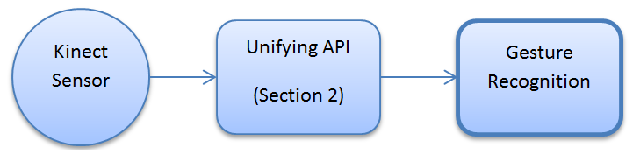
The gesture recognition program shall request data that needs to be acquired by the API implementation in order to receive the sensor data.

The gesture recognition program may assume that the data is transferred in a format that is defined by the API documentation.

The gesture recognition program shall provide information about the recognized action performed by the user.

3.2.3 User Characteristics
The end user will only have to perform gestures to be recognized by the system. As such, no specific characteristics are expected of the end users, besides from knowing which type of movement can be recognized.

3.2.4 Constraints
The system does not have any specific constraint. In particular, the gesture recognition is neither required to be in real time nor automatic. The software is not required to perform gesture recognition on several persons either, nor is it required to be able to recognize several gestures.

3.3 Specific Requirements
The gesture recognition program should handle the error event when the requested sensor is not available.

3.3.1 Interface Requirements

User Interfaces
The user interface shall recognize four different gestures. A user shall perform a gesture, and the gesture recognition software shall respond so that the user will clearly know the gesture was recognized.

Software Interfaces
This software will only communicate to the middleware which delivers the data based on the API defined in Section 2. For gesture recognition, it only utilizes Kinect sensor, and thus the computer that runs the gesture recognition program must be integrated with the Kinect. The rest of interfaces such as communication between the sensors and its specification are handled by the middleware.

An implementation of the API used by the gesture recognition software shall be implemented, following the requirements detailed in Section 2.

3.3.2 Functional Requirements
This section defines the functional requirement of the system. There is only one actor of the system, which is the gesture performer. In this section, we generically use a term “user” to represent the performer. The functional requirements assume that there exist training data of the performance made by the user.

Use Case Name | Perform Gesture
Trigger | The user starts the program
Precondition | The system contains the training data of the expected gestures.
Basic Path | 1. User presses “START” button  2. The system gives a counter from 5 to 0 in the “Instruction” text panel to let the user to perform a gesture  3. User performs a gesture  4. User presses “END” to end the process  5. The system infers the recognized gesture and displays the corresponding action performed on the “Display” and the associated services of the corresponding gesture in the “Instruction” panel.  6. User can re-start the gesture recognition or quit
Postcondition | The recognized gesture and its corresponding services are displayed
Exception Paths | The Reader may abandon the program at any time by pressing the close button.

The following diagram illustrates the sequential diagram for the above use
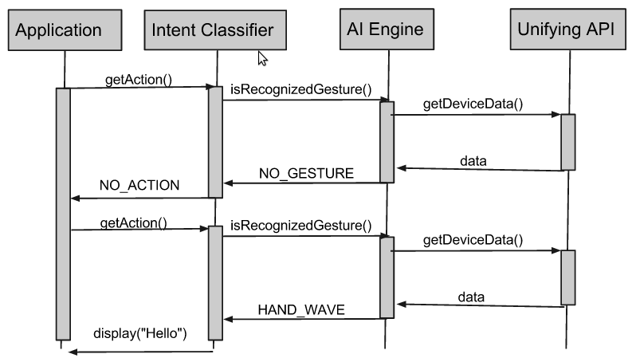

3.3.3 Behavioral Requirements

Use Case View
The user initiates the data collection process, performs a gesture, and ends the data collection process. That is, user manually annotates the time stamp of the beginning and the end of a gesture. After a moment, the computer displays the response to the action that is performed by the user and provides virtual service corresponding to that recognized gesture.
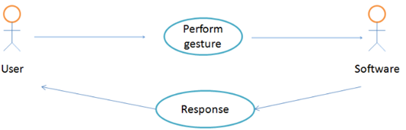

3.3 Non-Functional Requirements
The gesture recognition implementation and the API implementation shall be written in Java.

There is no requirement for reaction time of the gesture recognition. The goal of the gesture recognition and API implementation is to demonstrate the design detailed in Section 2 is useful.

The documentation should provide the instruction of how to use the gesture recognition system.

The gesture recognition system shall not affect any functionality of the API.

Use of the Kinect Sensor is preferred.

4. References
- Lee, Kevin. Sudhaakar, Raghuram. “Detailed Description”. http://cs.ucla.edu/classes/spring12/cs130/hw/ucla-project.doc.

