Cisco Kinect Team 2
Final Report

June 8, 2012

Jonathan Chan
Axel Colin de Verdiere
Greg Clark
Sunghoon Ivan Lee
Nancy Hsieh
Richard Yu

Table of Contents
1. Introduction 1
2. Overview 1
2.1 Document Organization 1
2.2 Motivation 1
2.3 Problem 1
2.4 Goals 2
2.5 Project Packages 2
2.6 Changes since System Specification 2
2.7 Glossary 3
3. Overall Architecture 4
3.1 Unified API 4
3.2 Gesture Recognition 5
4. Project Application: Gesture Recognition System 6
4.1 Overview 6
4.2 Usage 7
4.3 Gesture Recognition System and the Unified API 8
4.3.1 Overview 8
4.3.2 Driver: UniOpenNIDevice 8
4.3.3 Application: GestureRecognizer and SkeletonViewerPanel 8
4.4 Gesture Recognition Algorithm: K-Nearest-Neighbor (KNN) 9
4.4.1 Overview 9
4.4.2 Features 9
4.4.3 K-Nearest-Neighbors 9
4.4.4 GUI: SkeletonViewerPanel 11
4.4.5 Conclusion 11
5. Unified API for Driver Developers 12
5.1 Overview 12
5.2 Making Drivers Unified API-Compatible 12
5.2.1 UniDevice 13
5.2.2 UniChannel 13
5.2.3 UniChannelHeader and UniElementDescriptor 14
5.2.4 UniDataPacker 15
5.3 Example 15
6. Unified API for Application Developers 17
6.1 Overview 17
6.2 Using the Unified API 17
6.2.1 Connecting to a Device 17
6.2.2 Retrieving Data from a Device 17
6.3 Example 19
Table of Figures
Figure 1 Unified API Procedure 5
Figure 2 Overall architecture with detailed gesture recognition engine 5
Figure 3 Application GUI Screenshot 7
Figure 4 User waving in x-axis 10
Figure 5 Feature coordinate plane 10
Figure 6 KNN algorithm finding K nearest neighbors 11
Figure 7 Overview of Sensor Packet 12
Figure 8 Tree of classes to be used by driver developers 13
Figure 9 Representation of channel data (tuple array) 14
Figure 10 A tuple with its descriptor. A descriptor is an array of UniElementDescriptors 15

1. Introduction
This document provides a brief overview as well as a tutorial of this project. After reading this document, developers will understand the project background and be able to use the Unified API as well as the Gesture Recognition System. For more specific project details, please refer to the System Requirements or System Specification documents.

2. Overview

2.1 Document Organization
This document is divided into three parts:

- Goals/Project Overview (Section 2, 3)
- Project Description (Section 4)
- Developer Tutorial (Section 5, 6)

In the Goals/Project Overview, the goals are quite briefly mentioned. For detailed reading of the goals and architecture, refer to the “Requirements Specification” and the “System Specification”. In addition, this section outlines the source code packages and modifications since the “System Specification”.

The Project Description details the application that was developed and how it meets the goals/requirements.

The Developer Tutorial goes in depth on how to use the Unified API for your own purposes. It discusses the design choices made to accomplish the goals. A developer can solely read this part only to understand how to use the Unified API. The developer can use the project description as an extra example of how to use the Unified API.

It is advised to have a general understanding of the problem and proposed solution before reading this document. Briefly read the “Requirements Specification” and “System Specification” to do so.

2.2 Motivation
Recent research groups in both academia and industry are interested in developing smart spaces, which provides assistive environment that can sense themselves and their residents and enact mappings between the physical world and remote monitoring and intervention services. In the heart of such technology, there exists a human-computer interface named natural user interfaces (NUI), which allows a more natural way of interaction between human and computers.

2.3 Problem
An example of NUI is to infer the intention of users’ actions and to provide appropriate services. Intent recognition services are based on various sensor inputs (e.g. motion sensors, temperature sensors, acoustic sensors, etc.) However, due to the high degree of heterogeneity of input sensors, there is a need for a standardized, or unified, API. To demonstrate the effectiveness of this unified API, this project develops a Gesture Recognition System that uses the Unified API to simulate NUI.

2.4 Goals
The final vision is to create a system that takes data from many different types of sensors and recognizes the intents of the users inside the environment that the sensors are detecting. This project is only a subset of that vision. This project simply recognizes gestures using a single sensor.

The Gesture Recognition System is to simulate a natural interaction between human and computer by recognizing gestures, and performing services for the user. For a system to use many sensors and different types of data to recognize user intentions, there must be a generalized interface and format which allows developers to interact with any kind of sensor, thus “unifying” them. Currently, each sensor has a different API, so it is difficult for one system to interface with them all. The generalized API is called the Unified API.

This project develops a Unified API that will easily by implementable by device driver developers, and a Gesture Recognition System that employs the Unified API to retrieve data from a Microsoft Kinect.

2.5 Project Packages
Here are the packages developed in this project, and their purpose. Refer to the respective sections to read in detail about them.

- UnifyingAPI - All classes pertaining to the Unified API (both driver-side and middleware-side. See Section 3.1 “Unified API”)
- org.OpenNI - The driver package to run the Microsoft Kinect
  - UniOpenNIDevice - The modified driver to become Unified API-Compatible. This is a great example for driver developers
- UnifyingAPI.Samples - Simple examples of how to use the Unified API as an application developer
- gestureRecognition - The Gesture Recognition System which uses UnifyingAPI to perform gesture recognition. It is an example application.

2.6 Changes since System Specification

Regarding Unified API:
Change | Signed/Unsigned bit removed in tuple element descriptor.
Reason | Java does not support unsigned.
Detail | The bit is now added to the tuple element size (now 6 bits instead of 5).

Change | Channel packet encryption added
Reason | Cisco’s request
Detail | Channel packets can be encrypted; the sensor header cannot be encrypted

Change | The Endianness of the data packets is now defined as Big Endian
Reason | Endianness can have a large impact on the ability to correctly parse data and packet information
Detail | Sensor/Channel packets must be formed in a Big Endian system. Java normally defaults to Big Endian, but it can be changed. The driver and application programmers must ensure that the environment is in Big Endian.

Regarding Gesture Recognition System:
Change | Four gestures are now defined
Reason | Necessary for gesture recognition program
Detail | Gestures are:  1) hand-wave  2) kick  3) body tilt  4) punch

2.7 Glossary
In this document, there are many common terms that are used in specific purposes for this document. Please quickly skim over the table, and reference back if there are any terms that are difficult to understand.

Application | A program that is interested in sensor data. It encompasses any entity northbound of the Unified API. An application is a user.
Application Programming Interface (API) | A set of methods and classes used to interact with another component or system.
Driver | Software to interface with a specific sensor. In this project, drivers will have to implement methods and functions for the Unified API to work.
Feature | A single measurable property of a gesture. Can be thought of as a subset of Data (e.g. elbow joint angle).
Gesture Recognition System | An example application that uses the Microsoft Kinect to collect data and perform gesture recognition. It shall use the Unified API to demonstrate the API’s functionality.
Middleware | Software components that use the Unified API to communicate with the sensors.
Northbound | In reference to a certain level of the stack architecture. Entity A is northbound of entity B if A is “above” B in the architecture diagram. (refer to Figure 2)
Southbound | In reference to a certain level of the stack architecture. Entity A is southbound of entity B if A is “below” B in the architecture diagram. (refer to Figure 2)
Training Set | A set of sensor data from recording a certain gesture. The training set is referenced when the system attempts to recognize a gesture. The training set is a pre-condition of the Gesture Recognition System.
Unified API | The software API that specifies a common format and interface so that a software component can use it to interact with many different sensors.
Unified API-Compatible | A driver that has been modified to conform to the Unified API standard. To make a driver as such, refer to the steps in Section 5 “Unified API for Driver Developers”
User | An entity (ie. Person, machine, software, etc.) interested in sensor data.

3. Overall Architecture

3.1 Unified API
The Unified API specifies a common format and interface so that a user can use it to interact with many different sensors. It is spread between two software packages: the “middleware-side” and the “driver-side”. This allows the Unified API to act as a bridge between the driver and the middleware.

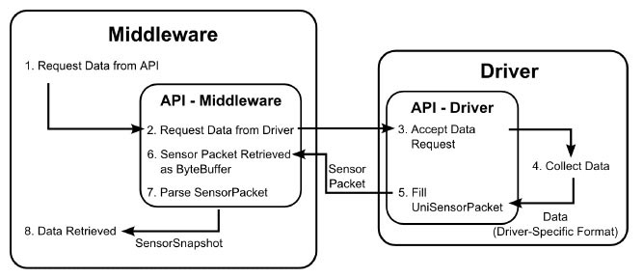
Figure 1 Unified API Procedure

Figure 1 shows how the Unified API bridge works. The middleware-side API is responsible for retrieving data requests from middleware, prompting the driver for data, and parsing the data into a friendly format for the middleware to user. On the other hand, the driver-side API is responsible for accepting data requests from the middleware, prompting the rest of the driver code to collect or process data, and sending out the sensor packet.

For further details regarding the Unified API communication and packet formats, refer to the System Specifications document.

3.2 Gesture Recognition
The Gesture Recognition System is a combination of the Gesture Recognition Engine as well as the Unified API. The Gesture Recognition System recognizes four different gestures and provides a user interface that instructs users to start and end the gesture performance as well as displays the result of the inferred gesture. Figure 2 shows how the Gesture Recognition Engine and the Unified API are interconnected.

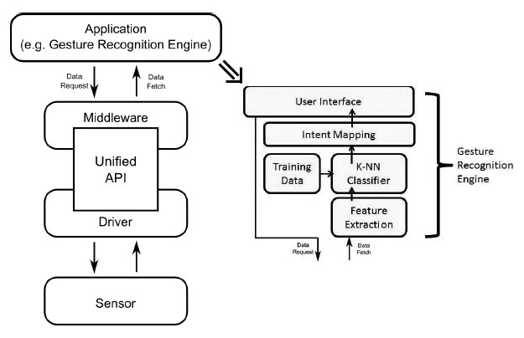
Figure 2 Overall architecture with detailed gesture recognition engine

The Gesture Recognition Engine contains four components (Feature Extraction, K-NN Classifier, Intent Mapping, and User Interface) and a local database containing training data for the K-NN classifier. For further details regarding each component, refer to the System Specifications document.

4. Project Application: Gesture Recognition System

4.1 Overview
This section will describe the overall system that was developed in this project. It will detail the application that simulates a solution to the NUI problem described in Section 2.2 “Problem”, and demonstrate how the Unified API meets the requirements of a generic API.

The Gesture Recognition System is an example application that demonstrates the use of the Unified API and provides a chance to evaluate the API’s effectiveness and ease-of-use in a real-world environment. The goals and requirements of the API can be summarized as:

- Extensibility - Ease of making a driver Unified API-Compatible (how much configuration necessary to make a driver compatible), and the variety of sensors that are compatible (e.g. temperature sensor, video sensor, acoustic sensor, etc.). Note that these are two different facets of equal importance.
- Scalability - Volume of sensors that can be connected at once.
- Consistency - How different sensor usage is between different sensors.

For the application (gesture recognition), Cisco required the system to be able to identify four distinct gestures using the Microsoft Kinect as a sensor. However, the classification algorithm and driver program were not defined.

For more details on how these goals and requirements were measured in this project, refer to “System Specification: Section 1.3 Project Scope”. For reasoning behind these goals and requirements, refer to the “Requirements Specification” document.

The resultant program consists of three major functional modules:
- Sensor driver made Unified API-Compatible for sensor data extraction
- The gesture recognition and KNN classifier
- The graphical user interface (GUI)

Note that these three modules depend on the Unified API package (UnifyingAPI.jar) which is an archive file of the carefully designed classes and interfaces built to meet the above goals. It is not listed as a “functional module” because it does not perform an action or meet functional requirements. However, it is the key to meeting the above goals.

The Gesture Recognition System uses the Unified API to extract skeletal data from the driver directly into the application software. The modules and description of the program functionality will be described in the following sections.

4.2 Usage
The Gesture Recognition System is accessed through a GUI. Upon application startup, the user sees the following screen:

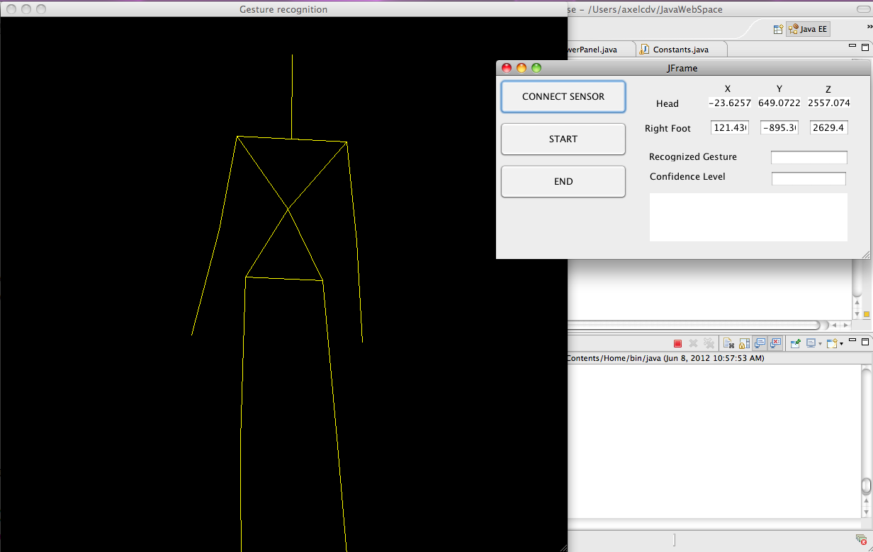
Figure 3 Application GUI Screenshot

When the Microsoft Kinect device is connected to the computer, the “Connect Sensor” button establishes the connection between the device and the program.

From here, the user can click on the “Start” button to start the gesture action phase of the recognition process.

During the gesture action phase, the user can perform one of four gestures: kicking, punching, tilting, and waving. The user can also choose to perform none of the recognized gestures. The gesture must be sustained and repeated for at least five seconds before the “Stop” button should be pressed to stop the gesture recognition.

The program will then process the data and display resultant text for the gesture:

Gesture | Result Text
Hand Wave | Hello there!
Body Tilt | Are you sick?
Punch | Please don’t punch me!!
Kick | You are a bad person!!
None | I don’t know what you are doing!!
Table 1: Application Functions

These five gestures fulfill the use cases specified in “Requirements Specification: Section 2 Functional Requirements”.

4.3 Gesture Recognition System and the Unified API

4.3.1 Overview
The Gesture Recognition System shall use the Unified API to extract the Microsoft Kinect’s data to perform gesture recognition. There is an opensource driver, OpenNI, that gives users access to the Kinect’s data. To simulate how a driver developer would make their driver Unified API-Compatible, the OpenNI driver was modified. The rest of the application then interfaced with this new driver to extract data and perform recognition.

4.3.2 Driver: UniOpenNIDevice
To make the OpenNI driver Unified API-Compatible, there are several steps that must be followed. They will be explained later in Section 5 “For Driver Developers”. At this point, all the reader needs to know is that the application created a new class, UniOpenNIDevice, which is a derived class of UniDevice. UniOpenNIDevice implements updateChannels() to place depth and user position data into the sensor packet. Refer to the source, org.OpenNI.UniOpenNIDevice.java.

There are several points to notice here.

- This design is extensible. The driver developer need only implement one class and one method to make the driver Unified API-Compatible. The method simply copies sensor data into a packet. For more details, refer to Section 5 “Unified API for Driver Developers”.
- The design is consistent. All drivers shall implement the same class and method the same way to make the driver compatible. Since there is no difference in configuration, northbound interfaces will extract data by the same method, regardless of sensor. For more details, refer to Section 6 “Unified API for Application Developers”.

Extensibility is an important point in this project. A universal API would not be very universal if it were not compatible with many sensors. This section merely describes one facet of extensibility; the concept that any Java driver being coded to conform to the Unified API. However, there is also another very important facet of extensibility; the concept that the Unified API must be flexible to the various types of data a sensor can provide. There is insightful design on this, and for detail, refer to the explanation of the tuple array in Section 5.2.2 “UniChannel”.

4.3.3 Application: GestureRecognizer and SkeletonViewerPanel
The Gesture Recognition System has two applications, symbolizing the wide variety of applications for the Unified API, thus meeting the extensibility requirement. The GestureRecognizer extracts Kinect depth data to measure features and perform a gesture recognition algorithm on them. The SkeletonViewerPanel extracts Kinect joint data to display the user skeleton on the GUI.

Both applications simply create a Sensor object, representing the Kinect, and use repetitive calls to getSensorSnapshot() to retrieve the necessary data. Each application then extracts the channel of data they are interested in, and can manipulate it however they want, making this API flexible. Both applications used the same method calls, without any new configurations, making this API consistent and scalable.

There are several design points to notice here:

- Scalability. Both applications create a Sensor object to represent the Kinect. An application that desires more sensors can simply create more Sensor objects, each object corresponding to one sensor. For more details, refer to Section 6 “Unified API for Application Developers”.
- Consistency. Every Sensor object, regardless of sensor, has a getSensorSnapshot() method that parses sensor data and returns an object with all the data in an organized form. For more details, refer to Section 6 “Unified API for Application Developers”.

4.4 Gesture Recognition Algorithm: K-Nearest-Neighbor (KNN)

4.4.1 Overview
The Gesture Recognition System uses the K-nearest-neighbor (KNN) algorithm to recognize gestures. It is oriented around the idea of collecting data on certain features (e.g. x coordinate of right hand), and comparing that data with an existing training set. If the features are similar to those in the training set, then the system concludes that a gesture was recognized. Refer to the source code, gestureRecognition.GestureRecognizer.java and gestureRecognition.GestureRecognizerApplet.java.

4.4.2 Features
A feature is a single quantifiable property of a gesture (see “2.5 Glossary”). In a hand wave, the right hand swinging back and forth is a property of a gesture, but it is not a feature because it is not measurable. However, the standard deviation of the x coordinate of the right hand is quantifiable, and characterizes a property of a gesture, so it is a feature.

For example, a hand wave may be characterized by a large standard deviation of the (x,y) coordinates of the right hand, and low standard deviation of the (x,y) coordinates of both the head and torso. The system must analyze sensor data to conclude whether such features exist. Choosing which features to analyze is an art. Recognizing too many may cause contradictions between different gestures. Recognizing too few, and incorrect gestures may be unintentionally recognized.

4.4.3 K-Nearest-Neighbors
The KNN algorithm depends on pre-existing data on what features each gesture has. This training set (see “2.5 Glossary”) must be collected before actual deployment in order to “train” the system. Generating the training set involves a human trainer, performing each gesture multiple times, and an operator, using the sensor to measure the features of interest. The data as saved and later referenced by the system.

The features of the training set can be plotted onto a coordinate plane. For example, consider the situation where one tries to recognize the hand wave and a head shake. Two plausible features to measure would be, Feature1: Standard deviation of x coordinate of the hand, and Feature2: Standard deviation of x coordinate of the head. One would expect Feature1 to have relatively great values compared to Feature2 since a person’s head will not move much during a wave, and vice versa during a head shake.

These two features can be plotted as in Figure 5

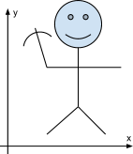
Figure 4 User waving in x-axis

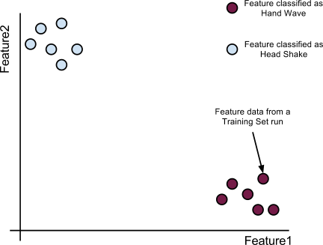
Figure 5 Feature coordinate plane

Each plotted point is feature data from a sample run from of the training set. One can see that during training, multiple sample runs show that each gesture’s features are quite similar to each other refer to Figure 5.

When the Gesture Recognition System attempts to recognize a gesture, it will record the data, and calculate the standard deviation of the x coordinate of the hand, and the standard deviation of the x coordinate of the head.

First, this point is plotted onto the coordinate plane in Figure 6. The system then searches for the K nearest training set features. One may do this by creating a circle around the point, and increasing its radius until K features are enclosed in the circle. The recognized gesture is the one that has the most training set features in the circle.
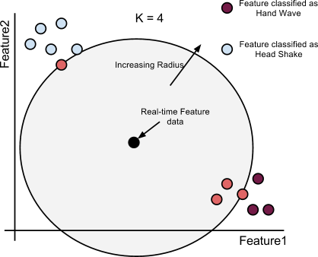
Figure 6 KNN algorithm finding K nearest neighbors

In general, most applications have more than two features to measure. If there are N features, the coordinate plane becomes N dimensional. The use of a circle no longer applies, but the algorithm continues to search for K nearest training set features to classify a gesture.

4.4.4 GUI: SkeletonViewerPanel
The SkeletonViewerPanel is a major portion of the GUI. It is actually unrelated to the gesture recognizing, and is mainly a feedback display of skeletal data for the user. It is a multi-threaded application that tracks and displays a user on the GUI by gathering data from the sensor via the Unified API. Because it is not the focus of the project, and a secondary example of Unified API usage, its implementation will not be discussed in detail. By no means does that say it was trivial!

4.4.5 Conclusion
This concludes the description of the application for the Unified API. The following sections serve more as a manual for how another developer would continue to use the Unified API. The important concepts and design choices are described in these sections as well. To appreciate these, it is recommended to read the following sections, even if the reader is not a developer planning on using the system.

5. Unified API for Driver Developers

5.1 Overview
Sensor data will be passed northbound as packets. Each sensor packet will be composed of metadata about the sensor, and channel packets (refer to Figure 7).
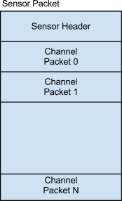
Figure 7 Overview of Sensor Packet

The middleware-side of the Unified API, specifically the Sensor class, will take the sensor packet, parse it, and produce an instance of the SensorSnapshot class that has getter methods to retrieve data (see section 6 for details). The driver is responsible for creating this sensor packet with all these channels.

A channel represents a stream of data (e.g. RBG data) from the sensor. A sensor with 3 streams of data (e.g. RGB, distance, and sound), would have 3 channels of data respectively. A channel packet has metadata about that channel, and a byte array containing the binary stream data. Each data element in the binary array should be stored Big Endian.

Fortunately, most of this action is abstracted away from the driver developer. There is a small set of classes the driver must use and implement. These classes will help the developer format data correctly so that northbound developers can interface with the sensor data, without needing to understand the internals of the Unified API. The driver need only have an “array” of data they want to send, and know the details of the data-type of each element in this array. All the classes are oriented around describing this array.

5.2 Making Drivers Unified API-Compatible
Driver developers should concern themselves with the Uni* classes. To make a driver Unified API-Compatible, the driver must:

- Inherit from UniDevice and implement its abstract method
- Implement the interface, UniDataPacker, which has one method

All the other Uni* classes are helper classes used to aid a developer in successfully implementing the above. Figure 8 is a tree of the Uni* classes the developer will directly use. The children of a node are the classes that are used to implement that node. The highlighted nodes are the ones that must be implemented. The other nodes are the helper classes.

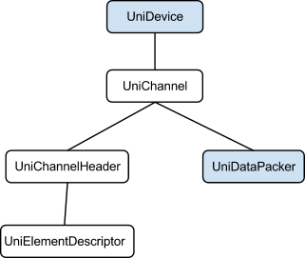
Figure 8 Tree of classes to be used by driver developers

5.2.1 UniDevice
This class represents the sensor that is collecting data. It has metadata about the sensor (i.e. Vendor ID, Product ID, etc.) and is holds all the channels (see below) of data in the proper format. The driver must inherit from the abstract base class, UniDevice, so a user can extract data via the Unified API. Sensor metadata (i.e. Vendor ID, Product ID, etc.) can be initialized in the constructor by making a call to super() and providing proper input parameters.

Application developers who use the Unified API to get sensor data will use an interface that will call UniDevice’s getSensorPacket() which is a conglomerate of sensor data and metadata. Driver developers do not implement getSensorPacket() when inheriting from UniDevice.

Instead, getSensorPacket() calls the abstract method, updateChannels(), which the driver developer must implement. To accommodate sensors that may have multiple streams of data (e.g. a video camera with both RGB data and sound data), each stream is considered a channel of data. Thus, the driver developer must only ensure that every time updateChannels() is called, fresh channels of data are added via addChannel (UniChannel channel).

5.2.2 UniChannel
The UniChannel represents a stream of data (e.g. RBG data) from a sensor. Each UniChannel has 2 parts: 1) Metadata about that stream (e.g. frequency of this channel’s data), and 2) A UniDataPacker that writes the channel’s data into a ByteBuffer as a tuple array.

The metadata about the stream is represented by UniChannelHeader. Its purpose is to describe the tuple array, and each tuple in the array. Each tuple is then described by UniElementDescriptor.

The concept of an array of tuples is at the heart of the Unified API’s flexibility. Consider the example of an RGB stream from a camera. Camera frames are often composed of a large 2D array of pixels, each pixel being an RGB triplet. In this case, the tuple would be one RGB triplet. A camera frame would then be represented as an array of these tuples. UniChannel would hold one frame’s worth of tuples, and a user can get a camera frame by making a call to updateChannels(). The flexibility lies in that any form of data can be represented with the array of tuples. Tuples can have [1, 2^16] elements, and arrays can have [1, 2^64] tuples.

Figure 9 shows the concept of a tuple array, and how it actually looks in the byte array.

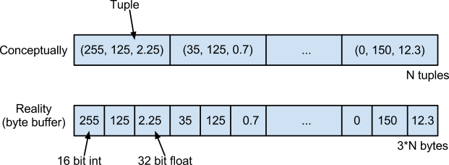
Figure 9 Representation of channel data (tuple array)

For the purposes of flexibility, each element of a tuple can be of any type. The type is described by how many bits long, and whether it is an integer or IEEE floating point. Note that all binary data, fall into these two subsets (e.g. a char is actually an 8 bit integer). To describe these details, the UniElementDescriptor is used.

5.2.3 UniChannelHeader and UniElementDescriptor
UniChannelHeader holds the name of a channel (as a string), the frequency at which the channel can update, the number of tuples in the array, and UniElementDescriptors to describe the elements in each tuple in the array.

A tuple is described by an array of UniElementDescriptors. Each UniElementDescriptor describes one element of the tuple, and how the binary data of one element of a tuple should be interpreted (e.g. size in bits of an element, interpreted as floating point or integer). For example, a tuple of size 3 will be represented by an array of size 3 of UniElementDescriptors.

In the camera frame example, RGB data may be represented as RGB 565 where red is a 5 bit integer, green is a 6 bit integer, and blue is a 5 bit integer. The UniElementDescriptor to describe red would be constructed to reflect that it was a non-primitive integer of 5 bits. This design aims to support the various sensors that provide differently formatted binary data.

Consider Figure 10. It is an example of a 3-element tuple consisting of a 32 bit integer, 12 bit integer, and 64 bit float. To describe it, a developer would create an array of 3 UniElementDescriptors, where each UniElementDescriptor describes one element of the tuple.

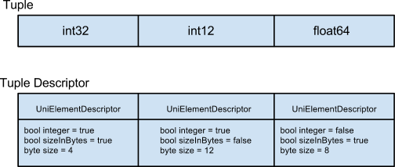
Figure 10 A tuple with its descriptor. A descriptor is an array of UniElementDescriptors

5.2.4 UniDataPacker
UniDataPacker is an interface that writes the sensor’s raw binary data into a given ByteBuffer. The driver developer must implement the method, writeDataIntoByteBuffer(ByteBuffer buffer). The implementation must write the data bytes into buffer in the “tuple array order” that is described by UniChannelHeader and UniElementDescriptor. That is, the implementation must write data into the byte buffer in Figure 9. Also, each element must be byte-aligned and written with a Big Endian byte ordering.

5.3 Example
The following is a code example of how one would implement a Camera driver to be Unified API-compatible. The Camera produces frames of RGB data (effectively arrays of pixels). Each pixel color is a 32 bit integer. The assumption here is that Camera also implements interfacing with the sensor (not shown here). Only the implementation of updateChannels() is shown.

- public class Camera extends UniDevice {

- private Frame frame;

- public Camera() {
- super(Sony_id, camera_id, camera_fps);
- init_my_sensor();
- }

- public void updateChannels() {
- /*
- * Create a Channel Header
- */
- String channel_name = "RGB";
- double channel_freq = frame.getFPS();
- long num_tuples = frame.getXRes()*frame.getYRes(); // # of pixels/frame
- int elem_per_tuple = 3;
- UniElementDescriptor[] rgb_tuple_desc = new UniElementDescriptor[elem_per_tuple];

- // Describe each element of a tuple
- bool red_isInt = true; // If float, set this to false
- bool red_isSizeInBytes = true; // If in bits, set this to false
- int red_sizeInBytes = 4;
- rgb_tuple_desc[0] = new UniElementDescriptor(red_isInt, red_isSizeInBytes, red_sizeInBytes);

- bool green_isInt = true;
- bool green_isSizeInBytes = true;
- int green_SizeInBytes = 4;
- rgb_tuple_desc[1] = new UniElementDescriptor(green_isInt, green_isSizeInBytes, green_sizeInBytes);

- bool blue_isInt = true;
- bool blue_isSizeInBytes = true;
- int blue_SizeInBytes = 4;
- rgb_tuple_desc[2] = new UniElementDescriptor(blue_isInt, blue_isSizeInBytes, blue_sizeInBytes);

- // Actually create the header
- UniChannelHeader rgb_header = new UniChannelHeader(num_tuples, channel_freq, rgb_tuple_desc, channel_name);

- /*
- * Create a DataPacker that can write data to a byte buffer
- * when provided one.
- */
- UniDataPacker rgb_data_packer = new RgbDataPacker(frame);

- // Use the header and data packer previously created to create a channel
- // Add the channel to the device
- UniChannel rgb_channel = new UniChannel(rgb_header, rgb_data_packer);
- addChannel(rgb_channel);
- }

- // Repeat the above to create/add more channels
- ...
- }

- public class RgbDataPacker implements UniDataPacker {
- /*
- * This class will pack RGB into a byte buffer in a specfic format.
- * This data packer is specific to the RGB channel. Must create another
- * class that implements UniDataPacker for other channels.
- */
- private Frame frame;

- public void writeDataIntoByteBuffer(ByteBuffer buffer) {
- for(Pixel p : frame.pixels) {
- // Place 4-byte integers in the same order specified by rgb_tuple_desc above
- buffer.putInt(p.getRed());
- buffer.putInt(p.getGreen());
- buffer.putInt(p.getBlue());
- }
- }

- ...
- }

6. Unified API for Application Developers

6.1 Overview
The Unified API provides the application with a generic form of data from the driver. This data not only includes the raw bit-format data, but also descriptions for the size and type of the data, as well as Strings that can be used to determine what measurement the data corresponds to. Although the Unified API provides data conversion methods, it is up to the application developer to determine the correct data type and call the appropriate data conversion method.

6.2 Using the Unified API

6.2.1 Connecting to a Device
The Sensor class is used to retrieve information from the driver and acts as the application’s interface with the actual sensor. Each instance of the Sensor class is tied to a single driver through the UniDevice parameter in the Sensor constructor. UniDevice instances are created by calling the constructor for the driver implementation of the class

UniDevice device = new UniOpenNIDevice(); //Get a UniDevice from the OpenNI driver
Sensor kinect = new Sensor(device); //Create a new Sensor for the Kinect

The Sensor class allows the application to both decrypt the sensor packet (if an encryption was used on it) and to retrieve the sensor packet in the form of the SensorSnapshot class.

6.2.2 Retrieving Data from a Device

6.2.2.1 Sensor Information and Data
The latest data from the driver can be received through the Sensor class. Data is obtained by requesting a SensorSnapshot, which contains the information transmitted from the driver to the application. The information contained in a SensorSnapshot can vary in size, content, and type, but always follows a typical structure.

SensorSnapshot snapshot = kinect.getSensorSnapshot(); //Get sensor data from driver

Other information about the sensor and driver can be directly obtained from the Sensor class. This information includes:
- Compliant Unified API version
- Vendor ID
- Product ID
- Data rate (in Hertz)

System.out.println(“This device gets data at a rate of ” + kinect.getFrequency() + “ Hz”);

6.2.2.1 Channel Selection
The SensorSnapshot class provides access to data channels and timestamp information. Available channels can be browsed using the getChannelNames() method call. This method returns a Set containing the names of each of the channels in the snapshot. To retrieve data from a particular channel, the getChannel() method can be used. The example program below illustrates these functionalities by finding the “RGB” channel from the snapshot, if it exists.

- Set<String> channels = snapshot.getChannelNames(); //Get channel list
- if(!channels.contains("RGB”)) //Check if RGB exists
- return;
- Channel rgbChannel = snapshot.getChannel(“RGB”); //Get RGB Channel

6.2.2.2 Channel Information
Each channel in a snapshot contains its own data and channel metadata. In addition to containing the channel data frequency and name, the metadata also includes information that describes how the data can and should be used. Section 5.2.2-3 describes the tuple format used to store channel data and should be read before continuing this section.
The application-side UniElementDescriptor is the ElementMetaData class. This class can be used to determine the type and size of a tuple element. Calling the getType() function returns a UniType that corresponds to the applicable data type. The ElementMetaData for each tuple member can be retrieved through the Channel class’s getElementMetaData() function call.

- //Get the data type for each tuple member
- ElementMetaData[] tupleMetaData = rgbChannel.getElementMetaData();
- for(int i = 0; i < rgbChannel.getTupleSize();i++)
- ElementMetaData currMeta = tupleMetaData[i];

In addition, the number of tuples in the channel can be obtained using the getNumberOfTuples() method from the Channel class.

6.2.2.3 Retrieving Channel Data
The actual data contained in a Channel is, by default, formatted in a one-dimensional array of tuples. However, it is possible to reference data as a two- or higher-dimensional array by using the Channel class’s setDimensions() function call. When obtaining data from the channel, the Channel class can only return a Tuple. Once a Tuple is received, the individual tuple elements may be retrieved from the Tuple class using the get method corresponding to the correct data type. Below are two examples of obtaining the red value of the 5th pixel in the second line of a 1920x1080 image. The first example uses the native one-dimensional array and the second example sets a dimension for the array.

- //1-D Example: get the red value for the 5th pixel in the 2nd line
- //Assume: pixels are 8-bit R,G,B values
- int line = 2;
- int column = 5;
- int lineWidth = 1920;
- Tuple pixel = rgbChannel.getTuple( (line-1)*lineWidth + column);
- byte red = pixel.getElementByte(0);

- //2-D example: get the red value for the 5th pixel in the 2nd line
- //Assume: pixels are 8-bit R,G,B values
- int line = 2;
- int column = 5;
- //Set the rgbChannel data to 1920x1080 pixels
- rgbChannel.setDimensions(1920, 1080);
- Tuple pixel = rgbChannel.getTuple(line-1, column);
- byte red = pixel.getElementByte(0);

6.3 Example
The example routine below prints the blue (B) value for each pixel for each image taken by the kinect camera. In this example, pixels can be either 8-bit (byte), 16-bit (short), or 32-bit (int).

- //Establish the sensor connection and set up the data collection and processing loop
- UniDevice device = new UniOpenNIDevice();
- Sensor kinect = new Sensor(device);

- int timeBetweenPackets; //Time between SensorSnapshots in milliseconds
- Date snapshotArrival; //Time when the SensorSnapshot was created

- int blueIndex = 2;

- while(true)
- {
- SensorSnapshot snapshot = kinect.getSensorSnapshot();

- //Setup information for determining when to loop
- timeBetweenPackets = (int)(1000/kinect.getFrequency()) + 1;
- snapshotArrival = snapshot.getTimestamp();

- Set <String> channelNames = snapShot.getChannelNames();

- //Sleep and continue if "RGBâ€ channel does not exist
- if( !channelNames.contains("RGBâ€) )
- {
- Date currentTime = new Date();
- long timeElapsed = currentTime.getTime() - snapshotArrival.getTime();
- Thread.sleep(timeBetweenPackets - timeElapsed);
- continue;
- }

- Channel rgbChannel = snapshot.getChannel("RGBâ€);
- ElementMetaData blueDescriptor = snapshot.getElementMetaData[blueIndex]);

- for(int tupleIndex = 0; tupleIndex < rgbChannel.getNumberOfTuples(); tupleIndex++)
- {
- Tuple pixel = rgbChannel.getTuple(tupleIndex);

- //Show the blue value, using the appropriate getElement method
- switch(blueDescriptor.getType())
- {
- case UniType.int8:
- System.out.println("Pixel blue value: " + pixel.getElementByte(blueIndex));
- break;
- case UniType.int16:
- System.out.println("Pixel blue value: " + pixel.getElementShort(blueIndex));
- break;
- case UniType.int32:
- System.out.println("Pixel blue value: " + pixel.getElementInt(blueIndex));
- break;
- default:
- System.out.println("Unhandled pixel value formatâ€);
- break;
- }
- }

- //Sleep until next packet arrives
- Date currentTime = new Date();
- long timeElapsed = currentTime.getTime() - snapshotArrival.getTime();
- Thread.sleep(timeBetweenPackets - timeElapsed);
- }

The code can be found online at https://github.com/c-team-2/deviceInterface for the API and https://github.com/c-team-2/gestureRecognition for the gesture recognition system.

