FEEDBACK-may 23
GRADE 89 of 100
DO NOT DELETE FEEDBACK
Getting way better!
3.2. Functional Requirements
Reduce the repetition in the usecases, why are the same usecases repeated twice in another section?
Condense merge those sections into one. Its a waste of space

-------------
FEEDBACK – MAY 15, 2012
Grade: as is 49%

1. Excellent start
2. 2.2.1 Product Perspective
* 2nd paragraph "Underneath the diagram..."; This whole paragraph needs more detail. It is not clear at all.
* Expand this section and go into more detail about the entities involved ... You should consider breaking down the main entities as sub sections and explain how they all connect.
* Use workflows, UML, sequence diagrams as necessary if they help make things clearer

3. 2.2.1 Product Functions
* Add more to this section.
* Quote: "The middleware API methods provide the middleware with the ability to access and recognize data sent from the drivers." ---> Does not make sense

4. 2.2.4 Constraints
* There are more constraints to your program other than those inherited by Ciscos Smart Connected Communities project

* Think more about them and add more detail

5. 2.3 Specific Requirements
* Usecases for each requirement, refer to the sample SRS document that I emailed.
* Kinect Gesture Recognition Requirements Section --- why not combine that w/ Specific requirements??? Or have them as 2 seperate subsections

6. 3.1.2 Product Scope
* Add more to this by thinking of more features and deciding what is in/out of scope
* Refer to what I taught during the 1st 2 weeks of class

7. 3.1.3 Section Overview
* Whats the point of this section???

* half of section 3 should have been in the 1st half of your document and not down this far. Revise all of section 3

8. 3.3.2 Functional Requirements and 2.3 Specific Requirements can be merged together.
* 3.3.2 is a good start, however usecases should be presented with that level of description for each requirement. Please add more

Cisco Kinect Team 2
Software Requirements Specification
Version 3

May 24, 2012

Jonathan Chan
Axel Colin de Verdiere
Greg Clark
Sunghoon Ivan Lee
Nancy Hsieh
Richard Yu

Introduction 5
1.1 Document Purpose 5
1.2 Project Scope 5
1.3 Glossary 6
1.4 References 6
1.5 Document Overview 7
2 Overall Description 8
2.1 System Environment 8
2.2 System Use 8
2.2.1 One-Handed Wave 8
2.2.2 T-Pose 9
2.2.3 Arm Raise 9
2.2.4 Torso-Tilt 9
2.2.5 Unrecognized Gesture 9
2.3 User Characteristics 9
3 Requirements Specification 10
3.1 Interface Requirements 10
3.2 Functional Requirements Specification 10
3.2.1 User Use Cases 10
3.3 Detailed Non-Functional Requirements 15
3.3.1 Java 16
3.3.2 Performance 16
3.3.3 Unified API 16
3.4 Design and Implementation Constraints 16
3.4.1 Unified API 16
3.4.2 System constraints 16

Introduction

Document Purpose
This document presents a detailed description of the Gesture Recognition System employing the unified application programming interface (API). This document provides the following items in detail:

- Purpose of the system
- Interfaces of the system
- Functions of the system
- Constraints or assumptions under which the system must operate

This document only applies to the development phase of the product for the CS130 course by the Cisco Kinect Team 2. It does not cover requirements for work done outside the span of the Spring 2012 CS130 course nor does it cover requirements for teams other than the Cisco Kinect Team 2. The intended readers of this document includes the future Cisco maintainers of the API and developers of the Smart Connected Communities software, the developers of the system, and the course administrators.

Project Scope
The final vision is to create a system that takes data from many different types of sensors and recognizes the intents of the users inside the environment that the sensors are detecting. The scope of this project is smaller than that: to create a prototype that simply recognizes gestures using a single sensor.

The Gesture Recognition System to be developed simulates a natural interaction between human and computer by recognizing gestures, and performing services for the user. The vision is that there are many different gestures, one system analyzing the gestures and providing a specific service for each gesture.

Since the envisioned system will use many sensors and different types of data to recognize user intentions, it needs a unified API to do so. The unified API must provide a generalized interface and format allowing developers to interact with any kind of sensor, thus “unifying” them (see 1.3. Glossary). Currently, each sensor has a different API, so it is difficult for one system to interface with them all.

This project must develop a unified API that will be easily implementable by device driver developers, and a Gesture Recognition System that employs the unified API to retrieve data from a Microsoft Kinect.

The scope of the Gesture Recognition System is limited to the following:

- The Gesture Recognition System shall employ the unified API which allows easy access to the data from multiple sensors. For the initial prototype, only one type of sensor, the Microsoft Kinect, data is accessed.
- The Gesture Recognition System shall recognize four different gestures.
- The Gesture Recognition System shall provide an interface that instructs the users to start and end the gesture performance, and also displays the result of the inferred gesture.

Glossary
Term | Definition
API (Application Programming Interface) | A set of methods a user can use to interact with some other software
Sensor | A hardware device that collects data, and provides the data to a computer for
Software Requirements Specification | A document that completely describes all of the functions of a proposed system and the constraints under which it must operate. For example, this document.
Stakeholder | Any person with an interest in the project who is not a developer.
System | The gesture recognition software that uses the unified API to retrieve data from sensors. A user directly interacts with the system by performing gestures to the sensors.
Unified API | The software API that specifies a common format and interface so that a software component can use it to interact with many different sensors.
User | A person that directly interacts with the system. The sensors of the system detect the user.

References
- IEEE. IEEE Std 830-1998 IEEE Recommended Practice for Software Requirements Specifications. IEEE Computer Society, 1998.
- Lee, Kevin. Sudhaakar, Raghuram. “Detailed Description”. http://cs.ucla.edu/classes/spring12/cs130/hw/ucla-project.doc.

Document Overview
The next chapter of this document, Overall Description, will describe how this system is used. It is written in simple language, describing how the user will interact with the system. The chapter is intended for stakeholders and and the general audience.

The last chapter, Requirements Specification, will describe in a technical manner how the system must behave given specific stimuli. The language will be intended for developers.

Both chapters will cover the entirety of the system and its requirements. However, chapter 2 “Overall Description” will have some specific sections for the general audience, and chapter 3 “Requirements Specification” will have some specific sections for developers.

Overall Description

System Environment
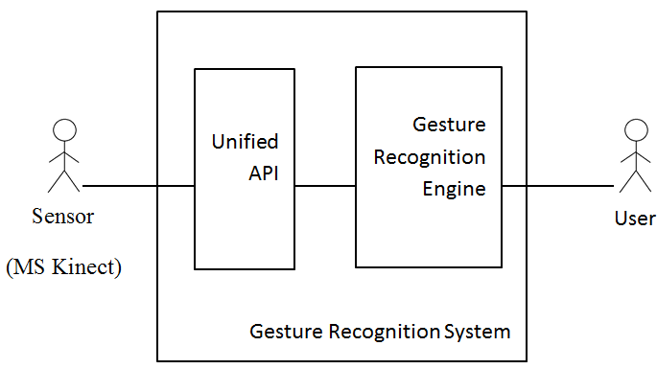
Figure 1 - System Environment

The Gesture Recognition System has two actors (i.e., the User and the Sensor) and two sub-systems (i.e., unified API and gesture recognition engine). The user interacts with the Gesture Recognition System by providing gestures and expects a response. The Sensor provides data on the gesture, and communicates it to the Gesture Recognition Engine. The Sensors must use the unified API to transfer data. The unified API must be compatible with many sensors.

System Use
There are four gestures the Gesture Recognition System (GRS) shall recognize. For detailed use cases, see section 3.2 Functional Requirements Specification. A brief overview is given here.

Each of the following gestures will be recognized. Before each of the following actions, the user must press a start key to initiate recognition, and face the Microsoft Kinect. After each action, the user must press an end key to halt recognition. Only one gesture shall be performed during each of these start/end sessions.

One-Handed Wave
The user shall raise his/her right arm, and wave (as if waving hello). The upper right arm shall be level with the shoulder, and forearm shall perform the waving motion.

T-Pose
The user shall stand with back straight, feet together, and raise both arms such that they are parallel to the floor (performing a T-shaped pose). The user shall remain still for several seconds before pressing the end key.

Arm Raise
The user shall raise both arms in the air, perpendicular to the floor. The user shall remain still for several seconds before pressing the end key.

Torso-Tilt
The user shall keep arms relaxed at the side, and tilt the torso from right to left and vice versa. Repeat the tilting continuously for several seconds. The axis of tilt is the hip. Ensure arms are controlled so that they are not waving, performing something similar to a T-pose, or raised perpendicularly above the head.

Unrecognized Gesture
The user performs some physical action besides those described above, or a combination of the above. Such action is considered an unrecognized gesture. The GRS shall then notify the user that the gesture was not recognized.

User Characteristics
The user is expected to perform gestures as stated in Section 2.2: User Use Cases and to be able to start the program, follow on-screen instructions, and push a start/stop key on a keyboard.

Requirements Specification

Interface Requirements
The interface provided to the User allows the User to perform a gesture, which is to be analyzed and to be inferred by the Gesture Recognition System. The interface provides two keys, start and stop, that informs the system the start and the stop moment of the performed gesture. The interface also provides a display which provides gesture recognition results (e.g., handed wave) and the associated services (e.g., say “Hello”). The interface also provides a instructional display that shows the status of the system (e.g., “Gesture recognition has been completed”).

Functional Requirements Specification
This section outlines the use case of the User.

User Use Cases

Perform One-handed Wave

Use case Perform one-handed wave
Diagram
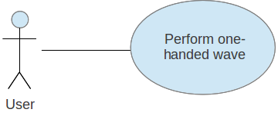

Brief Description
The User presses a key and then waves with their right hand.

Use Case Name | Perform One-handed Wave
XRef | Section 2.2.1, Perform One-handed wave
Trigger | The User pressed a start key.
Precondition | The User has initiated the Gesture.
Basic Path | - The system displays which key to press.  - The User presses the start key.  - The system displays an instruction to perform a gesture and press the same key once completed.  - The User waves his/her right hand by holding his/her upper arm level with his/her shoulders and bends at the elbow, moving his/her hand toward and away from his/her head.  - The User presses the stop key to indicate that the gesture is completed.  - The system displays that a one-handed wave was detected.
Alternative Path | None
Postcondition | The system acts in response to a one-handed wave.
Exception Paths | The User may gesture incorrectly.
Other | None

Perform T-pose

Use case Perform T-pose
Diagram
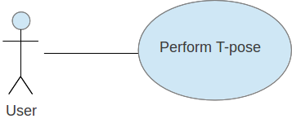

Brief Description
The User presses a key and then makes a T-pose (both arms outstretched horizontally, parallel to the floor).

Use Case Name | Perform T-pose
XRef | Section 2.2.2, Perform T-pose
Trigger | The User pressed a start key.
Precondition | The User has initiated the Gesture.
Basic Path | - The system displays which key to press.  - The User presses the start key.  - The system displays an instruction to perform a gesture and press the same key once completed.  - The User performs a T-pose by standing up straight with his/her feet together and his/her arms outstretched to the sides.  - The User presses the stop key to indicate that the gesture is completed.  - The system displays that a T-pose was detected.
Alternative Path | None
Postcondition | The system acts in response to a t-pose.
Exception Paths | The User may gesture incorrectly.
Other | None

Perform Arm Raise

Use case Perform arm raise
Diagram
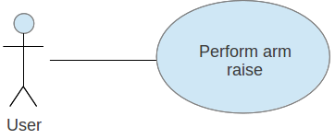

Brief Description
The User presses a key and then raises both arms above their head (perpendicular to the floor).

Use Case Name | Perform Arm Raise
XRef | Section 2.2.3, Perform Arm Raise
Trigger | The User pressed a start key.
Precondition | The User has initiated the Gesture.
Basic Path | - The system displays which key to press.  - The User presses the start key.  - The system displays an instruction to perform a gesture and press the same key once completed.  - The User raises both arms straight above his/her head.  - The User presses the stop key to indicate that the gesture is completed.  - The system displays that the arm raising was detected.
Alternative Path | None
Postcondition | The system acts in response to an arm raise.
Exception Paths | The User may gesture incorrectly.
Other | None

Perform Torso Tilt

Use case Perform torso tilt
Diagram
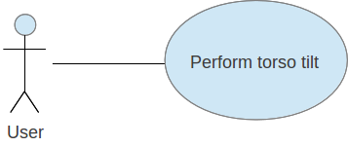

Brief Description
The User presses a key and then tilts their torso from side to side.

Use Case Name | Perform Torso Tilt
XRef | Section 2.2.4, Perform Torso Tilt
Trigger | The User pressed a start key.
Precondition | The User has initiated the Gesture.
Basic Path | - The system displays which key to press.  - The User presses the start key.  - The system displays an instruction to perform a gesture and press the same key once completed.  - The User repeatedly tilts his/her torso from right to left.  - The User presses the stop key to indicate that the gesture is completed.  - The system displays that torso tilting was detected.
Alternative Path | None
Postcondition | The system acts in response to an arm raise.
Exception Paths | The User may gesture incorrectly.
Other | None

Perform Unrecognized Gesture

Use case Perform unrecognized gesture
Diagram
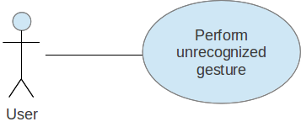

Brief Description
The User presses a key and then performs a gesture not recognized by the system.

Use Case Name | Perform Unrecognized Gesture
XRef | Section 2.2.5, Perform Unrecognized Gesture
Trigger | The User pressed a start key.
Precondition | The User has initiated the Gesture.
Basic Path | - The system displays which key to press.  - The User presses the start key.  - The system displays an instruction to perform a gesture and press the same key once completed.  - The User performs a gesture not recognized by the system.  - The User presses the stop key to indicate that the gesture is completed.  - The system displays that the gesture could not be recognized and lists instructions for how to perform recognizable gestures.
Alternative Path | None
Postcondition | The system acts in response to an unrecognized gesture.
Exception Paths | None
Other | None

Detailed Non-Functional Requirements

Java
Cisco Kinect Team 2 shall write the Gesture Recognition System and the unified API in Java. This was decided among the three Cisco Kinect Teams. The other teams are to program in C and C#.

Performance
There is no restriction on the reaction time of the Gesture Recognition System. The reaction time is defined as the time the user pushes the stop key on the keyboard until the time the system acts in response.

The system does not have any specific performance requirements.

Unified API
The unified API shall enable the Gesture Recognition Engine to retrieve data from the sensors. The data returned by the API must be in a format independent of the sensor. The system should be able to obtain the type and vendor of the sensor as well as the type and format of the data.

Design and Implementation Constraints

Unified API
The unified API shall be able to function on top of any kind of sensor as long as the driver implements the API functionality.

System constraints
The Gesture Recognition engine should run on a standard computer that has a Java Virtual Machine (JVM) installed running Java v1.6 or higher.

Retrieving data from a Microsoft Kinect requires OpenNI v1.5.2.23, PrimeSense NITE 1.5.2.21, and SensorKinect v5.1.0.25 or higher to be installed.

System shall use the Microsoft Xbox 360 Kinect as a sensor in this project.

