Overall:
Grade: 96 of 100
Very much improved!
- Make small grammatical corrections in the document and your good to go
- See the comments in the document sections

====V1 Comments:
Overall:

Grade: 80 of 100

This document is a great start!

Remember that the specification is supposed to be the road map to telling a developer (or me) how to develop your application, therefore keep in mind the flow and ensure that you describe the major actors you'd like to describe

* Given our discussion last week, I want to make sure that things are clarified about section 5 COMPONENT DESCRIPTION - GESTURE RECOGNITION ENGINE

- Gesture recognition is one type of application. If your not specifically implementing one, then don't explain the major as if you are. Only treat it as one type of application or "Actor" invoking your framework.
- I hope that clarifies some things. Therefore, if you are not implementing a Gesture Recognition engine, then you can drop the last section.

* Add Figures to describe some of the major interactions (including message types) that your defining. For example, if a Gesture recognition application requests sensor data, how does the interaction go between entities? What components from section "4 COMPONENT DESCRIPTION - Unified API" do I interact with?

* In particular, is it possible to breakdown any major entities, interfaces, classes, etc that your implementing in the two software packages: the “middleware-side” and/or the “driver-side” in section "3.2.2 Unified API Architecture"?

Cisco Kinect Team 2
System Specification
Version 2

May 24, 2012

Jonathan Chan
Axel Colin de Verdiere
Greg Clark
Sunghoon Ivan Lee
Nancy Hsieh
Richard Yu

1 INTRODUCTION 7
1.1 Document Purpose 7
1.2 Problem Overview 7
1.3 Project Scope 8
1.4 Glossary 8
1.5 References 10
2 DESIGN CONSIDERATIONS 11
2.1 Assumptions and Dependencies 11
2.2 General Constraints 11
2.3 Goals and Guidelines 11
2.4 Development Methods 11
3 SYSTEM DESIGN 13
3.1 Logical Model Description 13
3.1.1 Unified API Process Flow 14
3.1.2 Gesture Recognition Engine Process Flow 15
3.2 Architecture 16
3.2.1 System Architecture 16
3.2.2 Unified API Architecture 17
3.2.3 Gesture Recognition Engine Architecture 21
4 COMPONENT DESCRIPTION - Unified API 24
24
4.1 UniElementDescriptor 25
4.1.1 Type 25
4.1.2 Functions 25
4.1.3 Interfaces 25
4.1.4 Dependencies 25
4.1.5 Data 25
4.1.6 Resources 25
4.2 UniChannelHeader 25
4.2.1 Type 25
4.2.2 Functions 25
4.2.3 Interfaces 26
4.2.4 Dependencies 26
4.2.5 Data 26
4.2.6 Resources 26
4.3 UniChannel 26
4.3.1 Type 26
4.3.2 Functions 26
4.3.3 Interfaces 26
4.3.4 Dependencies 26
4.3.5 Data 26
4.3.6 Resources 26
4.4 UniSensorHeader 27
4.4.1 Type 27
4.4.2 Functions 27
4.4.3 Interfaces 27
4.4.4 Dependencies 27
4.4.5 Data 27
4.4.6 Resources 27
4.5 UniDevice 27
4.5.1 Type 27
4.5.2 Functions 27
4.5.3 Interfaces 27
4.5.4 Dependencies 28
4.5.5 Data 28
4.5.6 Resources 28
4.6 Sensor 28
4.6.1 Type 28
4.6.2 Functions 28
4.6.3 Interfaces 28
4.6.4 Dependencies 28
4.6.5 Data 28
4.6.6 Resources 28
4.7 ElementMetaData 28
4.7.1 Type 28
4.7.2 Functions 28
4.7.3 Interfaces 28
4.7.4 Dependencies 29
4.7.5 Data 29
4.7.6 Resources 29
4.8 Tuple 29
4.8.1 Type 29
4.8.2 Functions 29
4.8.3 Interfaces 29
4.8.4 Dependencies 29
4.8.5 Data 29
4.8.6 Resources 29
4.9 Channel 29
4.9.1 Type 29
4.9.2 Functions 30
4.9.3 Interfaces 30
4.9.4 Dependencies 30
4.9.5 Data 30
4.9.6 Resources 30
4.10 SensorSnapshot 30
4.10.1 Type 30
4.10.2 Functions 30
4.10.3 Interfaces 30
4.10.4 Dependencies 30
4.10.5 Data 30
4.10.6 Resources 31
5 COMPONENT DESCRIPTION - GESTURE RECOGNITION ENGINE 32
5.1 Class diagram 32
Figure 14 describes the overall architecture of the GRE. It consists of 6 main classes which are described in the following sections. 32
5.1 Main 33
5.1.1 Type 33
5.1.2 Functions 33
5.1.3 Interfaces 33
5.1.4 Dependencies 33
5.1.5 Data 33
5.1.6 Resources 33
5.2 DataExtractor 33
5.2.1 Type 33
5.2.2 Functions 33
5.2.3 Interfaces 34
5.2.4 Dependencies 34
5.2.5 Data 34
5.2.6 Resources 34
5.3 FeatureExtractor 34
5.3.1 Type 34
5.3.2 Functions 34
5.3.3 Interfaces 34
5.3.4 Dependencies 34
5.3.5 Data 34
5.3.6 Resources 34
5.4 FeatureContainer 34
5.4.1 Type 34
5.4.2 Functions 35
5.4.3 Interfaces 35
5.4.4 Dependencies 35
5.4.5 Data 35
5.4.6 Resources 35
5.5 KNNClassifier 35
5.5.1 Type 35
5.5.2 Functions 35
5.5.3 Interfaces 35
5.5.4 Dependencies 35
5.5.5 Data 35
5.5.6 Resources 35
5.6 UserInterface 36
5.6.1 Type 36
5.6.2 Functions 36
5.6.3 Interfaces 36
5.6.4 Dependencies 36
5.6.5 Data 36
5.6.6 Resources 36
6 Extensibility 37
6.1 Implementing a New Application 37
6.2 Implementing the API in a New Sensor 37

INTRODUCTION

Document Purpose
This document presents the software specification and architectural design of the Gesture Recognition System. This document includes description of

- Design considerations (Chapter 2) of the system
- System design and architecture (Chapter 3)
- Each component that constructs the system (Chapters 4 and 5)

This document focuses on the high level structure of the system. The detailed information about the system architecture (e.g., member variables and function definitions) will be defined in the detailed design phase. This document only applies to the implementation phase of the product for the CS130 course by the Cisco Kinect Team 2. It does not cover requirements for work done outside the span of the Spring 2012 CS130 course nor does it cover requirements for teams other than the Cisco Kinect Team 2. The intended readers of this document includes the future Cisco maintainers of the API and developers of the Smart Connected Communities software, the developers of the system, and the course administrators.

Problem Overview
Recent research groups in both academia and industry are interested in developing smart spaces, which provides assistive environment that can sense themselves and their residents and enact mappings between the physical world and remote monitoring and intervention services. In the heart of such technology, there exists a human-computer interface named natural user interface (NUI), which allows more natural way of interaction between human and computers. An example of this interface is to infer the intention of users’ actions and to provide appropriate services.

The project specifically focuses on implementing a platform that allows intent recognition services based on various sensor inputs (e.g., motion sensors, temperature sensors, acoustic sensors, etc.) However, due to the high degree of heterogeneity of input sensors, there is a need for a standardized, or unified API (see 1.4 Glossary) for these sensors (e.g., analogous to “Plug-and-Play” standard). To demonstrate the effectiveness of the Unified API, this project shall create an application, Gesture Recognition, that uses the Unified API to simulate NUI.

Project Scope
The final vision is to create a system that takes data from many different types of sensors and recognizes the intents of the users inside the environment that the sensors are detecting. The scope of this project is smaller than that: to create a prototype that simply recognizes gestures using a single sensor.

The project tasks are:
Task | Metric
Implementation of a Unified API between sensors and applications interested in sensor data. The application shall access any sensor’s data by only using this Unified API. | - Number of changes to Unified API per sensor  - Number of sensors Unified API can handle at any given time  - Application’s ease of access to sensor data
Specification of a data format a driver must organize its raw data into a consistent format for the Unified API to use. The implementation will most likely involve modifications to each sensor driver. | - Number of modifications made to sensor driver  - Number of driver implementers willing to conform to format versus Number of driver implementers unwilling to conform to format
Implementation of a Gesture Recognition Engine (GRE) that uses the Unified API to extract sensor data to perform Gesture Recognition. The GRE will recognize 4 gestures. | - Number of reliances on Unified API versus Number of reliances on external libraries or sensor-specific API’s to perform recognition

Non-Tasks (Outside of scope)
- Use of multiple sensors. Only need to use Microsoft Kinect. It provides a wide range of data, as if from multiple sensors.
- Implementation of any algorithm for Gesture Recognition. Any open source classifier is acceptable.

The Gesture Recognition System (GRS) is the composition of the Unified API and Gesture Recognition Engine (GRE).

Glossary
In this document, there are many common terms that are used in specific purposes for this document. Please quickly skim over the table, and reference back if there are any terms that are difficult to understand.

Application Programming Interface (API) | A set of methods and classes used to interact with another component or system.
Channel | A type of data from a sensor (e.g. RGB, distance, sound intensity, etc.)
Channel Packet | A packet that contains all the metadata and data of one channel. One or more channel packets are contained in a sensor packet.
Component | One or more related classes, interconnected to perform a small set of related tasks. Multiple components make up a system.
Data | Any quantifiable information that is gathered from the physical world by a sensor (e.g. skeletal data).
Driver | Software to interface with a specific sensor. In this project, drivers will have to implement methods and functions for the Unified API to work (see below “Driver-side Unified API”).
Driver-side Unified API | The set of methods and interfaces of the Unified API a driver writer would be expected to implement. The opposite side of the Unified API is the Middleware-side (see below).
End User | A person who uses the Gesture Recognition System.
Environment | Physical world that all the hardware sits in.
Feature | A single measurable property of a gesture. Can be thought of as a subset of Data (e.g. elbow joint angle).
Gesture Recognition Engine (GRE) | A component of the Gesture Recognition System that analyzes user intent.
Gesture Recognition System (GRS) | The product this document is specifying. It recognizes the intent of a user to perform services.
Middleware | Software components that use the Unified API to communicate with the sensors.
Middleware-side Unified API | The set of methods and interfaces of the Unified API that a middleware writer can use to extract data from sensors, instead of interacting with the driver directly. The opposite side of the Unified API is the Driver-side (see above).
Platform | The operating system with the necessary drivers to run the software being developed.
Unified API | The API this document is specifying. This API will allow middleware to interact with many different sensors, instead of having sensor-specific code for each sensor. The Driver-side Unified API is implemented by the driver writer, and the Middleware-side Unified API is used by middleware writers (see above).
Sensor | Hardware device that collects data from the environment.
Sensor Packet | A packet that contains all metadata and data from one specific sensor. The sensor packet is composed of one or more channel packets (see above “Channel Packet”).
Session | Quantifies the time frame corresponding to one gesture; between the moment the user pushes the “start” button and the moment he pushes the “end” button when performing a gesture for this project.
Smart Connected Community (SCC) | The overall vision, beyond this project scope. Cisco’s SCC envisions sensors, machines, and humans interacting in a natural fashion.

References
- Lee, Kevin. Sudhaakar, Raghuram. “Detailed Description”. http://cs.ucla.edu/classes/spring12/cs130/hw/ucla-project.doc.

DESIGN CONSIDERATIONS

Assumptions and Dependencies
This project is aimed at creating a prototype for Cisco’s SCC vision, so only a subset of this problem will be solved (see 1.2 Project Scope). In particular, the intent that GRS recognizes will be 4 gestures (see 3.2.3 Gesture Recognition Engine Architecture), using only one sensor (Microsoft Xbox 360 Kinect). Furthermore, the GRS will also assume a controlled environment to simplify gesture recognition. The environment the GRS is trained in (see below) is the environment it will be operating in. A start/stop key will be implemented to notify the GRS when to attempt a gesture recognition.

To perform gesture recognition, a training data set will be necessary for the GRS to infer user gestures. Thus, both time and careful training of the system must be done prior to proper operation.

The GRS will need an adequate platform to run on, and applicable sensors to retrieve data from the environment to perform gesture recognition. Specifically, the platform must have:

- Java Virtual Machine running Java v1.6 or higher
- PrimeSense NITE 1.5.2.21 or higher
- SensorKinect v5.1.0.25 or higher

General Constraints
Though the SCC envisions use of many sensors, this project is limited to using the Microsoft Xbox 360 Kinect. Also, the development of the entire Gesture Recognition System must be done in Java.

Goals and Guidelines
The goal for this project is for the GRS to recognize four gestures using sensor data passed through the unified API. Eventually, this system is expected to be expanded into a distributed platform that will offer intent recognition services (i.e. lights turn on depending on gestures, sounds, or human presence). In order for this distributed platform to operate on top of multiple sensors, the unified API must be extensible.

Development Methods
The project will be implemented in three phases: planning, implementation, and testing.

In the initial planning phase, the team will write the requirements and develop the system design.The system design includes both the GRS and the unified API.

In the implementation phase, the team will be divided into two sub-teams. One team is responsible for implementing the GRS, and the other team is responsible for implementing the unified API. Using agile methods, both teams will be working in the Eclipse IDE and implementing in Java.

In the final testing phase, the team will come together once again and piece the GRS and unified API together. The team will test that the GRS satisfies the goal of this project.

Documentation and version control will be done through a github repository.

SYSTEM DESIGN

Logical Model Description
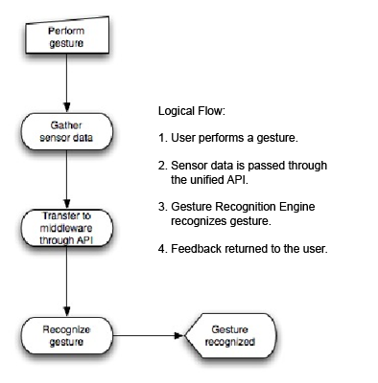
Figure 1: System Logical Model

Unified API Process Flow
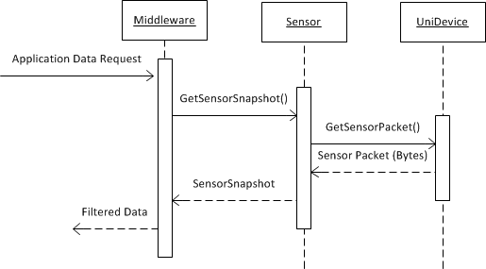
Figure 2: Unified API Process Flow
When the middleware receives a data request (refer to Figure 2), it calls GetSensorSnapshot() from the appropriate Sensor class instance. The Sensor class then retrieves a sensor packet from the driver and sends back the data in a SensorSnapshot class to the middleware.

Gesture Recognition Engine Process Flow
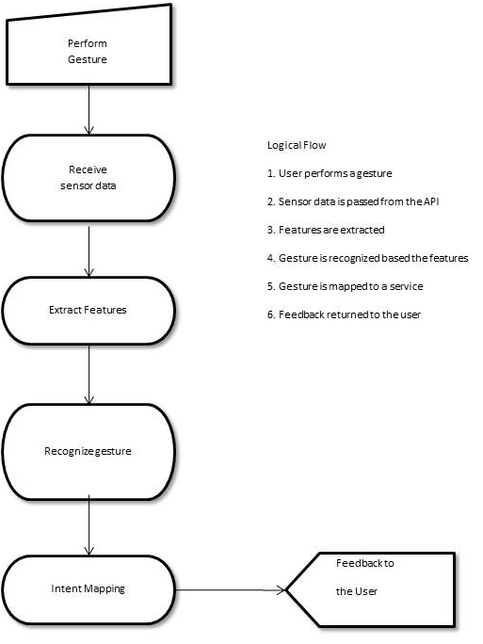
Figure 3: Gesture Recognition Engine Process Flow

Architecture

System Architecture
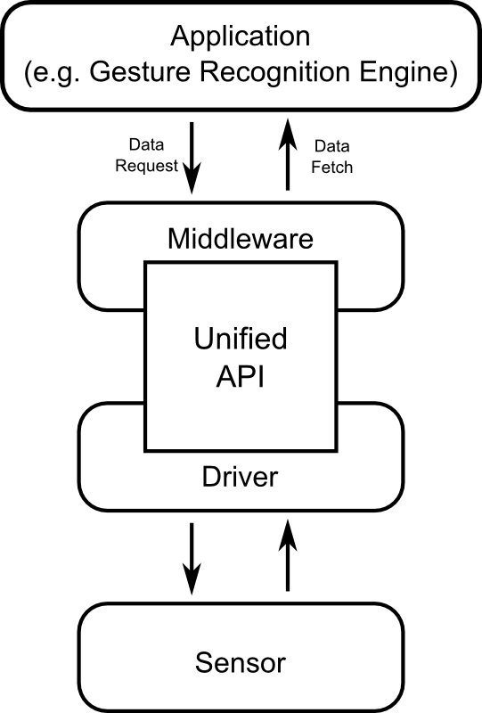
Figure 4: Overall Architecture

The architecture shown in Figure 4 can be used to describe the structure of both the Cisco Smart Connected Communities (SCC) project and the Gesture Recognition application. In this section, the general architecture will be described and the differences between the two systems will be noted.

In the general architecture, the application is responsible for processing the data and interacting with the end user or environment. In the SCC model, there are many possible applications that can connect to the middleware. In the GRS model, there exists a single application with a single user-centered function.

The middleware is responsible for collecting and sending data requested by the application. It contains connections to the driver (through the unified API), which provides data, and the application, from which it can receive data requests. In Cisco’s SCC initiative, the middleware exists as a cloud service capable of fulfilling application data requests. These requests are expected to contain information that the SCC middleware can use to filter its data requests and the results sent to the application. The GRS middleware, however, can be much less complex, since it is purpose-built for one sensor and one application. However, it still maintains a close resemblance to the SCC middleware functionalities of retrieving and filtering data.

Overlapping the middleware and driver packages is the unified API. The API is responsible for the communication between the driver and the middleware. It enables the middleware to uniformly extract data from any driver that implements the API. The architecture of the unified API is described in Section 3.2.2.
On the lowest level of the software chain sits the driver. This code is responsible for communicating with the physical sensor and sending data and feedback to the rest of the program. In the SCC model, the driver manufacturers will implement the driver-side unified API methods that can be used by the middleware to retrieve data. In the GRS system, the driver-side API must be implemented by modifying the driver provided by the OpenNI package.

Unified API Architecture
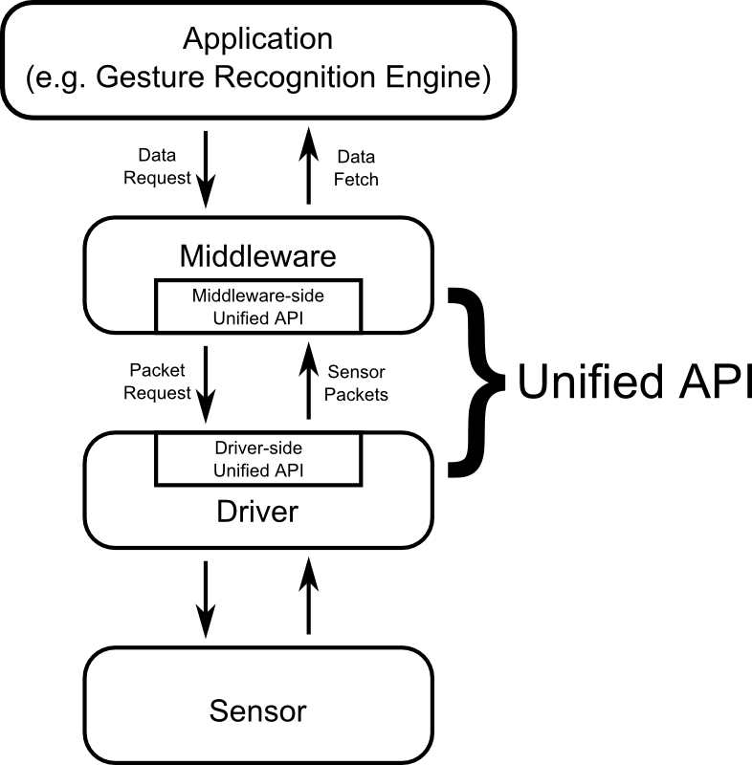
Figure 5: Overall Architecture with emphasis on the Unified API

The unified API, which is often referred to as a single entity in most of this document, is actually spread between two software packages: the “middleware-side” and the “driver-side”, as shown in Figure 5. Please reference the glossary (Chapter 1.4) if these terms are unclear. Figure 4 differs from Figure 5 in that the unified API block now consists of a middleware-side implementation, a driver-side implementation, and a communication protocol. This allows the API to act as a bridge between the driver and the middleware. However, it also forces the development of a formal transmission protocol between the two sides of the API. The transmission protocol design is a based on a packet-format that will be discussed in the following sections.

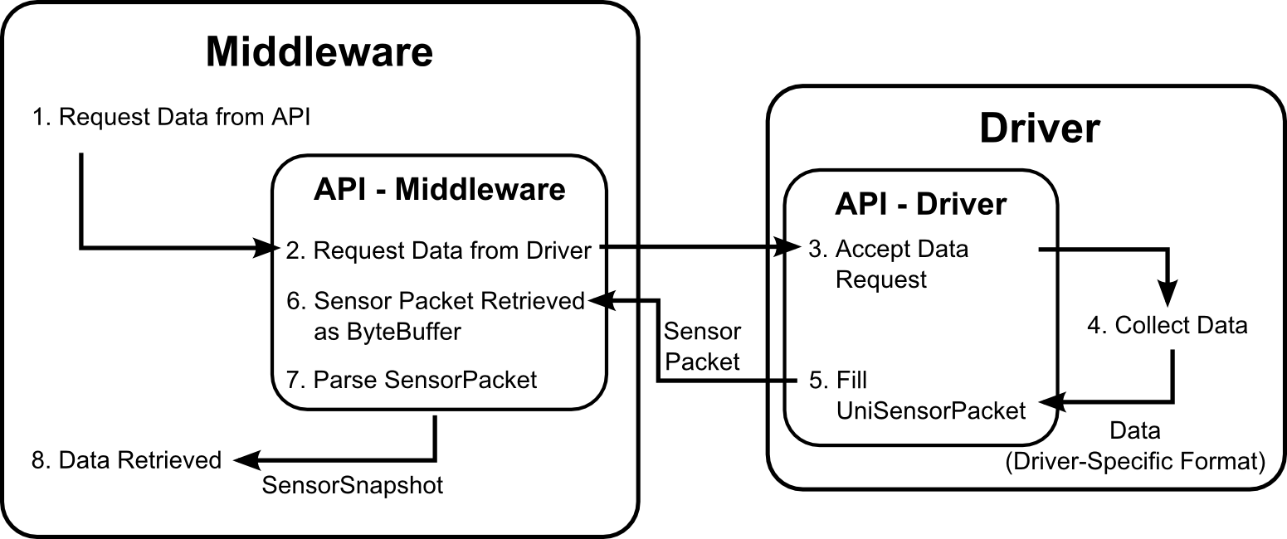
Figure 6: API Procedure

Figure 6 shows the functional responsibilities and process flows of the middleware and drive APIs. The middleware-side API is responsible for retrieving data requests from the middleware, prompting the driver for data, and parsing the data into a friendly format for the middleware to use. The driver-side API is responsible for accepting data requests from the middleware, prompting the rest of the driver code to collect or process data, and sending out the sensor packet.

Communication between the middleware, the two API implementations, and the driver utilizes a total of four data formats. The first format is the driver’s native data format. It is formed when the driver collects data from the sensor. The second format is the UniSensorPacket class, which is discussed in Section 4.2. This class serves as the communication between the driver and the driver-side Unified API. The driver-side Unified API then packs the UniSensorPacket into a sensor packet format described in the next section which is picked up by the middleware-side Unified API. Lastly, the data is parsed and expanded into the SensorSnapshot described in Section 4.8 which acts as a standard data format for the middleware to use.

Packet Overview
The unified API requires data packets in a specific protocol. Different sensors can have very different sets of data, but using a well-defined packet format will standardize driver-side packaging of data and middleware-side parsing of data. This packet format is shown below (Figure 7):

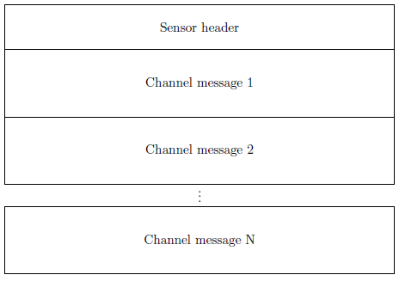
Figure 7: Overall Packet Format

A packet is composed of the sensor header and N channel messages. In the case that only metadata is transmitted, packets with only a sensor header and no channel messages are allowed.

Sensor Packet Description
The sensor header provides the middleware-side parsing with information about how to parse the sensor packet. The sensor header format is shown below (Figure 8):

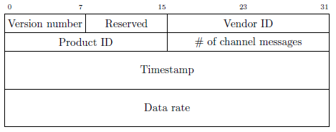
Figure 8: Sensor Packet Format

- Version number (1 byte): the version of the API used by this packet
- Reserved (1 byte): 1 byte set to 0, reserved for future use
- Vendor ID (2 bytes): the unique ID of the vendor of the sensor
- Product ID (2 bytes): the unique ID (within the context of the vendor ID - i.e. (Vendor ID, Product ID) is unique) of the sensor
- # of channel messages (2 bytes): the number of channel messages in this packet (see next section)
- Timestamp (8 bytes): the timestamp of this packet as applied by the sensor
- Data rate (8 bytes): a double representing the data rate of the sensor in Hz, by default the maximum data rate of all the channels

Channel Packet Description
Each channel packet comprises of a header describing the format of the data, and an array of tuples, each containing the same number of tuple elements, as determined in the channel header. The channel header gives the middleware-side parser information of how to store the channel data and how large the channel is. The channel packet format is shown below (Figure 9):

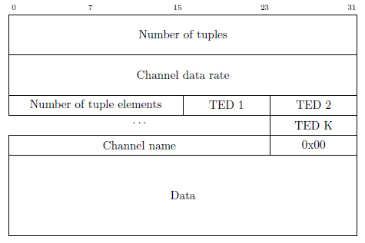
Figure 9: Channel Packet Format

- Number of tuples (8 bytes): The number of tuples in this channel message
- Channel data rate (8 bytes): A double representing the data rate of the channel in Hz
Number of tuple elements (2 bytes): the number of elements in each tuple
- TED -- Tuple element descriptor (1 byte): each tuple element is described by a tuple
- element descriptor (more details later)
- Channel name (variable size): the name of the channel, represented by a C string
- and terminated by the null character 0x00
- Data (variable size): the data corresponding to the channel, made of [Number of
- tuples] tuples each containing [Number of tuple elements] elements

Tuple Element Descriptor
Each element in a tuple can have a different data type. The Tuple Element Descriptor gives the middleware-side parser information about how each element should be stored once parsed.

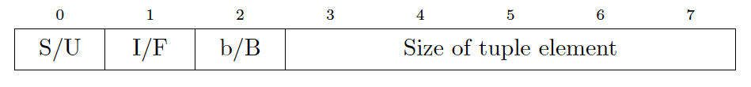
Figure 10: Tuple Element Descriptor (TED) Format

Refer to Figure 10 for the following bits:
- S/U flag: if set (1), the tuple element is an unsigned number. If cleared (0), it is signed
- I/F flag: if set (1), the tuple element is an integer. If cleared (0), it is a float
- b/B flag: if set (1), the tuple element size is in Bytes. If cleared (0), it is represented in bits
- Size of tuple element (5 bits): the size of the tuple element, in bits if the b flag is cleared, or in Bytes if it is set

Gesture Recognition Engine Architecture
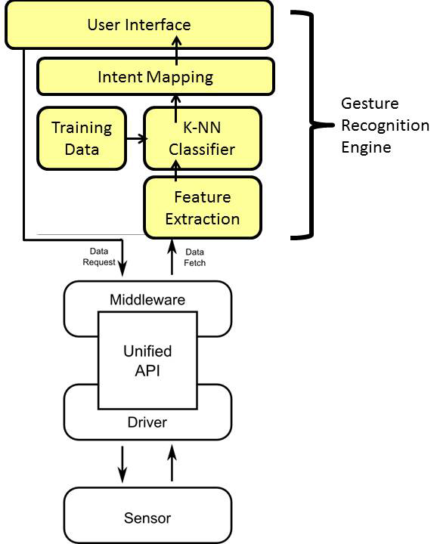
Figure 11: Detailed architectural design for Gesture Recognition Engine

The Gesture Recognition Engine contains four components (Feature Extraction, K-NN Classifier, Intent Mapping, and User Interface) and a local database containing training data for the K-NN classifier. Figure 11 illustrates architectural design of the Gesture Recognition Engine that shows how these components are interconnected. More detailed information of each component within the Gesture Recognition Engine is provided in the following subsections.

User Interface
The objective of the user interface is to provide an interface for the user to perform a gesture, and display the results of the gesture recognition. The interface contains two buttons to annotate the start and the end of the gesture, and a display that shows the recognized gesture and its corresponding services in text. The sample GUI may look similar to the following illustration (Figure 12).

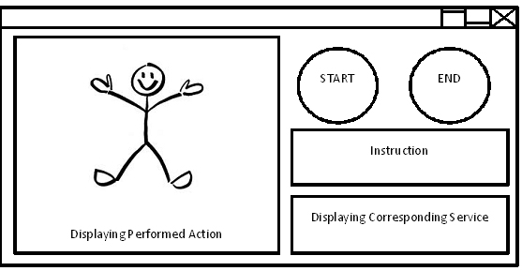
Figure 12: An example UI of the Gesture Recognition Engine

Feature Extraction
Once the user requests the application to record a gesture via the UI, data is captured from the Unified API and transferred to the Feature Extraction in order to process the raw data (i.e., Microsoft Kinect skeleton data). The objective of the Feature Extraction is to extract important information (i.e., features) from the raw data. An example of a feature can be standard deviation of the position of the hand over a certain period of time. These features are in numeric form (e.g., integer, float, double, etc), which are chosen to discriminate four different actions performed by the user.

K-NN Classifier
K - Nearest Neighbor (K-NN) Classifier is a method for classifying objects based on the closest training examples. K-NN is one of the simplest of all machine-learning algorithms. The specific mechanisms of this classifier are beyond the scope of this document, and the details are left to the reader. The output of the K-NN Classifier is a numeric value, which represents one of the four gestures that is recognized to be the closest to the performed gesture.

Training Data
Training Data contains the previously captured data of all four pre-defined gestures. Some features that are defined at the Feature Extraction are extracted from the Training Data. The K-NN Classifier compares the features of the captured gesture to the Training Data to find the most probably gesture.

Intent Mapping
Intent Mapping component receives the gesture recognition results from the K-NN Classifier and provide a service corresponding to that gesture. For example, when the recognized gesture is a “Hand waving” gesture, then printing “Hello” on the UI is provided as its associated service.

COMPONENT DESCRIPTION - Unified API

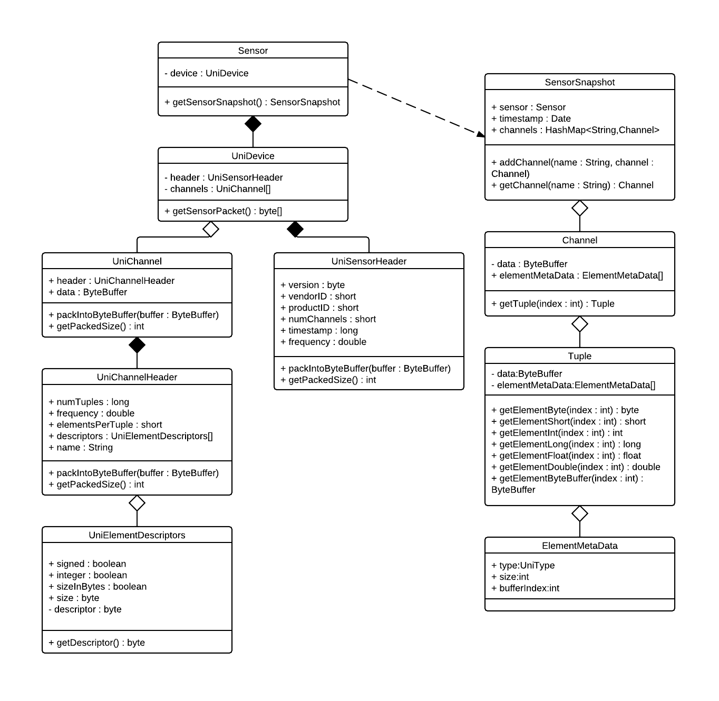
Figure 13 Unified API Class Relationship Diagram

Figure 13 shows the class relationships for the classes that are used for packing and parsing device data. Driver implementors only use or subclass the Uni-prefixed classes.

UniElementDescriptor

Type
Class

Functions
The UniElementDescriptor is a container for the metadata of a element in a tuple.

Interfaces
Public methods, accessed by UniChannelHeader, returns a byte to pack the descriptor data into a given ByteBuffer. There shall also be getter functions, accessed by Channel when parsing sensor packets, for determining the characteristics of an UniElementDescriptor.

Dependencies
Instantiated by UniChannelHeader for driver-side packing and by Channel for middleware-side parsing.

Data
Contains the following:
a boolean representing whether the element type is an integer or floating point number
a boolean representing whether the integer is signed or unsigned
a boolean representing whether the size is in bits or bytes
a byte representing the size of the element type

Resources
None

UniChannelHeader

Type
Class

Functions
The UniChannelHeader is a container for the channel packet header.

Interfaces
Public methods, accessed by the UniChannelPacket in which this UniChannelHeader is contained, pack the channel packet header into a given ByteBuffer. There are also getter functions accessed by Channel for middleware-side parsing.

Dependencies
Instantiated by a UniChannelHeader for driver-side parsing and by UniChannel for middleware-side parsing.

Data
Contains the following:
a String containing the channel’s name
a double representing the frequency at which the channel can be updated in Hz
a long representing the number of tuples in the channel
a short representing the number of elements per tuple
an array of UniElementDescriptors

Resources
None

UniChannel

Type
Class

Functions
The UniChannel is a container for a single channel's data from the device.

Interfaces
Public methods, accessed by the UniSensor in which this UniChannel is contained, pack the channel packet header and data into a given ByteBuffer.

Dependencies
Instantiated by UniSensor for driver-side packing and by Sensor for middleware-side parsing.

Data
Contains the data for a single channel as represented by the driver and a UniChannelHeader

Resources
None

UniSensorHeader

Type
Class

Functions
The UniSensorPacketHeader is a container for the header information in a device's sensor packets.

Interfaces
Public methods, accessed by the UniSensorHeader in which this UniSensorPacketHeader is contained, pack the sensor packet data header into a given ByteBuffer.

Dependencies
Instantiated by a UniDevice when UniDevice's public getSensorPacket function is called.

Data
Contains the following:
a byte representing the unified API version
a short representing the device's Vendor ID
a short representing the device's Product ID
a short representing the number of channels in the sensor packet
a long representing the Unix time when the sensor packet was created in milliseconds
a double representing the highest frequency of the available channels in Hz

Resources
None

UniDevice

Type
Class

Functions
The UniDevice is a wrapper class for the device driver. The middleware-side parsing interfaces with this class.

Interfaces
Public methods, accessed by the Sensor that instantiated this UniDevice, shall allow retrieval of a ByteBuffer that contains a sensor packet.

Dependencies
Instantiated by Sensor.

Data
Contains any persistent data needed by the device driver.

Resources
Requires the device to be connected to the computer.

Sensor

Type
Class

Functions
The Sensor parses sensor packet ByteBuffers into SensorSnapshots and returns SensorSnapshots to the gesture detection middleware.

Interfaces
Public functions, accessed by DataExtractor, will get a sensor packet ByteBuffer from a UniDevice, parse it into a SensorSnapshot, and return the SensorSnapshot back to DataExtractor.

Dependencies
Instantiated by gesture detection middleware.

Data
Contains the UniDevice from which it will receive sensor packets.

Resources
None

ElementMetaData

Type
Class

Functions
The ElementMetaData describes the data type of an element in an element.

Interfaces
There are public getter functions to be used by the gesture detection middleware.

Dependencies
Instantiated by Channel.

Data
Contains metadata about an element of a tuple:
an enum representing the data type (byte, short, int, long, float, double, or nonprimitive)
an int representing the size of the data in bytes
an int representing the byte index of this element in a tuple’s data ByteBuffer.

Resources
None

Tuple

Type
Class

Functions
The Tuple represents a single tuple after parsing.

Interfaces
There are public getter functions to be used by the gesture detection middleware that return one of the tuple’s elements. The middleware must use the getter function corresponding to the data type of that element.

Dependencies
Instantiated by Channel.

Data
Contains metadata about an element of a tuple:
a ByteBuffer that contains the tuple’s data
an array of ElementMetaDatas holding the metadata of the tuple’s elements

Resources
None

Channel

Type
Class

Functions
The Channel represents a single channel after parsing.

Interfaces
There are public functions to be accessed by the gesture detection middleware that return a tuple or metadata about the channel.

Dependencies
Instantiated by gesture detection middleware.

Data
Contains the following:
a ByteBuffer that contains the channel’s data
an array of ElementMetaDatas holding the metadata of the channel’s tuple elements
a double representing the frequency in Hz at which this channel can be updated
a long representing the number of tuples in this channel

Resources
None

SensorSnapshot

Type
Class

Functions
The SensorSnapshot is a container for the parsed sensor packet data.

Interfaces
Public function addChannel is used by Sensor when parsing. Public functions accessed by the gesture recognition middleware can return channels or metadata about the sensor packet.

Dependencies
Instantiated by Sensor

Data
Contains the information from the sensor packet parsed into a format that is easily accessible by the gesture recognition middleware:
a Date representing the timestamp for the creation of the sensor packet
a reference to the Sensor that created this sensor packet
a HashMap that maps Channel names (String) to Channels

Resources
None

COMPONENT DESCRIPTION - GESTURE RECOGNITION ENGINE
In addition to the unified API, a gesture recognition engine that utilizes the unified API is required by Cisco. The component description of the gesture recognition engine implementation is detailed below.

5.1 Class diagram

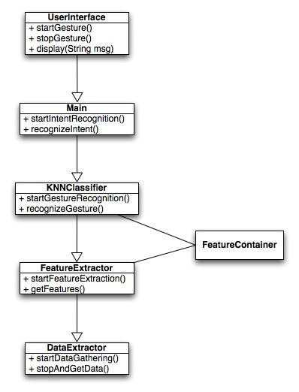
Figure 14: Architectural diagram of the GRE

Figure 14 describes the overall architecture of the GRE. It consists of 6 main classes which are described in the following sections.

Main

Type
Class.

Functions
This is the main class; it is responsible for initializing the system by instantiating the UserInterface as well as the KNNClassifier.
It will have two functions: startIntentRecognition(), which starts the recognition session, and recognizeIntent(), which ends the recognition session and performs the action corresponding to the gesture recognized.

Interfaces
Both methods shall be called by the UserInterface object.

Dependencies
None: main() is a top-level process, i.e. the first process executed.

Data
Contains a mapping between the recognized gestures and the actions to perform, or what to ask the UserInterface to display.

Resources
None.

DataExtractor

Type
Class.

Functions
The DataExtractor is responsible for gathering SensorSnapshots from the unified API through the Sensor class and passing it to the FeatureExtractor class.

The DataExtractor object has two functions: startDataGathering(), which will start collecting SensorSnapshots from the Kinect by polling the API, and stopAndGetData(String[] channels), which will stop the data collection and return the list of SensorSnapshots containing the requested channels.

Interfaces
Both methods will be called by the FeatureExtractor object, respectively at the beginning and at the end of the Recognition session.

Dependencies
Instantiated from the FeatureExtractor object.

Data
Stores the current SensorSnapshots in the session.

Resources
None.

FeatureExtractor

Type
Class.

Functions
The FeatureExtractor object has two functions: startFeatureExtraction(), which will start the feature extraction session, and getFeatures(), which will end the session and return the FeatureContainer object containing the features computed from the SensorSnapshots passed by the DataExtractor.

Interfaces
Both methods will be called by the KNNClassifier object, respectively at the beginning and at the end of the session.

Dependencies
Instantiated from KNNClassifier.

Data
Contains a collection of SensorSnapshots objects objects.

Resources
None.

FeatureContainer

Type
Class.

Functions
The Feature object is a container for the features of a session used by the KNNClassifier to recognize gestures.

Interfaces
All the attributes shall be public and directly accessed.

Dependencies
Instantiated by FeatureExtractor.

Data
FeatureContainer shall contain a representation of all the features needed for recognizing gestures.

Resources
None

KNNClassifier

Type
Class.

Functions
Uses the previously recorded set of training data to recognize gestures.

Interfaces
The KNNClassifier has two public methods, startGestureRecognition(), which will start the recognition session, and recognizeGesture(), which will end the session and return the recognized (or not) gesture.

Dependencies
Instantiated by the Main class.

Data
Contains a mapping between FeatureContainers and gestures representing the training data.

Resources
None

UserInterface

Type
Class

Functions
Interfaces with the user and allow them to start and stop a gesture recognition session. The UserInterface object shall have three functions: startGesture(), which will start the recognition session by calling the corresponding function of Main, stopGesture(), which will notify Main that the user has finished performing the gesture, and display(String message), which shall display a message on the screen.

Interfaces
startGesture() and stopGesture() will be directly called by UI buttons, whereas the display function will be accessed by Main.

Dependencies
Instantiated by the Main class.

Data
None.

Resources
Access to the UI.

Extensibility

Implementing a New Application
It will be possible to use the API to implement another application, replacing the GRE. To do so, a developer only needs its application to interface with the Sensor class and call its getSensorSnapshot() method to collect data, and be able to understand and process SensorSnapshot objects.

Implementing the API in a New Sensor
To implement the driver-side API for a new sensor, the driver provider must create a class that implements the UniDevice class. The implementation entails:
- The constructor, which can be used to initialize any necessary values and components for the driver
- getSensorPacket(), which packs sensor and channel information into the unified packet format for transmission to the middleware

