1)The shell hangs after typing a command whose executable is not in the system.The parent exits early then the child.
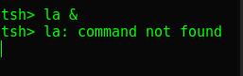

2) The Shell hangs after closing a backgroud process.
