**MEMORANDUM**

|  |  |
| --- | --- |
| **To:** | Carole Voulgaris, Course Instructor, SES 5215 |
| **From:** | Ramona Quimby, Student, SES 5215 |
| **Date:** | November 18, 2022 |
| **Subject:** | Assignment 5, Multiple regression |

The purpose of this memo is to present the results of a linear regression model that addresses the question:

**What is the effect of a Boston census tract’s median age on the number of crashes per square kilometer that occur there, after accounting for the effects of poverty and population density?**

I address this question using crash data from Vision Zero Boston **(https://data.boston.gov/dataset/vision-zero-crash-records)** and demographic data from the 2016-2020 American Community Survey. My dataset includes 187 census tracts in Boston (excluding tracts with zero households), shown in Figure 1 below.

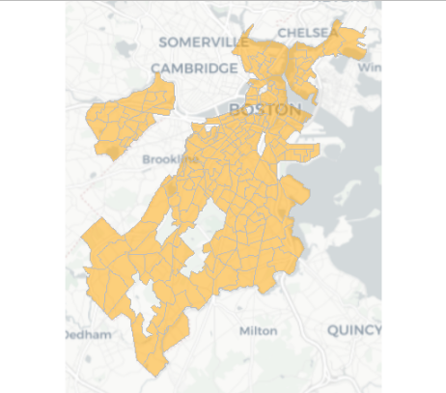

***Figure 1: Census tracts in the study area***

The variables in my data set are:

1. Crash density: The number of crashes recorded in each census tract between January 1, 2015 and September 30, 2022, divided by the area (square kilometers) of land within the census tract.
2. Median age: The median age of census tract residents.
3. Population density: The number of residents per square kilometer of land area in each census tract.
4. Majority poverty: A categorical variable indicating whether the majority of census tract residents have income below the poverty level.

I estimated a linear regression model predicting crash density based on median age, population density, and poverty status. Both density variables are log-transformed. The results are shown in Table 1. The model has an R-squared value of 0.09, indicating that about nine percent of the variation in crash density can be explained by variation in median age, population density, and poverty status. The coefficient for median age is not significant, so we cannot conclude that there is a relationship between the median age in a census tract and the number of crashes per square kilometer.

***Table 1: Regression results***

|  |  |  |
| --- | --- | --- |
| Variable | Coefficient estimate | p-value |
| Median age | -0.01 | 0.4999 |
| Population density (log-transformed) | 0.28 | 0.0003 |
| Majority poverty | 0.32 | 0.0919 |