# Survey on Safe Routes to SChool

We invite you to participate in a survey to help students and researchers understand how to make it easier and safer for kids to walk or bike to school in Somerville.

You can take the survey online at:

<https://tinyurl.com/school-travel-sps>

or by using this QR code:

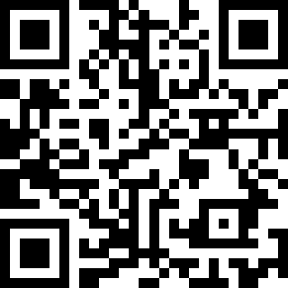

# Placeholder for Spanish Translation

# Placeholder for Portuguese Translation

# Placeholder for Hatian Creole Translation