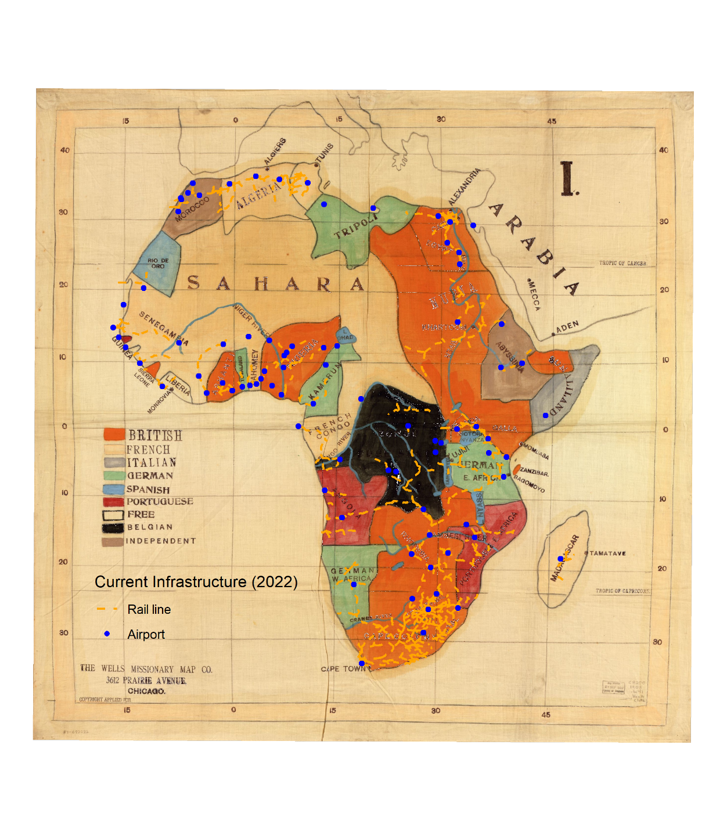

*Former Colonies and Current Infrastructure*

The original map is available from the Library of Congress Geography and Map Division (<https://www.loc.gov/item/87692282/>) and additional data layers are from Natural Earth (<https://www.naturalearthdata.com/>).

My classmate, Bruce Boucek, helpfully suggested I use Microsoft Word to create my final layout instead of messing around in Illustrator.

How has the history of colonialism and imperialism in Africa shaped the development of the continent’s transport infrastructure? This map shows which European nations controlled much of the African continent when the map was created in approximately 1908. Current locations of rail lines and airports are superimposed on the map.