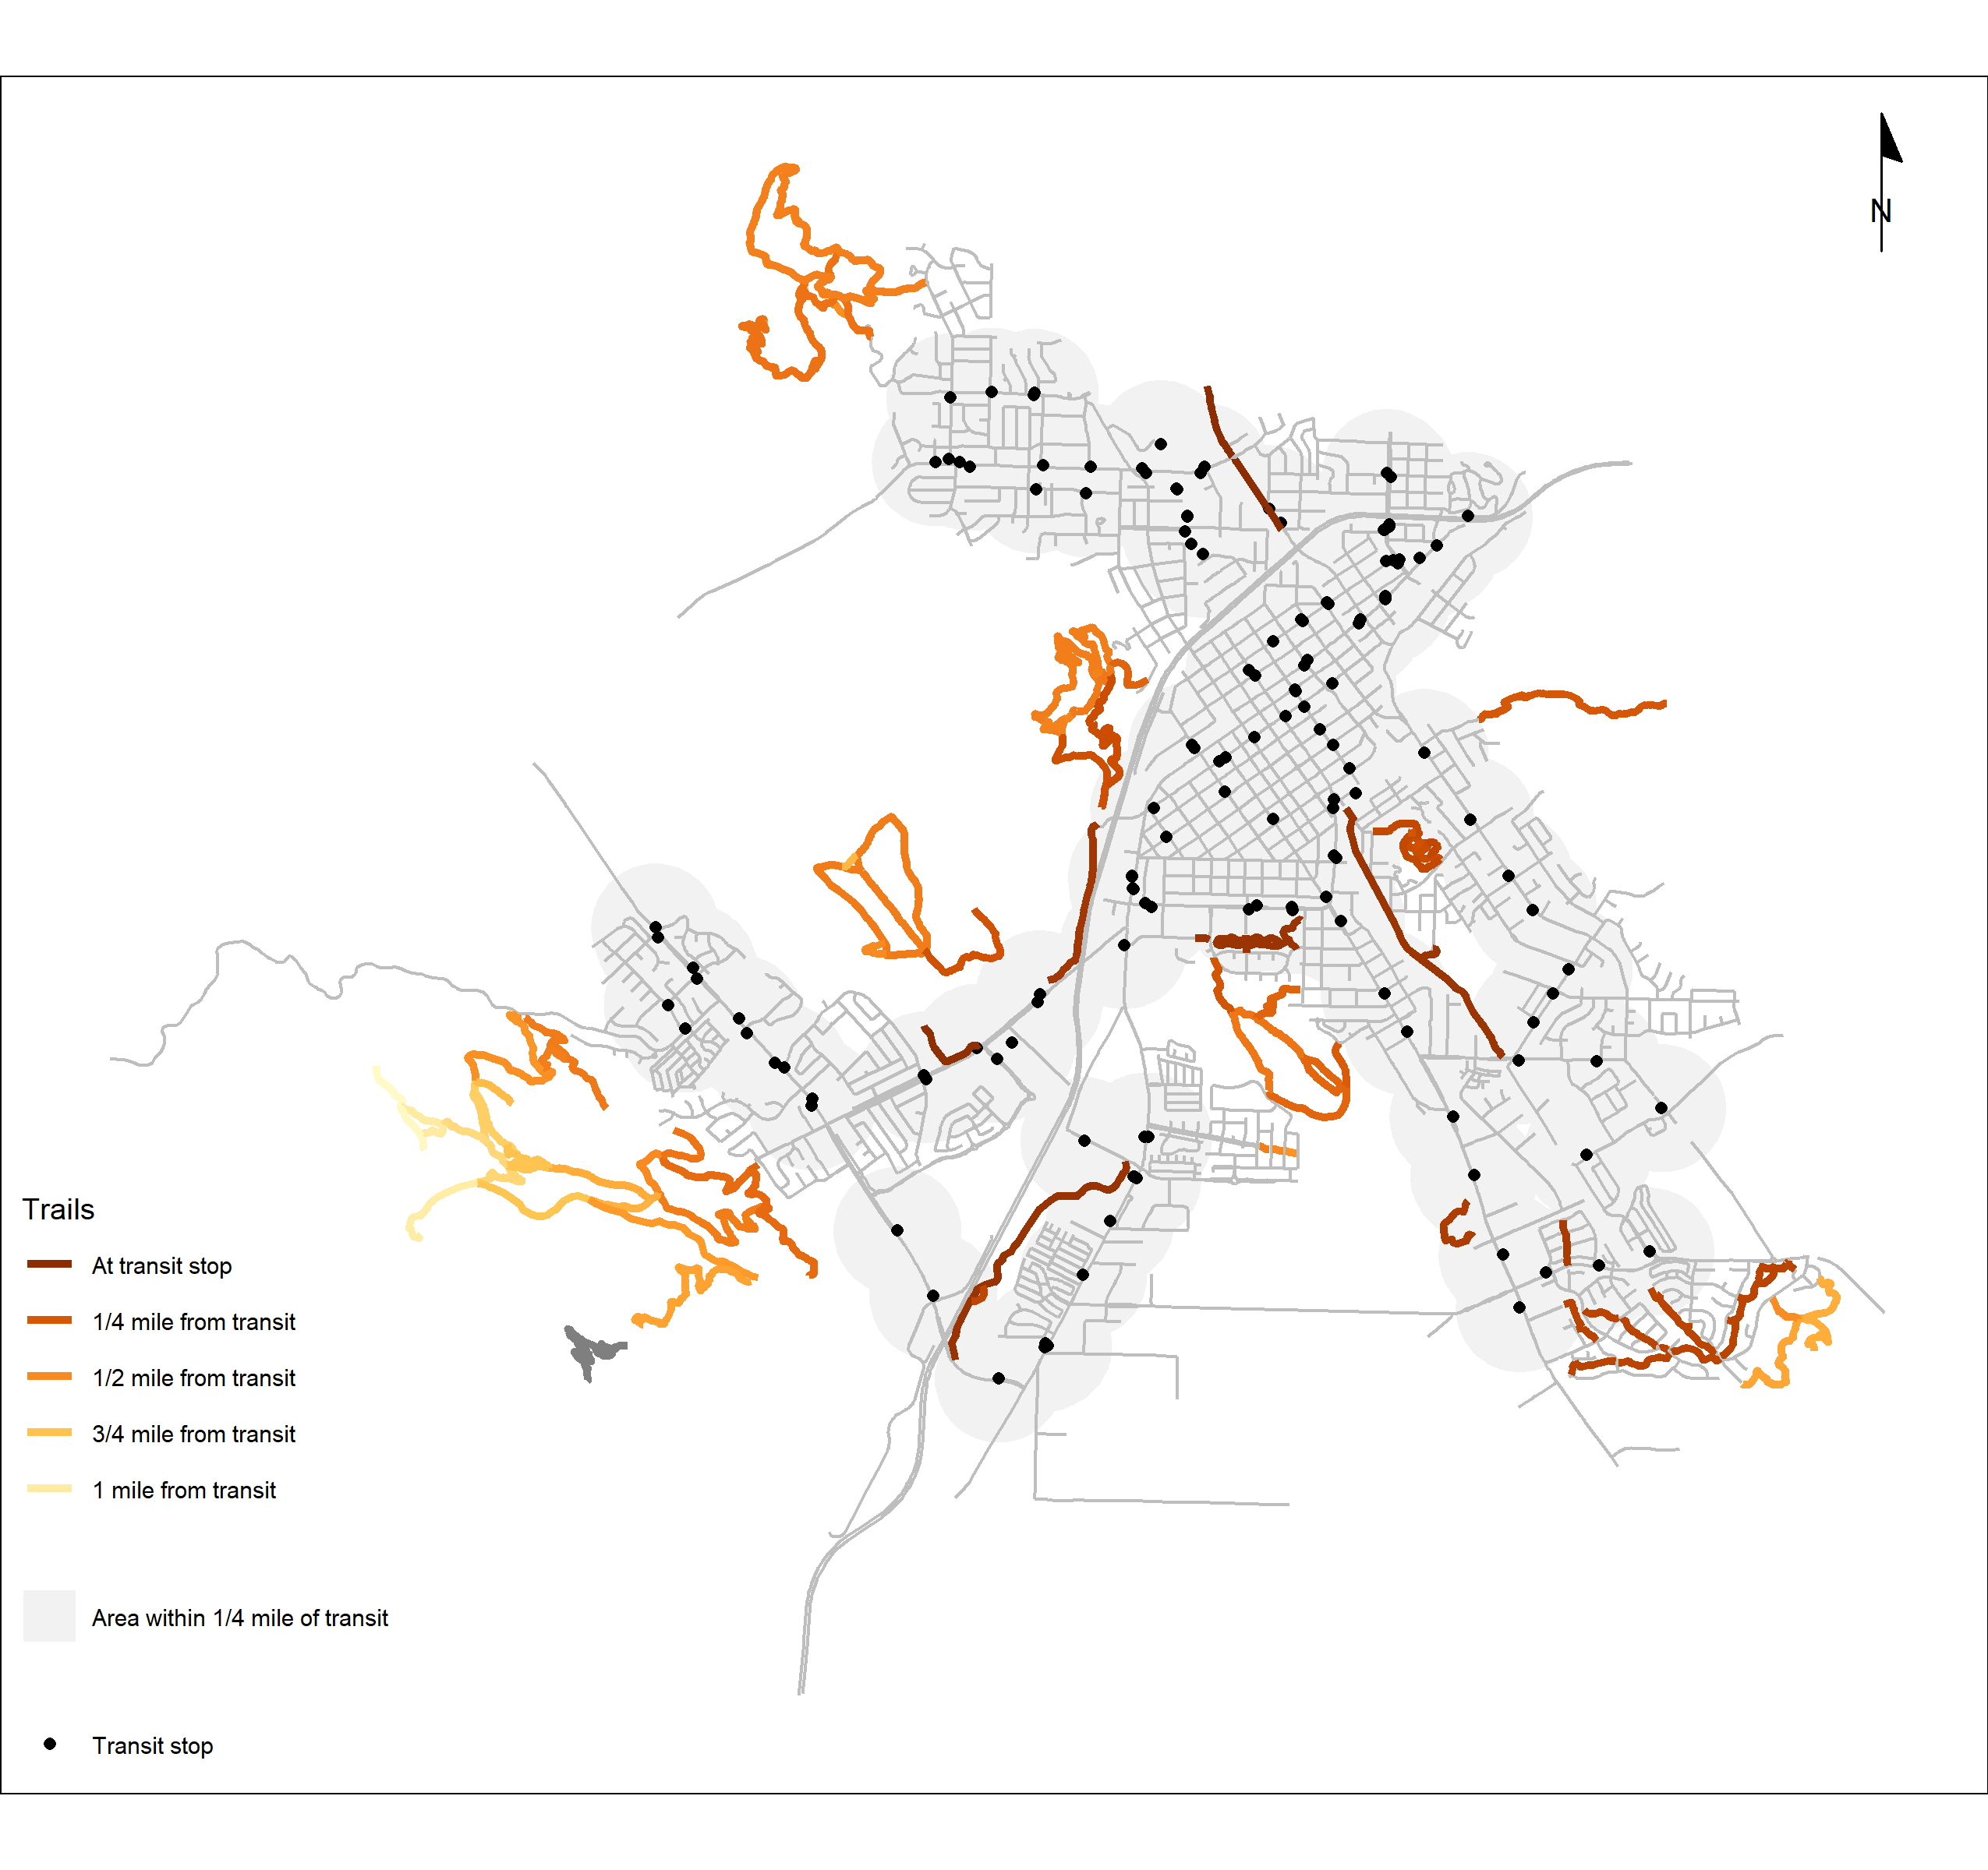

**Acknowledgment:**

My classmate, Rachel Meltzer, suggested displaying the buffers as transparent, filled shapes rather than as outlines, which I think works well.

**Sources:**

Street network data from [OpenStreetMap](openstreetmap.org) contributors

Trail data from [San Luis Opispo County Open Data](https://opendata.slocounty.ca.gov/datasets/county-trails/explore) and [City of San Luis Obispo GIS Hub](https://gis-slocity.hub.arcgis.com/datasets/SLOCity::trail/explore?location=35.293030%2C-120.668450%2C11.99).

Transit stop data from the [SLO Transit GTFS feed](https://app.mecatran.com/urb/ws/feed/c2l0ZT1zbG90cmFuc2l0O2NsaWVudD1zZWxmO2V4cGlyZT07dHlwZT1ndGZzO2tleT0zZTMwMzM1OTRiMTE2NzA0N2IxNjQwNjA0ZjQwMGMzMzdiM2E1MTQ0) and the [RTA GTFS feed](http://slo.connexionz.net/rtt/public/resource/gtfs.zip)

Trails and Transit

How accessible is San Luis Obispo’s trail system by public transit? This map shows that while much of the city’s urban trails are with a quarter mile of a transit stop, a few remain accessible primarily by private car, particularly Islay Hill, Old Prospector, Froom Creek, Bishop Peak, and Felsman Loop.

Bishop Peak

Felsman Loop

Islay Hill

Old Prospector

Froom Creek

Morro View