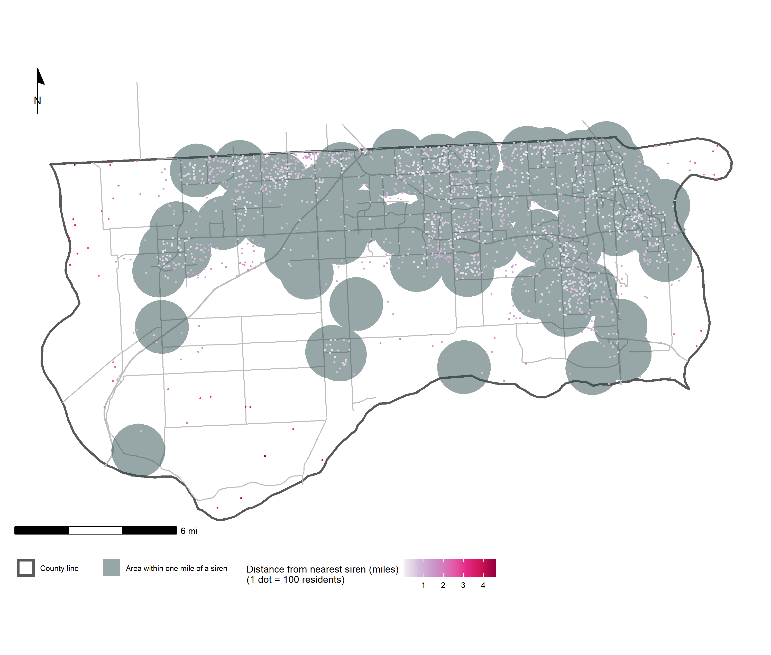

My classmate, Hannah Teicher, suggested tornado sirens as an example of an amenity with a usefulness that decreases with Euclidean distance.

**Data sources:**

Street layer from OpenStreetMap contributors (https://www.openstreetmap.org/copyright)

Siren locations from Sarpy County GIS (https://gis.sarpy.gov/datasets/3e5e276b46914943a49abaf3d2887007/about)

County boundaries and block group populations from United States Census Bureau, accessed via tidycensus (Walker and Herman 2022)

Kyle Walker and Matt Herman (2022). tidycensus: Load US Census Boundary and Attribute Data as 'tidyverse' and 'sf'-Ready Data Frames. R package version 1.2. https://CRAN.R-project.org/package=tidycensus

Sixty-nine tornado warning sirens located throughout **Sarpy County, Nebraska** with a theoretical sounding radius of one mile can warn residents to seek shelter in case of a tornado. This map shows the distribution of the population throughout the county (approximated based on census block group populations from the 2020 Census) and suggests that most of the county’s population lives within earshot of a warning siren, but that these warnings may not reach some residents living in the southern and western parts of the county.

Who can hear a tornado warning?