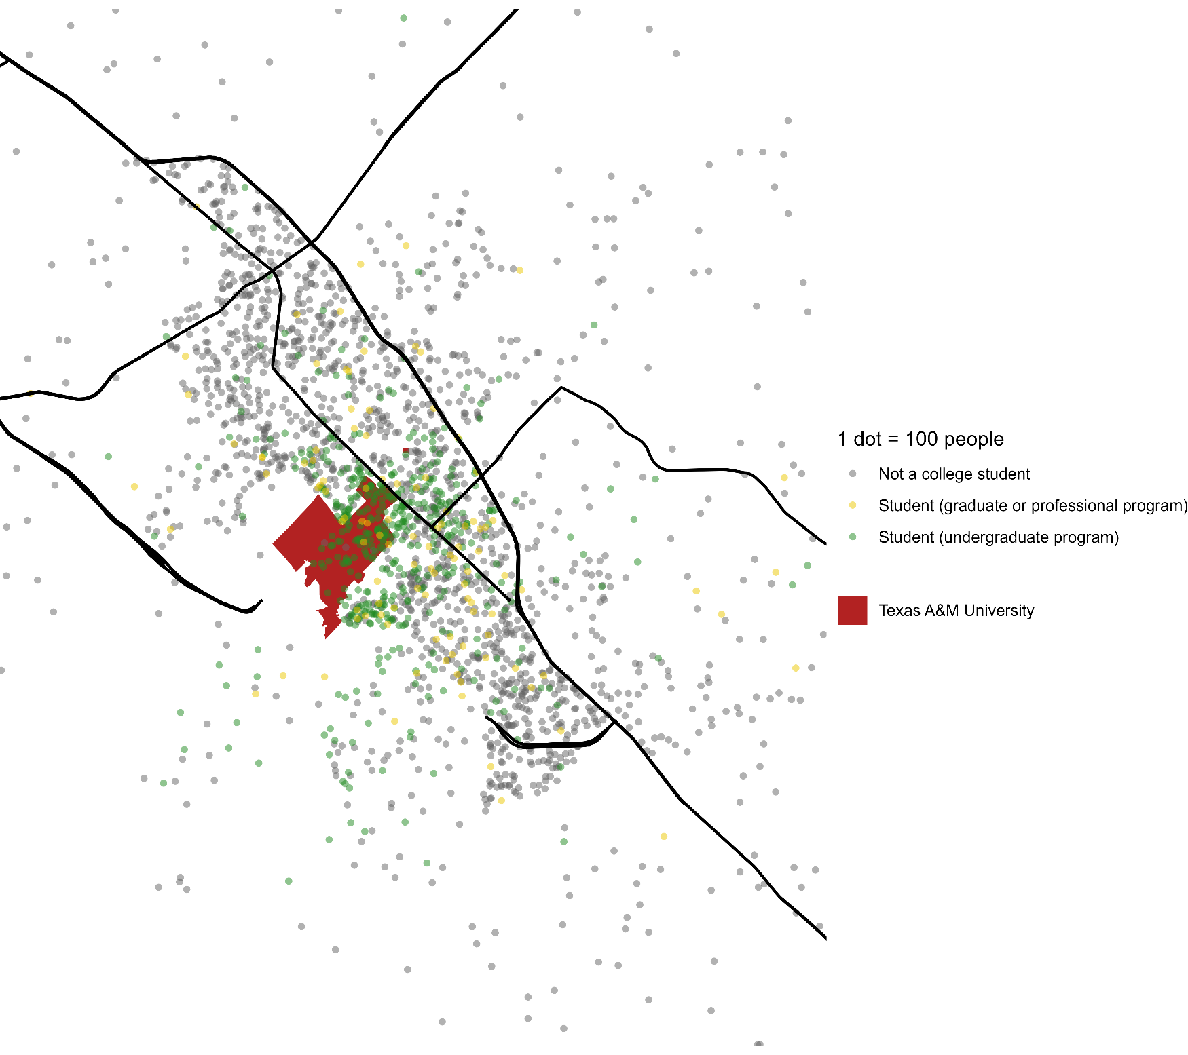
Distribution of Students in College Station, Texas
Texas A&M University is a major anchor of the College Station – Bryan Metropolitan Statistical Area in Texas, which comprises Brazos, Robertson, and Burleson Counties.
The most densely-settled area of the metropolitan area in the immediate vicinity of the university. Within that area, undergraduate students are clustered on and near the university campus, while graduate students are somewhat more dispersed and integrated with the general population.

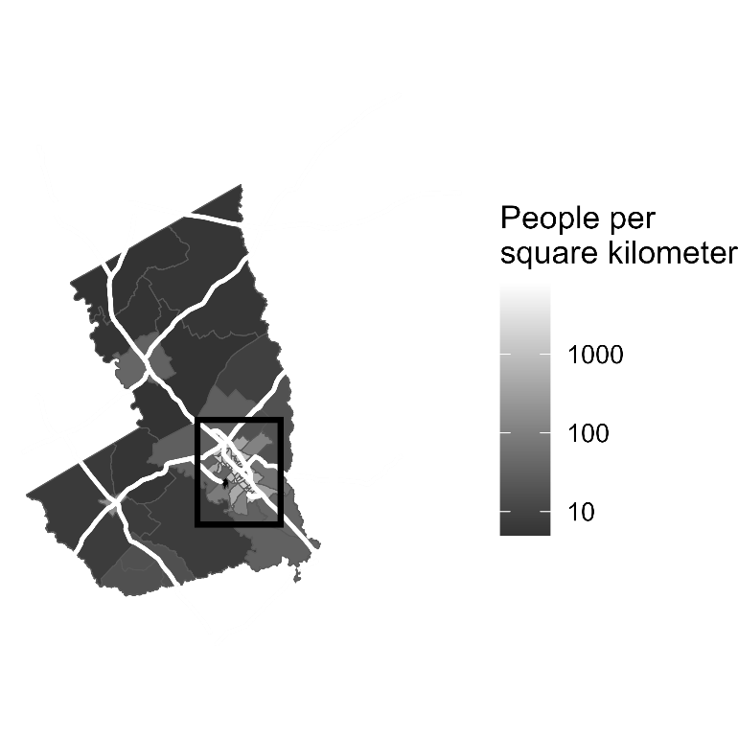
North

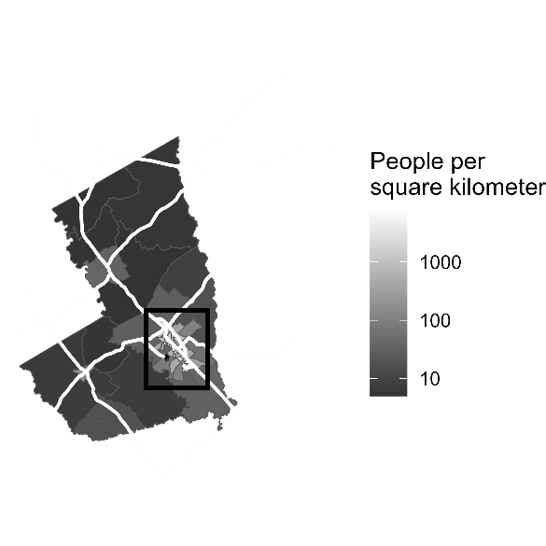

College Station – Bryan, Texas Metropolitan Statistical Area
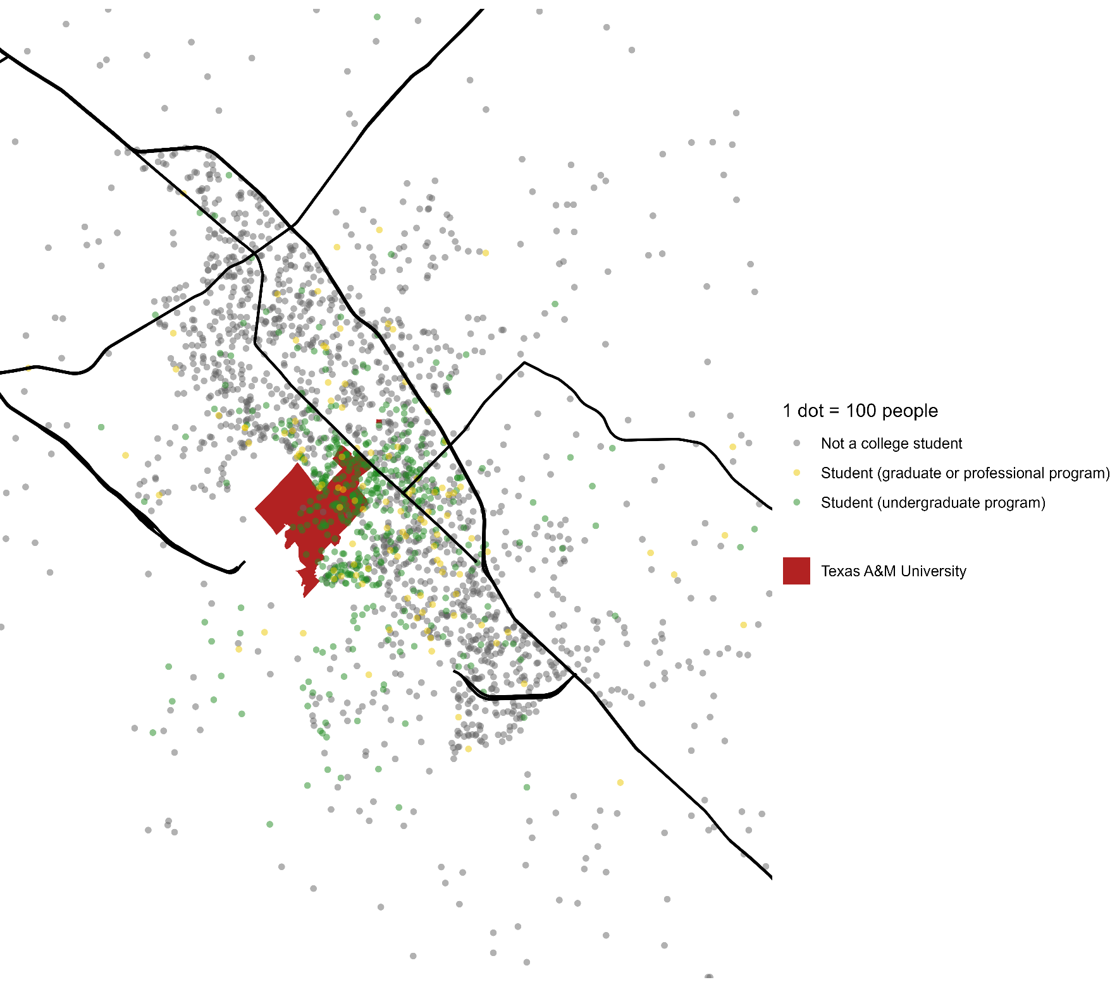
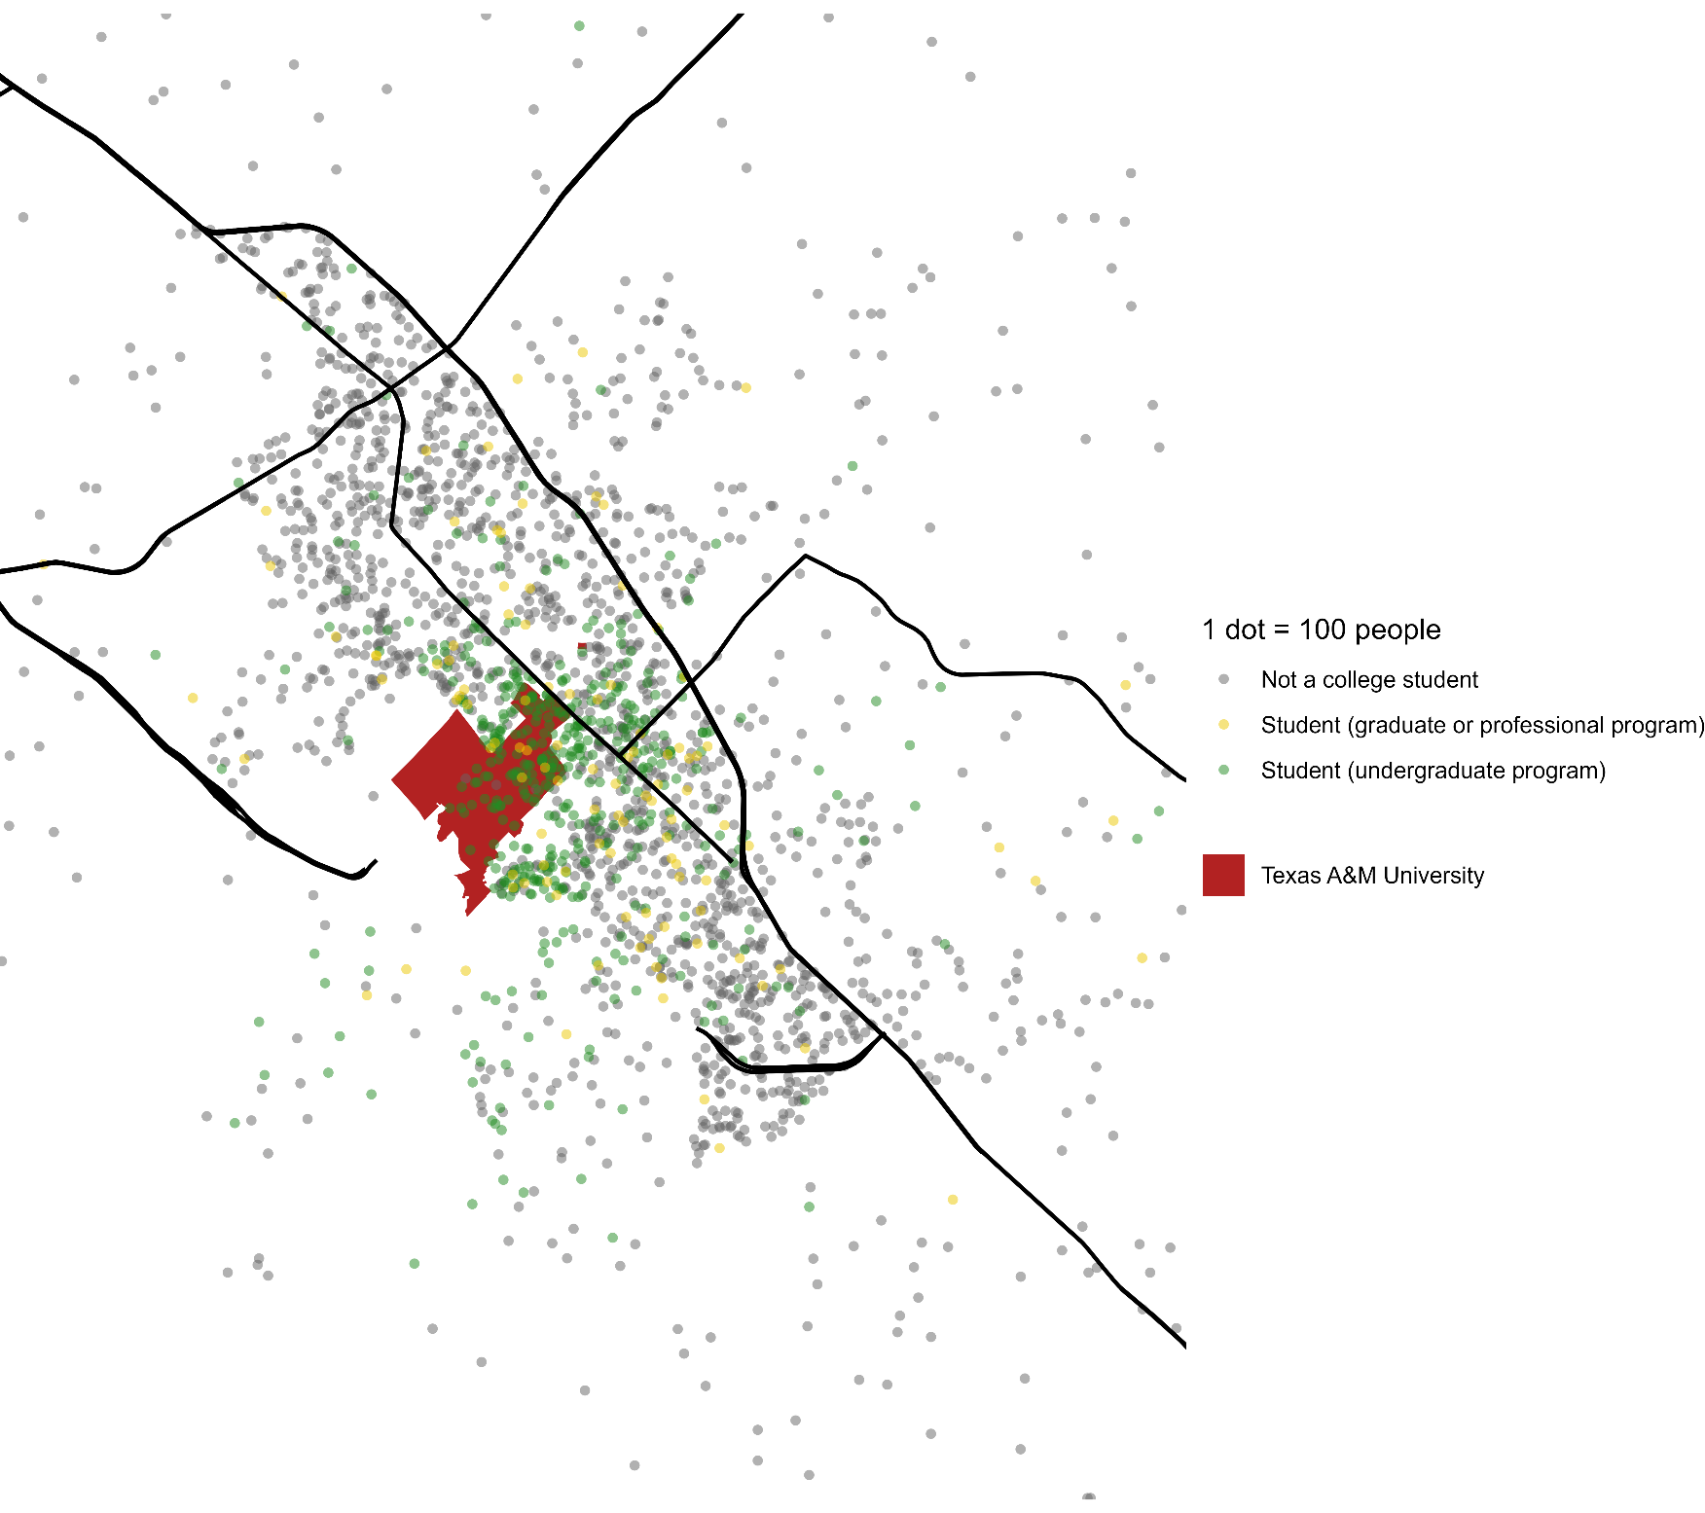
Data Attribution
From 2024 Census TIGER files (accessed via tigris R package):
- MSA Boundaries
- Census tract boundaries (areas from ALAND variable)
- Primary and secondary roads
- University boundary (Landmark layer)
From 2019 – 2023 American Community Survey 5-year estimates (accessed via tidycensus R package):
- Tract populations (Table B01001)
- Number of undergraduate and graduate students by tract (Table B14001)

Text responses
- I am happy with the way this assignment turned out. I definitely struggled with the question of how to arrange the two different layouts on the page to tell a coherent story, but the idea of using the chloropleth map to orient the reader to the general area while using the dot-density map to show more detail seems to have been a good solution. I’m not sure what I would have done differently if I had had more time, but there are definitely things I would have done differently if I had had a larger page (or more pages).
- I did some online searching to figure out how to add a rectangle to the chloropleth map. Sarah Ferriter was very generous in helping my troubleshoot my code during office hours. My classmate, Nur Shlapobersky, offered me useful feedback on the color palette I chose. I relied heavily on course lecture notes as well.
- I created the maps in R and laid them out (including cropping and repositioning the legends) in Microsoft Word. I also added the north arrow in Micorsoft Word.
- You have my permission to post this work as an example on the course website.

