**Railways and Urban Areas in the Contiguous United States**

**Data sources**

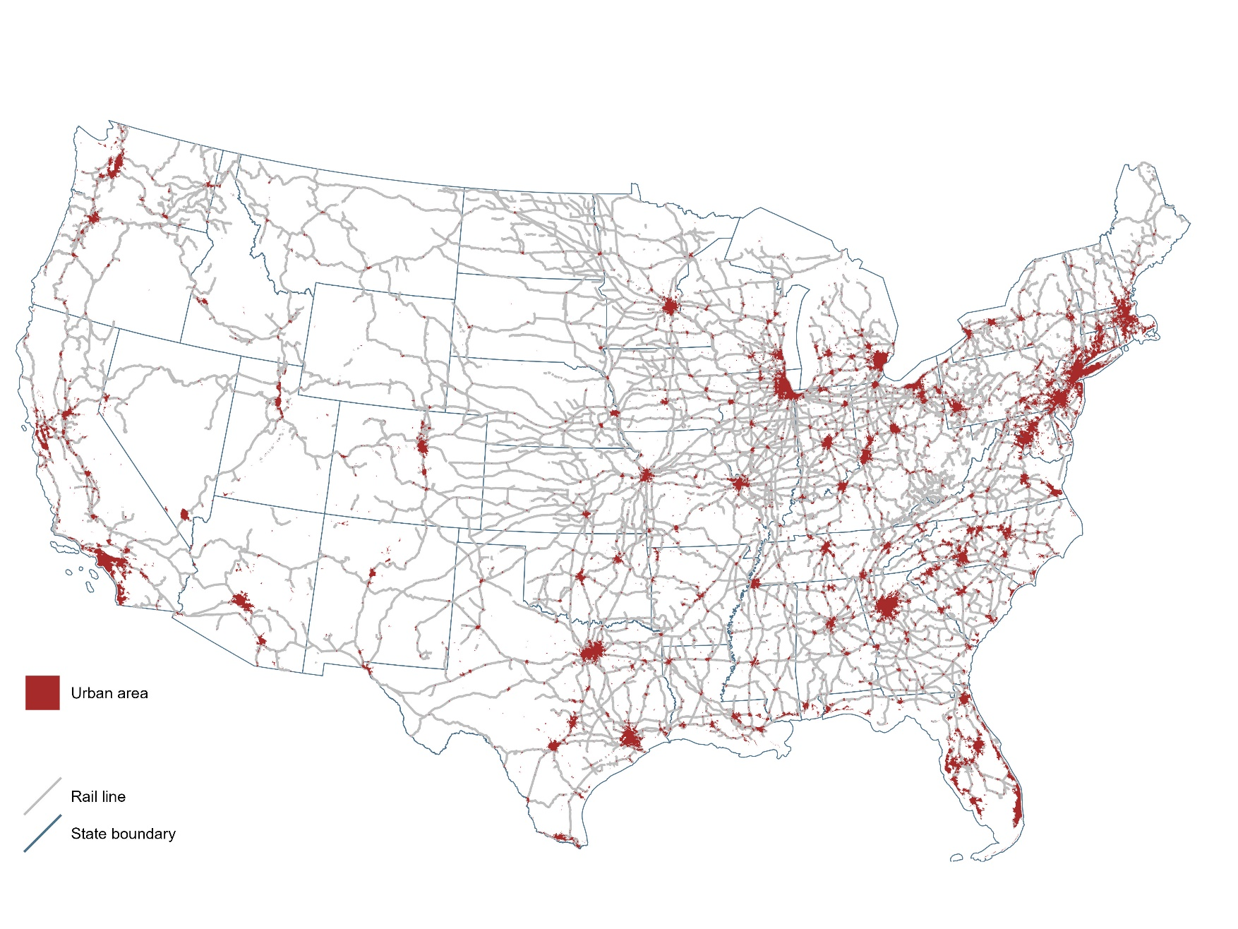

I created the map and legend using the sf and ggplot2 packages in R. I imported the figure into Microsoft Word, which I used to complete the layout and add titles and notes.

**Software**

State boundaries, rail lines, and urbanized area boundaries are all taken form Census TIGER files, accessed via the tigris package in R. All three layers are from the 2021 datasets.

**Audience and purpose**

This map is intended for an audience that is generally familiar with the geography of North America and the United States, so I assume a familiarity with the scale and orientation. The purpose of the map is to illustrate the relationship between the density of the rail network and the density of urban development.