Data sources:

Historical transit frequencies: archived GTFS feeds from OpenMobilityData.

Distribution of essential jobs: Payroll data compiled by the United States Census Bureau. Essential jobs will be defined as jobs in industries identified by the CDC as employing essential workers.

American Community Survey

Our analysis will focus on the following three points in time. We will determine the approximate date of each time point based on transit service and ridership date, and those dates may vary by region.

1. Pre-pandemic conditions (PPC): A point in time immediately preceding the changes in ridership and transit services associated with the beginning of public health advisories to limit non-essential trips and practice social distancing. For most regions, we anticipate that this will have been at some point in February 2020.
2. Minimum transit (MT): A point in time when the reduction in overall ridership and transit service reached their minimum levels prior to rebounding ridership and the availability of funding through CARES Act, ARPA and other recovery programs. For most regions, we anticipate that this will have been at some point in the late spring or early summer of 2020.
3. Initial recovery (IR): A point in time when transit ridership had begun to rebound and service levels had moved substantially toward the levels provided at the PPC point. For most regions, we anticipate that this will have been at some point in the summer of 2021.

We will evaluate two outcomes at each of the above three time points. First, we will evaluate transit service frequency at the route level, defined as the number of scheduled trips (i.e. the number of scheduled arrivals per transit stop) per weekday, based on archived GTFS feeds. Second, we will evaluate accessibility to essential jobs.

We will define the accessibility of each census tract as the weighted number of jobs within the region, with weights assigned based on a decay function of transit travel time from each job to the tract’s centroid. The decay function (shown in Figure 1) is based on the cumulative distribution function of a logistic distribution, which relates well to discrete choice theory. We will use logistic distribution with a median (inflection point) of 45 minutes (to approximately correspond to the average commute time of bus commuters in the United States) and a standard deviation of 10 minutes. This decay function approximates the probability that a worker would consider a job to be accessible by transit.

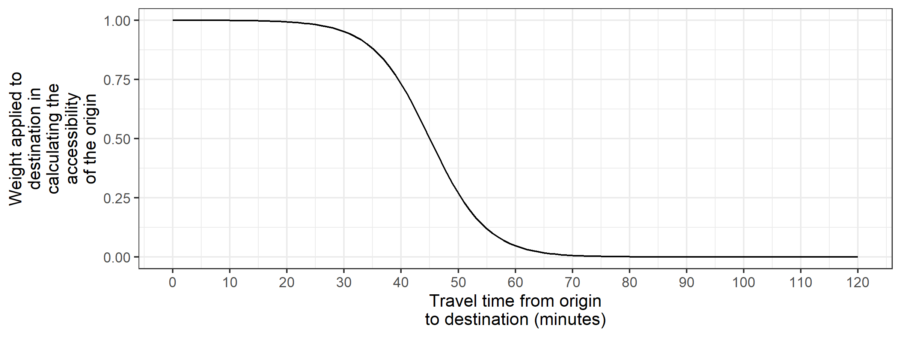

Figure . Decay function for accessibility calculation

We will estimate four multilevel models with varying slopes and intercepts. Two models will predict route-level changes in transit frequency (from the PPC to the MT point in time, and from the MT to the IR point in time), and two models will predict tract-level changes in essential job accessibility (for the same two time periods). Multilevel models are appropriate when observations (transit routes or census tracts, in this case) are nested in groups (regions, in this case), with explanatory variables at the individual level and at the group level. This model form will allow us to evaluate differences among regions as well as differences among individual neighborhoods and transit routes within regions.

All four models will include regional-level predictors describing transit board governance structure and transit board representation by race, gender, disability status, travel behavior, and professional background of board members. Model 1 will include route-level predictors describing the sociodemographic and employment characteristics of individuals living and working each route’s service area (the area within a quarter mile of each stop on the route) and well as route-level ridership. Model 2 will include sociodemographic and employment characteristics of individuals living and working in each census tract.