# Overview

The GPS Watch specified in this document is a simple version of a class of devices that is growing rapidly, both in number and capabilities. This one is based loosely on the earlier Garmin Forerunner devices (205, 301, etc.).

As the name indicates, this is a wearable device, the size of a large wristwatch, and it can be thought of as the integration of a GPS system and a stop watch. These devices are used to track fitness activities such as running, cycling, and hiking.

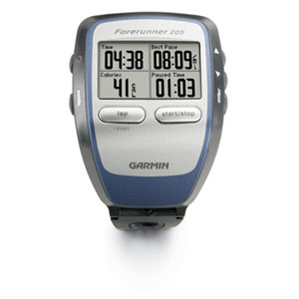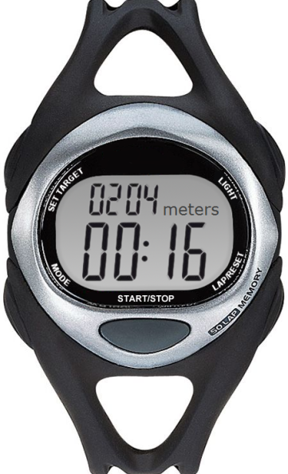

# Capabilities

The device has two primary capabilities. First, it provides real-time information to the user regarding distance traveled, elapsed time, speed, and status relative to goals. Second, it logs information, including the route traveled, heart rate, and achievement of goals, for later analysis. This track log can be examined on the device or off-loaded to a computer for analysis. For example, a track log of a completed route can be loaded into Google Earth for viewing as a three-dimensional map overlay. Also, software provided by the device maker typically provides graphs such as pace over time.

The device is typically used in one of two fashions. The simplest approach involves starting the timer when a run, hike, or cycling session begins, stopping the timer at the end of the session, and viewing relevant data along the way and at the end of the session. Another approach involves establishing one or more goals, such as maintaining a particular pace for a certain distance, and then striving to achieve these goals during the session while the device provides an indication of whether the current goal is being met.

# Requirements

### Logging and Goals

|  |  |
| --- | --- |
| **ID** | **Description** |
| L-1 | Whenever the timer is running, the location of the device is recorded as a track point at one-second intervals. |
| L-2 | Each track point is specified as latitude, longitude, and altitude. |
| L-3 | The UTC time for each track point is recorded. |
| L-4 | An unlimited number of lap markers may be created. |
| L-5 | Each lap marker specifies a particular track point within the track log. |
| L-6 | The track log can be off-loaded from the device to a computer for analysis. |
| L-7 | Whenever the timer is running, the heart rate of the user is recorded at one-second intervals. |
| L-8 | The UTC time of each recorded heart rate is recorded. |
| L-9 | The collection of all recorded heart rates can be off-loaded from the device to a computer for analysis. |
| L-10 | Up to five goals can be established for each session. |
| L-11 | No more than one goal is executing at any given time. |
| L-12 | The collection of goals is executed according to a sequence number assigned by the user to each goal. |
| L-13 | The success or failure of the user to achieve each goal is recorded. |
| L-14 | A goal may specify a minimum and maximum speed or pace to be maintained for a length of time. |
| L-15 | A goal may specify a minimum and maximum speed or pace to be maintained for a distance. |
| L-16 | A goal may specify a minimum and maximum heart rate to be maintained for a length of time. |
| L-17 | A goal may specify a minimum and maximum heart rate to be maintained for a distance. |

### User Interface

|  |  |
| --- | --- |
| **ID** | **Description** |
| UI-1 | The primary page of the display always includes elapsed time. |
| UI-2 | The primary page of the display shows one of: accumulated distance, speed, lap count, pace, or heart rate. |
| UI-3 | Pushing the mode button when the primary page is displayed causes the next quantity in the sequence described in UI-2 to be displayed. |
| UI-4 | Pushing the start/stop button when the timer is not running causes the timer to start running. |
| UI-5 | Pushing the start/stop button when the timer is running causes the timer to stop running. |
| UI-6 | Pressing the lap/reset button when the timer is not running resets the timer. |
| UI-7 | Pressing the lap/reset button when the timer is not running deletes the track log, recorded heart rates, and all records of goal achievement. |
| UI-8 | Pressing the lap/reset button when the timer is running creates a lap marker. |
| UI-9 | Goals are created using a menu system and a virtual keyboard. |
| UI-10 | Whenever a goal is executing, the display provides a visual indication of whether the goal is currently being met. |