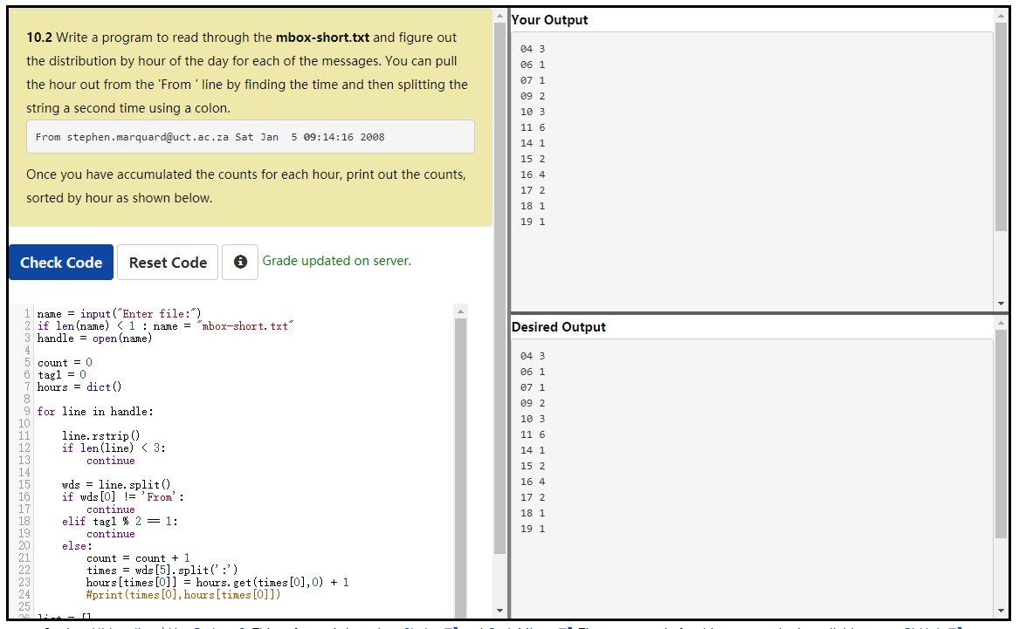

name = input("Enter file:")

if len(name) < 1 : name = "mbox-short.txt"

handle = open(name)

count = 0

tag1 = 0

hours = dict()

for line in handle:

line.rstrip()

if len(line) < 3:

continue

wds = line.split()

if wds[0] != 'From':

continue

elif tag1 % 2 == 1:

continue

else:

count = count + 1

times = wds[5].split(':')

hours[times[0]] = hours.get(times[0],0) + 1

list = []

for key,value in hours.items():

newtuple = (key,value)

list.append(newtuple)

#print(sorted([(key,value) for key,value in hours.items()]))

list2 = sorted(list)

for key,value in list2:

print(key,value)