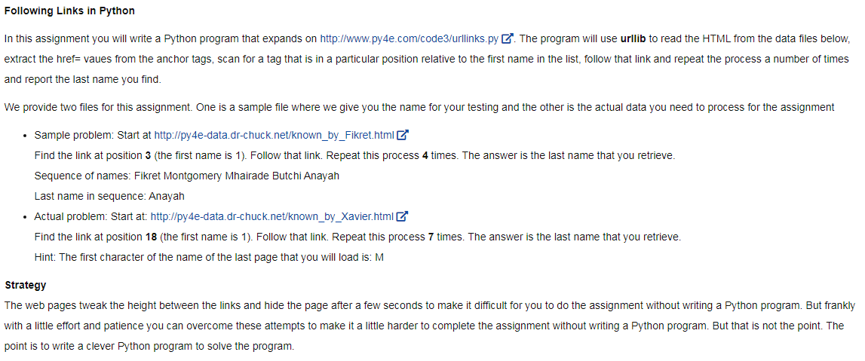

# To run this, download the BeautifulSoup zip file

# http://www.py4e.com/code3/bs4.zip

# and unzip it in the same directory as this file

import urllib.request, urllib.parse, urllib.error

from bs4 import BeautifulSoup

import ssl

import re

# Ignore SSL certificate errors

ctx = ssl.create_default_context()

ctx.check_hostname = False

ctx.verify_mode = ssl.CERT_NONE

url1 = input('Enter - ')

count1 = 7

pos1 = 18

#decode text func

def trace(url):

html = urllib.request.urlopen(url, context=ctx).read()

soup = BeautifulSoup(html, 'html.parser')

return soup

#loop name func

def explore(soup, pos):

tags = soup('a')

pos_tag = 0

for tag in tags:

link = tag.get('href', None)

pos_tag = pos_tag + 1

#print(pos_tag)

if pos_tag == pos:

break

else:

continue

return link