9.4 Write a program to read through the mbox-short.txt and figure out who has sent the greatest number of mail messages. The program looks for 'From ' lines and takes the second word of those lines as the person who sent the mail. The program creates a Python dictionary that maps the sender's mail address to a count of the number of times they appear in the file. After the dictionary is produced, the program reads through the dictionary using a maximum loop to find the most prolific committer.

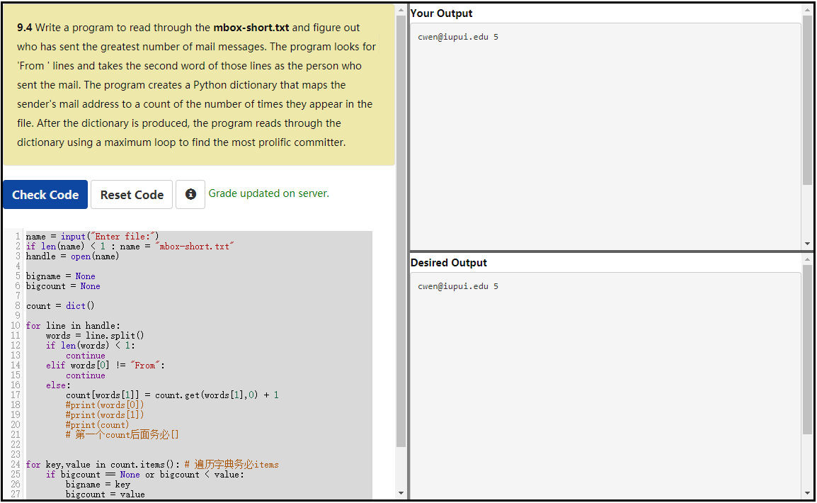

name = input("Enter file:")

if len(name) < 1 : name = "mbox-short.txt"

handle = open(name)

bigname = None

bigcount = None

count = dict()

for line in handle:

words = line.split()

if len(words) < 1:

continue

elif words[0] != "From":

continue

else:

count[words[1]] = count.get(words[1],0) + 1

#print(words[0])

#print(words[1])

#print(count)

# 第一个count后面务必[]

for key,value in count.items(): # 遍历字典务必items

if bigcount == None or bigcount < value:

bigname = key

bigcount = value

print(bigname, bigcount)